Local Deformable Precomputed Radiance Transfer

(Note: all photos are taken from the project and run at approximately 40FPS)

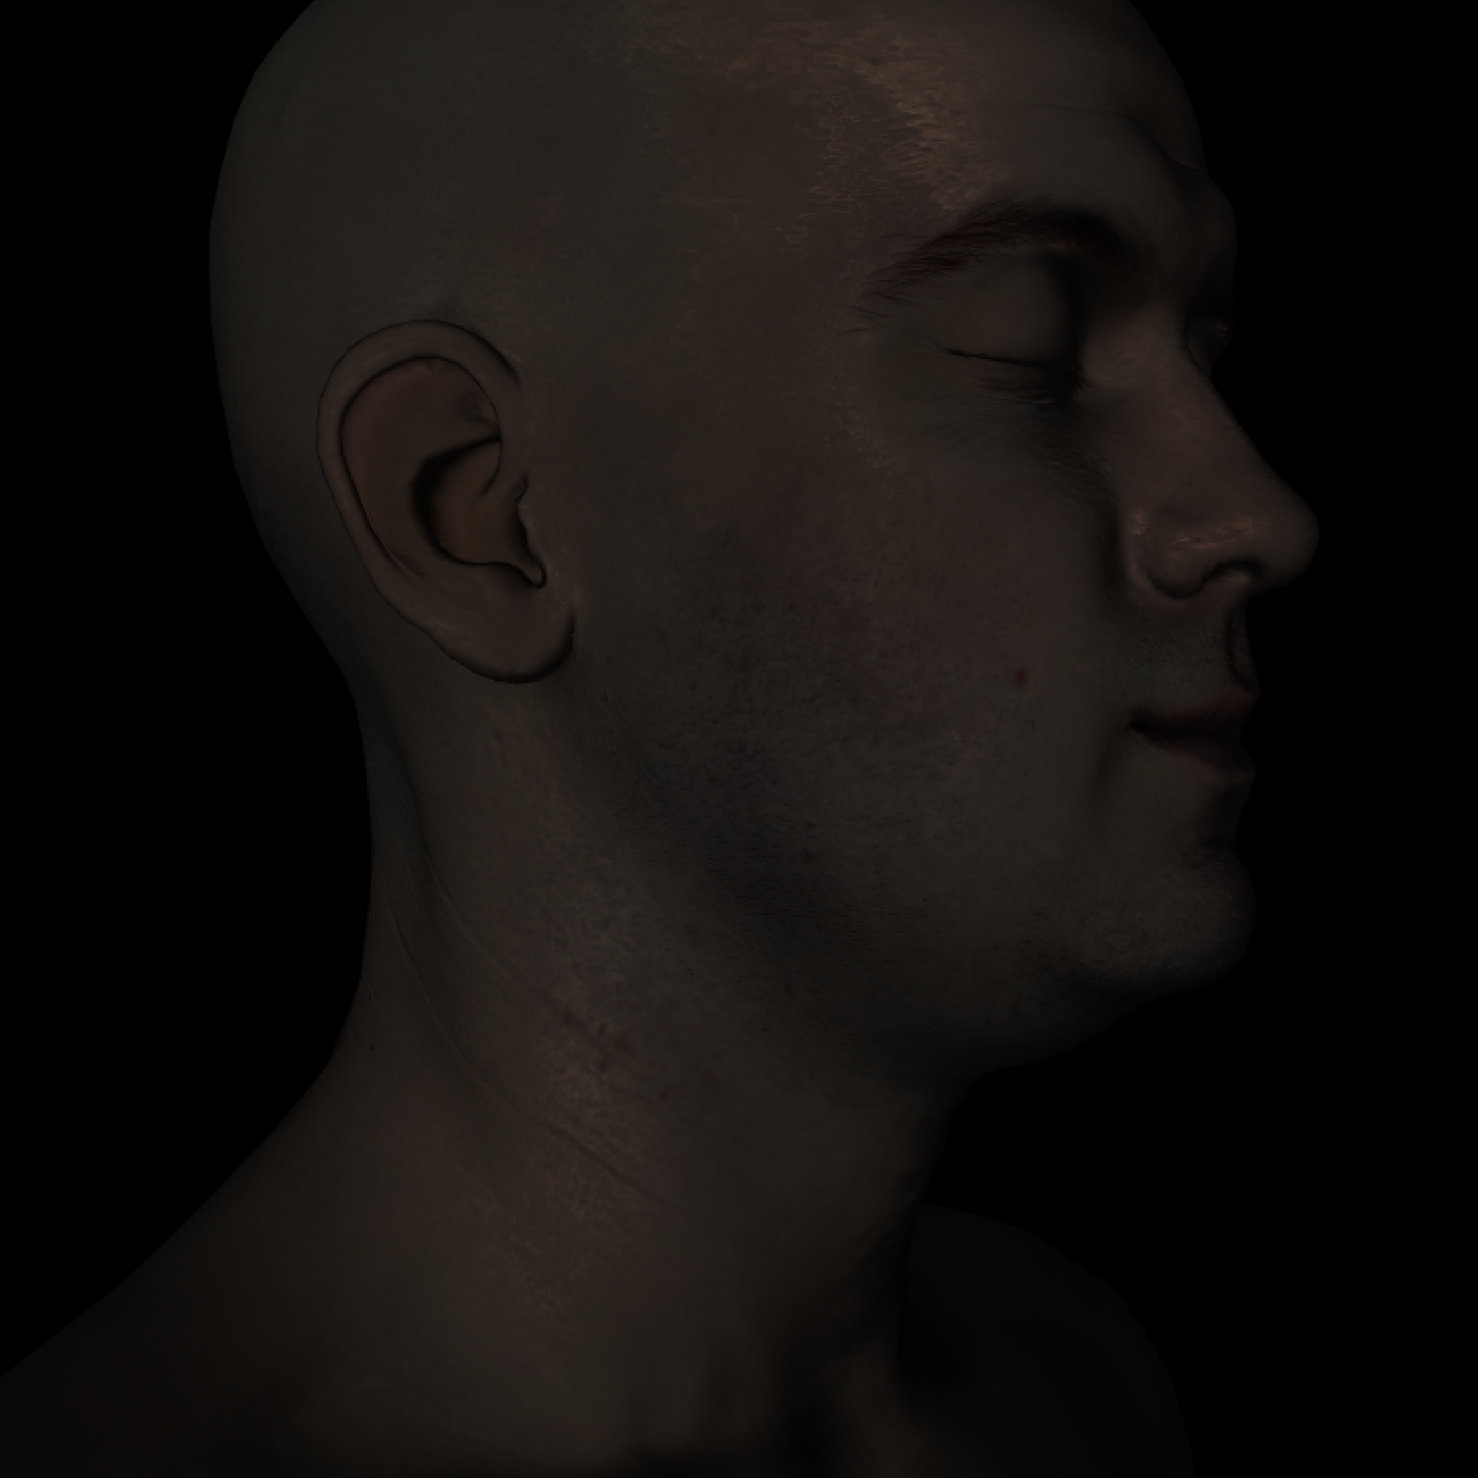

Motivation:

Local Deformable Precomputed Radiance Transfer (LDPRT) is a method proposed by Microsoft in 2005 to compensate for the common problems with its predecessor: Precomputed Radiance Transfer (PRT). PRTs permit an application to represent diffuse lighting phenomena such as shadows, interreflections, and subsurface scattering as a set of constants. The constants are calculated though an offline simulation via methods similar to that of a raytracer. To accomplish this feat, PRTs represent data in the scene using Spherical Harmonics. Because Spherical Harmonics form the basis of SO(3) (3D rotation group), information for how lighting interacts at arbitrary light angles can be stored within them. Once the constants are produced, models can be rendered in real-time with global illumination effects. These effects are consistent for all camera positions given the light source is infinitely far away from the scene. The direction of the incoming light is input into the PRT at runtime and vertex colors taking into account global illumination are returned. Unfortunately, PRTs only work for static scenes as when a vertex position changes, the PRT lighting model fails. LDPRTs seek to compensate for PRTs Achilles heel by using a Zonal Harmonic basis. Thus, an LDPRT can quickly rotate a rest coordinate frame to its current deformed orientation. LDPRTs work best for limited motion such as facial expressions as they do not fully model global illumination for the rotated frame.

Morph Targeting

Morph Targeting is an alternative to Skeletal Animation. Morph Targeting allows for an artist to move vertices on a model to a desired position in order to more effectively create the ideal pose. Once all poses / morphs are made by the artist, a base morph (a chosen pose) is established. To animate the figure, the artist interpolates between the difference between the morph vertex's position and that of the base. Morph Targets are primarily used in facial animation to give the artist complete control over how a character looks. Since the process is cumbersome and animations are not as smooth as those produced by Skeletal Animation, Morph Targeting still remains limited to expression. However, because facial expressions do not require large vertex changes, LDPRT works perfectly for Morph Targeting.

Example Facial Expression:

Extreme Facial Deform

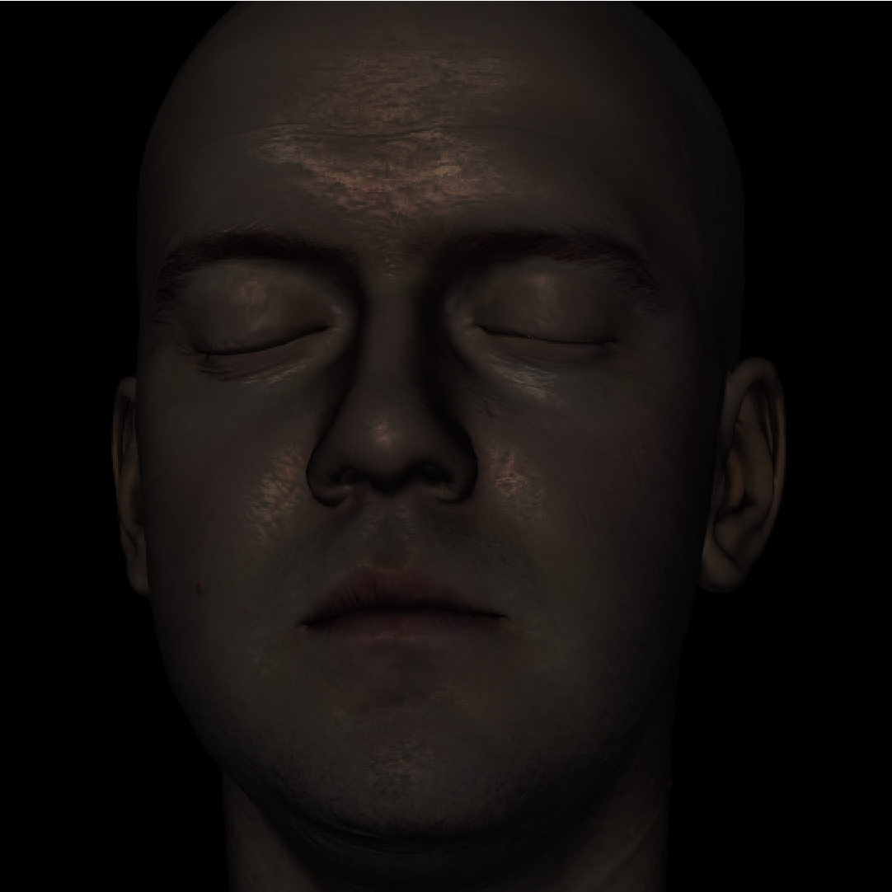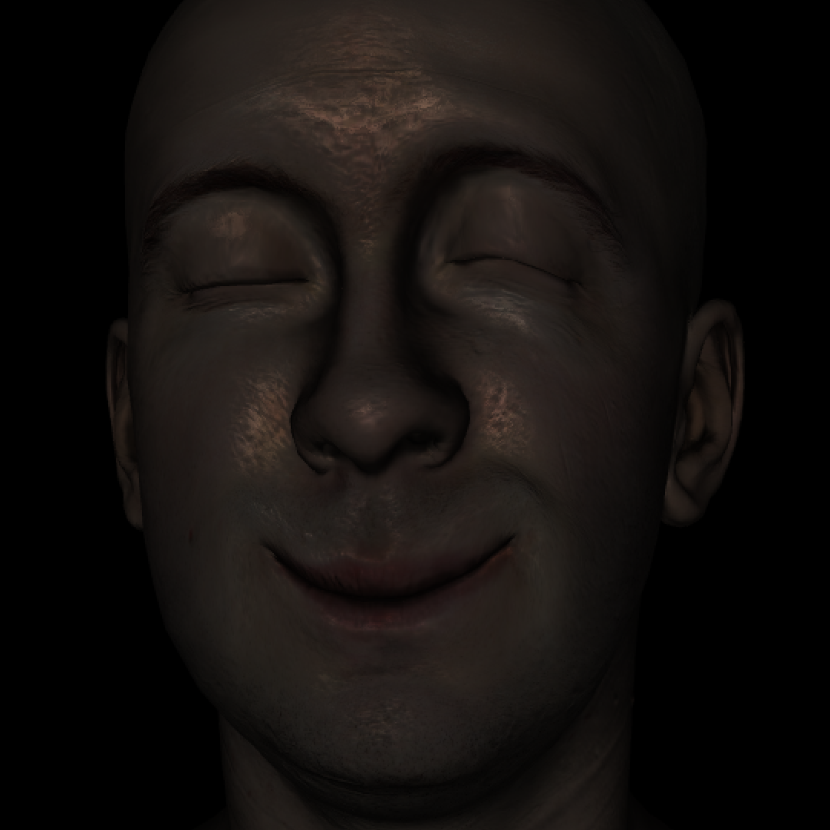

Rest Frame

A wrinkle model was also implemented to alter normals based on the difference in primitive area between the rest and deformed frame. Normals are created by linlearly interpolating between deformed frame normals and bump map normal. The result is that deforming skin leads to darker wrinkles. To increase the prominence of wrinkles and small details, the mesh is tessellated with a displacement map applied to it. A displacement map and bump map are both utilized because the displacement map operates at a coarser grain than the bump map, leading to a good mix of detail at interactive framerates.

Wrinkle Model:

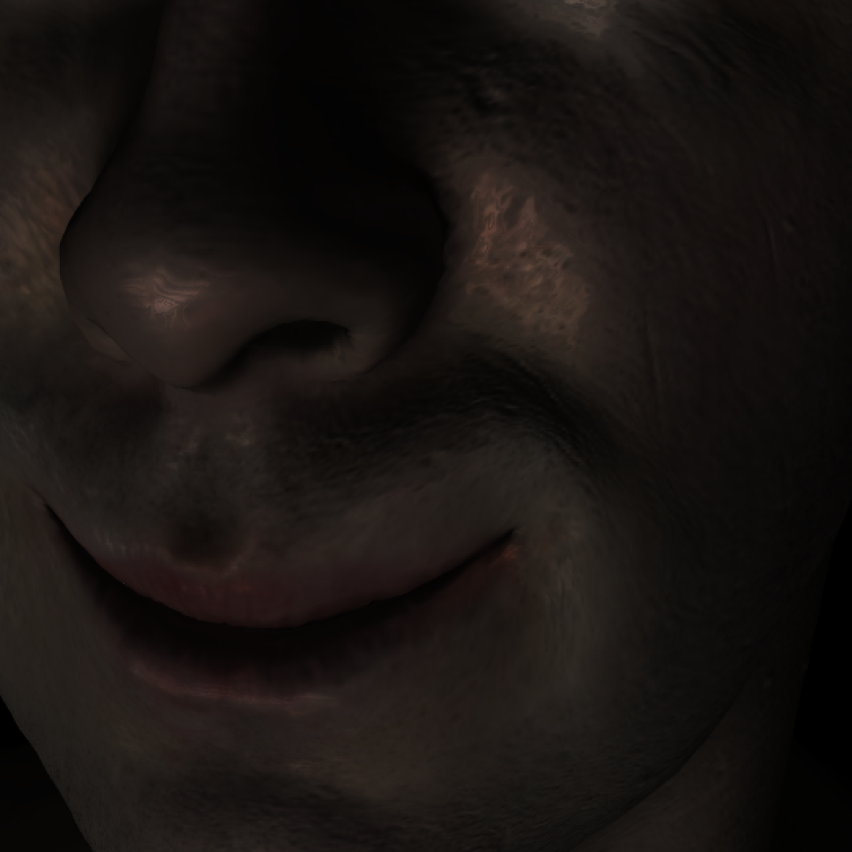

Optimization of Lobe Axis

Using Zonal Harmonics, LDPRTs estimate PRT lighting with a BFGS to minimize error between the two models. Although Zonal Harmonics can have multiple lobe axis, one is chosen for this project to reduce the amount of data needing to be transferred to the GPU. Zonal Harmonics require a lobe axis for rotation which, in most cases, is the same as the normal. Hence, after the BFGS is completed, model normals are replaced with the direction of Zonal Harmonic lobe axis.

Normals without BFGS and with BFGS

(approximately .01 difference for single lobe which is not noticeable)

BFGS Normals

Model Normals

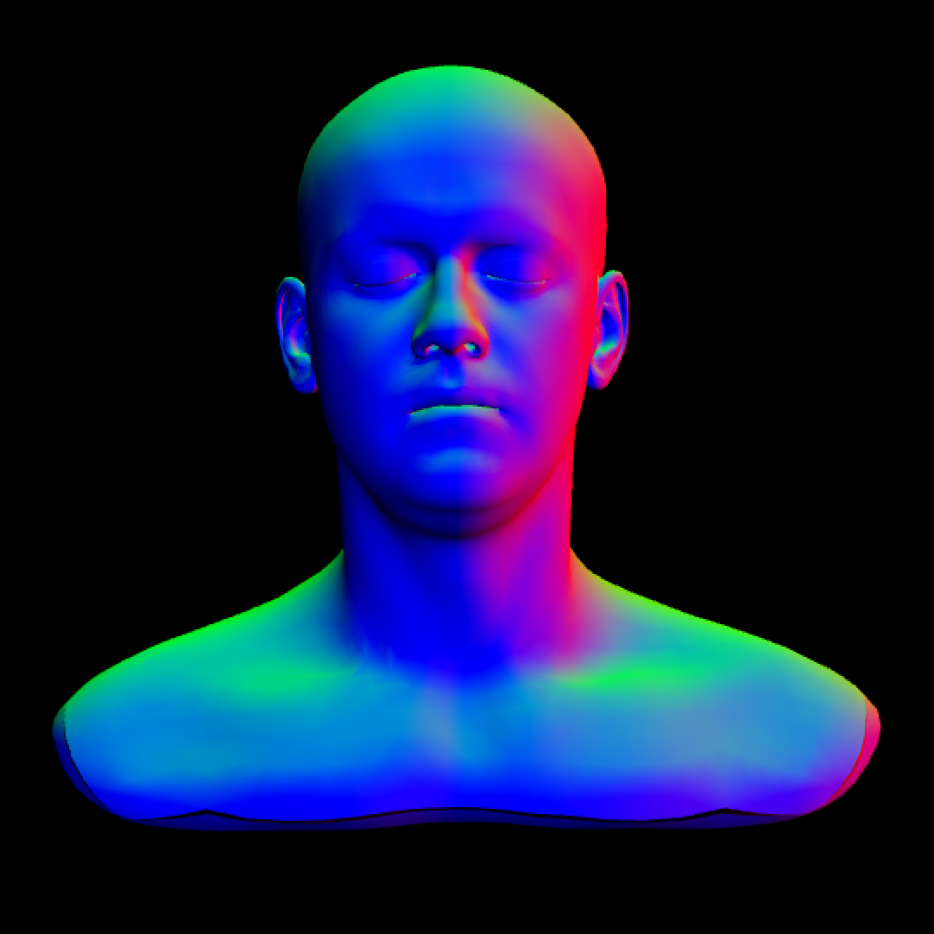

Soft shadows

To compute a PRT, several samples are taken for light sources scattered around a sphere that has an infinite radius. Since the light source is infinitely far away, a ray can be cast from every vertex on the mesh towards the light source to see if it is blocked. Thus, for every sample lights ource, one ray is produced for every vertex per sample. Because this is similar to Monte Carlo integration in a ray tracer for soft shadows, soft shadows are obtained with no additional cost to what the PRT would already have to do to light the scene.

Interreflections

The results from the soft shadow PRT yield the amount of energy present at each vertex in the scene. To preform radiosity, all surfaces are assumed to be lambertian reflectors. After going through a set number of bounces, it is assumed that the results converges. The below scene demonstrates interreflections in the infamous Cornell Box. The green and red color of the walls “bleed” onto the white boxes in the scene.

Red Color Bleed

Green Color Bleed



Subsurface Scattering

For subsurface scattering, the random walk algorithm is implemented. By choosing several randomly generated paths, the subsurface scattering of skin is approximated. After moving a set distance, the path is randomly rotated by a certain number of degrees before proceeding. Hence, subsurface scattering is implemented via monte carlo integration. In the below image, note how the area below the cheek is lit although the light source is on the other side of the model.

Subsurface Scattering

