Designing and Running Workflows for Materials Project

Anubhav Jain

Nov 2013

Version 2.1

# Introduction and “Prerequisites”

This document is a guide for designing and running materials science and chemistry workflows using the Materials Project codebases (pymatgen, FireWorks, custodian, etc.) and NERSC resources.

The advantage of learning the infrastructure is that once you gain familiarity, you will be able to very easily run and manage your calculations. If you need to perform a set of computations over a new compound, you will simply need to execute a command rather than editing input files, ssh’ing them to NERSC, running qsub, etc…This is crucial when running hundreds of thousands of jobs, but you’ll probably find it very nice to have in your day-to-day work as well. Whenever you want to compute a new structure, you can do it in almost no time.

In addition, the infrastructure is meant to help you rigorously test your workflows over test sets of compounds and rapidly analyze the results.

However, before taking advantage of this infrastructure you must take a little time to learn it. In particular, there are many components to making the Materials Project high-throughput project function and you will need to learn at least a bit about all of them:

* The **pymatgen** codebase (http://pymatgen.org) is used to read and write input and output files for various computational codes (like VASP or NWChem) given arbitrary structures and for different computational types (like static or structure optimization). The **pymatgen-db** codebase (http://pythonhosted.org/pymatgen-db/) is used to parse output files.
* The **custodian** codebase (http://pythonhosted.org/custodian/) is used to execute the desired code in a way that can fix most errors that might be encountered during the run
* The **FireWorks** codebase (http://pythonhosted.org/FireWorks/) allows us to automically run and track many thousands of jobs (such as custodian jobs) over supercomputing resources. FireWorks can also fix more complicated errors that may arise (like server crashes) and help design dynamic workflows.

This documentation focuses on how these codebases work together and is *not* intended to teach you how to use the codebases individually. Before starting, it is therefore crucial that you review and have a basic understanding of each codebase in isolation, so things will make sense when we start putting things together.

**A note about installation at NERSC**

Installing codes and databases at the NERSC supercomputing center is now handled semi-automatically via the MPenv codebase (<https://github.com/materialsproject/MPenv>). **Therefore, you do not need to install these codebases yourself at NERSC**. More on this in Chapter 3.

## FireWorks prerequisites

FireWorks documentation can be found at **http://pythonhosted.org/FireWorks/**

Before starting this documentation, make sure you have read through all the documentation on FireWorks and have a basic understanding of at least the following tutorials:

* Quickstart
* Defining Jobs using FireTasks
* Creating Workflows
* Dynamic Workflows
* Tips for designing FireTasks, FireWorks, and Workflows

This documentation assumes that you have at least a basic grasp of the concepts of those tutorials. If you are interested in not only designing and submitting workflows, but running testing or production jobs at NERSC, you should also review the following FireWorks documentation (you should *read* the tutorials, but you don’t have to actually follow the instructions to install anything at NERSC; remember, MPEnv will do that for you):

* Worker Tutorial
* Launch Rockets through a queue
* Reserving FireWorks upon queue submission
* Installation Notes on various clusters / supercomputing centers

## custodian prerequisites

custodian documentation can be found at **http://pythonhosted.org/custodian/**

Additionally, you should read all the documentation on custodian (it is a single page)

## pymatgen and pymatgen-db prerequisites

pymatgen documentation can be found at **http://pythonhosted.org/pymatgen/**pymatgen db documentation is at **http://pythonhosted.org/pymatgen-db/**

Before starting this documentation, you should have enough familiarity with pymatgen to:

* write input files for the code you want to execute (e.g., VASP or NWChem) and
* parse output files for the code you want to execute into a MongoDB (JSON) format

For the latter functionality, you might need to consult the pymatgen-db codebase.

## Other prerequisites

You should have the **MPWorks** codebase downloaded (so you can see the source code), e.g. through MPenv at NERSC. We’ll be referring to source code in MPWorks during the course of this guide, so it’s important you have it available.

# Designing Scientific Workflows for running at NERSC

## How workflow design fits in

If you recall the FireWorks documentation, there are essentially two steps to running scientific workflows at NERSC (Figure 1):

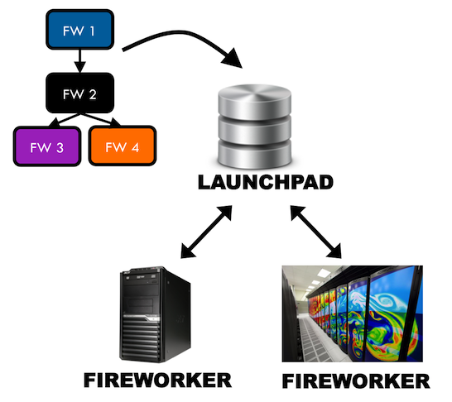

Figure FireWorks operation

The steps are:

1. Defining Workflows in FireWorks format and putting them in the “LaunchPad” (a MongoDB database that is hosted “somewhere”)
2. Running Workflows on NERSC (a FireWorker) by pulling jobs from the LaunchPad

This section concentrates only on part 1 – defining workflows and putting them in the LaunchPad. This part does not actually require logging into a NERSC machine and can be done from your laptop at home. Running jobs will be covered in Chapter 3.

## Designing Workflows for Materials Science

The goal of this section is to explain how, given any crystal or molecule, one might construct a FireWorks Workflow for computing its properties (Figure 2):

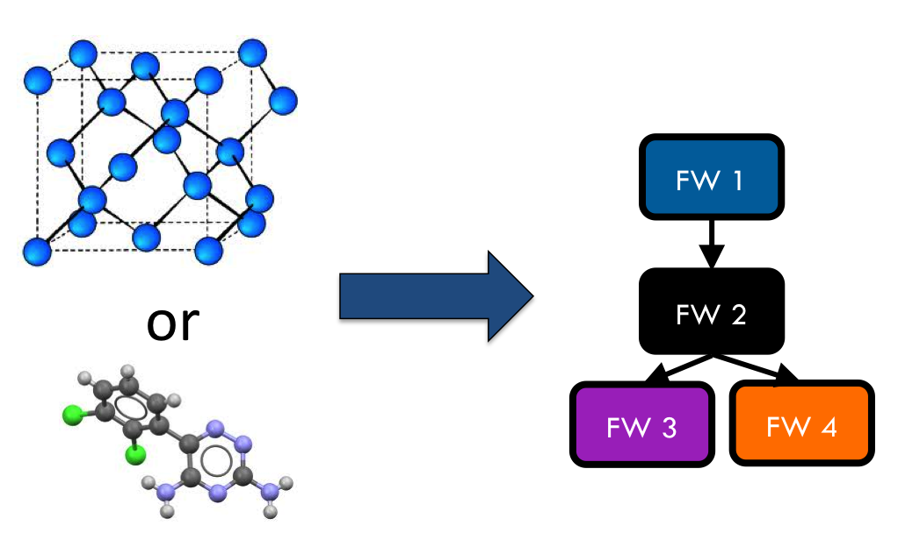

Figure Goal of this section – automatically create a FireWorks workflow for any crystal or molecule

Once we can write some code that will take any compound and construct a workflow, automation is easy. Those workflows can be run very easily at NERSC using the job execution features of FireWorks (Chapter 3).

The issue then is how to write code that will take in a compound and create a Workflow. If you recall the FireWorks documentation, a Workflow is composed of multiple FireWorks, which are in turn composed of multiple FireTasks. Each FireTask is meant to be an atomic “action”. In our case, a single FireTask might:

* write some input files for a code
* execute code (e.g. VASP or NWChem), either directly in Python or within a **custodian**
* move files around
* parse some files and enter them in a database
* decide whether more computations are needed and add them to the database if needed (using dynamic workflow features built into FireWorks)

By putting together multiple FireTasks and FireWorks, we’ll end up with a Workflow that suits our needs. So we need to do two things:

* write the code for each individual FireTask
* meld them into an appropriate Workflow sequence, splitting some of them up into different FireWorks

Although these topics are somewhat related, we’ll try to cover some examples of writing FireTasks first, and then move onto constructing Workflows that tie them together.

## Writing FireTasks: a few examples

It is somewhat difficult to create a guide for writing FireTasks – a FireTask can really be arbitrary code. Therefore, we’ll just point to a few case studies in the MPWorks and Rubicon codebases. These codebases contain specific implementations of FireTasks for the Materials Project and JCESR project, respectively. They depend on **pymatgen**, **custodian**, and **FireWorks** in order to work.

Note that these FireTasks change from time to time, so use this as a rough guide. Also, don’t worry about understanding every detail of these FireTasks – just get a rough sense for what they’re doing and try to get through this section with a basic understanding the first time. Ask an MPWorks expert (e.g., Wei or Anubhav) when you really need to understand the fine details.

**Important note:** Recall from the FireTasks documentation that the *run_task()* method of a FireTask is what gets executed. You should concentrate on this method for each FireTask.

### VaspWriterTask

VaspWriterTask is located in **/mpworks/firetasks/vasp_io_tasks.py**

The VaspWriterTask is about as simple as it gets – it is just a few lines of code. It reads information from the *fw_spec* and uses that information to write INCAR, KPOINTS, POSCAR, and POTCAR files to the current directory. The expectation is that the next FireTask in the sequence will run VASP.

More specifically, this task is reading in the “vasp” key of the *fw_spec* that was stored by the person creating the FireWork. This key contains the information needed generate the input files. The format of the “vasp” key is pymatgen dictionary representations of the INCAR, POSCAR, etc objects. Given these dictionary objects, this FireTask will write the input files.

Therefore, if you are trying to write some VASP input files, you can just create a FireWork with the appropriate *spec* (a “vasp” key with Pymatgen dictionary representations of input files) and then add the *VaspWriterTask* as one of your FireTasks.

Note that you might wonder why the specification expects pymatgen representations of these files, rather than just the raw String content. Either would work; the pymatgen dictionary representations are much easier to query and explore with MongoDB. For example, you can very easily search for all the FireWorks where the INCAR parameter has NSW set to 0, which is harder (and slower) to do via String matching over the database.

### VaspCustodianTask

A simplified version of VaspCustodianTask (called VaspCustodianTaskEx) is located in **/mpworks/examples/firetasks_ex.py.** The actual VaspCustodianTask is located in **/mpworks/firetasks/custodian_task.py**. We will discuss the simple version.

The VaspCustodianTaskEx uses custodian to run an executable such as VASP. It expects that all input files for VASP are already written in the directory (e.g., via a VaspWriterTask). The job of VaspCustodianTaskEx is to execute a **custodian** to call the VASP executable.

This is the core code that loads a custodian and runs it:

c = Custodian(self.handlers, self.jobs, self.max_errors)

custodian_out = c.run()

You might notice that this code has nothing to do with VASP. The parameters *self.handlers* and *self.jobs* contain **custodian** objects that represent VASP jobs. The user passes these in via the FireTask’s *parameters*. In the constructor for VaspCustodianTask, you’ll notice a line of code that looks like this:

self.jobs = map(VaspJob.from_dict, parameters['jobs'])

This is what is loading the Vasp Jobs based on the parameters of the FireTask. To use VaspCustodianTaskEx, you must therefore create this FireTask with the *job* and *handlers* parameters set to dictionary representations of VaspJob and VasprunHandler objects from custodian.

There is some extra code in this task regarding a choice between “aprun” and “mpirun” because the command to execute VASP depends on the machine we are running on. But the core of this method is to load custodian Job and Handler objects in the constructor, and then instantiate and run the custodian in the run() method.

Note that another way to run VASP is to simply use the command:

import subprocess

subprocess.check_call([“vasp”])

inside the run() method, and do away with complicated constructors, reading parameters like *job* or *handlers*, and make life simple. However, if we did this we would not be able to use the error-correction features of custodian.

### VaspCopyTask

VaspCopyTask is located in **/mpworks/firetasks/vasp_io_tasks.py**

The VaspCopyTask in MPWorks is also very simple. All it’s doing is copying a bunch of files from some directory to the current directory. This FireTask is used, for example, to copy output files from the structure optimization run to the static run. The directory containing the previous run must be defined in the FireWork specification under the “prev_vasp_dir” key. Other than that, there are some options for choosing what files to move and dealing with tricky things like “.relax#” extensions to output files added by certain types of VASP custodian runs.

### VaspToDBTask

A simplified version of VaspToDBTask called VaspToDBTaskEx is located in **/mpworks/examples/firetasks_ex.py.** The actual VaspToDBTask is located in **/mpworks/firetasks/vasp_io_tasks.py**. We will discuss the simple version first, then the more complex version.

The VASPtoDBTaskEx uses the pymatgen-db codebase to enter the output of a VASP run into the database.

First, it loads the VASP output directory from the “prev_dir” parameter. Then, it instantiates an *MPVaspDrone* object which, given database credentials, can parse the output directory and enter the results into the database. The actual database insertion is done via the command:

t_id, d = drone.assimilate(prev_dir,launches_coll=LaunchPad.auto_load().launches)

At this point, we are largely done with the simplified VaspToDBTaskEx.

The more complex VaspToDBTask (without the Ex) does the following (feel free to skip these details if you’re just getting started):

* Before database insertion, this task is also moving files from NERSC’s **$SCRATCH** filesystem to NERSC’s **$PROJECT** filesystem (we refer to it as the “garden”). All runs need to be moved from SCRATCH to PROJECT after completion, due to limited space (but better disk performance) on SCRATCH.
* After database insertion, there is a lot of complicated code determining whether this task should be rerun using a new Workflow step. Feel free to ignore this detail for the moment. Normally, this whole ordeal would be handled by **custodian** in a cleaner way. However, the limitation of **custodian** is that all job restarts occur within the same walltime at NERSC. If we have a 7-day walltime, and the job fails after 6.5 days, a **custodian**-based restart would only give the job’s reincarnation 0.5 days to complete. Most of the time, jobs fail early and it’s OK to use **custodian** and restart within the same walltime limit. However, some errors (like those detected by UnconvergedHandler) fail very late or at the end of the job, and they need to be wrapped in a new FireWork that will allow the reincarnation of the job to run with a brand new 7-day walltime.

### Other MPWorks tasks, e.g. “Setup”-style tasks and Controller tasks

Setup-style tasks are located in **/mpworks/firetasks/vasp_setup_tasks.py**. Controller tasks are located in **/mpworks/firetasks/controller_tasks.py**

There are many MPWorks tasks that take the output of a previous VASP directory and modify some of the inputs for the next step in the workflow. For example, the final structure and run parameters of a structure optimization run is used to create the input parameters of a static run (with just a few parameters changed). The “Setup” style tasks will read in the output files of the previous run (after they are moved using VaspCopyTask), and perform the necessary operations to create input files for the current run.

The “Controller Task” is more complicated in that it reads in data from a previous VASP run and dynamically creates new jobs as needed. At the time of this writing, the controller task will create more VASP jobs if initial calculations demonstrate the material to be an insulator with gap > 0.5 eV.

You can review these tasks on your own and contact the MP development list if you have questions. In our example FireTask, we won’t be using some of these FireTasks.

## Organizing FireTasks into Workflows

After studying the previous section, you should have a good idea of what FireTasks are and some idea of how you might write some simple FireTasks. The next step is to organize FireTasks into Workflows. Recall that there are multiple ways to do this, in particular whether to put many FireTasks in a single FireWork or to use multiple FireWorks (Figure 3):

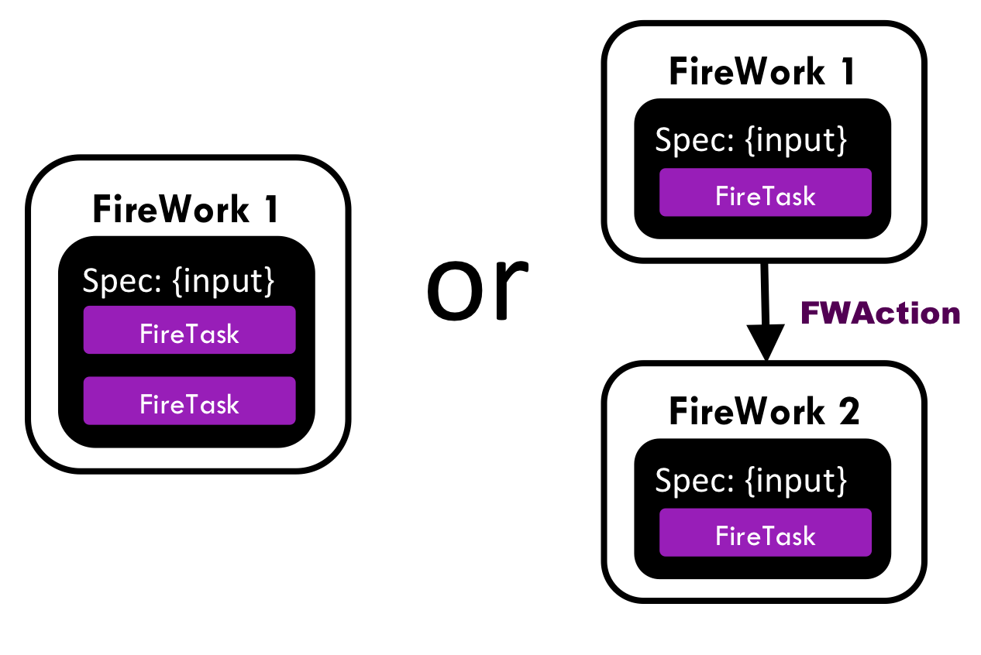

Figure Put all FireTasks in a single FireWork, or split the tasks amongst multiple FireWorks?

The FireWorks documentation, in particular the tutorial on “Tips for designing FireTasks, FireWorks, and Workflows”, contains many details on how to do the design. In this section, we’ll follow one of the recommendations in that tutorial and begin by putting all the FireTasks in a single FireWork (left side of the diagram), and then iterating on that design to see where multiple FireWorks are needed.

### A prototypical Materials Science workflow – iteration 1

In Figure XX, we draw a prototypical materials science workflow, where FireTasks are in purple and all are within a single FireWork (Figure 4):

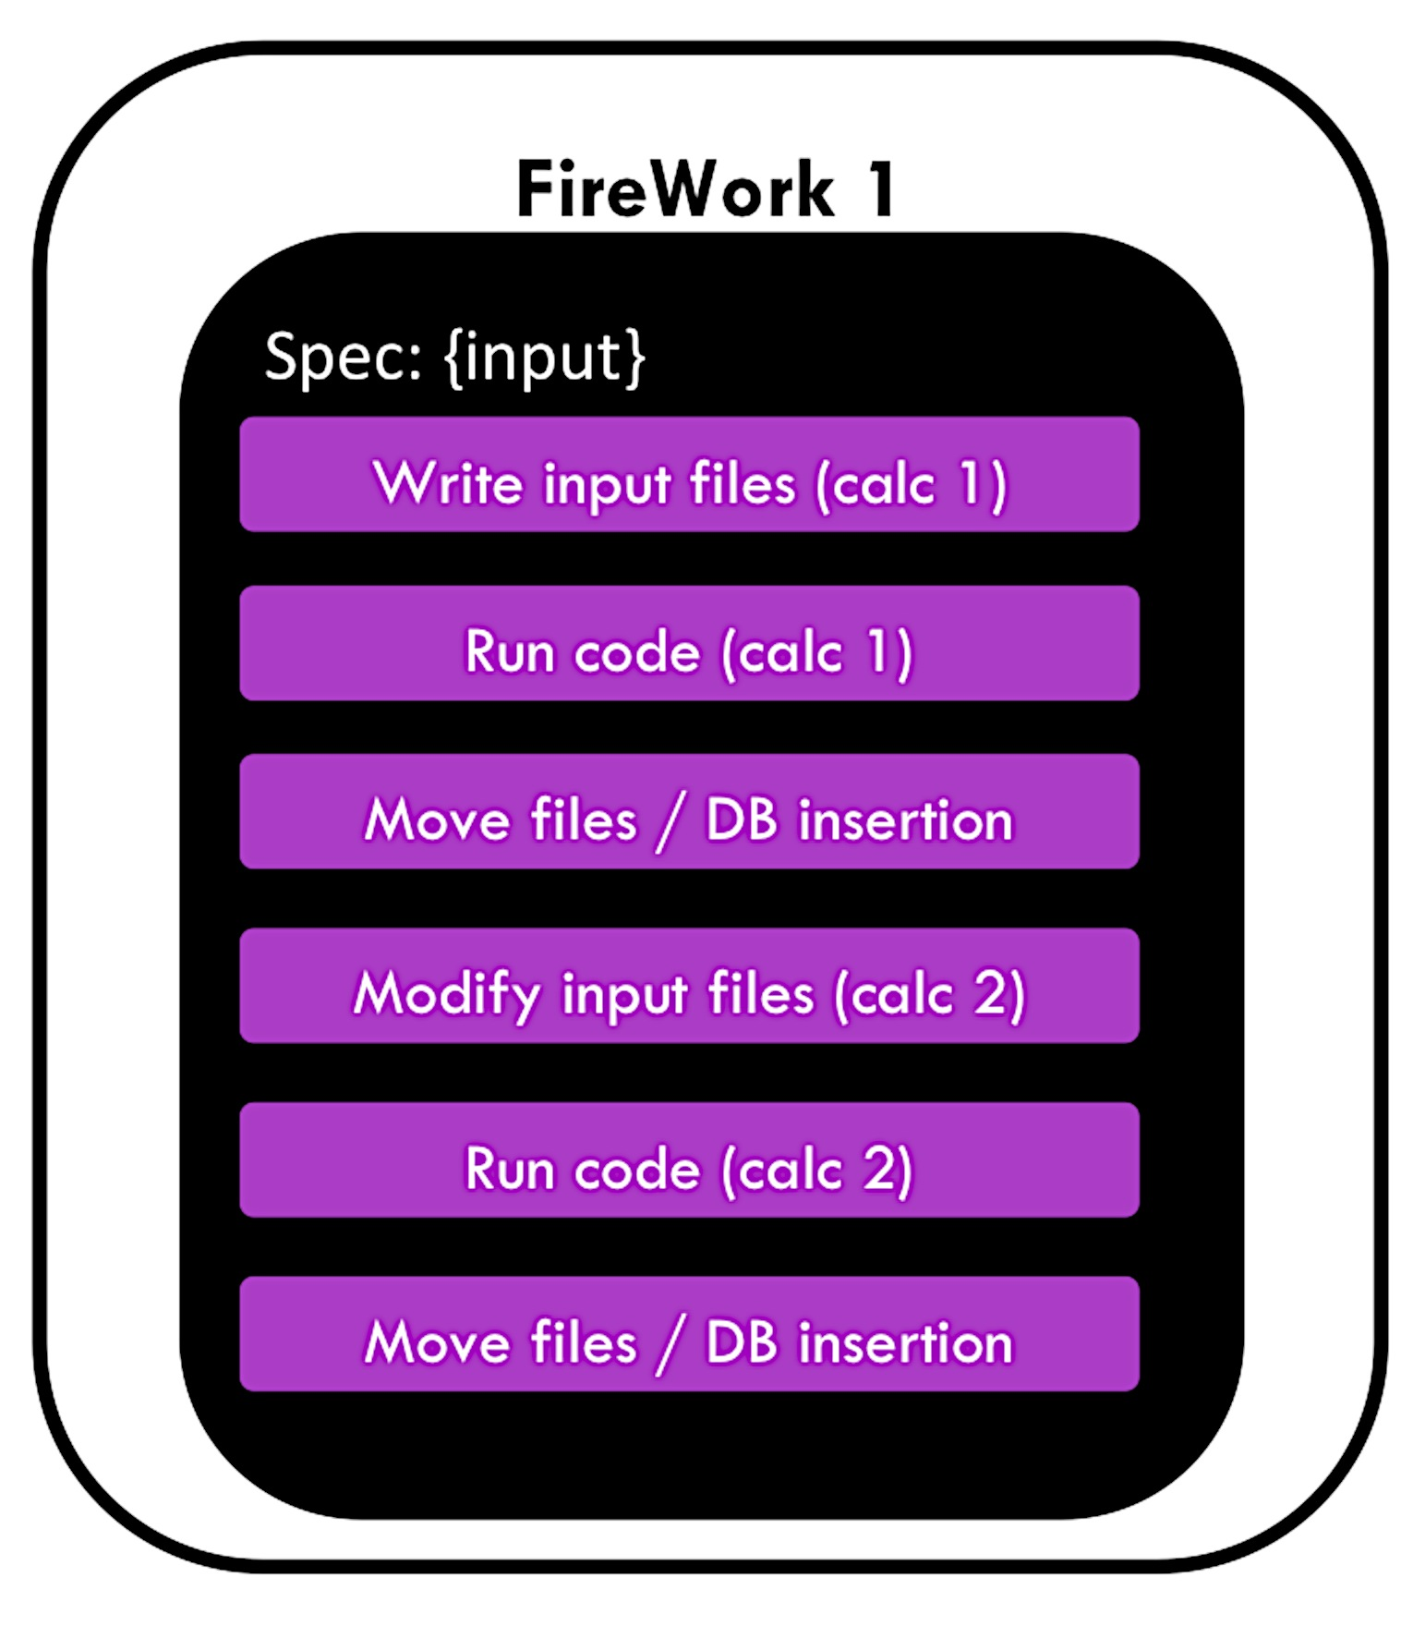

Figure Initial draft of how a Workflow could be written. This is not the suggested way to do things.

The Workflow in Figure 4 runs two types of calculations and two database insertions (one for each calculation). Each calculation might represent a VASP run, GULP calculation, NWChem calculation, or MD simulation.

While putting everything in a single FireWork is an easy way to design a Workflow, it suffers from several limitations:

* Recall that each FireWork gets its own job at NERSC, with a single walltime. The walltime at NERSC (7 days) might not be enough to confidently finish both calculations. We might want to give each calculation its own 7-day walltime
* We might want to run the calculations on different machines or with different parameters. e.g., if calculation 1 requires using 2 nodes with low memory but calculation 2 requires using 100 nodes with high memory, you would need to put the jobs in different FireWorks so they can use different queue settings or run on different machines altogether.
* Recall that if you want to rerun a job, you’ll need to rerun the entire FireWork from scratch. This means that if you embed the Workflow within a single FireWork, and a server crashes or memory error occurs during calculation 2, FireWorks must rerun everything from scratch in this design.
* Similarly, duplicate checking occurs at the FireWork level. So if you’ve already run calculation 1 in the past but not calculation 2, FireWorks cannot do atomistic duplicate checking and only run calculation 2 (unless you split the Workflow into 2 FireWorks).
* We might want to do some branching operation in between the calculations. For example, calculation 2 might not be necessary if calculation 1 finishes with an error. It is then more natural to program this using 2 FireWorks, and have the first FireWork send an instruction to quit or branch the workflow after its execution through the FWAction object.
* We might want the FireWorks codebase to compile runtime statistics for us, and get separate reports for calculation 1 and calculation 2. This cannot be done if everything is within a single FireWork – only the overall stats for that FireWork will be reported.

All these considerations lead to the conclusion that each executable job should probably be run within its own FireWork. Let’s consider this option in the next iteration of our Workflow.

### A prototypical Materials Science workflow – iteration 2

If we put each of the two calculations within its own FireWork, the Workflow will look like Figure 5:

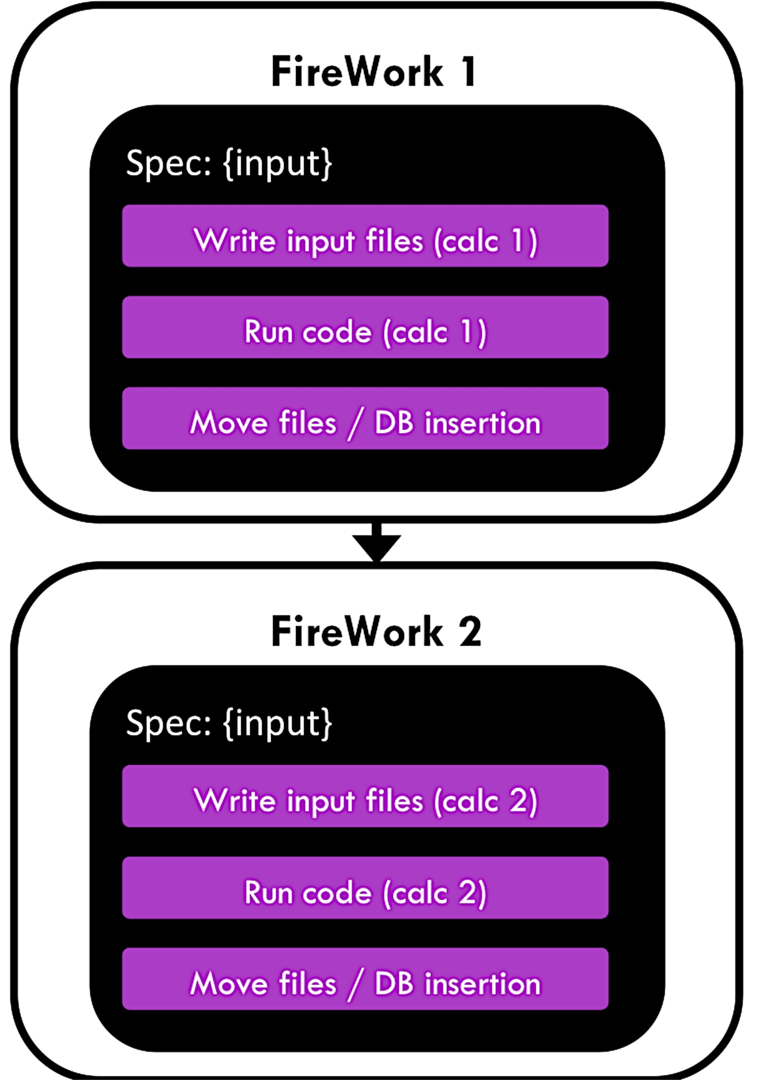

Figure Second iteration of how a Workflow could be written. This is not the suggested way to do things.

In Figure 5, each calculation gets its own FireWork, which solves most of the issues in our initial draft. For example, now each calculation will get its own job at NERSC and its own walltime. If something goes wrong during the second calculation, we can rerun just that calculation without repeating calculation 1 using FireWork’s rerun features.

However, splitting the Workflow also adds some complications:

* The second calculation might need to know some information from the first one. For example, it might need to know some of the results, or might even need to know the directory where it output files so it can copy some of them. As a user, you will need to explictly pass the information you need between FireWorks using the FWAction object. This complicates things. Two key pieces of information passed between FireWorks in the MPWorks codebase are:
  + the directory where the previous job ran
  + the type of task of the previous job (“structure optimization”, “static”, etc…)
* By default, the calculations may run on different machines: the FireWorks codebase runs each FireWork on whatever machine is available. If you want to run the jobs on the same machine, or on specific machines, you as a user will need to setup FireWorks to do this explicitly (see the docs). Of course, you now also gain the freedom to run the jobs on different machines (or the first available machine) if this is what you’d like to do.

These issues are all solvable, but require extra effort on the part of the user to setup FireWorks correctly. In addition, our second iteration has more pressing problems:

* File movement and database insertion are performed at the end of a FireWork. If the calculation doesn’t leave enough walltime for these operations to complete, you might end up with an incomplete state where file movement or database insertion is incomplete.
* If database insertion fails due to a parse error, you cannot rerun only database insertion (e.g., with a patched code). You must rerun the entire FireWork (including the calculation part)
* We might want to track stats like database insertion time or calculation time separately within FireWorks

For these reason,s it might make sense to separate these steps into their own FireWork, so that you can be confident that these operations will have their own walltime that you can set as high as you need and so you can rerun these steps atomically as needed. This leads us to the next (and final iteration) of the workflow.

### A prototypical Materials Science workflow – iteration 3

In this third (and final) iteration of the Workflow, both calculations and file movement/database steps are given their own FireWorks (Figure 6):

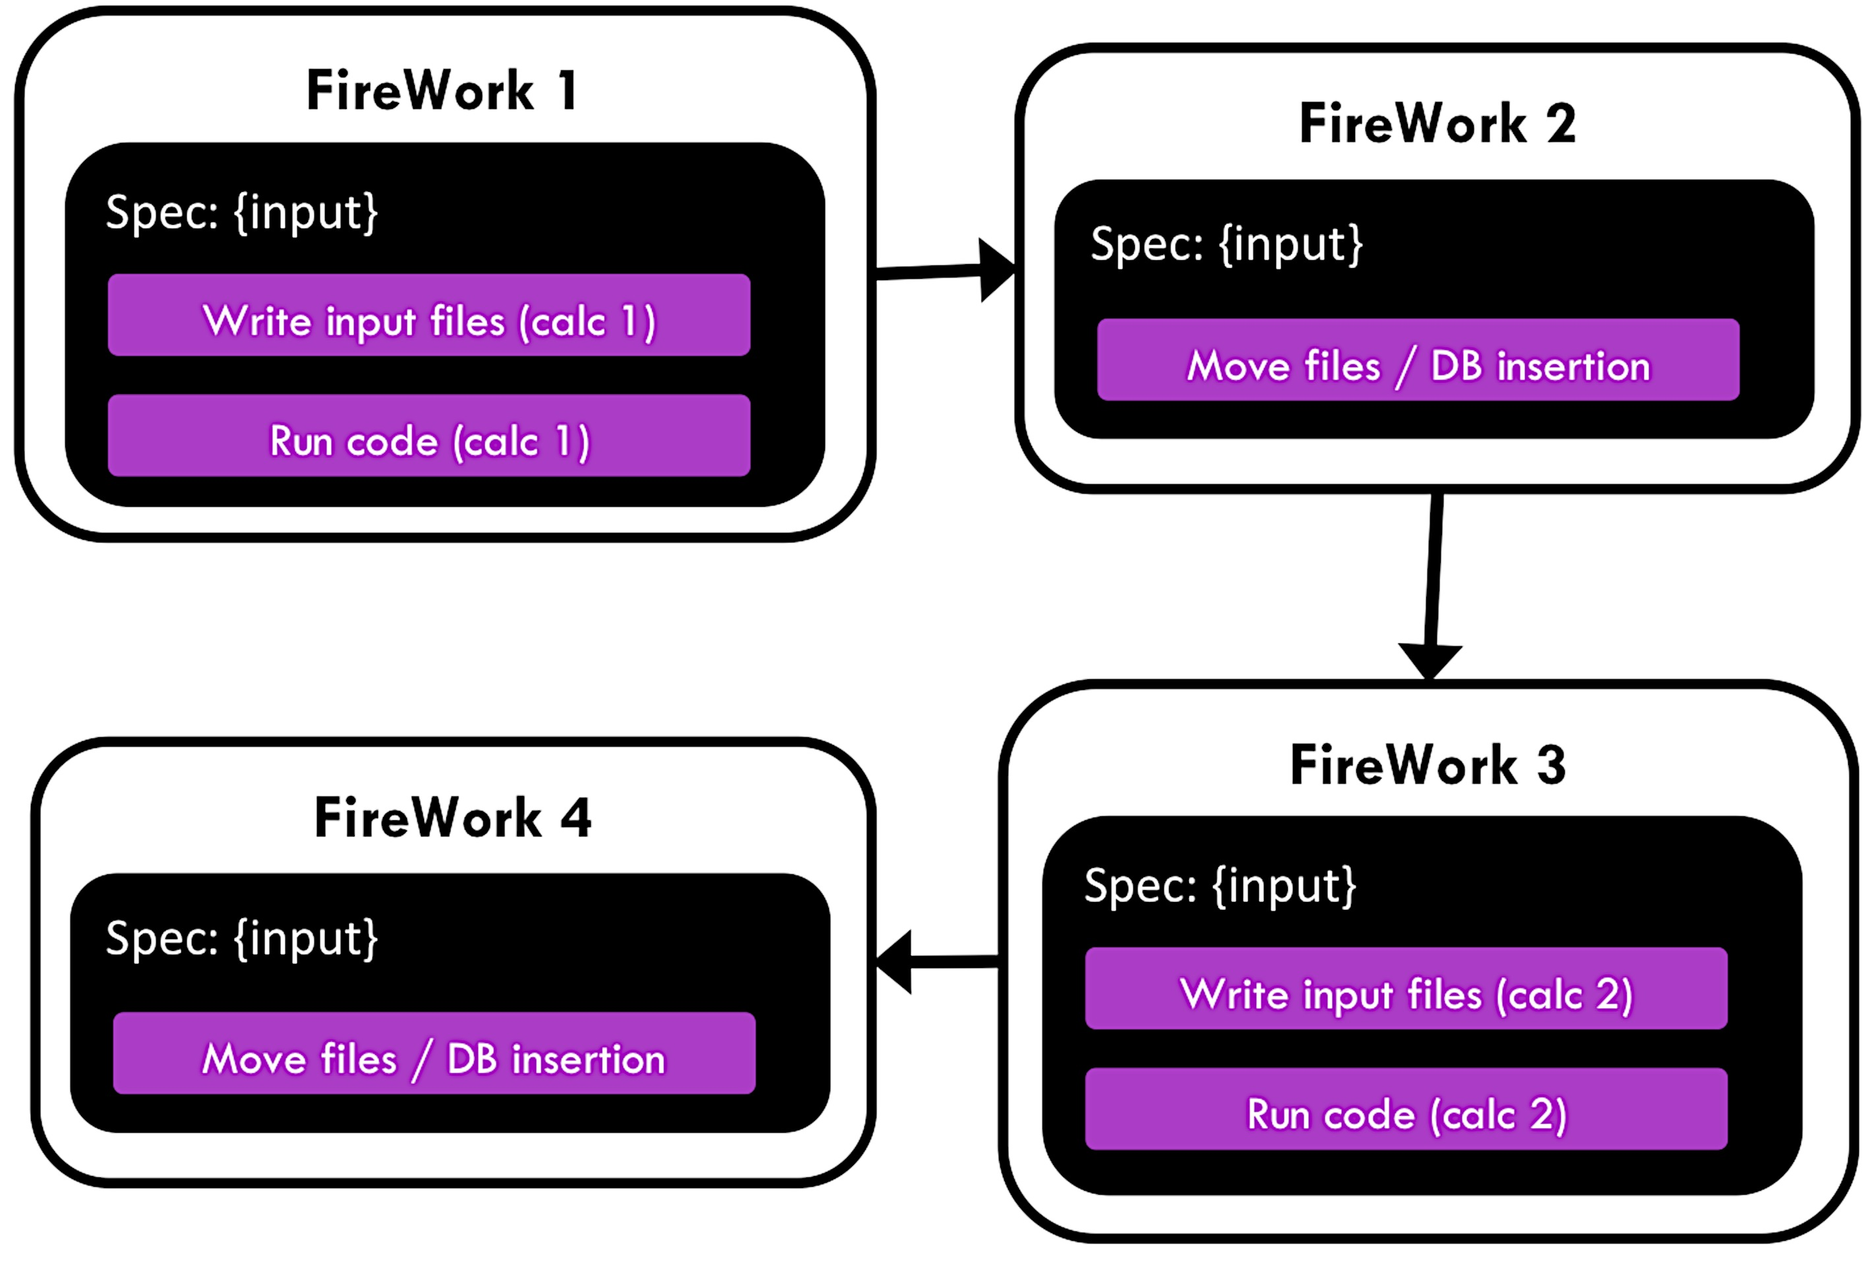

Figure Third iteration of how a Workflow could be written – both calculations and database insertions are given their own FireWorks.

Now we finally have a situation where all our major tasks have their own FireWork. They can be rerun independently, all get their own walltime and resources, and are tracked and monitored independently. This is all quite helpful, but we did add some complications:

* We still need to make sure we pass all the necessary data between FireWorks, and there is even more data passing going on now
* We again need to set things up so each job runs on the appropriate machine and with the right resources. For example, we might want the database insertions to occur on a different machine (maybe even on regular server without walltime rather than a supercomputer). If you want to do anything other than “run any job on any machine”, you’ll need to provide specifics to FireWorks
* Each FireWork carries some overhead. For example, each FireWork has its own run directory on the filesystem, and typically writes a few files like FW.json in that directory. More FireWorks means more run directories and more files written for this overhead (you can turn off certain things like the FW.json in the configuration).

All of these bullet points have solutions, but you may need to send a message to the development list if you get stuck.

## Workflow implementations

Recall in the beginning of this Chapter, we stated that the goal was to start with a crystal or molecule and end up with a Workflow (Figure 2). Throughout this chapter, we’ve provided an introduction to some concepts on how to achieve this. Now that you’re familiar with these concepts, the next step is to look at some of the actual code used in MPWorks and Rubicon to construct these workflows.

### A simple workflow to start with – Structure to Workflow

structure_to_wf() is located in **/mpworks/examples/wf_ex.py**

Recall that the goal is to start with a pymatgen *Structure* object and transform it to a FireWorks *Workflow* object. You can then add that *Workflow* to the FireWorks database and run it.

A simple example to get started with is wf_ex.py. You can try running this method and seeing that a Workflow object is indeed produced (“Si_wf.json”). The key method is *structure_to_wf()*, which transforms a structure into a workflow. This workflow uses the concepts of the previous sections to build a simple Workflow that will optimize a structure with VASP and then perform a static run on it, along with database insertion after each step. Later in this manual, we will add this Workflow to the FireWorks database and run it. Note that instead of generating a file, we could also have directly used Python code to enter the Workflow in the FireWorks database, but for simplicity in this tutorial we will use the file method.

Note that anytime you have *any* pymatgen Structure, you can now use the s*tructure_to_wf()* to transform that into a Workflow file!

### MPWorks – SNL to Workflow

snl_to_wf() is located in **/mpworks/workflows/snl_to_wf.py**

If you want to graduate to the big leagues, you can take a look at *snl_to_wf()*. However, this method is significantly more complicated than the previous one so we suggest that you skip it the first time around.

The MPWorks code that takes any crystal and creates a Workflow is *snl_to_wf()*. Recall that SNL (or StructureNL) is just a pymatgen Structure with some additional information attached (like authors, references, tags, etc.). We suggest that you take a look at *snl_to_wf()* now.

Here is a rough guide to the current workflow:

* The initial step adds the submission to an “SNL” database and does some duplicate checking on the structure alone (insufficient to do real duplicate checks which also involve VASP parameters) – *for now, just ignore this step*
* A GGA structure optimization job is created as the first step, just like Figure 6
* A database insertion job is created as the second step, just like Figure 6
* The third step is different; it is a “Controller” job that can dynamically create more calculations depending on the output of the first calculation. The current Controller creates static, Uniform, and band structure calculations if the calculated gap from the structure optimization is greater than 0.5 eV (see the code for ControllerTask).
* Finally, the second step forks into another branch for transition metal oxides. For these systems, we run a GGA+U calculation that uses the optimized structure of the GGA calculation as a starting point. After the GGA+U calculation is another DB step, and another controller step that creates GGA+U static, Uniform, and band structure calculations. This GGA+U “branch” acts independently and parallel to the GGA branch, after the initial structure optimization.

# Running Workflows at NERSC

The main purpose of writing workflow code and using FireWorks was to make it easy to run your jobs at supercomputing centers (there are also other benefits, like having a database and built in FW web tool in which you can query your jobs). This section will show you how to run your jobs at NERSC. In particular, it will show you how to run your jobs in a *personal environment* that will let you test and run your workflows. While users have used the *personal environment* to do their own research, one of the main goals of a personal environment is to allow you to develop and test workflows so that they can be integrated into the Materials Project production environment.

## Installing MPenv

The MPenv codebase is used to automatically install one or more personal environments into your user account at NERSC. Once you are up and running with your environment, it is your job to manage it. Note that your environment is a sandbox that does not interact with other environments or the Materials Project production environment. This is because it uses separate codebase copies and separate databases from other environments. So, you can develop confidently and not be afraid of messing something up in production.

## Environment system

An *environment* is combination of:

* A particular version of all the Materials Project codebases (pymatgen, FireWorks, rubicon, etc)
* A set of databases
* Settings files, e.g. config files for FireWorks that choose a queue to run on, default walltimes, etc.

A user might have several environments, e.g. one for testing and one for production, or one for each separate projects. Each environment is a standalone sandbox for storing and running FireWorks computations with the Materials Project infrastructure (e.g. pymatgen, custodian, etc).

You can switch between environments by “activating” them through the command “use_*<env_name>*”. For example, suppose you have two environments, “test” and “prod”. If you type “use_test” you will be in the testing environment. Now, if you clear the FireWorks database, nothing in the production environment will be affected. Only the test environment will be affected. Similarly, if you change queue config parameters in your test environment, your production environment will continue running as before.



Figure Activating an environment on the matcomp user chooses a set of codebases (left) and databases (right) to use. You can then operate on one environment without affecting the others.

When you *activate* an environment, the following happens (Figure 7:

* A Python virtual environment is chosen and activated. If you activate the test environment, for example, the code copies in the directory *test/codes* will be used. (There are separate copies of the code for each environment)
* A set of standard environment variables are set, which give the paths to database credentials and settings files. Because codes like MPWorks use environment variables to determine what database to connect to, by switching the environment variables we can connect to different versions of a database. These settings files are located in the “config” directory of your environment (e.g., *test/config*). They contain credentials for the databases to connect to (e.g., *test/config/dbs*) as well as the FireWorks settings to use (e.g., *test/config/config_Hopper*).

To see how the environment variables are being modified to point to different database and settings files based on the environment, look inside your “.bashrc.ext” file. You’ll see a line like:

alias use_aj='source /global/u2/a/ajain/aj/virtenv_aj/bin/activate; export FW_CONFIG_FILE=$FW_CONFIG_aj; export DB_LOC=/global/u2/a/ajain/aj/config/dbs; export VENV_LOC=/global/u2/a/ajain/aj/virtenv_aj/bin/activate; export SCRIPT_LOC=/global/u2/a/ajain/aj/config/scripts; echo "You are in environment aj."'

As you can see, this line of code is for activating the “aj” environment and sets several environment variables like FW_CONFIG_FILE, DB_LOC, VENV_LOC, and SCRIPT_LOC to environment-specific locations. The MPWorks code uses these environment variables to dynamically shift what databases and queue parameters are being used.

## Running workflows within the environment system

Now that you are all set up, the next step is to add some Workflows to your personal FireWorks database and run it.

### Adding Workflows to your LaunchPad

#### Option 1 : Add a simple MPWorks workflow

Recall that we earlier created a simple Workflow object called “Si_wf.json” in Section 2.5.1. We can navigate to this file in the MPWorks code on the NERSC machine by typing the following your prompt:

cd <env_name>/codes/MPWorks/mpworks/examples

lpad add Si_wf.json

Note: Make sure that the “mpworks.examples” directory is in your ADD_USER_PACKAGES option in your FWConfig.yaml file (in<env_name>/ configs/config_XXXX)

#### Option 2 : Add a workflow from your laptop

If you have a Workflow object already (called, for example, *my_wf*), you can add it to your testing environment using the following Python code:

lp = LaunchPad.from_file(“my_launchpad.yaml”)

lp.add_wf(my_wf)

where *my_wf* is your workflow and my_launchpad.yaml is the db file from MPenv located in in *<env_name>/config/config_Hopper*. You might have to delete a few lines in my_launchpad.yaml, e.g. ones relating to log directories on your remote machine, to get it working.

#### Option 3 : Use the submissions framework

The MPWorks submissions framework will add a production-level workflow from an SNL object using the snl_to_wf() function discussed in 2.5.2. The sequence of events is as follows:

* You use the SubmissionMongoAdapter to submit raw SNL objects to a submissions database
* You use the SubmissionProcessor to turn those submitted SNL to Workflows that get added to the LaunchPad (this uses snl_to_wf() under the hood)

A schematic is shown below

### 

Figure Submissions framework

The nice thing about this method is that, once set up, all you need to do is submit StructureNL or molecule objects and not worry about Workflows or FireWorks. To submit a compound, use code that looks like this:

from mpworks.submission.submission_mongo import SubmissionMongoAdapter

sma = SubmissionMongoAdapter.from_file("submission_db.yaml")

sma.submit_snl(my_snl_object)

where *my_snl_object* is your StructureNL object (compound), and “submission_db.yaml” can be found in *<env_name>/config/dbs*.

This will only add a compound to the submissions database. It does not yet create FireWorks to run. To create the FireWorks, you must:

1. Log into NERSC
2. Activate your desired test environment using ACTIVATE_CMD, e.g. “use_test”
3. Run the command

go_submissions

The go_submissions command will use snl_to_wf() to convert all your SNL into FireWork workflows.

#### Option 4 : Use the built-in test set

Using the built in test set, you can create Workflows for 45 “test” materials automatically. Like in the previous section, this method uses the snl_to_wf() method to create Workflows. The difference is that a set of about 45 compounds are pre-chosen and you don’t need to do any work to create SNL files or Workflow files.

This method is useful if you change the Workflow defined in snl_to_wf(), and want to test your changes over a set of 45 compounds.

To use this method

1. Log into NERSC
2. Activate your desired test environment using ACTIVATE_CMD , e.g. “use_test”
3. Run the commands

go_testing --clear (warning, this clears your databases!!)

go_submissions

The first command (“go_testing --clear”) will clear all test databases (submissions, FireWorks, vasp, SNL) and then submit 45 compounds to submissions. (Note: You can run this command without the --clear option. There is also a --name option to submit only single compound.)

**Important:** Never run “go_testing –clear” when in a production environment! You will destroy all your results.

The second command (“go_submissions”) is the same as in the last section – this will use the snl_to_wf() method to convert the submissions into Workflows and enter them in the LaunchPad.

### Verifying your workflows

To verify your workflows got entered:

1. Log into NERSC
2. Activate your desired test environment using ACTIVATE_CMD , e.g. “use_test”
3. Run the command

lpad get_fws –d less

(this will print all your workflows)

For a more comprehensive list of query commands, see the FireWorks documentation on Querying FireWorks and Workflows. For example, you can count the number of Workflows completed over time.

<http://pythonhosted.org/FireWorks/query_tutorial.html>

### Running the workflows

Once your Workflows are in the LaunchPad, running them is really simple

* Log into NERSC
* Navigate to a SCRATCH directory, e.g.

cd $SCRATCH/<my_name>

where <my_name> is the directory you created when setting up your environment (see Section 3.3.1)

* Now that you are in the correct directory, type the command

qlaunch -r rapidfire --nlaunches infinite -m 20 --sleep 100 -b 1000

(type qlaunch rapidfire –h if you want help on what the options mean). This will start launching jobs to the queue . You will want to keep this window alive as long as possible (or until all your workflows complete). Unfortunately, this is difficult to do at NERSC as NERSC will timeout a terminal after inactivity and close the connection. Another option employed by Materials Project is to coordinate setting up a crontab with NERSC to periodically run jobs. In this case you should set --nlaunches to be 0 as this will prevent infinite looping of many queue launchers.

### Updating code

After activating the new environment, you can update all codes with the command:

update_codes

You can also modify individual codebases:

cd <ENV_NAME>/codes

cd MPWorks

git pull

python setup.py develop (this command is needed when version changes)

This will pull the latest changes to MPWorks.

## Looking under the hood and concluding remarks

You’ve now created a personal execution environment, added Workflows using one of several methods, and executed the Workflowsusing FireWorks. With this infrastructure, you should be able to automate as many jobs as you need.

However, even with this lengthy tutorial, there are many aspects of the MP workflow that were not covered. The best way to ask questions is through the Materials Project development group:

https://groups.google.com/forum/#!forum/matproj-develop

# Give feedback!

This documentation, and the testing environment in general, are works in progress. Despite best efforts, there might be typos and topics or commands left out. Please give your feedback to improve this as a reference for yourself and others.