* **[DevOps-Assignment](https://github.com/FiftyfiveTech/devops-assignment)**

## Task 1 :

# Use official WordPress image as the base image

FROM wordpress:latest

# Set author label

LABEL maintainer="souvik9733848376@gmail.com"

# Expose port 80

EXPOSE 80

# Command to run when the container starts

CMD ["apache2-foreground"]

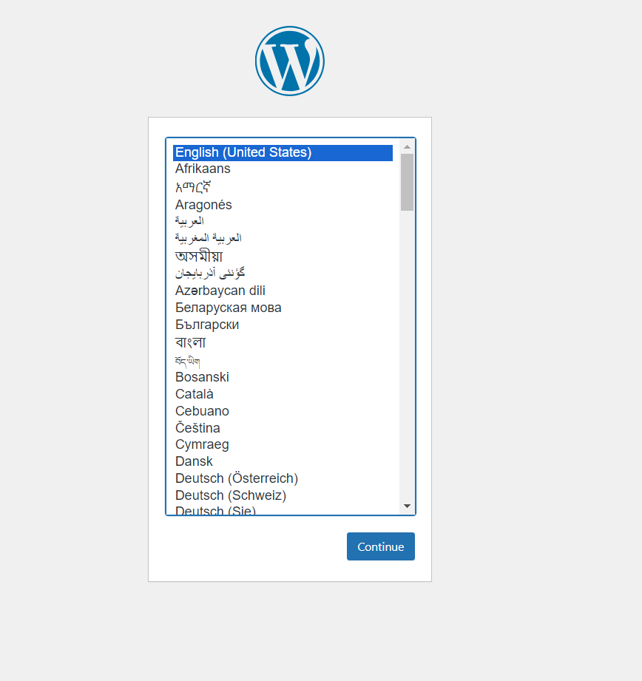

## Task 2 :

version: '3'

services:

  # WordPress service

  wordpress:

    image: wordpress:latest

    container_name: my-wordpress

    restart: always

    depends_on:

      - mysql_db

    environment:

      WORDPRESS_DB_HOST: mysql_db:3306

      WORDPRESS_DB_NAME: wordpress

      WORDPRESS_DB_USER: wp_user

      WORDPRESS_DB_PASSWORD: wp_password

    ports:

      - "8081:80"

  # Database service

  mysql_db:

    image: mysql:latest

    container_name: my-mysql

    restart: always

    volumes:

      - db_data:/var/lib/mysql

    environment:

      MYSQL_ROOT_PASSWORD: root_password

      MYSQL_DATABASE: wordpress

      MYSQL_USER: wp_user

      MYSQL_PASSWORD: wp_password

# adding volume

volumes:

    db_data: {}

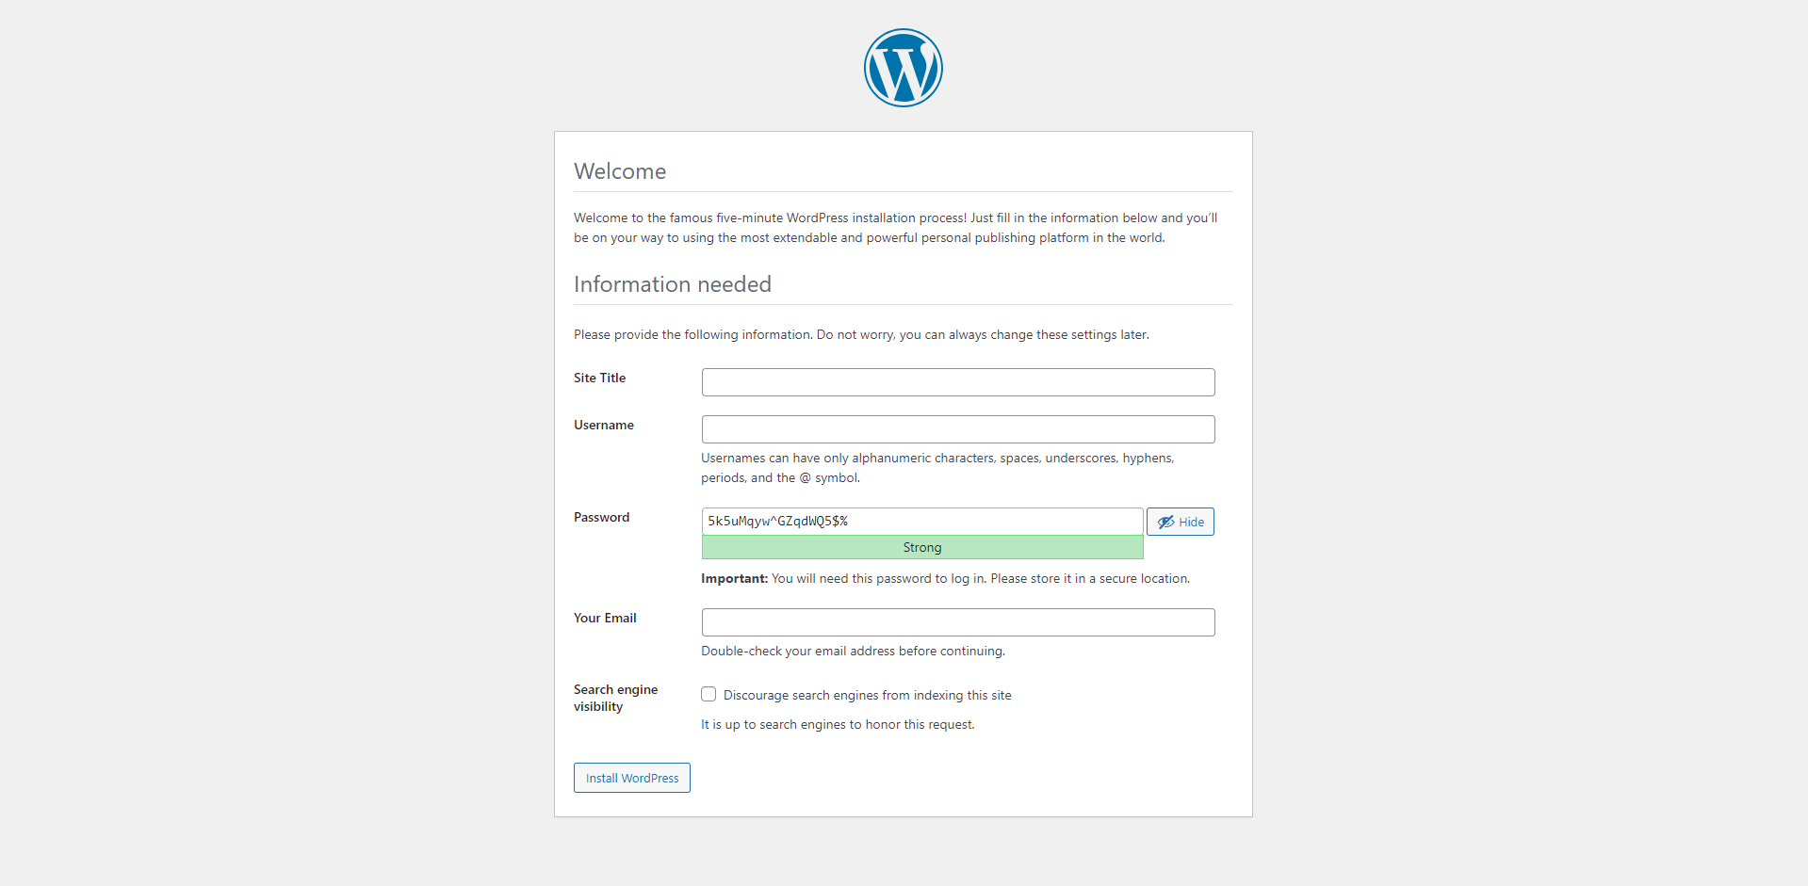

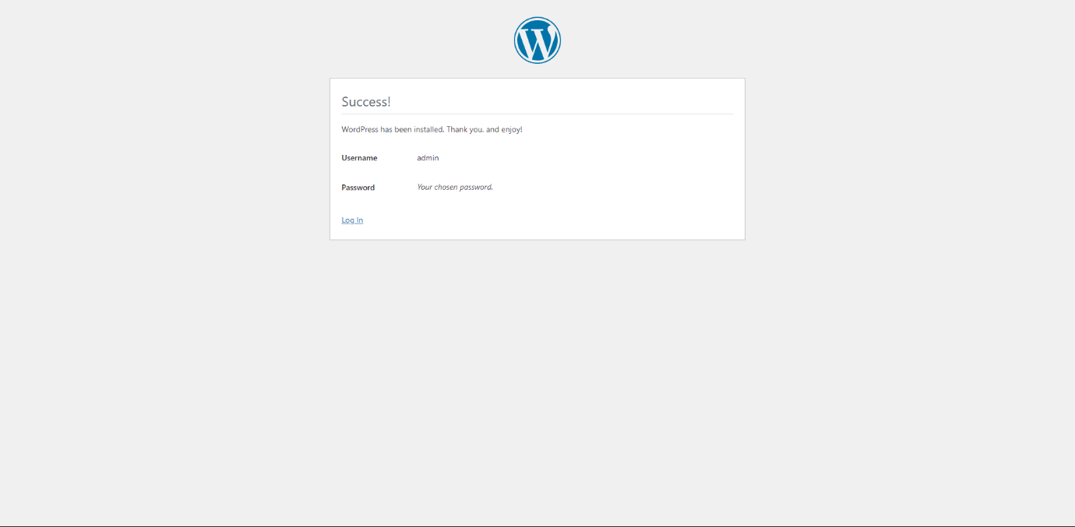

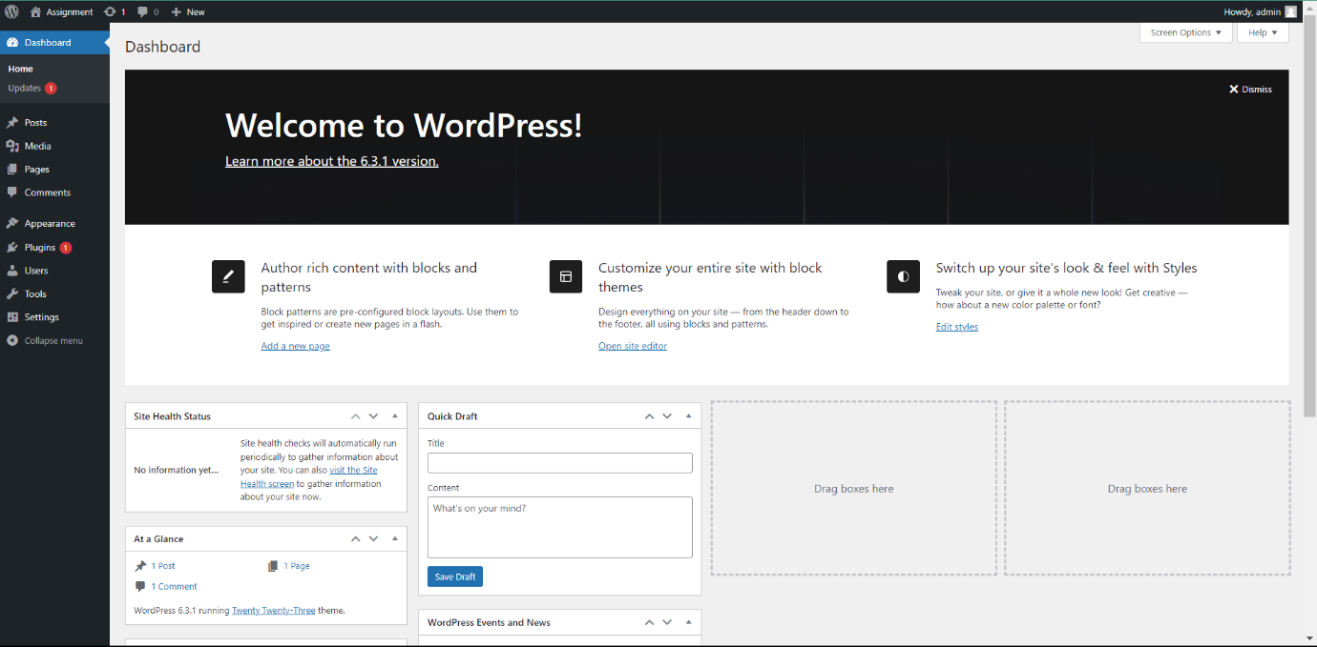

**Task 3 :**

Container access and login

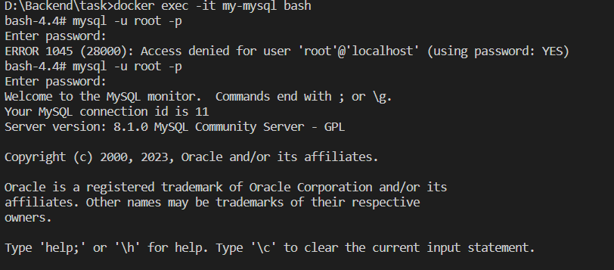

Showing database

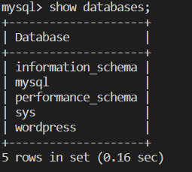

Using database and showing table

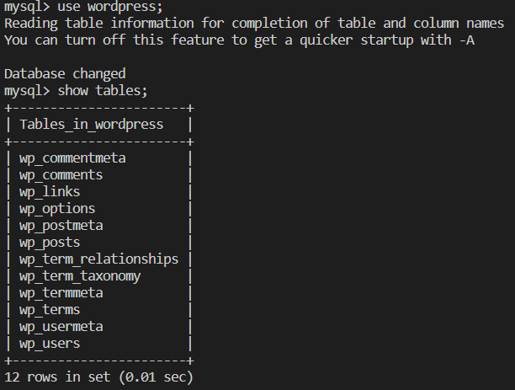

To Analyze Query Performance : Identify slow-running queries using the EXPLAIN statement

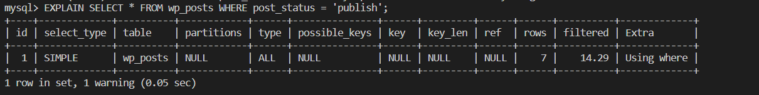

Indexing : Identify frequently used columns adding indexes to them

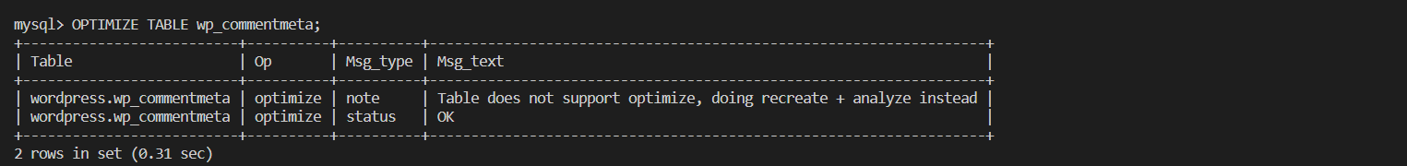

Ensure that each table has a primary key



Optimize Queries : Only retrieve the columns needed

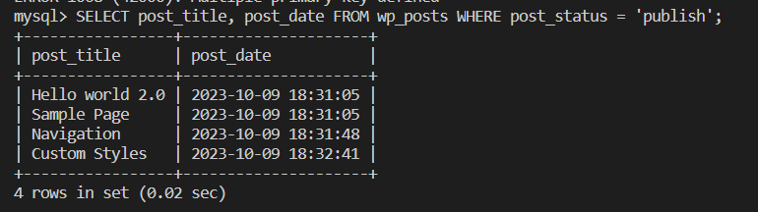

Regular Maintenance : Analyze and Optimize Tables

