Devops-Assignment

Task1 Create Dockerfile

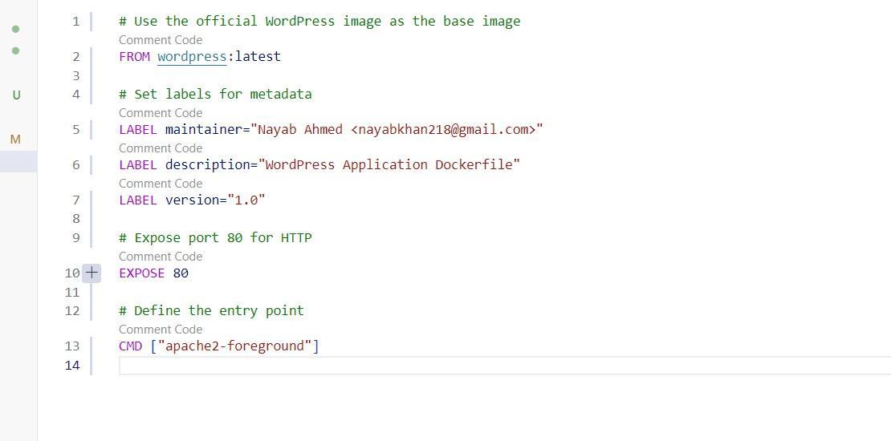

docker build -t wordpress .

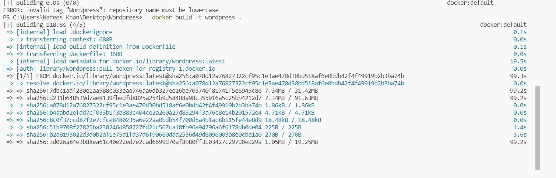

docker run -p 8080:80 --name wordpress-container wordpress

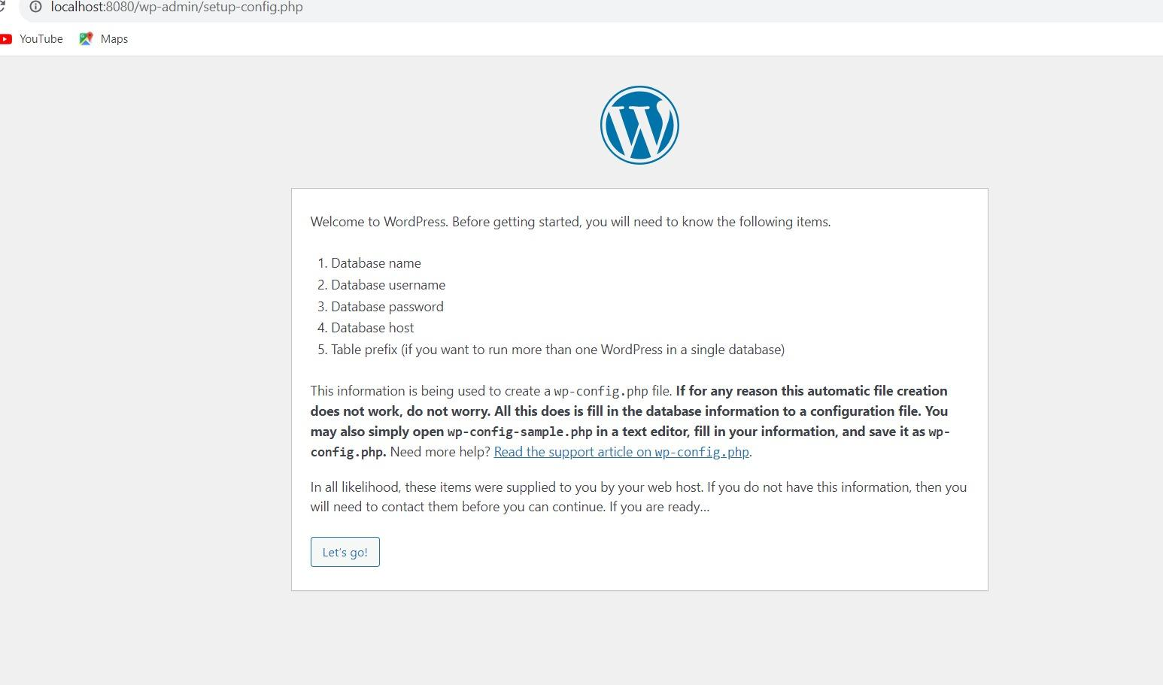

"htttp://localhost:8080"

task 2 docker-compose.yml

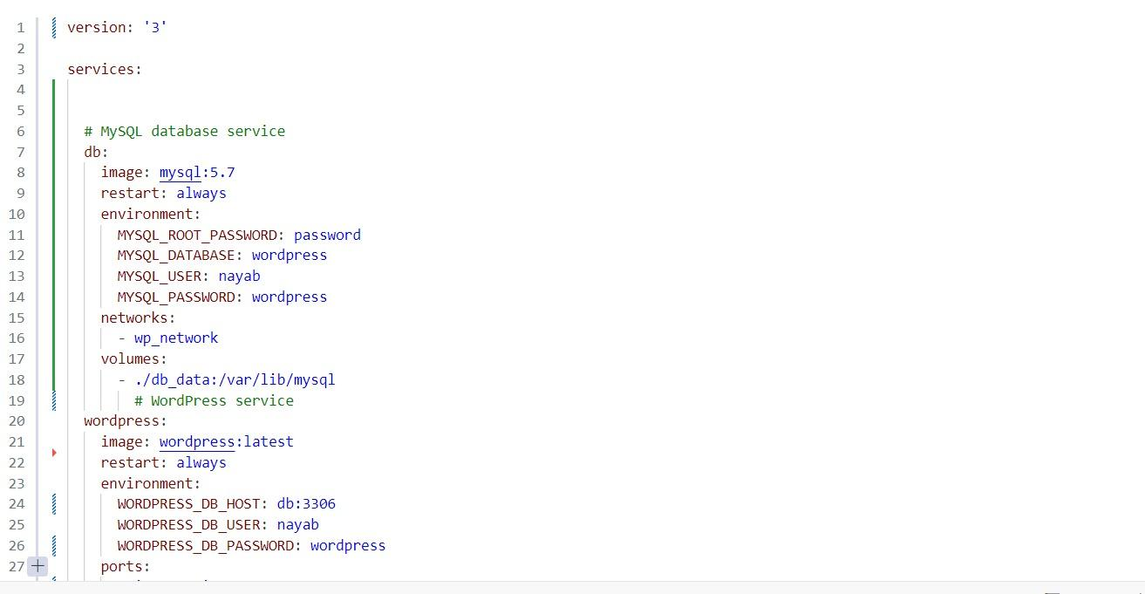

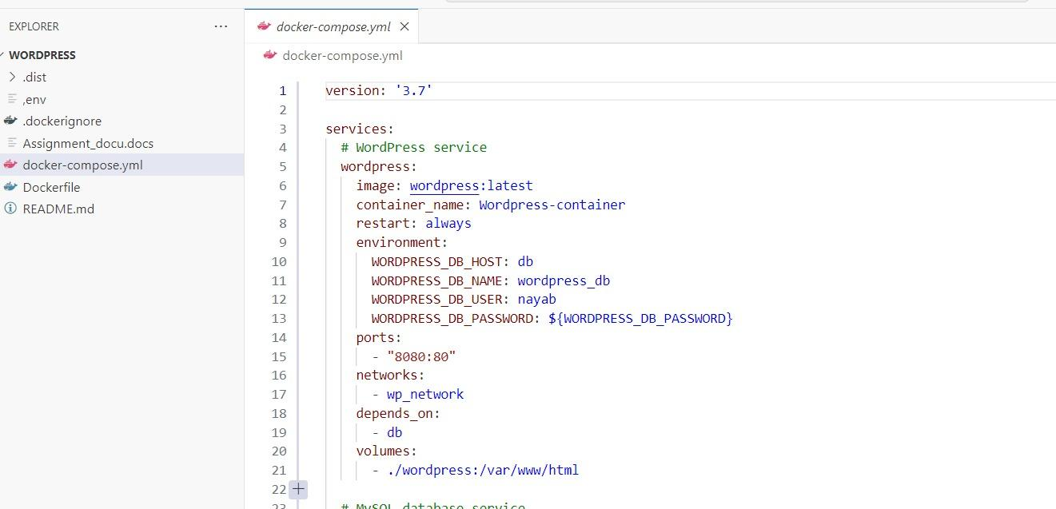

docker-compose up -d



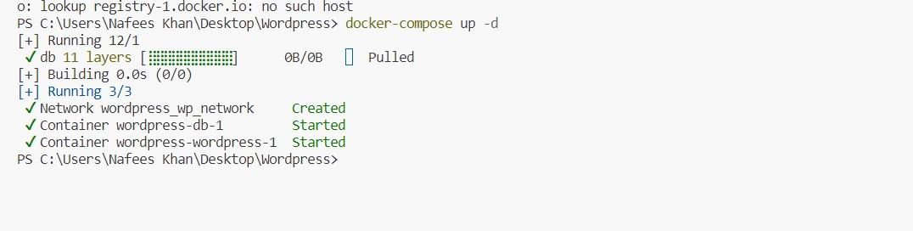

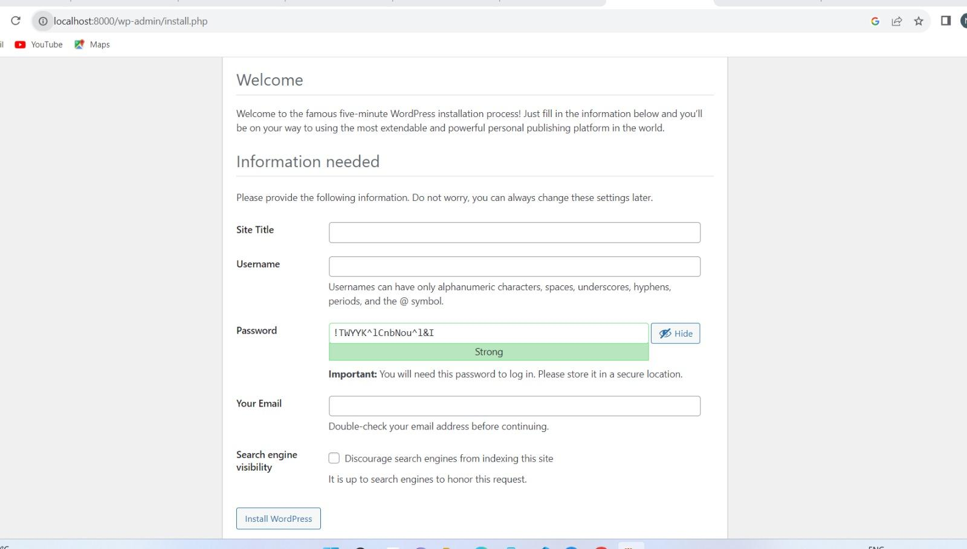

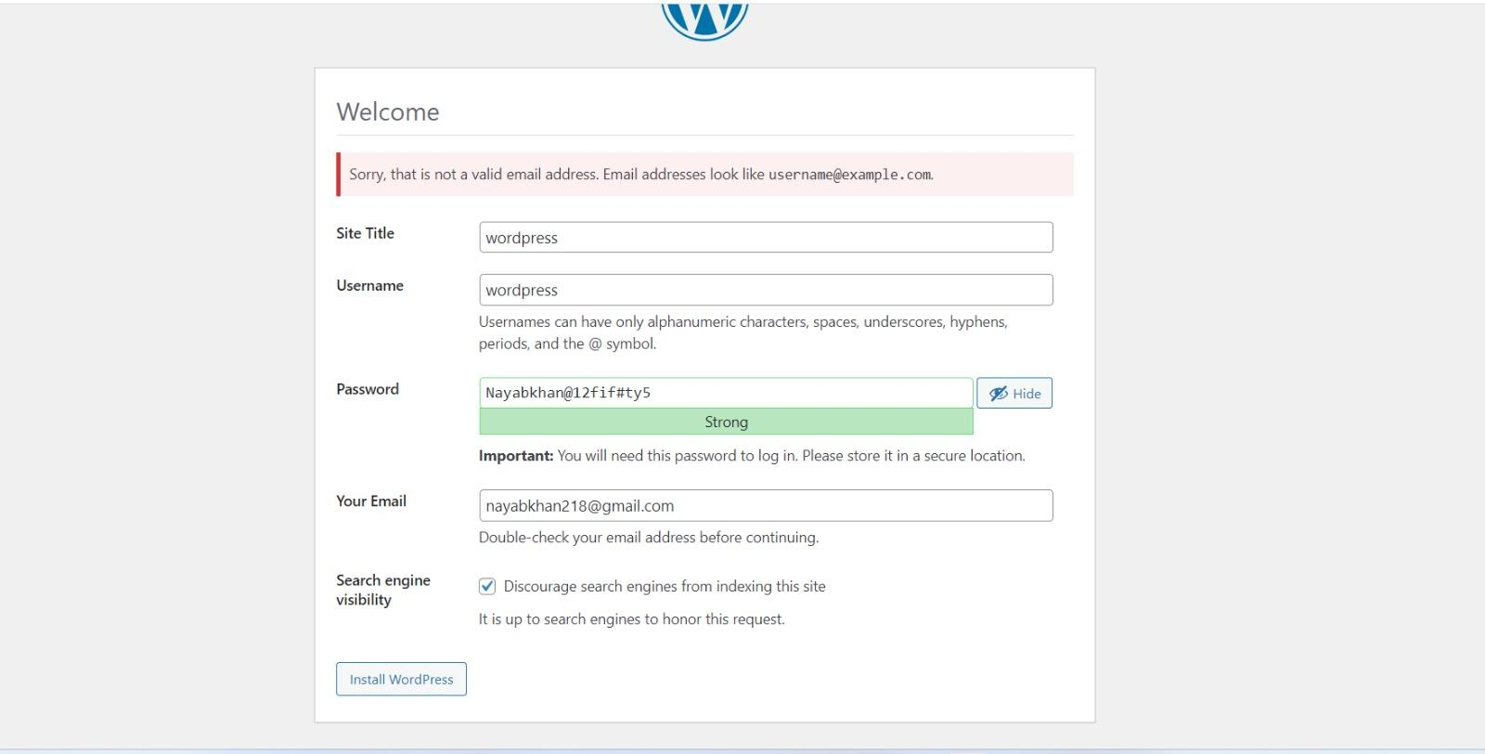

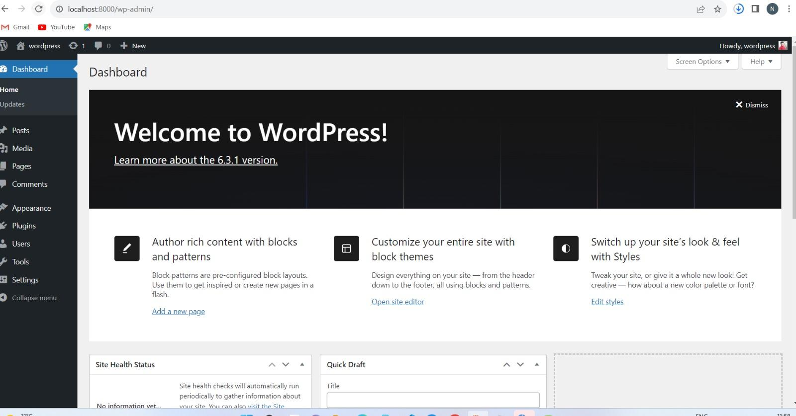

Task 3

To login to MySQL and enter the password

mysql -u root -p

To show To use databse and showing the tables

show database;

use wordpress;

show table;

To Analyze Query Performance : Identify slow-running queries using the EXPLAIN statement:

EXPLAIN SELECT * FROM wp_posts WHERE post_status = 'publish;

Indexing : Identify frequently used columns adding indexes to them

CREATE INDEX idx_title ON wp_posts (post_title);

Ensure that each table has a primary key

ALTER TABLE wp_posts ADD PRIMARY KEY (ID);

Optimize Queries : Only retrieve the columns needed

SELECT post_title, post_date FROM wp_posts WHERE post_status = 'publish';

Regular Maintenance : Analyze and Optimize Tables

ANALYZE TABLE wp_posts;

OPTIMIZE TABLE wp_posts;

Remove Unnecessary Data : Remove unused data to reduce the size of your database.

Partitioning : Partitioning them to distribute data across multiple partitions.

Monitor Performance : Continuously monitor the performance of database using tools like MySQL Workbench and Zabbix.