**API ENDPOINTS**

**List all websites.**HTTP METHOD: GET

URL: {base_url}/websites/  
RESPONSE:

[

{

"id": 1,

"name": "foo",

"url": "http://foo.com"

},

{

"id": 2,

"name": "bar",

"url": "http://bar.com"

}

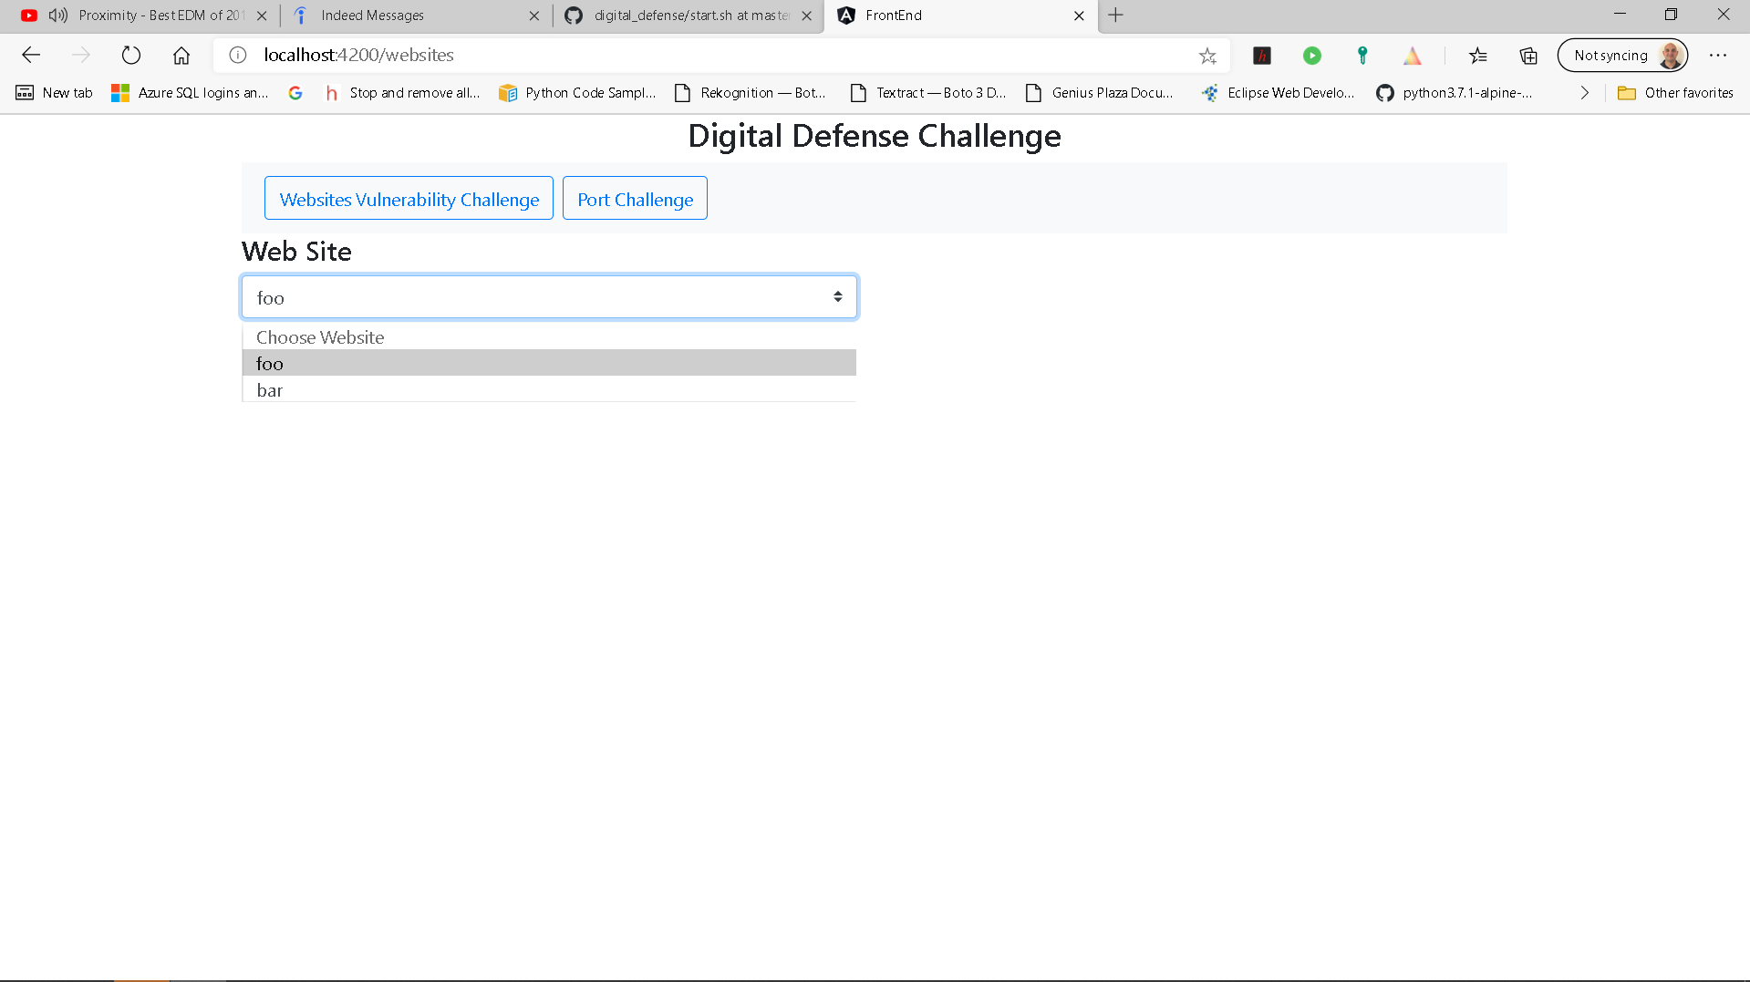]

**Retrieve Page for Website:**HTTP METHOD: GET

URL: {base_url}/pages/

QUERY PARAM:

website_id = id of Website object  
RESPONSE: [

{

"id": 3,

"website_id": 1,

"path": "/admin.html"

},

{

"id": 2,

"website_id": 1,

"path": "/logout.html"

},

{

"id": 1,

"website_id": 1,

"path": "/login.html"

}

] 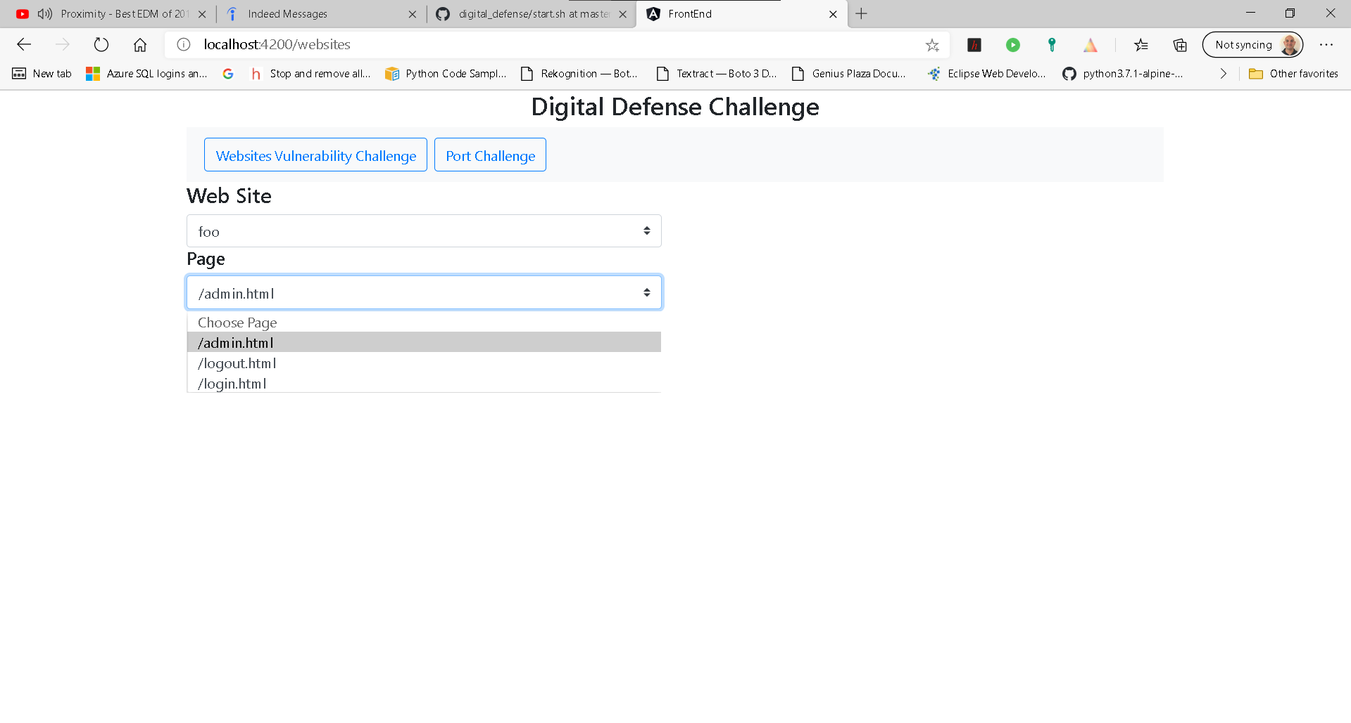

**Retrieve Vulnerabilities for a Page:**HTTP METHOD: GET

URL: {base_url}/ vulnerabilities /

QUERY PARAM:

page_id = id of page object  
RESPONSE: [

{

"id": 3,

"page_id": 1,

"data": "Stored XSS response"

},

{

"id": 2,

"page_id": 1,

"data": "XXE response"

},

{

"id": 1,

"page_id": 1,

"data": "SQL injection response blah"

}

]

