https://kubernetes.io/docs/tutorials/hello-minikube/

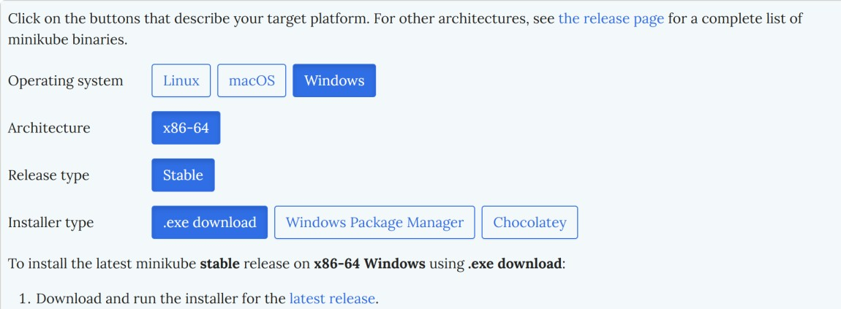
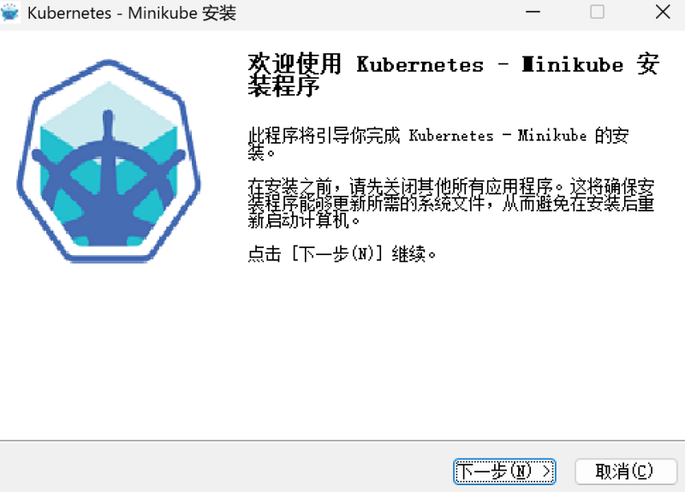

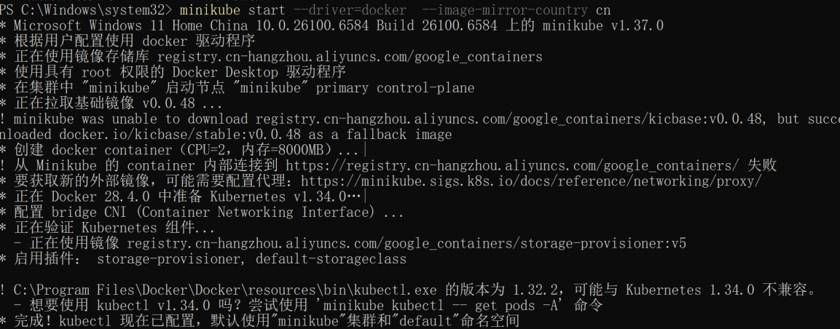
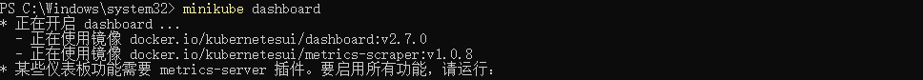
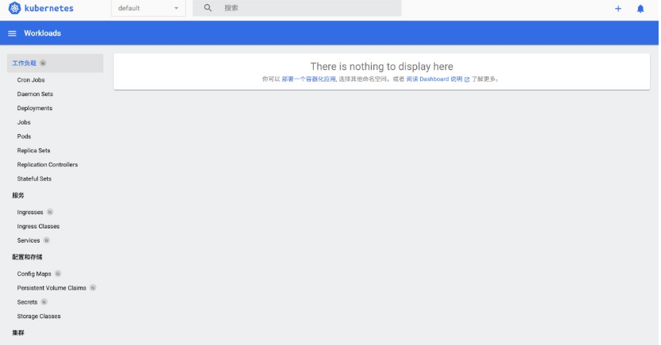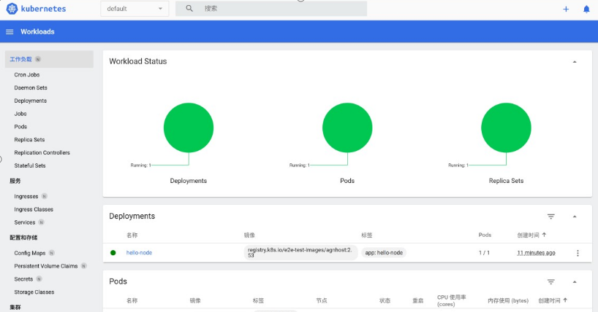
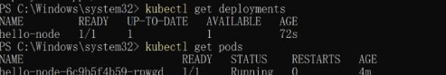

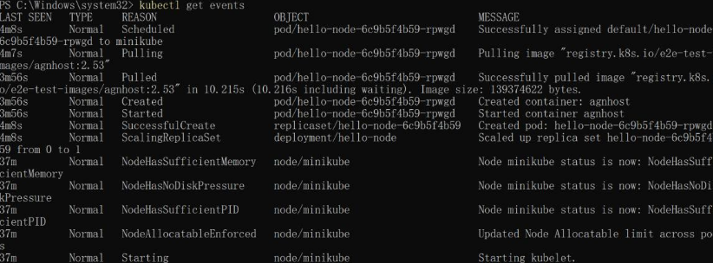
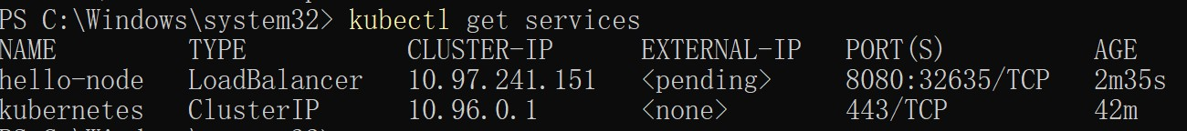

https://kubernetes.io/docs/tutorials/kubernetes-basics/deploy-app/deploy-intro/
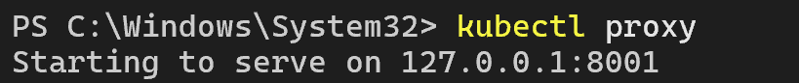
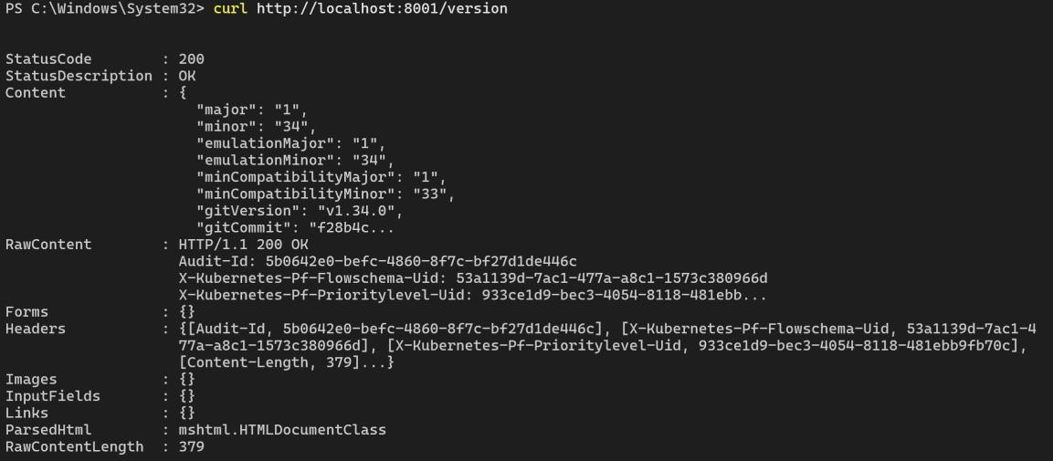

https://kubernetes.io/docs/tutorials/kubernetes-basics/explore/explore-intro/
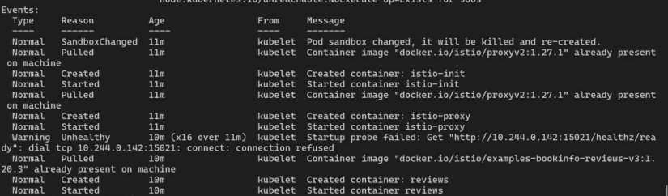
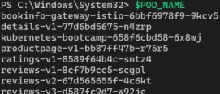
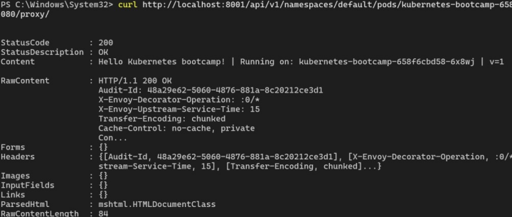
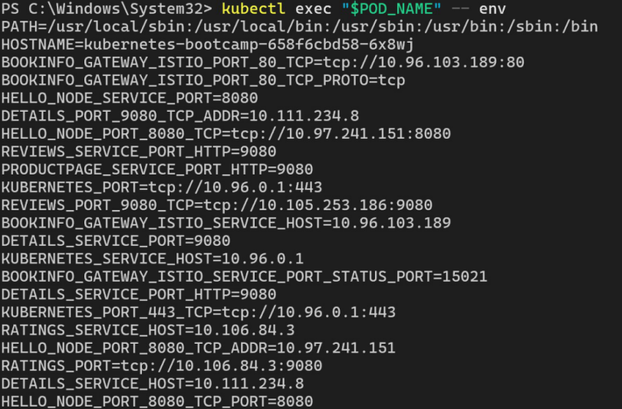
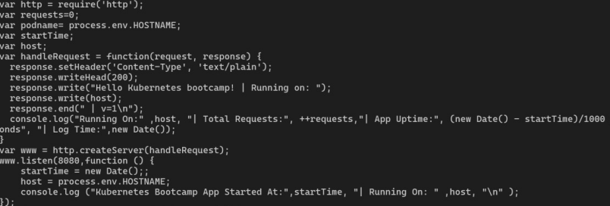
https://kubernetes.io/docs/tutorials/kubernetes-basics/expose/expose-intro/

https://kubernetes.io/docs/tutorials/kubernetes-basics/update/update-intro/
