Istio Introductory Experiment Report

Experiment Title: Basic installation of Istio Service Mesh and demo of Bookinfo application (demo profile)
Experiment Date: January 2026
Experiment Environment: Minikube (latest version), kubectl, istioctl

Experimental Objectives:
Successfully install Istio (demo configuration, no default gateway)
Deploy the classic Bookinfo sample application and inject the sidecar
Expose the application via the Gateway API
Observe the service mesh traffic topology using Kiali

1. Pre-processing and downloading Istio

1.1 To confirm the cluster is running: use `kubectl cluster-info` or `kubectl get nodes`
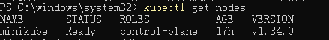

1.2 Download the latest Istio: `curl -L https://istio.io/downloadIstio`
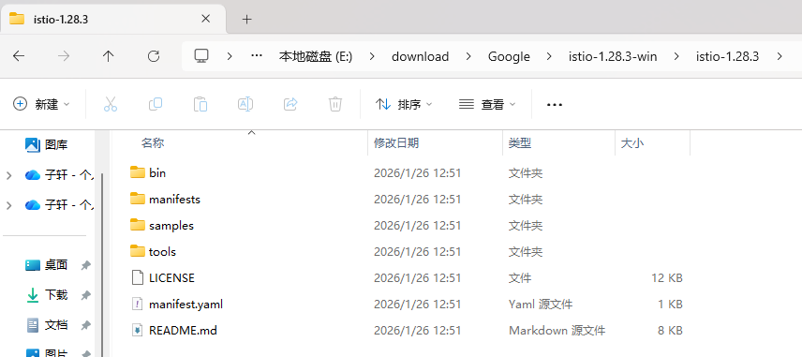

1.3 Enter the directory and add PATH

2. Install Istio

2.1 istioctl install -f samples/bookinfo/demo-profile-no-gateways.yaml -y
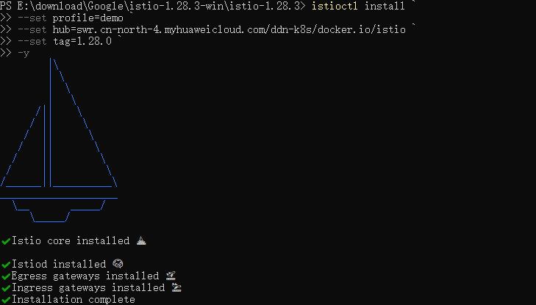

2.2 Verify installation: kubectl get pods -n istio-system
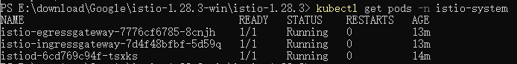

2.3 Enable automatic injection in the default namespace: `kubectl label namespace default istio-injection=enabled`

3. Install Kubernetes Gateway API CRDs
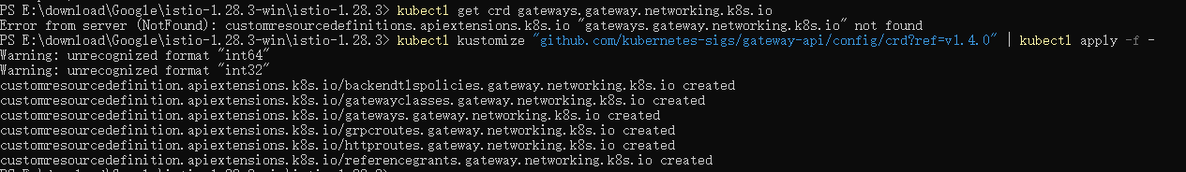

4. Deploy the Bookinfo sample application

4.1 kubectl apply -f samples/bookinfo/platform/kube/bookinfo.yaml
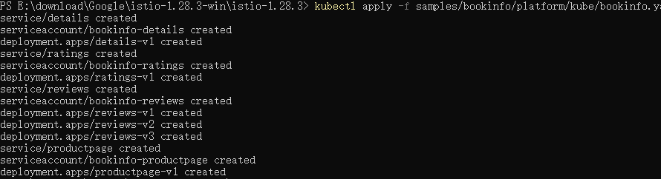

4.2 Waiting for and verifying sidecar injection: `kubectl get pods`
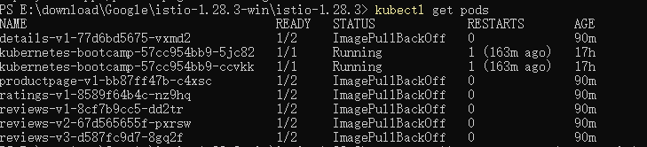

4.3 Internal connectivity test: `kubectl exec ... -c ratings -- curl -sS productpage:9080/productpage | grep title`
fail

5. Exposing the Bookinfo application via Gateway API

5.1 kubectl apply -f samples/bookinfo/gateway-api/bookinfo-gateway.yaml

5.2 Configure ClusterIP (to avoid LoadBalancer): `kubectl annotate gateway bookinfo-gateway networking.istio.io/service-type=ClusterIP --namespace=default`

5.3 Port forwarding access: kubectl port-forward svc/bookinfo-gateway-istio 8080:80

