- Experiment Objective

This experiment aims to master the deployment and serviceization process of machine learning models in a cloud-native environment by deploying KServe in a local Kubernetes (Minikube) environment. By creating and running a KServe InferenceService, we will achieve online inference access to the prediction model and understand how to monitor, debug, and access the model service.
Through this experiment, we will further understand KServe's role as a model inference platform in the Kubernetes ecosystem and its differences from traditional model deployment methods.

- Experiment Environment
Project | Version / Description
Project | Version / Description
Operating System | Windows 11
Docker | Docker Desktop
Minikube | v1.37.0
Kubernetes | v1.34.0
KServe | Latest stable version
Model Type | sklearn

3.Introduction to Experiment Principles
3.1 Introduction to KServe
KServe is a Kubernetes-based machine learning model inference platform that provides a unified API (InferenceService) for model deployment and supports various mainstream machine learning frameworks, such as TensorFlow, PyTorch, and Scikit-learn.

KServe has the following characteristics:
Cloud-native architecture based on Kubernetes
Automatic scaling
Supports multiple model formats
Provides a unified model inference interface

3.2 InferenceService Concept

InferenceService is the core resource object in KServe used to describe model services, including:
Model type and storage location
Inference protocol
Service status and running information

4. Experiment Process and Key Steps
4.1 Starting the Minikube Cluster

Start the local Kubernetes cluster using Minikube:

.

4.2 Installing and Configuring KServe

According to the official documentation, install the KServe components in the Minikube cluster.
Check if the KServe related Pods are running normally:
4.3 Deploying the Prediction Model (InferenceService)
This experiment selects an example prediction model (such as an sklearn example model) for deployment. Creating the InferenceService resource:

kubectl apply -f isvc.yaml

Viewing the InferenceService status:

kubectl get inferenceservices

When the status shows Ready=True, it indicates that the model service has been successfully deployed.

kubectl apply -n kserve-test -f - <<EOF
apiVersion: "serving.kserve.io/v1beta1"
kind: "InferenceService"
metadata:
name: "sklearn-iris"
namespace: kserve-test
spec:
predictor:
model:
modelFormat:
name: sklearn
storageUri: "gs://kfserving-examples/models/sklearn/1.0/model"
resources:
requests:
cpu: "100m"
memory: "512Mi"
limits:
cpu: "1"
memory: "1Gi"
EOF
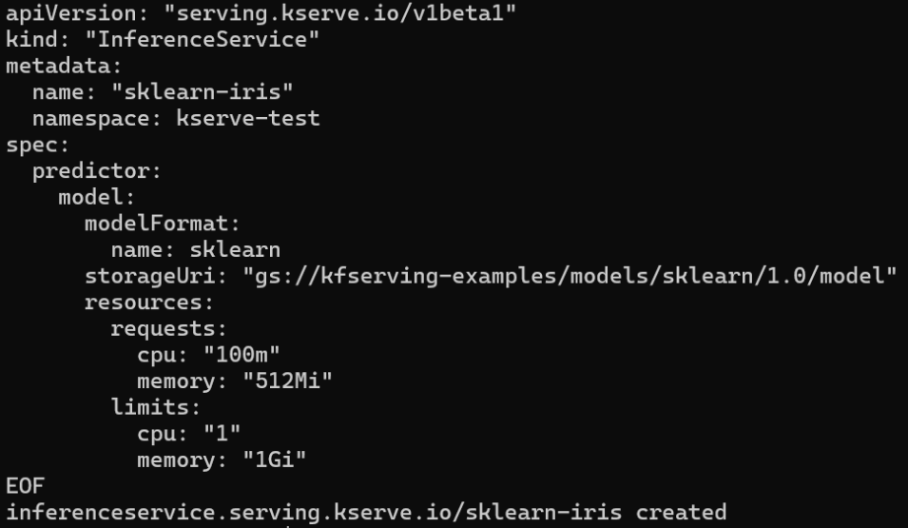

4.4 Monitoring Service Status and Debugging

Use the following commands to view Pod status and logs for troubleshooting potential issues:
kubectl get inferenceservices sklearn-iris -n kserve-test
kubectl get svc istio-ingressgateway -n istio-system

4.5 Accessing InferenceService from outside the cluster

Since InferenceService runs inside the cluster by default, it needs to be accessed via port forwarding or Minikube Service.

kubectl port-forward svc/<service-name> 8080:80
4.6 Sending Inference Requests and Viewing Results

Use curl to send inference requests to the model service:

curl -X POST http://localhost:8080/v1/models/model:predict \
-H "Content-Type: application/json" \
-d '{"instances": [[5.1, 3.5, 1.4, 0.2]]}'

The model returns the prediction result, indicating that the inference service is running correctly.

5. Experiment Results Analysis

This experiment successfully completed the following:

Deployed KServe in a local Minikube cluster

Published a prediction model using InferenceService

Successfully accessed the model service from outside the cluster

Implemented online inference requests for the model

The experiment shows that KServe can effectively simplify the model deployment process and provide a standardized model service interface.

6️⃣ Common Problems and Debugging Experience

During the experiment, you may encounter the following problems:

Pod fails to start (image pull failed)

InferenceService status remains NotReady for a long time

Unable to access the service from outside the cluster

By checking the Pod status, description information, and logs, you can quickly identify and resolve the problems. 7. Experiment Summary

KServe provides an efficient and standardized solution for model deployment and inference, enabling machine learning models to run as services in a Kubernetes environment. Compared to traditional model deployment methods, KServe offers greater scalability, maintainability, and automation capabilities.

This experiment deepened our understanding of cloud-native machine learning inference platforms and laid the foundation for further learning about MLOps and cloud-native AI applications.

