Download Istio
Go to the Istio release page to download the installation file for your OS, or download and extract the latest release automatically (Linux or macOS):

$ curl -L https://istio.io/downloadIstio | sh -

Move to the Istio package directory. For example, if the package is istio-1.28.2:

$ cd istio-1.28.2

The installation directory contains:

Sample applications in samples/
The istioctl client binary in the bin/ directory.
Add the istioctl client to your path (Linux or macOS):

$ export PATH=$PWD/bin:$PATH
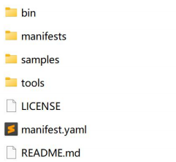

Install Istio
For this guide, we use the demo configuration profile. It is selected to have a good set of defaults for testing, but there are other profiles for production, performance testing or OpenShift.

Unlike Istio Gateways, creating Kubernetes Gateways will, by default, also deploy gateway proxy servers. Because they won’t be used, we disable the deployment of the default Istio gateway services that are normally installed as part of the demo profile.

Install Istio using the demo profile, without any gateways:

$ istioctl install -f samples/bookinfo/demo-profile-no-gateways.yaml -y
✔ Istio core installed
✔ Istiod installed
✔ Installation complete

Made this installation the default for injection and validation.
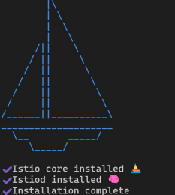
Add a namespace label to instruct Istio to automatically inject Envoy sidecar proxies when you deploy your application later:

$ kubectl label namespace default istio-injection=enabled
namespace/default labeled

Install the Kubernetes Gateway API CRDs
The Kubernetes Gateway API CRDs do not come installed by default on most Kubernetes clusters, so make sure they are installed before using the Gateway API.

Install the Gateway API CRDs, if they are not already present:

$ kubectl get crd gateways.gateway.networking.k8s.io &> /dev/null || \
{ kubectl kustomize "github.com/kubernetes-sigs/gateway-api/config/crd?ref=v1.4.0" | kubectl apply -f -; }
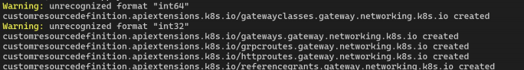

Deploy the sample application
You have configured Istio to inject sidecar containers into any application you deploy in your default namespace.

Deploy the Bookinfo sample application:

$ kubectl apply -f samples/bookinfo/platform/kube/bookinfo.yaml
service/details created
serviceaccount/bookinfo-details created
deployment.apps/details-v1 created
service/ratings created
serviceaccount/bookinfo-ratings created
deployment.apps/ratings-v1 created
service/reviews created
serviceaccount/bookinfo-reviews created
deployment.apps/reviews-v1 created
deployment.apps/reviews-v2 created
deployment.apps/reviews-v3 created
service/productpage created
serviceaccount/bookinfo-productpage created
deployment.apps/productpage-v1 created
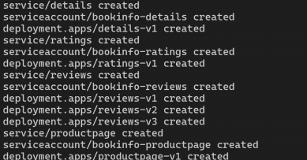
The application will start. As each pod becomes ready, the Istio sidecar will be deployed along with it.

$ kubectl get services
NAME TYPE CLUSTER-IP EXTERNAL-IP PORT(S) AGE
details ClusterIP 10.0.0.212 <none> 9080/TCP 29s
kubernetes ClusterIP 10.0.0.1 <none> 443/TCP 25m
productpage ClusterIP 10.0.0.57 <none> 9080/TCP 28s
ratings ClusterIP 10.0.0.33 <none> 9080/TCP 29s
reviews ClusterIP 10.0.0.28 <none> 9080/TCP 29s
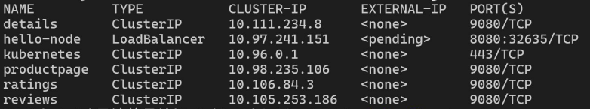
and

$ kubectl get pods
NAME READY STATUS RESTARTS AGE
details-v1-558b8b4b76-2llld 2/2 Running 0 2m41s
productpage-v1-6987489c74-lpkgl 2/2 Running 0 2m40s
ratings-v1-7dc98c7588-vzftc 2/2 Running 0 2m41s
reviews-v1-7f99cc4496-gdxfn 2/2 Running 0 2m41s
reviews-v2-7d79d5bd5d-8zzqd 2/2 Running 0 2m41s
reviews-v3-7dbcdcbc56-m8dph 2/2 Running 0 2m41s
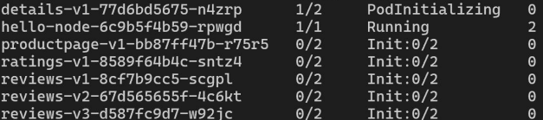
Note that the pods show READY 2/2, confirming they have their application container and the Istio sidecar container.

Validate that the app is running inside the cluster by checking for the page title in the response:

$ kubectl exec "$(kubectl get pod -l app=ratings -o jsonpath='{.items[0].metadata.name}')" -c ratings -- curl -sS productpage:9080/productpage | grep -o "<title>.*</title>"
<title>Simple Bookstore App</title>

Open the application to outside traffic
The Bookinfo application is deployed, but not accessible from the outside. To make it accessible, you need to create an ingress gateway, which maps a path to a route at the edge of your mesh.

Create a Kubernetes Gateway for the Bookinfo application:

$ kubectl apply -f samples/bookinfo/gateway-api/bookinfo-gateway.yaml
gateway.gateway.networking.k8s.io/bookinfo-gateway created
httproute.gateway.networking.k8s.io/bookinfo created
By default, Istio creates a LoadBalancer service for a gateway. As we will access this gateway by a tunnel, we don’t need a load balancer. If you want to learn about how load balancers are configured for external IP addresses, read the ingress gateways documentation.
Change the service type to ClusterIP by annotating the gateway:
$ kubectl annotate gateway bookinfo-gateway networking.istio.io/service-type=ClusterIP --namespace=default
To check the status of the gateway, run:
$ kubectl get gateway
NAME CLASS ADDRESS PROGRAMMED AGE
bookinfo-gateway istio bookinfo-gateway-istio.default.svc.cluster.local True 42s

Access the application
You will connect to the Bookinfo productpage service through the gateway you just provisioned. To access the gateway, you need to use the kubectl port-forward command:
$ kubectl port-forward svc/bookinfo-gateway-istio 8080:80

Open your browser and navigate to http://localhost:8080/productpage to view the Bookinfo application.
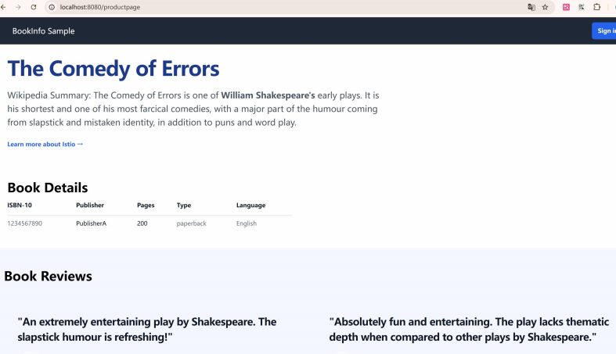
Bookinfo Application
Bookinfo Application
If you refresh the page, you should see the book reviews and ratings changing as the requests are distributed across the different versions of the reviews service.

View the dashboard
Istio integrates with several different telemetry applications. These can help you gain an understanding of the structure of your service mesh, display the topology of the mesh, and analyze the health of your mesh.

Use the following instructions to deploy the Kiali dashboard, along with Prometheus, Grafana, and Jaeger.

Install Kiali and the other addons and wait for them to be deployed.

$ kubectl apply -f samples/addons/kiali.yaml
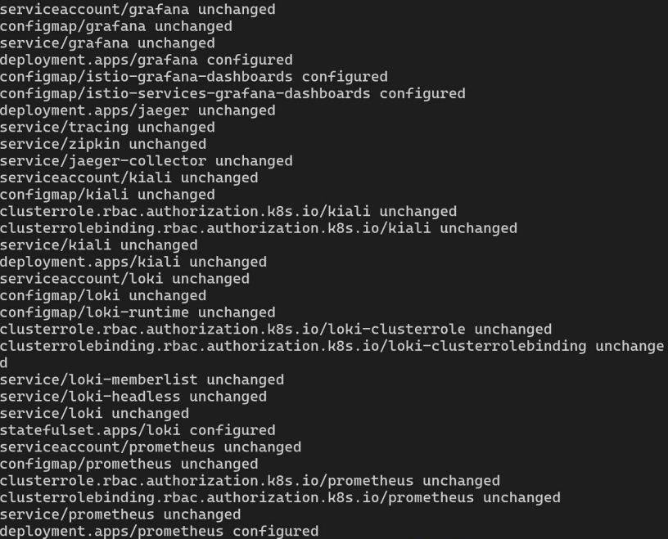
$ kubectl rollout status deployment/kiali -n istio-system
Waiting for deployment "kiali" rollout to finish: 0 of 1 updated replicas are available...
deployment "kiali" successfully rolled out

Access the Kiali dashboard.

