https://istio.io/latest/docs/tasks/traffic-management/traffic-shifting/

To get started, run this command to route all traffic to the v1 version:
Istio APIsGateway API
$ kubectl apply -f samples/bookinfo/networking/virtual-service-all-v1.yaml
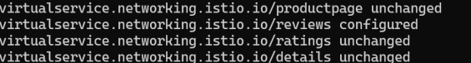
Open the Bookinfo site in your browser. The URL is http://$GATEWAY_URL/productpage, where $GATEWAY_URL is the External IP address of the ingress, as explained in the Bookinfo doc.
Notice that the reviews part of the page displays with no rating stars, no matter how many times you refresh. This is because you configured Istio to route all traffic for the reviews service to the version reviews:v1 and this version of the service does not access the star ratings service.
Transfer 50% of the traffic from reviews:v1 to reviews:v3 with the following command:
Istio APIsGateway API
$ kubectl apply -f samples/bookinfo/networking/virtual-service-reviews-50-v3.yaml
Wait a few seconds for the new rules to propagate and then confirm the rule was replaced:
$ kubectl get virtualservice reviews -o yaml
apiVersion: networking.istio.io/v1
kind: VirtualService
...
spec:
hosts:
- reviews
http:
- route:
- destination:
host: reviews
subset: v1
weight: 50
- destination:
host: reviews
subset: v3
weight: 50
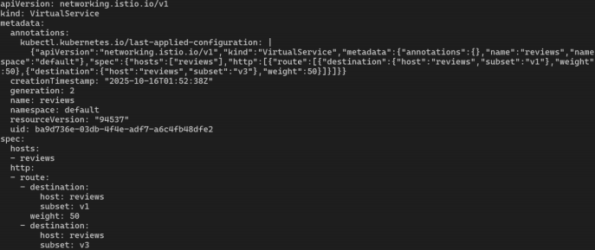
Assuming you decide that the reviews:v3 microservice is stable, you can route 100% of the traffic to reviews:v3 by applying this virtual service:

Istio APIsGateway API
$ kubectl apply -f samples/bookinfo/networking/virtual-service-reviews-v3.yaml
Refresh the /productpage several times. Now you will always see book reviews with red colored star ratings for each review.

https://istio.io/latest/docs/tasks/traffic-management/request-routing/
Route to version 1
To route to one version only, you configure route rules that send traffic to default versions for the microservices.

If you haven’t already, follow the instructions in define the service versions.
Run the following command to create the route rules:
Istio APIsGateway API
Istio uses virtual services to define route rules. Run the following command to apply virtual services that will route all traffic to v1 of each microservice:

$ kubectl apply -f samples/bookinfo/networking/virtual-service-all-v1.yaml
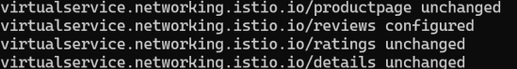
Because configuration propagation is eventually consistent, wait a few seconds for the virtual services to take effect.

Display the defined routes with the following command:
Istio APIsGateway API
$ kubectl get virtualservices -o yaml
Test the new routing configuration

You can easily test the new configuration by once again refreshing the /productpage of the Bookinfo app in your browser. Notice that the reviews part of the page displays with no rating stars, no matter how many times you refresh. This is because you configured Istio to route all traffic for the reviews service to the version reviews:v1 and this version of the service does not access the star ratings service.

You have successfully accomplished the first part of this task: route traffic to one version of a service.

Route based on user identity
Next, you will change the route configuration so that all traffic from a specific user is routed to a specific service version. In this case, all traffic from a user named Jason will be routed to the service reviews:v2.

This example is enabled by the fact that the productpage service adds a custom end-user header to all outbound HTTP requests to the reviews service.

Istio also supports routing based on strongly authenticated JWT on ingress gateway, refer to the JWT claim based routing for more details.

Remember, reviews:v2 is the version that includes the star ratings feature.

Run the following command to enable user-based routing:
Istio APIsGateway API
$ kubectl apply -f samples/bookinfo/networking/virtual-service-reviews-test-v2.yaml

https://istio.io/latest/docs/tasks/traffic-management/fault-injection/
Create a fault injection rule to delay traffic coming from the test user jason.

$ kubectl apply -f samples/bookinfo/networking/virtual-service-ratings-test-delay.yaml
Confirm the rule was created:

$ kubectl get virtualservice ratings -o yaml
apiVersion: networking.istio.io/v1
kind: VirtualService
...
spec:
hosts:
- ratings
http:
- fault:
delay:
fixedDelay: 7s
percentage:
value: 100
match:
- headers:
end-user:
exact: jason
route:
- destination:
host: ratings
subset: v1
- route:
- destination:
host: ratings
subset: v1
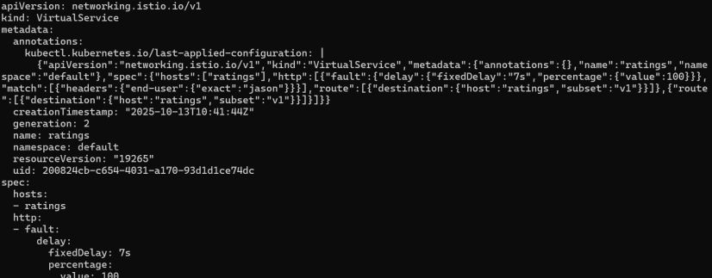
Injecting an HTTP abort fault
Another way to test microservice resiliency is to introduce an HTTP abort fault. In this task, you will introduce an HTTP abort to the ratings microservices for the test user jason.

In this case, you expect the page to load immediately and display the Ratings service is currently unavailable message.

Create a fault injection rule to send an HTTP abort for user jason:

$ kubectl apply -f samples/bookinfo/networking/virtual-service-ratings-test-abort.yaml
Confirm the rule was created:

$ kubectl get virtualservice ratings -o yaml
apiVersion: networking.istio.io/v1
kind: VirtualService
...
spec:
hosts:
- ratings
http:
- fault:
abort:
httpStatus: 500
percentage:
value: 100
match:
- headers:
end-user:
exact: jason
route:
- destination:
host: ratings
subset: v1
- route:
- destination:
host: ratings
subset: v1
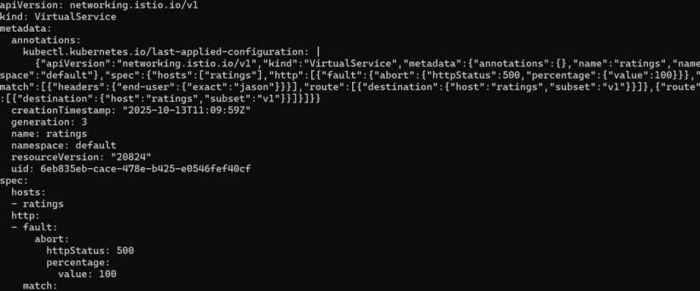

https://istio.io/latest/docs/tasks/traffic-management/circuit-breaking/
Before you begin
Setup Istio by following the instructions in the Installation guide.
Start the httpbin sample.

If you have enabled automatic sidecar injection, deploy the httpbin service:

$ kubectl apply -f samples/httpbin/httpbin.yaml
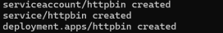
Otherwise, you have to manually inject the sidecar before deploying the httpbin application:
$ kubectl apply -f <(istioctl kube-inject -f samples/httpbin/httpbin.yaml)

Create a client to send traffic to the httpbin service. The client is a simple load-testing client called fortio. Fortio lets you control the number of connections, concurrency, and delays for outgoing HTTP calls. You will use this client to “trip” the circuit breaker policies you set in the DestinationRule.

Inject the client with the Istio sidecar proxy so network interactions are governed by Istio.

If you have enabled automatic sidecar injection, deploy the fortio service:

$ kubectl apply -f samples/httpbin/sample-client/fortio-deploy.yaml
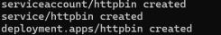
Otherwise, you have to manually inject the sidecar before deploying the fortio application:
$ kubectl apply -f <(istioctl kube-inject -f samples/httpbin/sample-client/fortio-deploy.yaml)

