1. Experiment Objectives
1.1 Why use Knative?
In traditional Kubernetes, applications typically run as Deployments, requiring manual or semi-automatic configuration of replica counts and scaling policies. Even when there are no requests, the application still consumes cluster resources.
Knative is a Serverless framework built on top of Kubernetes. It provides a higher level of abstraction, allowing developers to focus on the application logic itself without worrying about the underlying container lifecycle management. Knative supports on-demand startup, automatic scaling, and scaling down to zero, making it ideal for event-driven and lightweight service scenarios.

1.2 Relationship between Knative and Kubernetes
Kubernetes is the underlying container orchestration platform, responsible for managing Pods, Services, networking, and resource scheduling;
Knative runs on top of Kubernetes, extending its capabilities to provide Serverless features.

2. Experiment Environment
Project | Version / Description
Operating System | Windows 11
Docker | Docker Desktop
Minikube | v1.37.0
Kubernetes | v1.34.0
Knative | Serving + Eventing

3. Experiment Process and Key Steps (including screenshots)

This section records the key operational steps in the experiment and uses screenshots to demonstrate the successful deployment of the environment and components.

3.1 Starting the Minikube Cluster

Use the following command to start the local Kubernetes cluster:

minikube start --driver=docker --memory=15360 --cpus=8 --base-image=registry.k8s.io/kicbase/stable:v0.0.48 --kubernetes-version=v1.34.0

After startup, the cluster is successfully running.
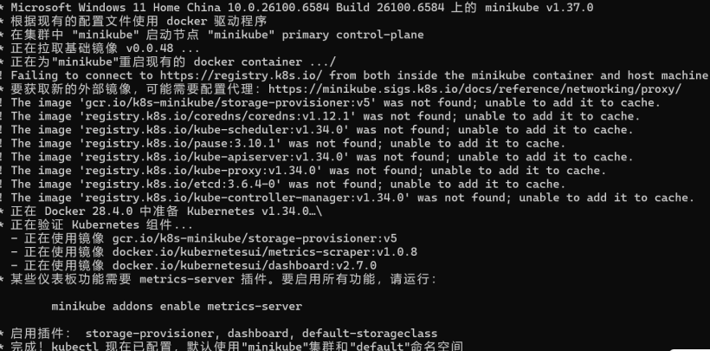

3.2 Installing Knative Serving

Install Knative Serving components using YAML files:

kubectl apply -f serving-crds.yaml
kubectl apply -f serving-core.yaml

Check the Pod status in the Knative Serving namespace:

kubectl get pods -n knative-serving

All Pods are in the Running state, indicating that Serving installation was successful.
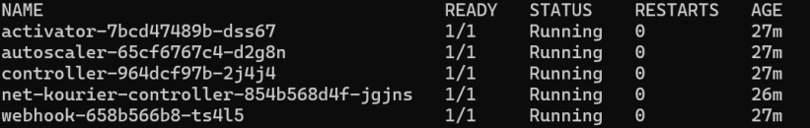
3.3 Installing Istio Network Components

Knative Serving relies on Istio as the network layer for request routing and traffic management.

kubectl apply -f istio.yaml
kubectl apply -f net-istio.yaml

Check the Istio-related Pods:

kubectl get pods -n istio-system
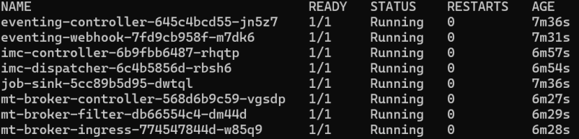

3.4 Installing Knative Eventing

Knative Eventing is used to support event-driven serverless architecture.

kubectl apply -f eventing-crd.yaml
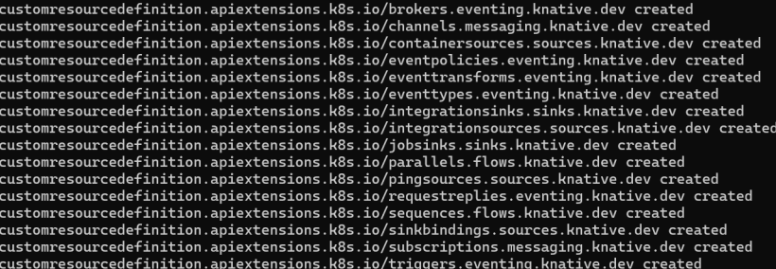
kubectl apply -f eventing-core.yaml
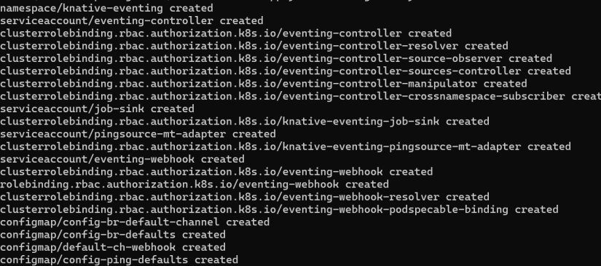

Confirm that the Eventing components are running correctly.

3.5 Creating a Function using Knative Functions

This experiment uses Knative Functions for functional development, using a local image repository without actual deployment.

Create a function project:

kn func create -l go hello

Run the function locally:

kn func run

The function should run successfully and return a response.

4. Experiment Summary
Based on this experiment, the main advantages of Knative can be summarized as follows:
Automatic scaling, supporting scaling down to 0, saving resources
No need to manually manage Pods and replicas
Supports HTTP services and event-driven models
Improves development efficiency and reduces operational complexity
Knative is very suitable for microservices, event-driven systems, and serverless application scenarios.

5.Conclusion
This experiment successfully deployed and ran Knative Serving, Eventing, and Functions in a local Minikube environment, providing a complete experience of the Kubernetes-based Serverless application development process and deepening the understanding of cloud-native and Serverless architectures.

