Kubernetes Basic Experiment Report

Experiment Title: Kubernetes Basic Operation Practice (Introduction to Minikube + kubectl)
Experiment Date: January 2026
Experiment Environment: Minikube (latest version), kubectl, and a personal computer with Docker installed
Experiment Objective: Master the basic operations of Deployment, Pod, Service, Scale, Rolling Update

1.Creating a local Kubernetes cluster (Hello Minikube)

1.1 minikube cluster started successfully
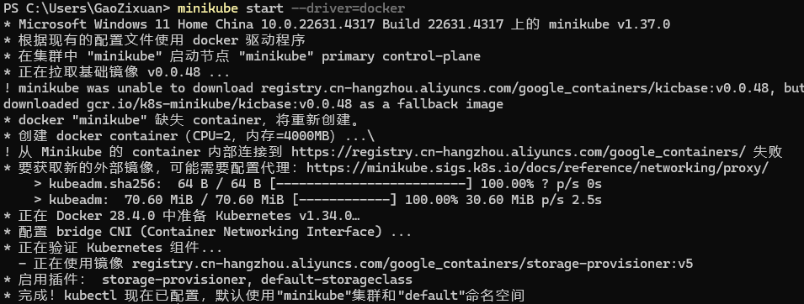

1.2 minikube dashboard automatically opens the Dashboard in your browser
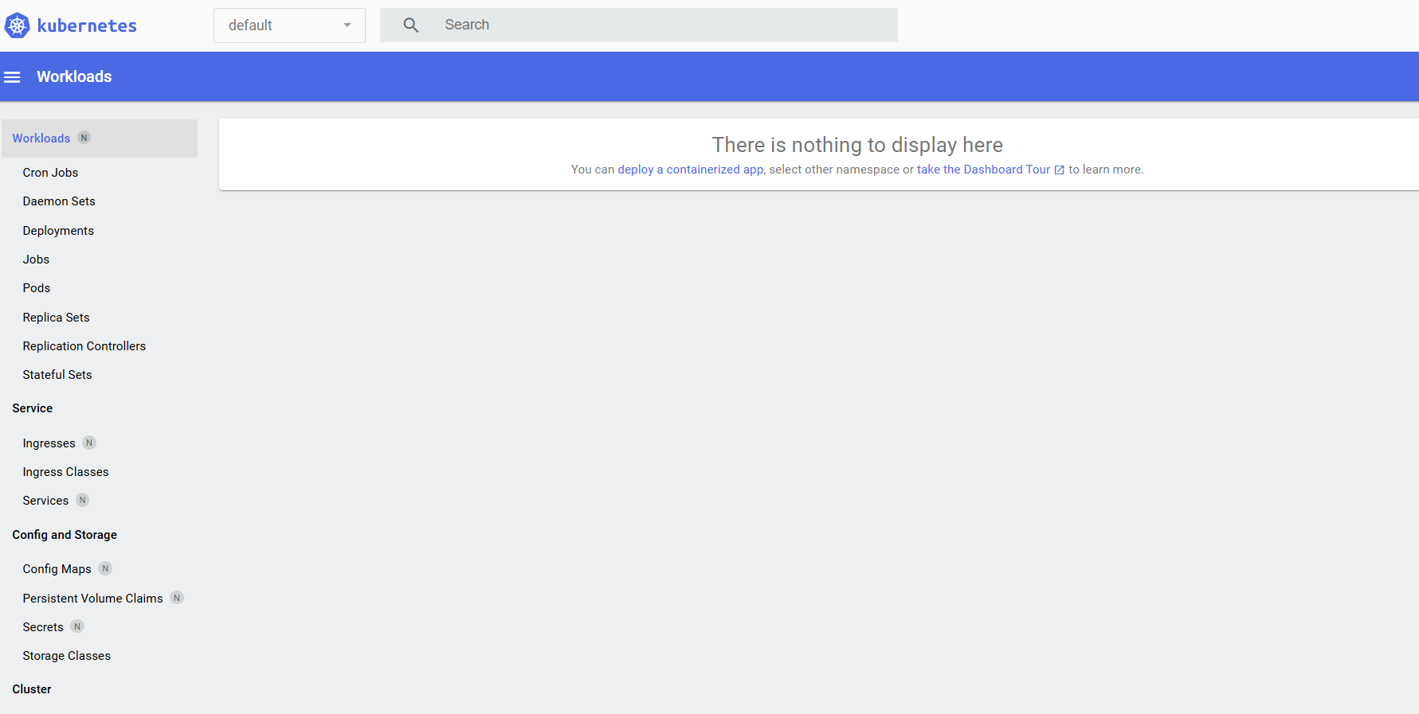

1.3 kubectl create deployment hello-node --image=registry.k8s.io/e2e-test-images/agnhost:2.53 -- /agnhost netexec --http-port=8080

1.4 The output of `kubectl get deployments` shows READY as 1/1
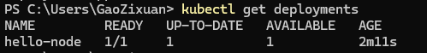

1.5 One of the most important screenshots: `kubectl get pods` showing 1 Running Pod (displaying the Pod name and STATUS=Running)

1.6 `kubectl expose deployment hello-node --type=LoadBalancer --port=8080` The command successfully outputs `service/hello-node exposed`

1.7 `minikube service hello-node` The browser opens the page and shows a successful response. Most important screenshot: the final browser page (showing "Congratulations" or similar success message)
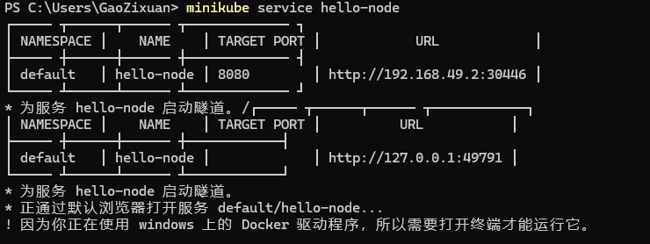
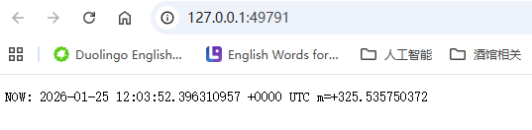

1.8 Cleanup: `kubectl delete svc,deploy hello-node` Deletion successful. Optional: Comparison of `kubectl get all` before and after deletion
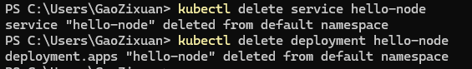

2. Create and view a Deployment (Basics - Deploy)

2.1 kubectl create deployment kubernetes-bootcamp --image=gcr.io/google-samples/kubernetes-bootcamp:v1deployment created command successful + get deployments immediately

2.2 kubectl get deploymentsREADY 1/1

2.3 kubectl get pods 1 Running Pod Pod List (Running)

2.4 Run `kubectl proxy`, then test it in a new terminal using `curl` to access it via `localhost:8001`
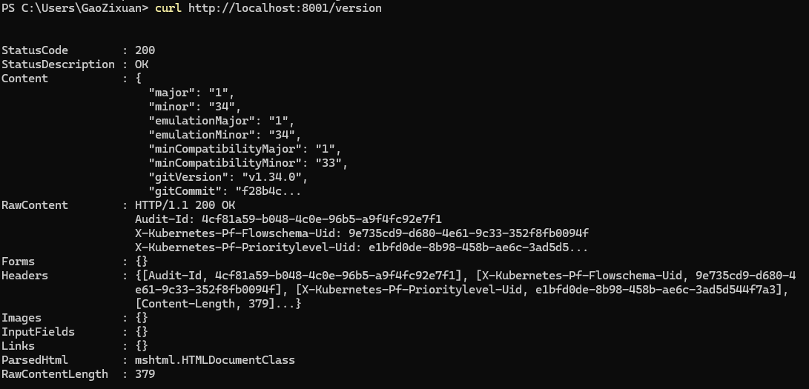

3. Exploring Clusters and Pods (Basics - Explore)

3.1 `kubectl get pods` lists the Pods that are in the Running state.

3.2 `kubectl describe pods` displays detailed Pod information (IP address, ports, events, etc.)
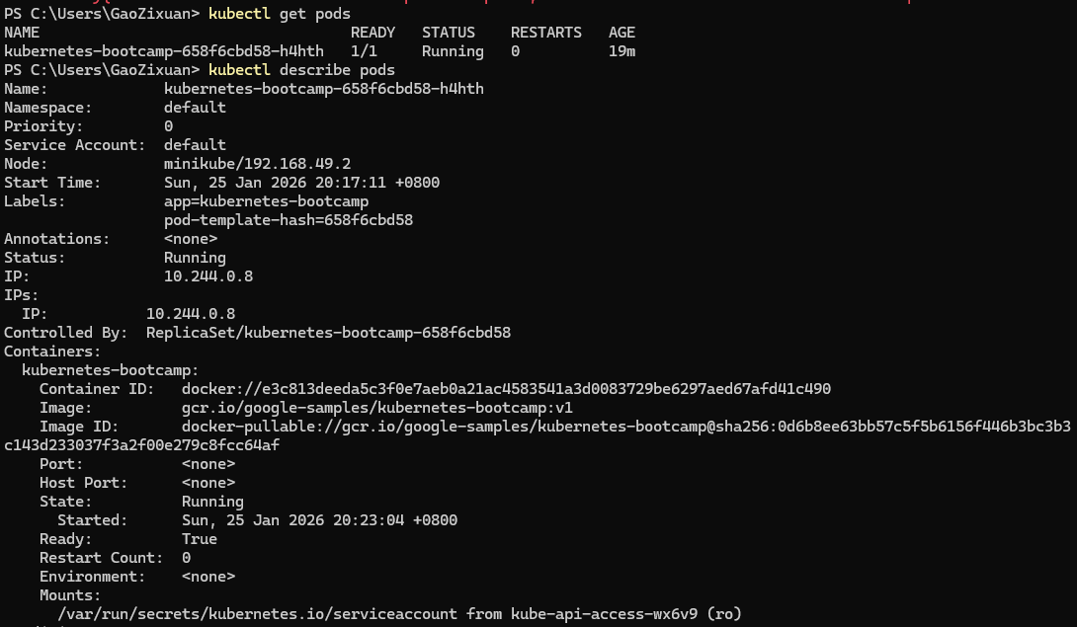
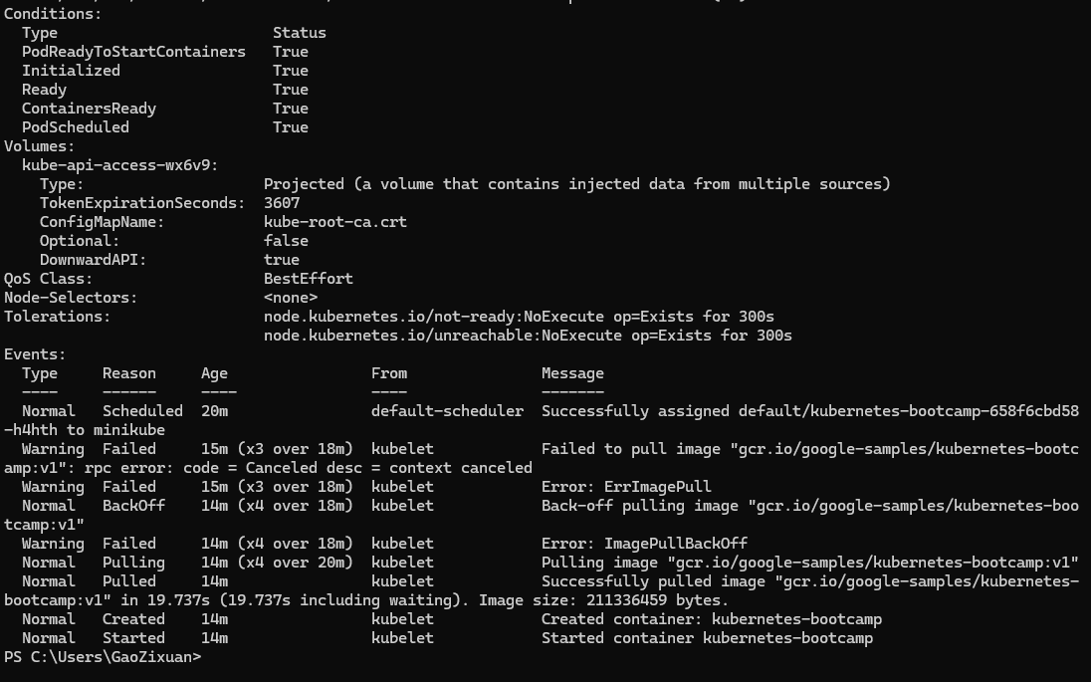

3.3 `kubectl logs <pod-name>` displays the container logs, which contain key information such as "Listening on port 8080"
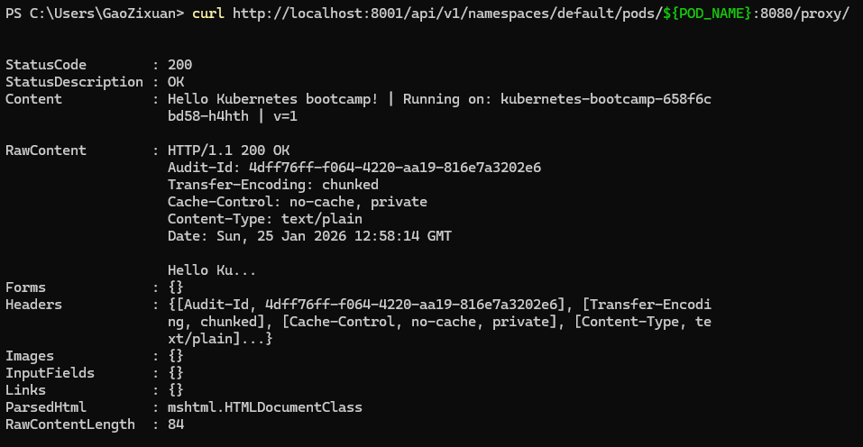

3.4 `kubectl exec -it <pod-name> -- bash` → `curl localhost:8080` (This allows you to access the application from within the container.) Recommended: Execute `curl` (or `cat /app.js`) after entering the container to verify a successful response
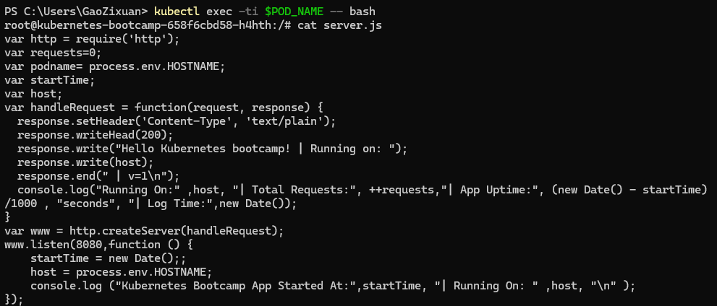

3.5 Using `kubectl proxy` and `curl`, you can access the application through the proxy at `localhost:8001`

4. Exposed Services (Basics - Expose)

4.1 kubectl expose deployment kubernetes-bootcamp --type=NodePort --port=8080service created command successful

4.2 run `kubectl get svc`, see the `kubernetes-bootcamp` service + NodePort.

4.3 Detailed port mappings
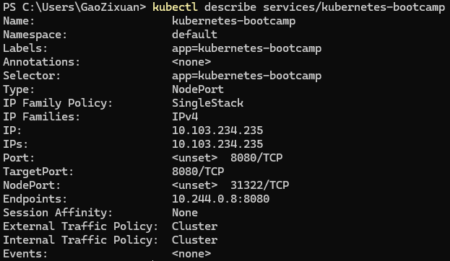

4.4 Export NODE_PORT=... Then, `curl http://$(minikube ip):$NODE_PORT` successfully returns the application response
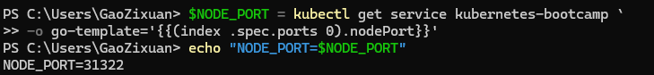
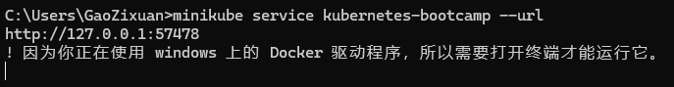
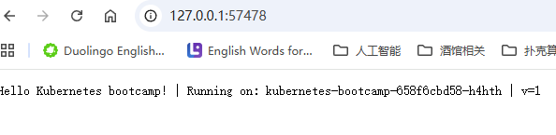

4.5 Finally, the service was deleted using `kubectl delete svc kubernetes-bootcamp`. The service was removed, and the `curl` command failed

5. Horizontal Scaling (Basics - Scale)

5.1 `kubectl get deployments` Initial state: 1/1
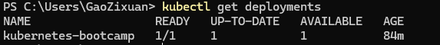

5.2 `kubectl scale deployment kubernetes-bootcamp --replicas=4` Scale command executed successfully

5.3 `kubectl get deployments` READY becomes 4/4 Important: After scaling, READY is 4/4
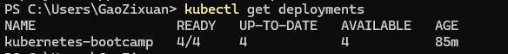

5.4 `kubectl get pods -o wide` Shows 4 different Pods + IPs
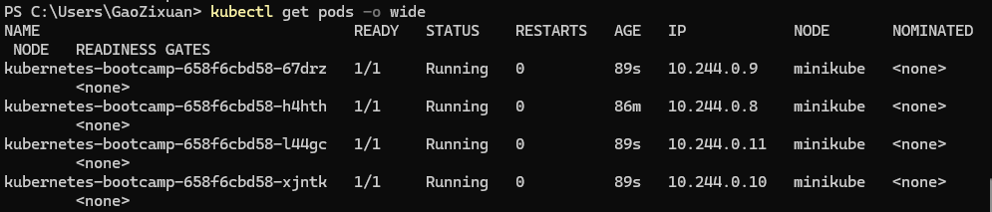

5.5 Scale back down: `kubectl scale deployment kubernetes-bootcamp --replicas=2` Scaling down successful
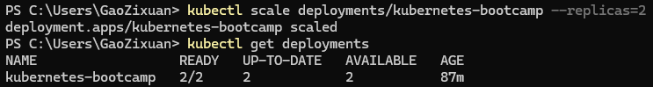

6. Rolling Updates and Rollbacks (Basics - Update)

6.1 `kubectl set image deployment/kubernetes-bootcamp kubernetes-bootcamp=jocatalin/kubernetes-bootcamp:v2` command executed successfully

6.2 `kubectl rollout status deployment/kubernetes-bootcamp` shows "deployment '...' successfully rolled out". The rollout status eventually shows "successful"

6.3 `kubectl get pods`: Old Pods gradually disappear, and new Pods (v2) appear
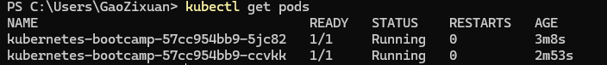

6.4 `kubectl describe pods`: Confirm that the Image has changed to v2. The Image field in the describe output shows v2
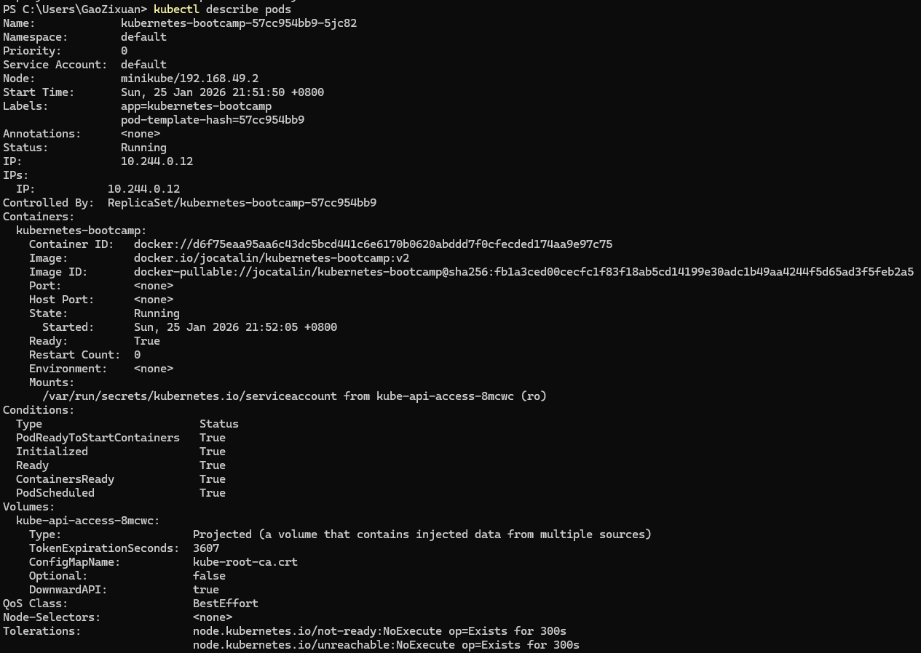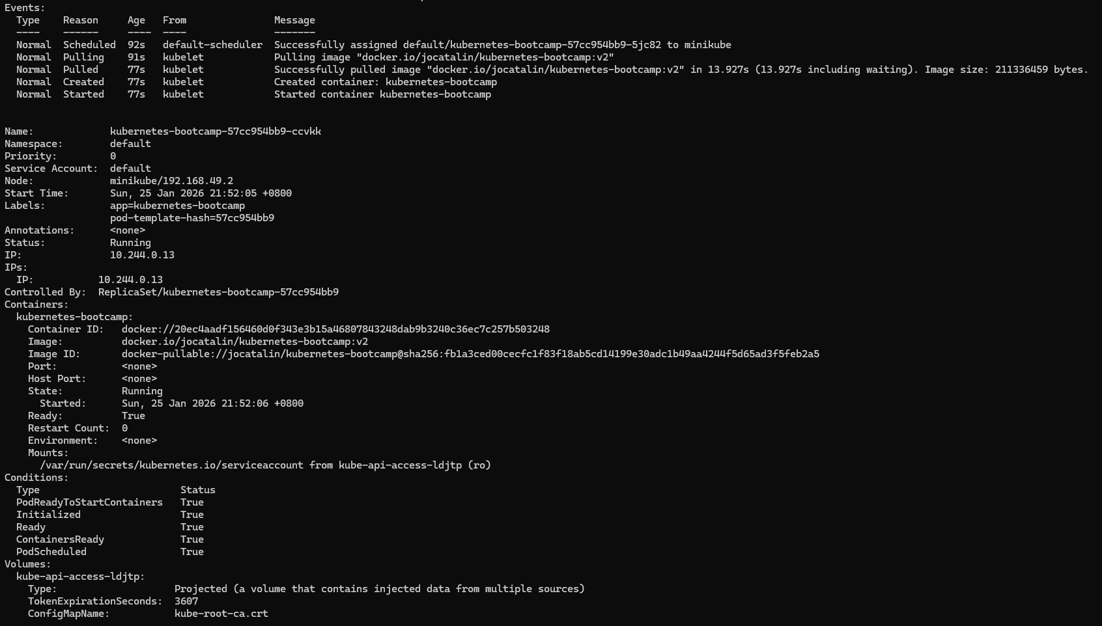
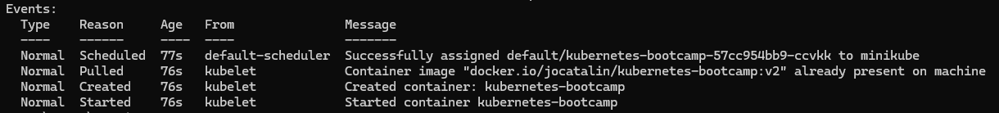

6.5 Try a non-existent version like v10 → Observe the rollout status getting stuck

6.6 `kubectl rollout undo deployment/kubernetes-bootcamp`: Rollback to v1

