What is a container?
https://docs.docker.com/get-started/docker-concepts/the-basics/what-is-a-container/

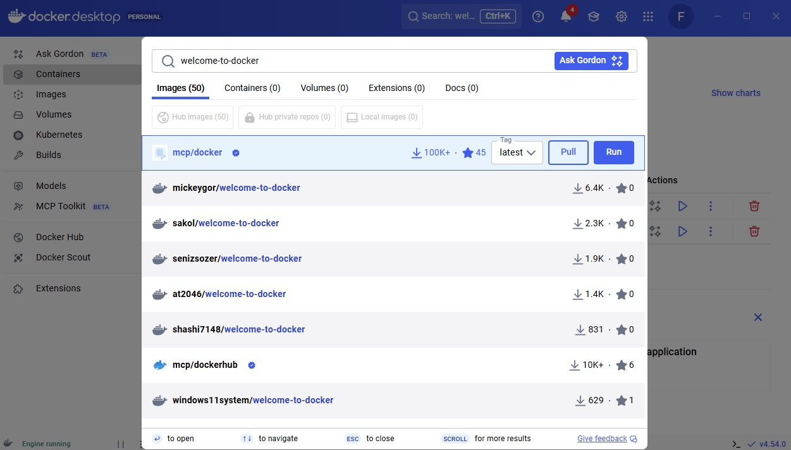
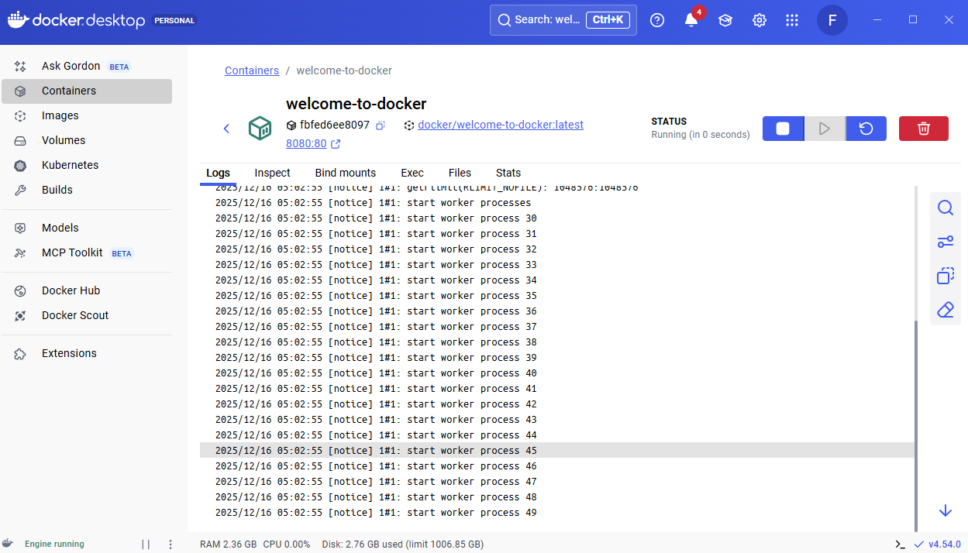

What is an image?
https://docs.docker.com/get-started/docker-concepts/the-basics/what-is-an-image/

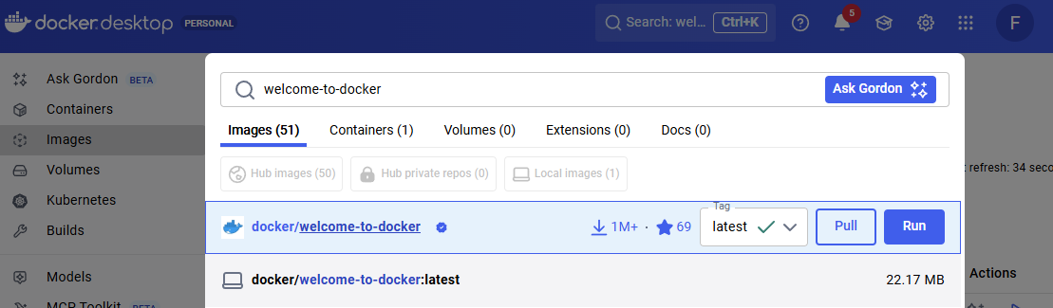


What is Docker Compose?
https://docs.docker.com/get-started/docker-concepts/the-basics/what-is-docker-compose/
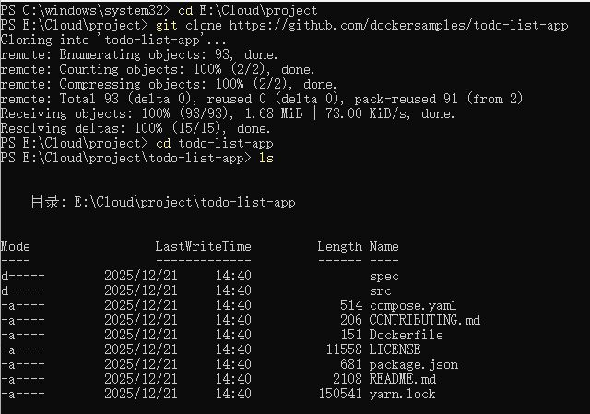
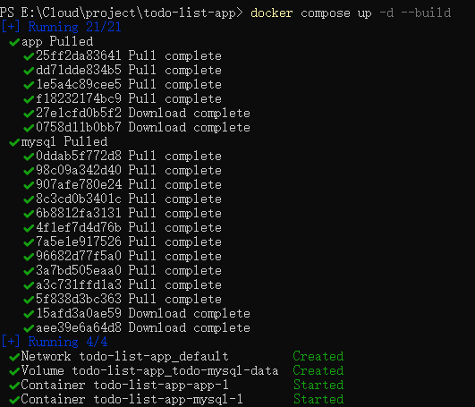
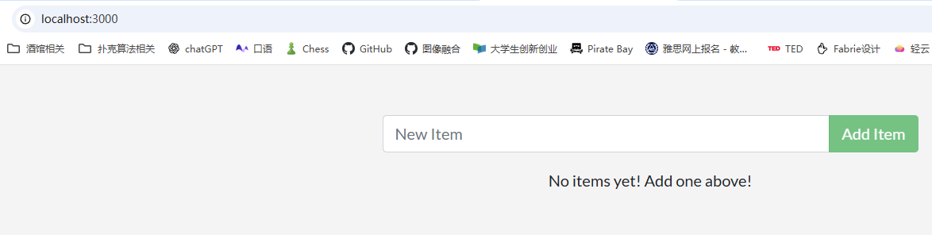

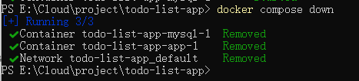

Publishing and exposing ports
https://docs.docker.com/get-started/docker-concepts/running-containers/publishing-ports/

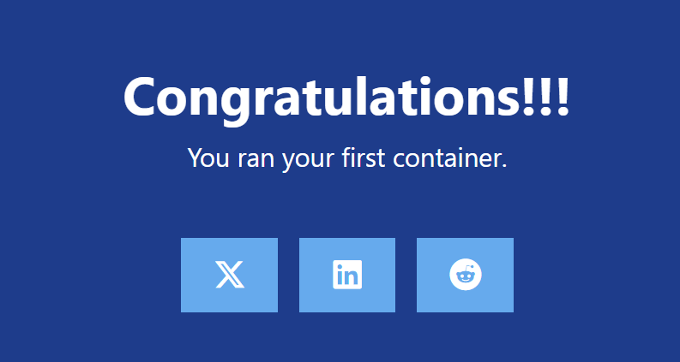
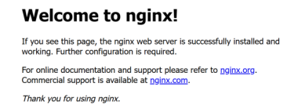

Overriding container defaults
https://docs.docker.com/get-started/docker-concepts/running-containers/overriding-container-defaults/
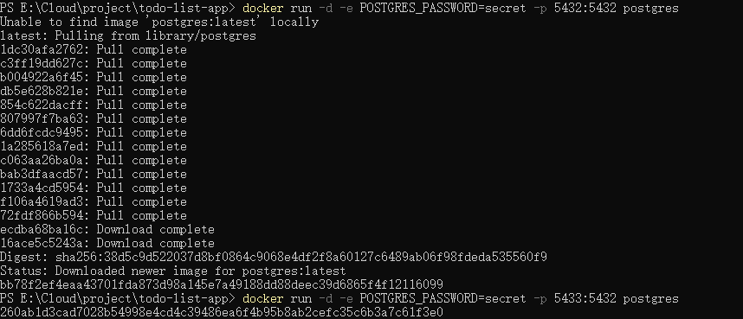
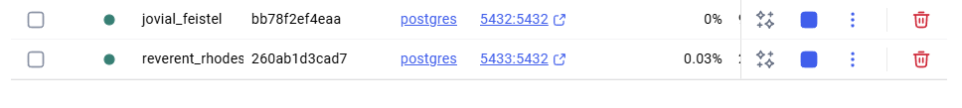
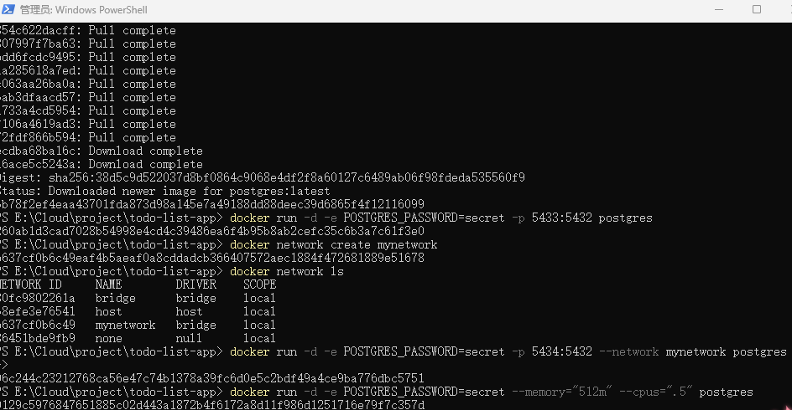

Persisting container data
https://docs.docker.com/get-started/docker-concepts/running-containers/persisting-container-data/
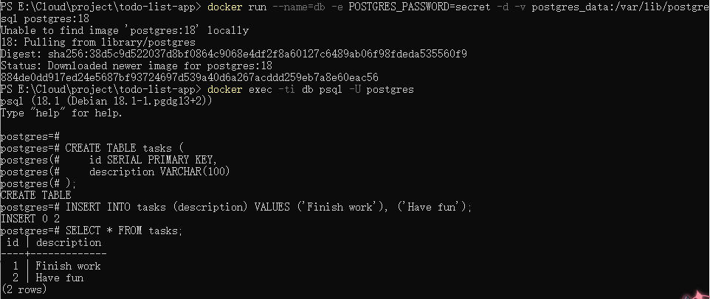
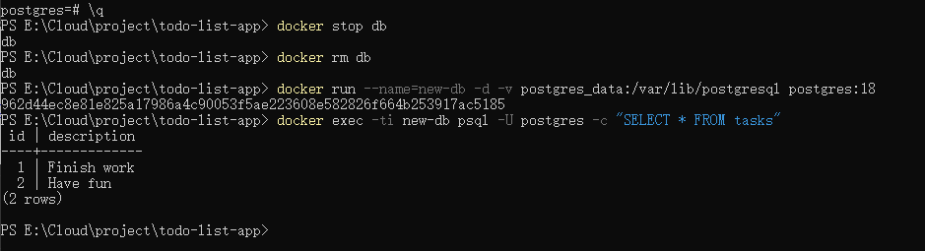

Sharing local files with containers
https://docs.docker.com/get-started/docker-concepts/running-containers/sharing-local-files/
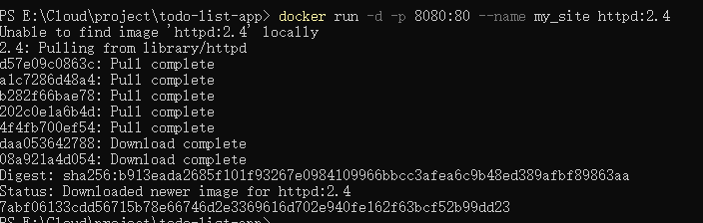
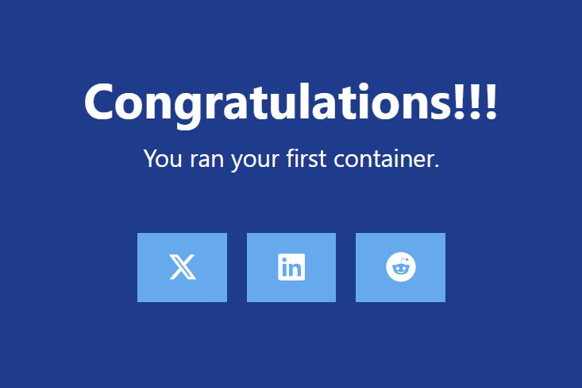
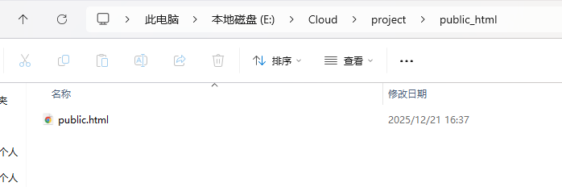
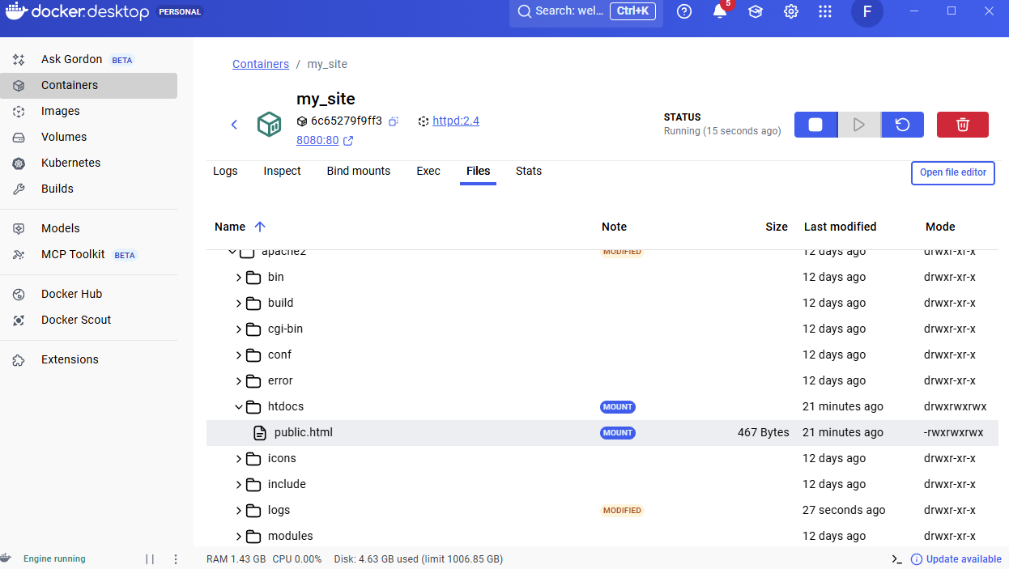、
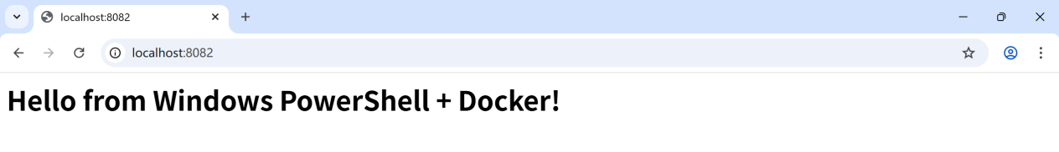

Multi-container applications
https://docs.docker.com/get-started/docker-concepts/running-containers/multi-container-applications/

