Assignment 2
By Abhishek Sharma

Task 1
#importing important libraries
from google.colab import files
uploaded = files.upload() # Choose the file manually
import numpy as np
import cv2
import matplotlib.pylab as plt

img=cv2.imread('computer.jpg')
img2=cv2.imread('computer.jpg')
img=cv2.cvtColor(img,cv2.COLOR_BGR2RGB)
plt.imshow(img)
plt.axis('off')
plt.title("original image")
plt.show()

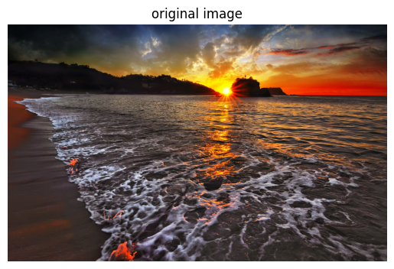
def show_hsv_channels(image):
hsv = cv2.cvtColor(image, cv2.COLOR_RGB2HSV)
h, s, v = cv2.split(hsv)
titles = ['Hue', 'Saturation', 'Value']
images = [h, s, v]
plt.figure(figsize=(10, 3))
for i in range(3):
plt.subplot(1, 3, i + 1)
plt.imshow(images[i], cmap='gray')
plt.title(titles[i])
plt.axis('off')
plt.suptitle("HSV Channels")
plt.show()
show_hsv_channels(img)

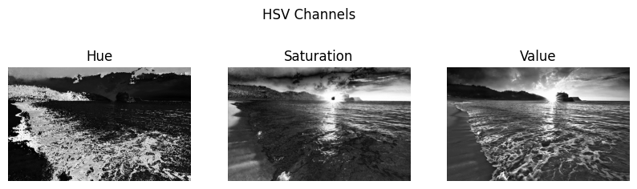
def show_histogram_equalization(image):
gray = cv2.cvtColor(image, cv2.COLOR_RGB2GRAY)
equalized = cv2.equalizeHist(gray)
plt.figure(figsize=(8, 4))
plt.subplot(1, 2, 1)
plt.imshow(gray, cmap='gray')
plt.title('Original Grayscale')
plt.axis('off')

plt.subplot(1, 2, 2)
plt.imshow(equalized, cmap='gray')
plt.title('Histogram Equalized')
plt.axis('off')
plt.suptitle("Histogram Equalization")
plt.show()
show_histogram_equalization(img)

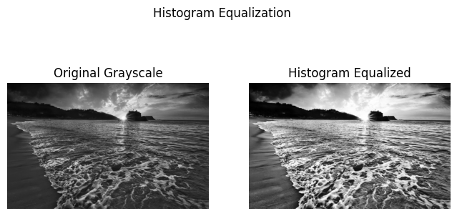
def show_binary_inversion(image, threshold=128):
gray = cv2.cvtColor(image, cv2.COLOR_RGB2GRAY)
_, binary = cv2.threshold(gray, threshold, 255, cv2.THRESH_BINARY_INV)

plt.imshow(binary, cmap='gray')
plt.title("Binary Inversion Thresholding")
plt.axis('off')
plt.show()
show_binary_inversion(img)

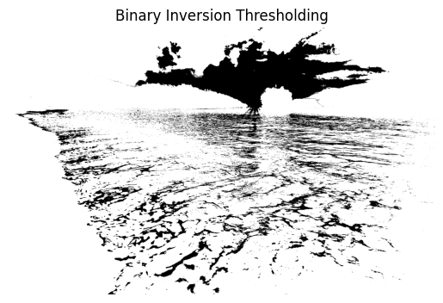
def show_posterized_image(image):
gray = cv2.cvtColor(image, cv2.COLOR_RGB2GRAY)
posterized = (gray // 64) * 64

plt.imshow(posterized, cmap='gray')
plt.title("4 Gray Intensity Levels")
plt.axis('off')
plt.show()
show_posterized_image(img)

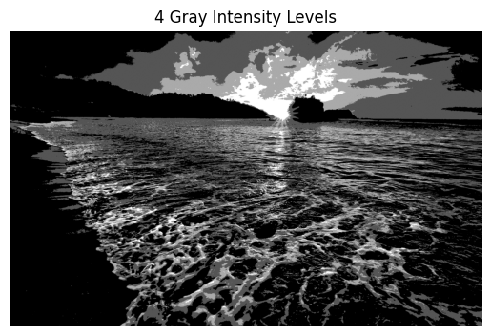

def show_laplacian_scharr(image):
gray = cv2.cvtColor(image, cv2.COLOR_RGB2GRAY)
lap = cv2.Laplacian(gray, cv2.CV_64F)
scharr = cv2.Scharr(gray, cv2.CV_64F, 1, 0) + cv2.Scharr(gray, cv2.CV_64F, 0, 1)

plt.figure(figsize=(8, 4))
plt.subplot(1, 2, 1)
plt.imshow(np.uint8(np.absolute(lap)), cmap='gray')
plt.title("Laplacian")
plt.axis('off')

plt.subplot(1, 2, 2)
plt.imshow(np.uint8(np.absolute(scharr)), cmap='gray')
plt.title("Scharr")
plt.axis('off')
plt.suptitle("Edge Detection")
plt.show()
show_laplacian_scharr(img2)

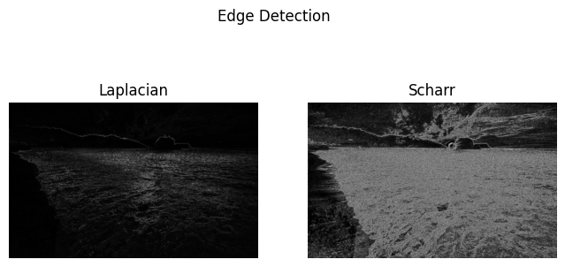

Task 2

Set up YOLOv5 environment

Apply the following steps:
Run the following commands in terminal
Step1- git clone https://github.com/ultralytics/yolov5
Step2- cd yolov5
Step3- python -m venv yolov5env
Step4- yolov5env\Scripts\activate
step5 -pip install -r requirements.txt
Step6- Upload the image to train the model on the that
python detect.py --source data/images.jpg --weights yolov5s.pt

Here are some original images and images after detection

Original Image
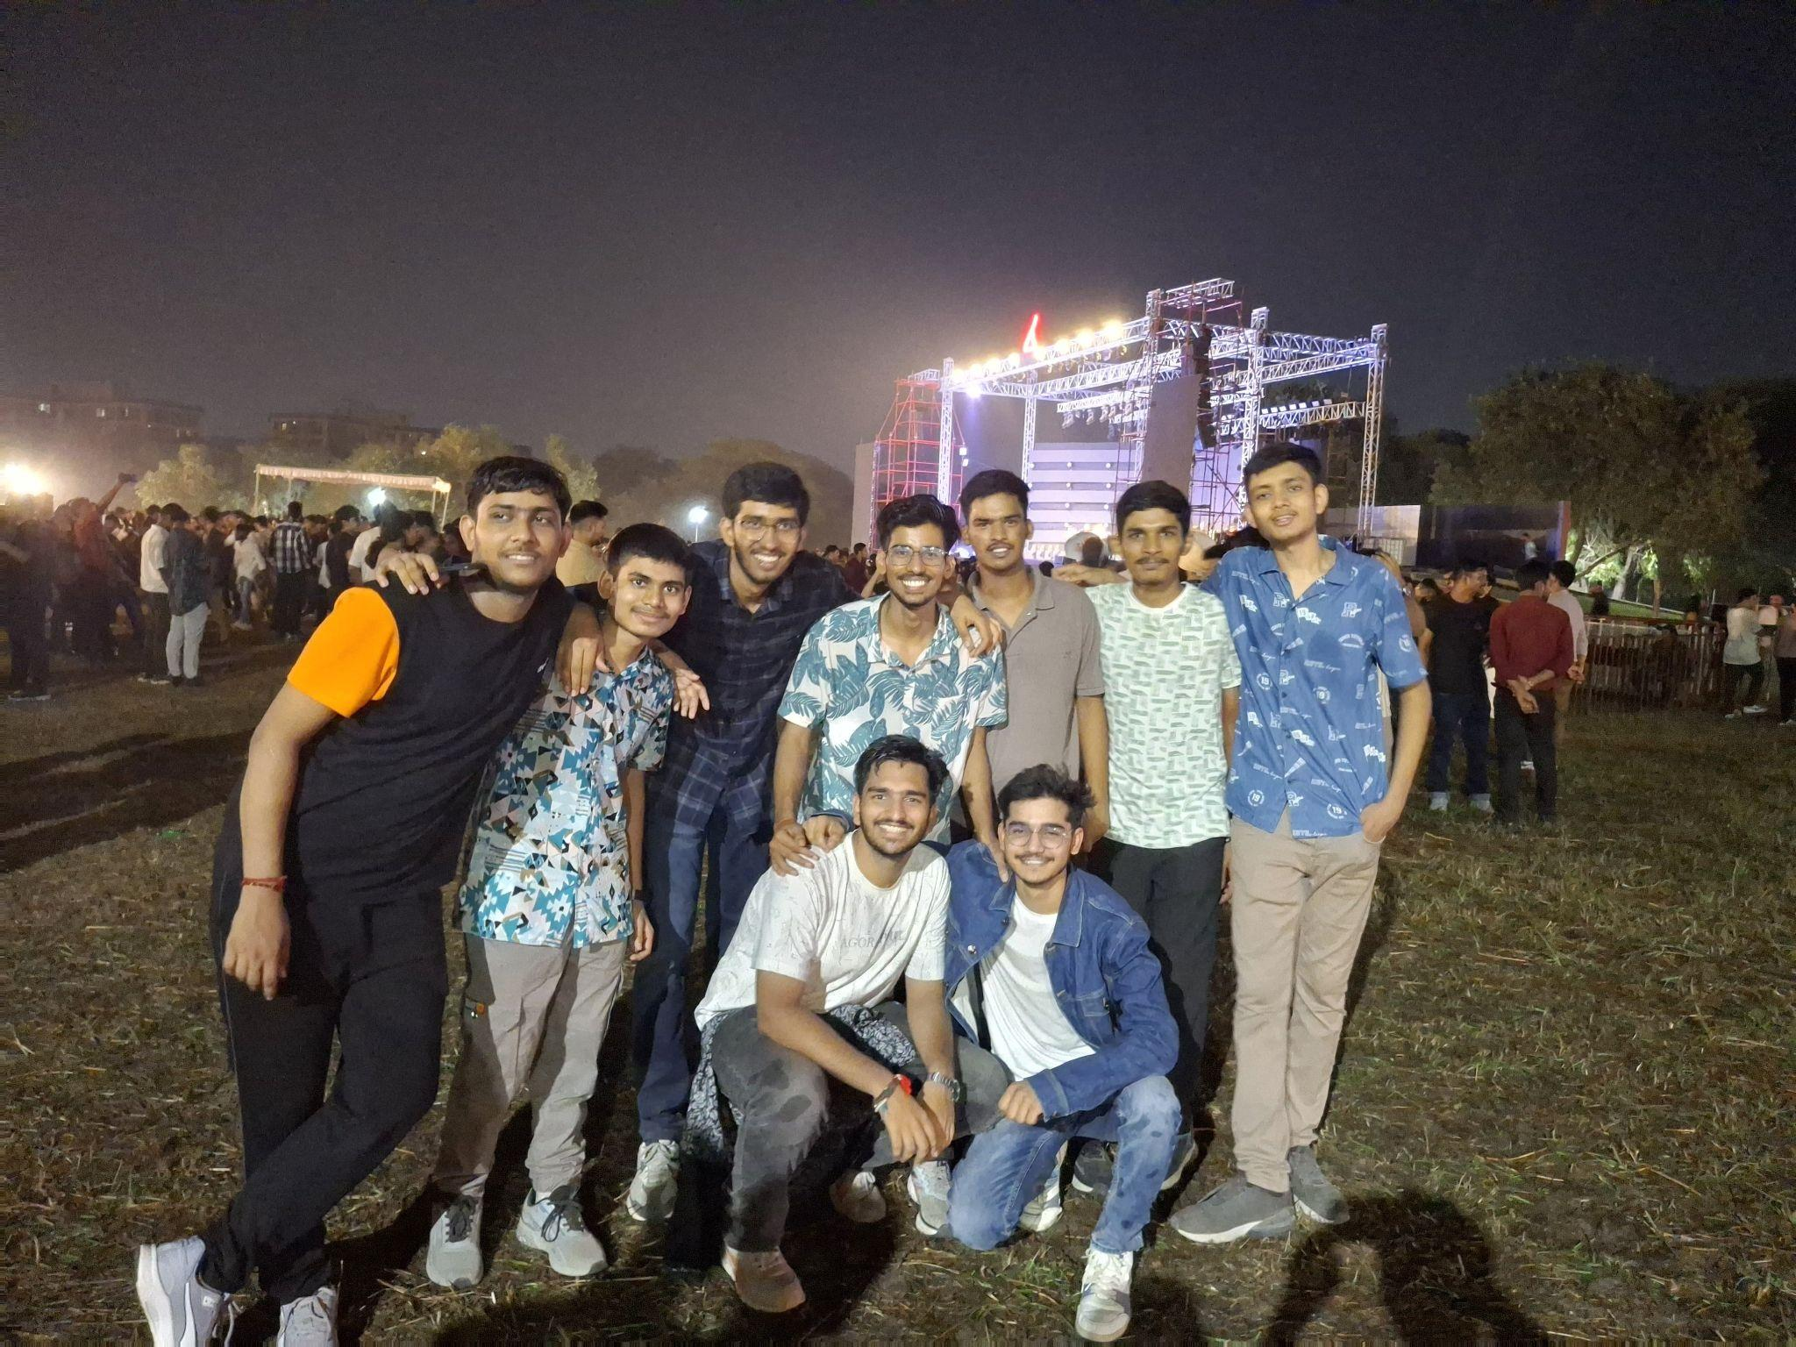

Image after applying model
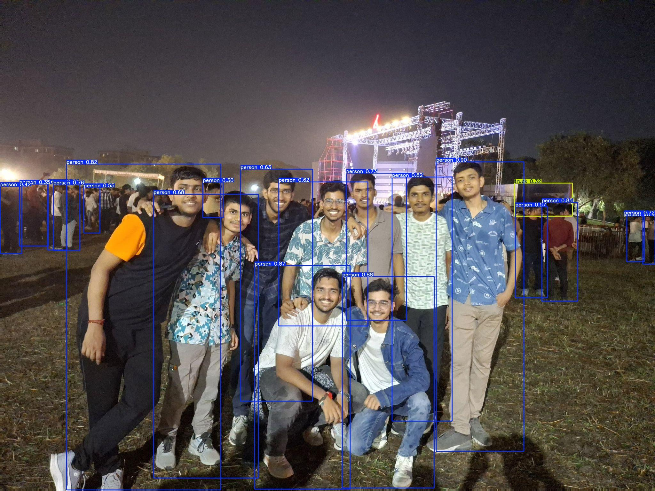

Original image 2
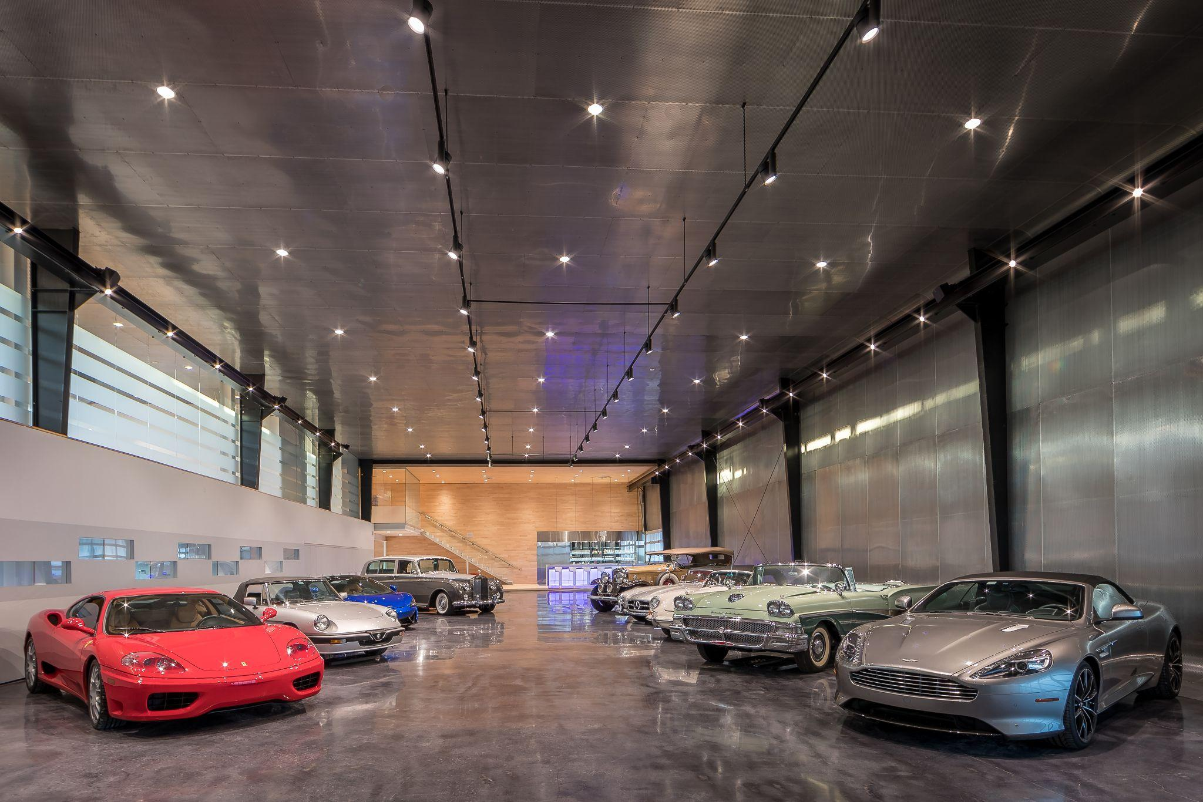

Image after applying model
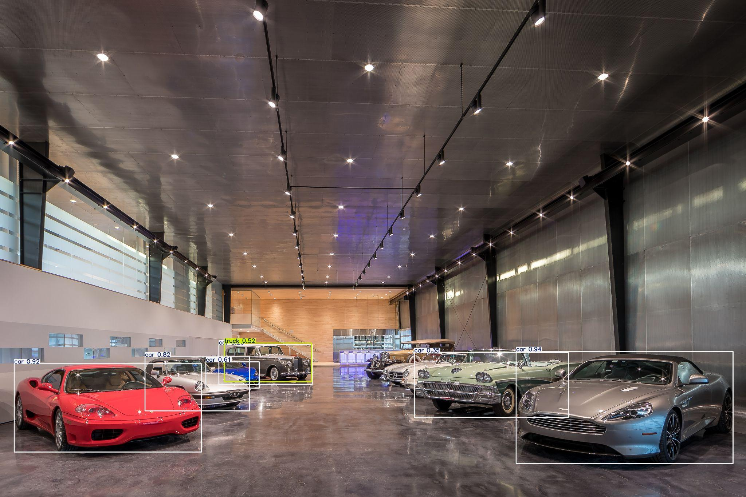
Task 3
Creating a yolo model to detect the poland and indonesia national flag
Follow the instruction given in the video linked in the assignment to create the model using yolo

- Results

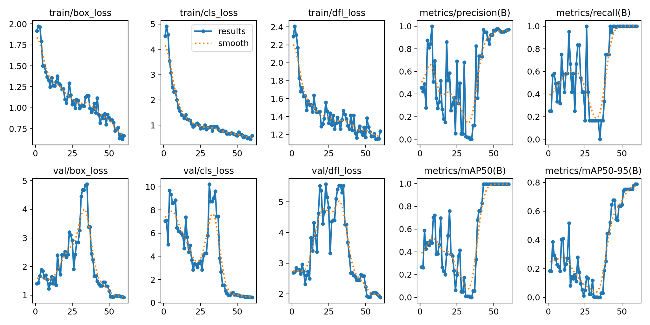
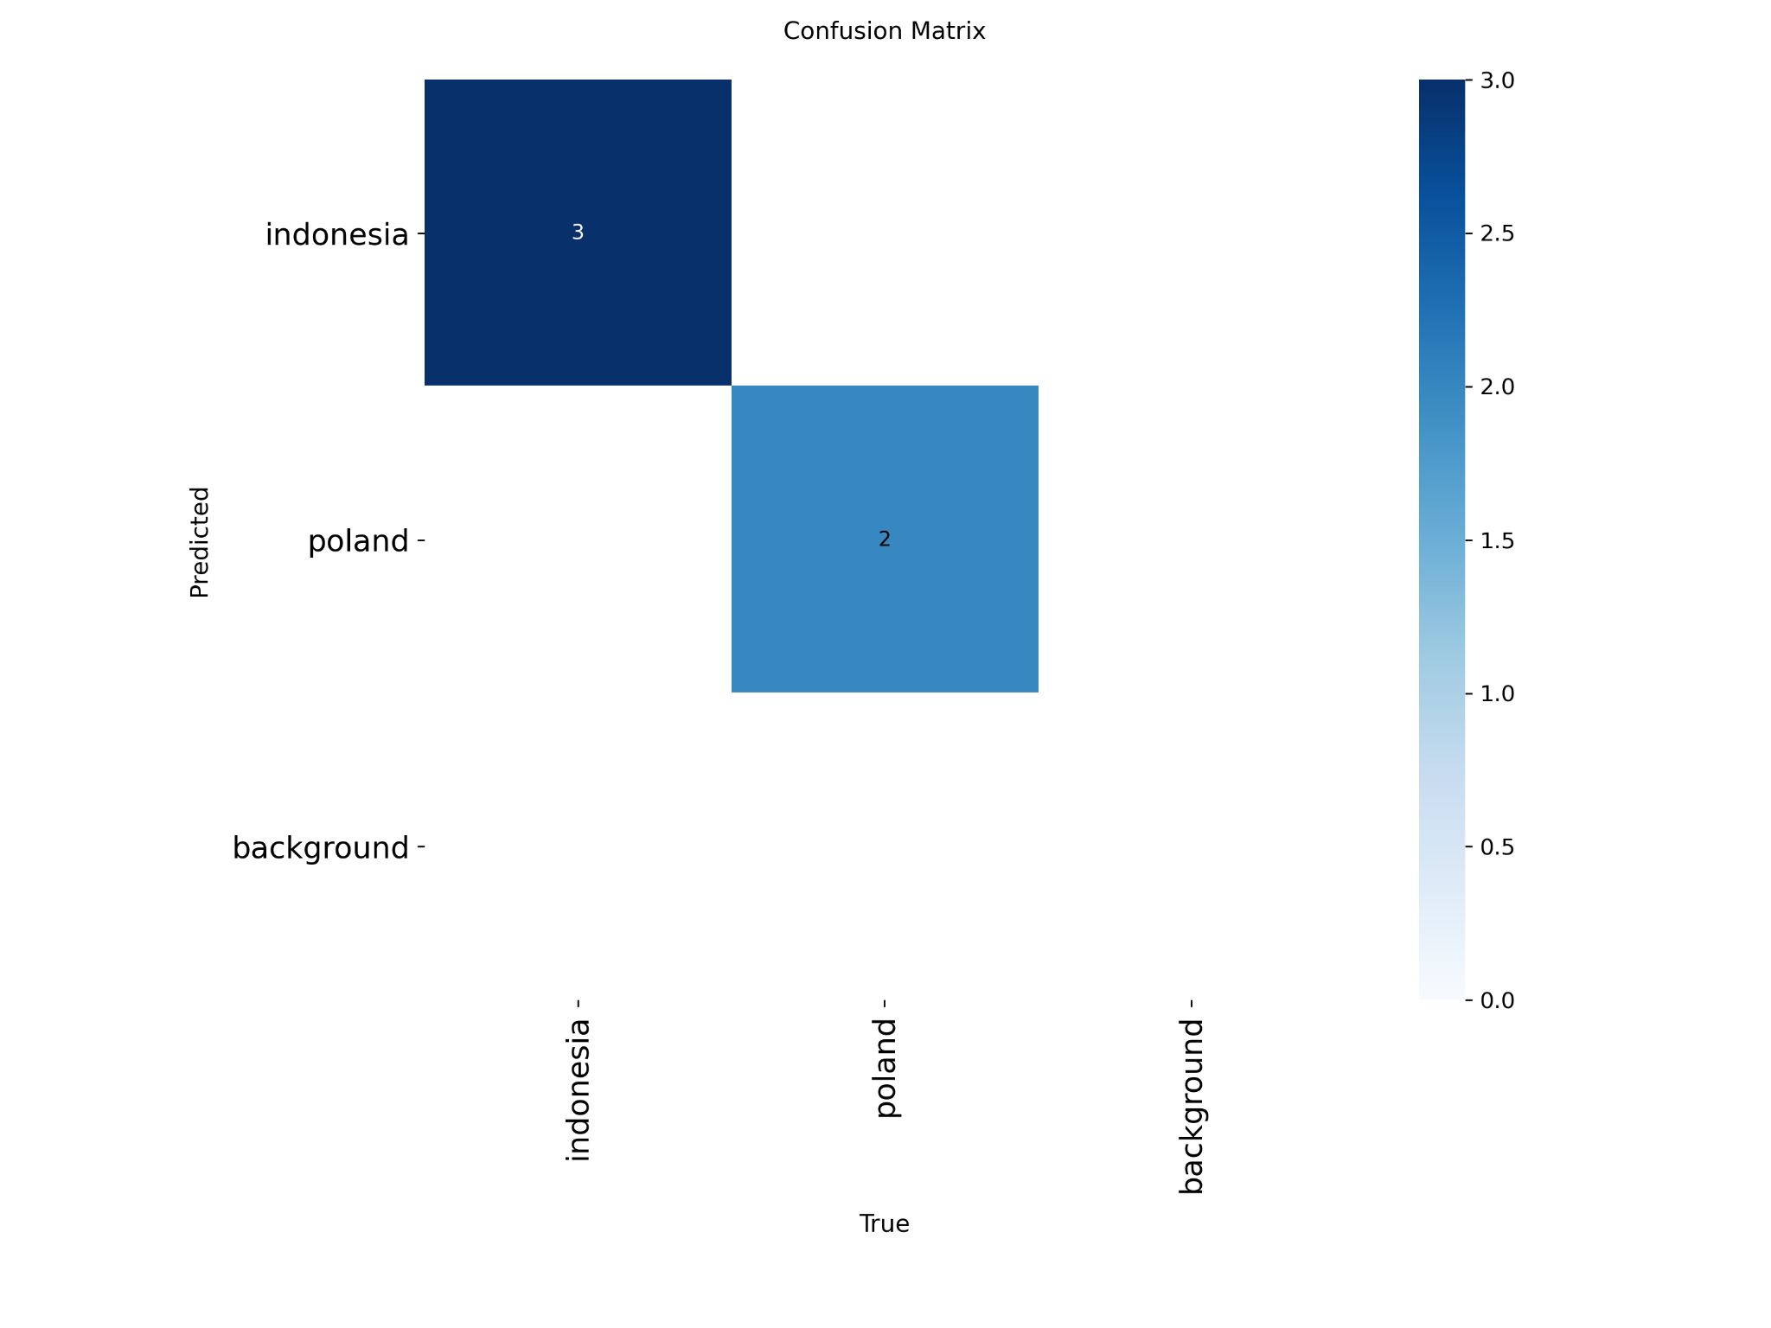

Some training datasets

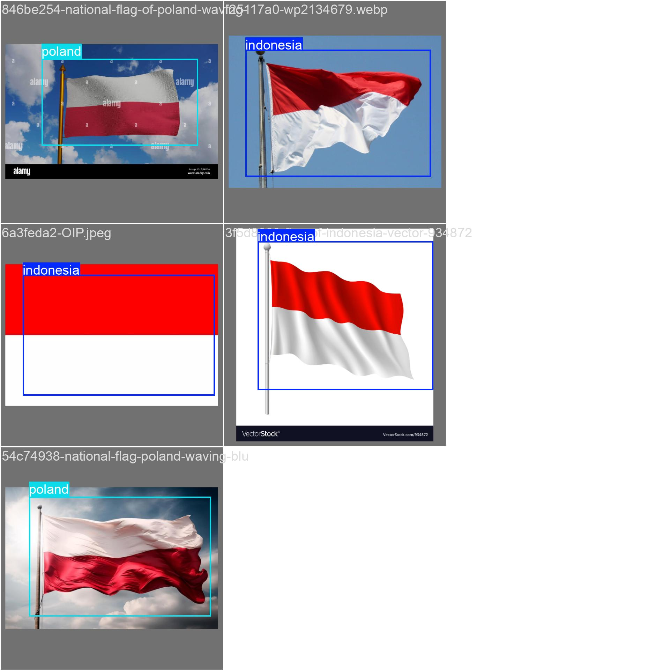

Some testing datasets

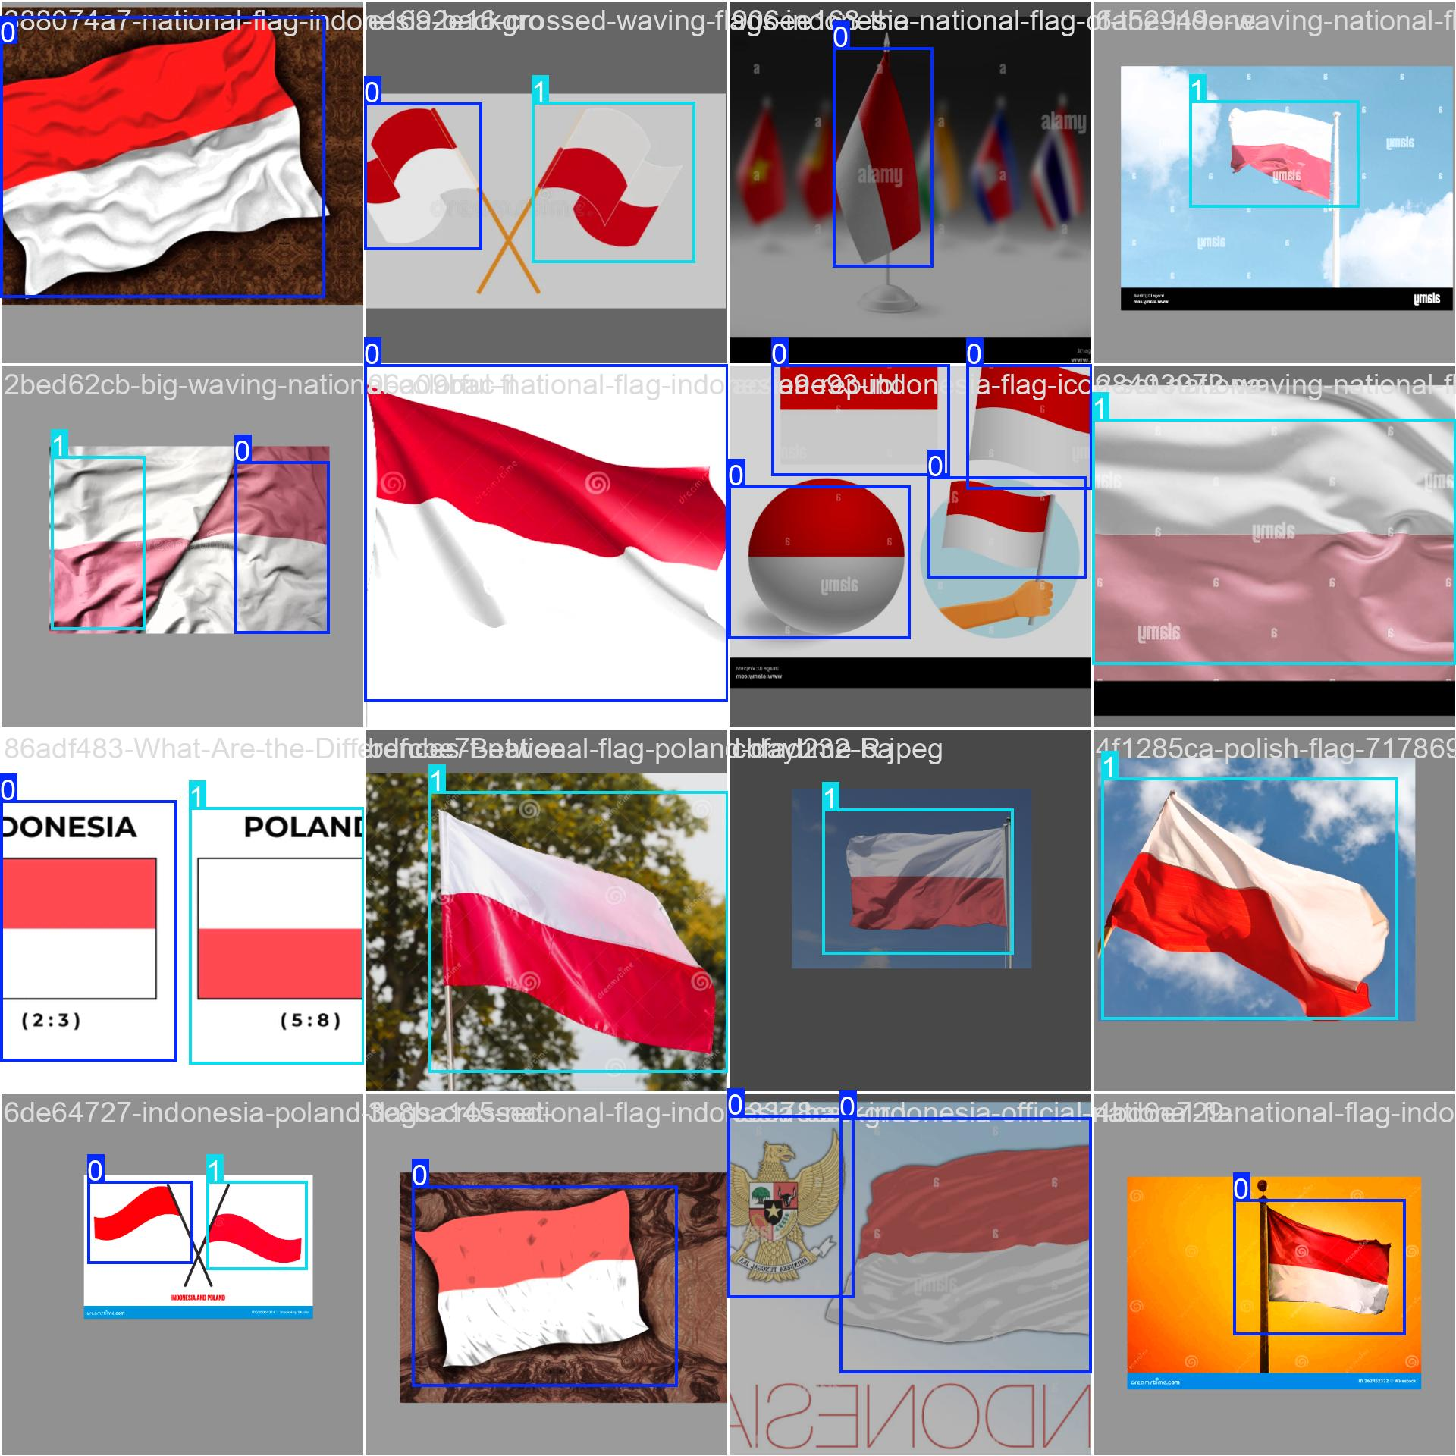

Task 4
Summary of YOLOv5 research paper
This research paper presents a detailed analysis of YOLOv5, a state-of-the-art object detection model developed by Ultralytics. YOLOv5 stands out for its speed, accuracy, and efficiency, making it a preferred choice for real-time and resource-constrained applications like edge computing and IoT.

1. Objective of the Study
The main goal of the study is to:
- Examine YOLOv5’s internal architecture, training methods, and evolution.
- Compare its performance to other object detection models.
- Analyze the trade-offs between model size, accuracy, and speed among its variants (n, s, m, l, x).
- Highlight YOLOv5's transition from the Darknet framework to PyTorch, and how it has improved usability, flexibility, and development.

2. Architecture Overview
YOLOv5 follows the traditional YOLO architecture with three main components:
- Backbone: Extracts features from the image using CSP (Cross Stage Partial) networks.
- Neck: Uses PANet for feature fusion at different scales.
- Head: Generates final predictions for object bounding boxes and classes.
This design allows the model to detect small, medium, and large objects effectively in real-time.

3. Training Techniques
Two key training methodologies are emphasized:
- Data Augmentation: Including mosaic augmentation, which stitches four images into one to improve detection of small or rare objects.
- Loss Function: A combination of classification, objectness, and localization losses using Binary Cross-Entropy and Complete IoU (CIoU).
These techniques enhance generalization, especially in real-world conditions.

4. PyTorch Transition
Shifting from the Darknet (C-based) to PyTorch allowed:
- Easier integration of new features.
- More user-friendly training and deployment.
- Support for modern development tools and hardware acceleration.

5. Supporting Tools and Formats
YOLOv5 supports:
- A simple TXT annotation format with YAML config files.
- Popular labeling tools like Roboflow, LabelImg, CVAT, with easy format conversion.
- Integration with platforms like Weights & Biases, ClearML, and Deci for tracking, deployment, and optimization.

6. Innovations and Impact
The paper highlights the following YOLOv5 innovations:
- CSP Backbone: Reduces redundancy and improves training efficiency.
- PA-Net Neck: Better feature aggregation.
- 16-bit precision: Faster inference on supported GPUs.
- Flexible model variants: Support various use cases.
These make YOLOv5 one of the most efficient and adaptable models for real-time object detection.

Conclusion
YOLOv5 is not just an improvement in object detection but also a significant step forward in model accessibility and usability. Its PyTorch implementation, modular design, and scalable architecture make it suitable for a wide range of real-world applications—from smart manufacturing to renewable energy monitoring.
By combining speed, accuracy, and ease of deployment, YOLOv5 sets a high benchmark for modern object detection systems.

