Use Case Specification Report

**Use Case Specification**

Code Foundation - Requisitos del proyecto

Revision: 0.2

abril 17, 2018

Approval

|  |
| --- |
| The original of this document is approved and signed by:  Name:  Surname:  Title:  Date:  Signature: |

Revision History

|  |  |  |  |
| --- | --- | --- | --- |
| **Revision** | **Date** | **Description** | **Author** |
| 0.1 | <date 1> | <draft> | <Author name> |
| 0.2 | <date 2> | <release> | <Author name> |

Table of Contents

Microsoft Word users please click here and press F9 to create Table of Contents.

OpenOffice.org users please remove this text and select Insert Table of Content from menu.

Index of Use-Cases

|  |  |
| --- | --- |
| **UseCase** | **Page** |
| Aceptar préstamo | Error! Bookmark not defined. |
| Almacenar Información | Error! Bookmark not defined. |
| Aviso de estado deficiente | Error! Bookmark not defined. |
| Comentario de libro | Error! Bookmark not defined. |
| Crear Cuenta | Error! Bookmark not defined. |
| Describir estado de un libro | Error! Bookmark not defined. |
| Devolver libro | Error! Bookmark not defined. |
| Eliminar cuenta | Error! Bookmark not defined. |
| Eliminar libro | Error! Bookmark not defined. |
| Enviar mensaje | Error! Bookmark not defined. |
| Ingresar Cuenta | Error! Bookmark not defined. |
| Insertar Contraseña | Error! Bookmark not defined. |
| Insertar Correo | Error! Bookmark not defined. |
| Introducir libro | Error! Bookmark not defined. |
| Modificar Cuenta | Error! Bookmark not defined. |
| Modificar libro | Error! Bookmark not defined. |
| Mostrar información | Error! Bookmark not defined. |
| Pedir datos personales | Error! Bookmark not defined. |
| Puntuar libro | Error! Bookmark not defined. |
| Realizar búsqueda | Error! Bookmark not defined. |
| Seleccionable de estado | Error! Bookmark not defined. |
| Solicitar libro | Error! Bookmark not defined. |
| Valorar libro | Error! Bookmark not defined. |
| Valorar Usuario | Error! Bookmark not defined. |
| Verificar Cuenta | Error! Bookmark not defined. |

# Introduction

## Purpose

<This Document describes Use Case Specification Report.>

## Scope

<This Document intends to describe use case specification for the system.>

## Overview

<Describe what the document contains and explain how the document is organized.>

# Actor Summary

|  |  |
| --- | --- |
| **Primary Actor** | **Use Cases** |
|  |  |
|  |  |
| Administrador | * Administrar libro      * Administrar libro      * Aviso de estado deficiente |
| Correo | * Comprobar Correo |
| Sistema | * Almacenar Información      * Almacenar Información      * Almacenar Información      * Realizar búsqueda      * Verificar Cuenta |
| Usuario | * Aceptar préstamo      * Búsqueda libro      * Comprobar Correo      * Crear Cuenta      * Crear Cuenta      * Describir estado de un libro      * Devolución de un libro      * Devolver libro      * Eliminar cuenta      * Enviar mensaje      * Enviar mensaje      * Ingresar Cuenta      * Ingresar Cuenta      * Introducir libro      * Introducir libro      * Modificar Cuenta      * Modificar libro      * Mostrar información      * Mostrar información      * Pedir datos personales      * Realizar búsqueda      * Solicitar libro      * Solicitar libro      * Valorar libro      * Valorar libro      * Valorar Usuario      * Valorar Usuario |
| Usuario2 | * Aceptar préstamo      * Aceptar préstamo      * Devolver libro      * Enviar mensaje      * Enviar mensaje      * Mostrar información      * Mostrar información      * Pedir datos personales      * Solicitar libro      * Valorar Usuario |

# Use Case: Libro Diagram

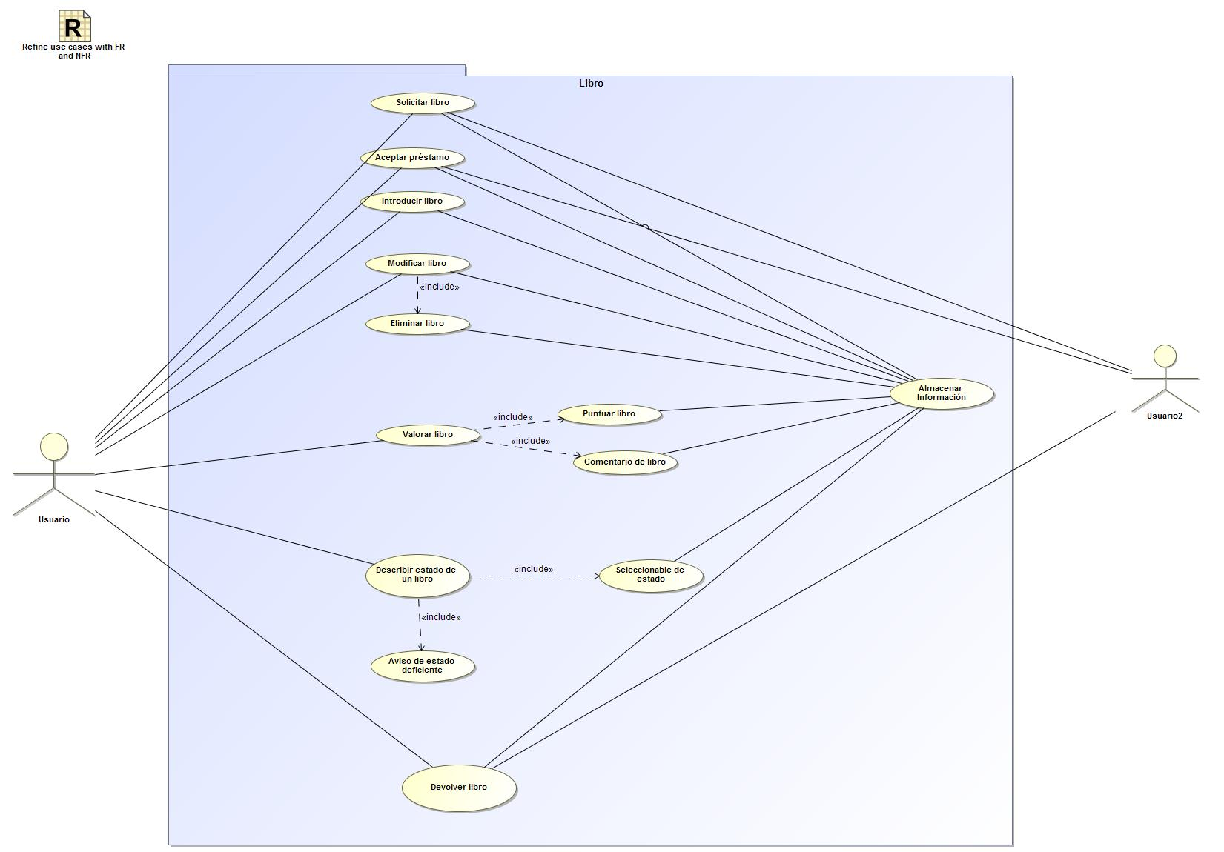

## Aceptar préstamo Use Case

|  |  |  |  |
| --- | --- | --- | --- |
| **Use Case Name** | Aceptar préstamo | ID |  |
| **Complexity** | Average Complexity | | |
| **Description** |  | | |
| **Actors** | * Usuario * Usuario2 | | |
| **Goal** |  | | |
| **Assumption** |  | | |
| **Non Functional Requirements** |  | | |
| **Pre Condition** |  | | |
| **Post Condition** |  | | |
| **Constraints** |  | | |

|  |  |
| --- | --- |
| **Relations** | |
| **Association** | * Almacenar Información UseCase * Usuario Actor * Usuario2 Actor |
| **Include** |  |
| **Extend** |  |
| **Generalization** |  |

|  |  |
| --- | --- |
| **Scenarios** | |
| **Basic Flow of Events** |  |
| **Basic Flow of Events Diagrams** |  |
| **Alternative Flow of Events** |  |
| **Alternative Flow of Events Diagrams** |  |
| **Exceptional Flow of Events** |  |
| **Exceptional Flow of Events Diagrams** |  |

## Almacenar Información Use Case

|  |  |  |  |
| --- | --- | --- | --- |
| **Use Case Name** | Almacenar Información | ID |  |
| **Complexity** | Average Complexity | | |
| **Description** |  | | |
| **Actors** | * Sistema | | |
| **Goal** |  | | |
| **Assumption** |  | | |
| **Non Functional Requirements** |  | | |
| **Pre Condition** |  | | |
| **Post Condition** |  | | |
| **Constraints** |  | | |

|  |  |
| --- | --- |
| **Relations** | |
| **Association** | * Aceptar préstamo UseCase * Apellidos UseCase * Ciudad UseCase * Comentario de libro UseCase * Contraseña UseCase * Correo UseCase * Código Postal UseCase * Devolución de un libro UseCase * Devolver libro UseCase * Dirección UseCase * DNI UseCase * Eliminar libro UseCase * Introducir libro UseCase * Localidad UseCase * Modificar libro UseCase * Nombre UseCase * Puntuar libro UseCase * Seleccionable de estado UseCase * Sistema Actor * Solicitar libro UseCase * Telefono UseCase |
| **Include** |  |
| **Extend** |  |
| **Generalization** |  |

|  |  |
| --- | --- |
| **Scenarios** | |
| **Basic Flow of Events** |  |
| **Basic Flow of Events Diagrams** |  |
| **Alternative Flow of Events** |  |
| **Alternative Flow of Events Diagrams** |  |
| **Exceptional Flow of Events** |  |
| **Exceptional Flow of Events Diagrams** |  |

## Aviso de estado deficiente Use Case

|  |  |  |  |
| --- | --- | --- | --- |
| **Use Case Name** | Aviso de estado deficiente | ID |  |
| **Complexity** | Average Complexity | | |
| **Description** |  | | |
| **Actors** | * Administrador | | |
| **Goal** |  | | |
| **Assumption** |  | | |
| **Non Functional Requirements** |  | | |
| **Pre Condition** |  | | |
| **Post Condition** |  | | |
| **Constraints** |  | | |

|  |  |
| --- | --- |
| **Relations** | |
| **Association** | * Administrador Actor |
| **Include** |  |
| **Extend** | * Seleccionable de estado UseCase |
| **Generalization** |  |

|  |  |
| --- | --- |
| **Scenarios** | |
| **Basic Flow of Events** |  |
| **Basic Flow of Events Diagrams** |  |
| **Alternative Flow of Events** |  |
| **Alternative Flow of Events Diagrams** |  |
| **Exceptional Flow of Events** |  |
| **Exceptional Flow of Events Diagrams** |  |

## Comentario de libro Use Case

|  |  |  |  |
| --- | --- | --- | --- |
| **Use Case Name** | Comentario de libro | ID |  |
| **Complexity** | Average Complexity | | |
| **Description** |  | | |
| **Actors** |  | | |
| **Goal** |  | | |
| **Assumption** |  | | |
| **Non Functional Requirements** |  | | |
| **Pre Condition** |  | | |
| **Post Condition** |  | | |
| **Constraints** |  | | |

|  |  |
| --- | --- |
| **Relations** | |
| **Association** | * Almacenar Información UseCase |
| **Include** |  |
| **Extend** |  |
| **Generalization** |  |

|  |  |
| --- | --- |
| **Scenarios** | |
| **Basic Flow of Events** |  |
| **Basic Flow of Events Diagrams** |  |
| **Alternative Flow of Events** |  |
| **Alternative Flow of Events Diagrams** |  |
| **Exceptional Flow of Events** |  |
| **Exceptional Flow of Events Diagrams** |  |

## Describir estado de un libro Use Case

|  |  |  |  |
| --- | --- | --- | --- |
| **Use Case Name** | Describir estado de un libro | ID |  |
| **Complexity** | Average Complexity | | |
| **Description** |  | | |
| **Actors** | * Usuario | | |
| **Goal** |  | | |
| **Assumption** |  | | |
| **Non Functional Requirements** |  | | |
| **Pre Condition** |  | | |
| **Post Condition** |  | | |
| **Constraints** |  | | |

|  |  |
| --- | --- |
| **Relations** | |
| **Association** | * Usuario Actor |
| **Include** | * Aviso de estado deficiente UseCase * Seleccionable de estado UseCase |
| **Extend** |  |
| **Generalization** |  |

|  |  |
| --- | --- |
| **Scenarios** | |
| **Basic Flow of Events** |  |
| **Basic Flow of Events Diagrams** |  |
| **Alternative Flow of Events** |  |
| **Alternative Flow of Events Diagrams** |  |
| **Exceptional Flow of Events** |  |
| **Exceptional Flow of Events Diagrams** |  |

## Devolver libro Use Case

|  |  |  |  |
| --- | --- | --- | --- |
| **Use Case Name** | Devolver libro | ID |  |
| **Complexity** | Average Complexity | | |
| **Description** |  | | |
| **Actors** | * Usuario * Usuario2 | | |
| **Goal** |  | | |
| **Assumption** |  | | |
| **Non Functional Requirements** |  | | |
| **Pre Condition** |  | | |
| **Post Condition** |  | | |
| **Constraints** |  | | |

|  |  |
| --- | --- |
| **Relations** | |
| **Association** | * Almacenar Información UseCase * Usuario Actor * Usuario2 Actor |
| **Include** |  |
| **Extend** |  |
| **Generalization** |  |

|  |  |
| --- | --- |
| **Scenarios** | |
| **Basic Flow of Events** |  |
| **Basic Flow of Events Diagrams** |  |
| **Alternative Flow of Events** |  |
| **Alternative Flow of Events Diagrams** |  |
| **Exceptional Flow of Events** |  |
| **Exceptional Flow of Events Diagrams** |  |

## Eliminar libro Use Case

|  |  |  |  |
| --- | --- | --- | --- |
| **Use Case Name** | Eliminar libro | ID |  |
| **Complexity** | Average Complexity | | |
| **Description** |  | | |
| **Actors** |  | | |
| **Goal** |  | | |
| **Assumption** |  | | |
| **Non Functional Requirements** |  | | |
| **Pre Condition** |  | | |
| **Post Condition** |  | | |
| **Constraints** |  | | |

|  |  |
| --- | --- |
| **Relations** | |
| **Association** | * Almacenar Información UseCase |
| **Include** |  |
| **Extend** |  |
| **Generalization** |  |

|  |  |
| --- | --- |
| **Scenarios** | |
| **Basic Flow of Events** |  |
| **Basic Flow of Events Diagrams** |  |
| **Alternative Flow of Events** |  |
| **Alternative Flow of Events Diagrams** |  |
| **Exceptional Flow of Events** |  |
| **Exceptional Flow of Events Diagrams** |  |

## Introducir libro Use Case

|  |  |  |  |
| --- | --- | --- | --- |
| **Use Case Name** | Introducir libro | ID |  |
| **Complexity** | Average Complexity | | |
| **Description** |  | | |
| **Actors** | * Usuario | | |
| **Goal** |  | | |
| **Assumption** |  | | |
| **Non Functional Requirements** |  | | |
| **Pre Condition** |  | | |
| **Post Condition** |  | | |
| **Constraints** |  | | |

|  |  |
| --- | --- |
| **Relations** | |
| **Association** | * Almacenar Información UseCase * Usuario Actor |
| **Include** |  |
| **Extend** |  |
| **Generalization** |  |

|  |  |
| --- | --- |
| **Scenarios** | |
| **Basic Flow of Events** |  |
| **Basic Flow of Events Diagrams** |  |
| **Alternative Flow of Events** |  |
| **Alternative Flow of Events Diagrams** |  |
| **Exceptional Flow of Events** |  |
| **Exceptional Flow of Events Diagrams** |  |

## Modificar libro Use Case

|  |  |  |  |
| --- | --- | --- | --- |
| **Use Case Name** | Modificar libro | ID |  |
| **Complexity** | Average Complexity | | |
| **Description** |  | | |
| **Actors** | * Usuario | | |
| **Goal** |  | | |
| **Assumption** |  | | |
| **Non Functional Requirements** |  | | |
| **Pre Condition** |  | | |
| **Post Condition** |  | | |
| **Constraints** |  | | |

|  |  |
| --- | --- |
| **Relations** | |
| **Association** | * Almacenar Información UseCase * Usuario Actor |
| **Include** | * Eliminar libro UseCase |
| **Extend** | * Introducir libro UseCase |
| **Generalization** |  |

|  |  |
| --- | --- |
| **Scenarios** | |
| **Basic Flow of Events** |  |
| **Basic Flow of Events Diagrams** |  |
| **Alternative Flow of Events** |  |
| **Alternative Flow of Events Diagrams** |  |
| **Exceptional Flow of Events** |  |
| **Exceptional Flow of Events Diagrams** |  |

## Puntuar libro Use Case

|  |  |  |  |
| --- | --- | --- | --- |
| **Use Case Name** | Puntuar libro | ID |  |
| **Complexity** | Average Complexity | | |
| **Description** |  | | |
| **Actors** |  | | |
| **Goal** |  | | |
| **Assumption** |  | | |
| **Non Functional Requirements** |  | | |
| **Pre Condition** |  | | |
| **Post Condition** |  | | |
| **Constraints** |  | | |

|  |  |
| --- | --- |
| **Relations** | |
| **Association** | * Almacenar Información UseCase |
| **Include** |  |
| **Extend** |  |
| **Generalization** |  |

|  |  |
| --- | --- |
| **Scenarios** | |
| **Basic Flow of Events** |  |
| **Basic Flow of Events Diagrams** |  |
| **Alternative Flow of Events** |  |
| **Alternative Flow of Events Diagrams** |  |
| **Exceptional Flow of Events** |  |
| **Exceptional Flow of Events Diagrams** |  |

## Seleccionable de estado Use Case

|  |  |  |  |
| --- | --- | --- | --- |
| **Use Case Name** | Seleccionable de estado | ID |  |
| **Complexity** | Average Complexity | | |
| **Description** |  | | |
| **Actors** |  | | |
| **Goal** |  | | |
| **Assumption** |  | | |
| **Non Functional Requirements** |  | | |
| **Pre Condition** |  | | |
| **Post Condition** |  | | |
| **Constraints** |  | | |

|  |  |
| --- | --- |
| **Relations** | |
| **Association** | * Almacenar Información UseCase |
| **Include** |  |
| **Extend** |  |
| **Generalization** |  |

|  |  |
| --- | --- |
| **Scenarios** | |
| **Basic Flow of Events** |  |
| **Basic Flow of Events Diagrams** |  |
| **Alternative Flow of Events** |  |
| **Alternative Flow of Events Diagrams** |  |
| **Exceptional Flow of Events** |  |
| **Exceptional Flow of Events Diagrams** |  |

## Solicitar libro Use Case

|  |  |  |  |
| --- | --- | --- | --- |
| **Use Case Name** | Solicitar libro | ID |  |
| **Complexity** | Average Complexity | | |
| **Description** |  | | |
| **Actors** | * Usuario * Usuario2 | | |
| **Goal** |  | | |
| **Assumption** |  | | |
| **Non Functional Requirements** |  | | |
| **Pre Condition** |  | | |
| **Post Condition** |  | | |
| **Constraints** |  | | |

|  |  |
| --- | --- |
| **Relations** | |
| **Association** | * Almacenar Información UseCase * Usuario Actor * Usuario2 Actor |
| **Include** | * Aceptar préstamo UseCase |
| **Extend** |  |
| **Generalization** |  |

|  |  |
| --- | --- |
| **Scenarios** | |
| **Basic Flow of Events** |  |
| **Basic Flow of Events Diagrams** |  |
| **Alternative Flow of Events** |  |
| **Alternative Flow of Events Diagrams** |  |
| **Exceptional Flow of Events** |  |
| **Exceptional Flow of Events Diagrams** |  |

## Valorar libro Use Case

|  |  |  |  |
| --- | --- | --- | --- |
| **Use Case Name** | Valorar libro | ID |  |
| **Complexity** | Average Complexity | | |
| **Description** |  | | |
| **Actors** | * Usuario | | |
| **Goal** |  | | |
| **Assumption** |  | | |
| **Non Functional Requirements** |  | | |
| **Pre Condition** |  | | |
| **Post Condition** |  | | |
| **Constraints** |  | | |

|  |  |
| --- | --- |
| **Relations** | |
| **Association** | * Usuario Actor |
| **Include** | * Comentario de libro UseCase * Comentario de libro UseCase * Puntuar libro UseCase * Puntuar libro UseCase |
| **Extend** |  |
| **Generalization** |  |

|  |  |
| --- | --- |
| **Scenarios** | |
| **Basic Flow of Events** |  |
| **Basic Flow of Events Diagrams** |  |
| **Alternative Flow of Events** |  |
| **Alternative Flow of Events Diagrams** |  |
| **Exceptional Flow of Events** |  |
| **Exceptional Flow of Events Diagrams** |  |

# Use Case: Usuario Diagram

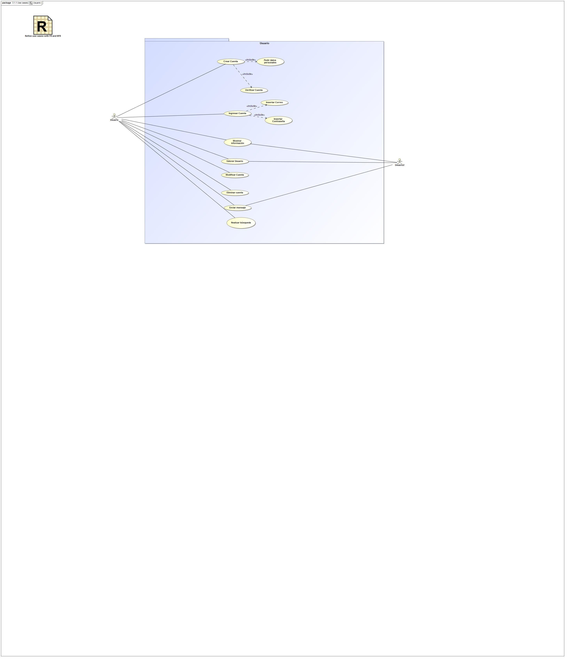

## Crear Cuenta Use Case

|  |  |  |  |
| --- | --- | --- | --- |
| **Use Case Name** | Crear Cuenta | ID |  |
| **Complexity** | Average Complexity | | |
| **Description** |  | | |
| **Actors** | * Usuario | | |
| **Goal** |  | | |
| **Assumption** |  | | |
| **Non Functional Requirements** |  | | |
| **Pre Condition** |  | | |
| **Post Condition** |  | | |
| **Constraints** |  | | |

|  |  |
| --- | --- |
| **Relations** | |
| **Association** | * Usuario Actor |
| **Include** | * Pedir datos personales UseCase * Verificar Cuenta UseCase * Verificar Cuenta UseCase |
| **Extend** |  |
| **Generalization** |  |

|  |  |
| --- | --- |
| **Scenarios** | |
| **Basic Flow of Events** | 1. User action  2. System response |
| **Basic Flow of Events Diagrams** |  |
| **Alternative Flow of Events** |  |
| **Alternative Flow of Events Diagrams** |  |
| **Exceptional Flow of Events** |  |
| **Exceptional Flow of Events Diagrams** |  |

## Eliminar cuenta Use Case

|  |  |  |  |
| --- | --- | --- | --- |
| **Use Case Name** | Eliminar cuenta | ID |  |
| **Complexity** | Average Complexity | | |
| **Description** |  | | |
| **Actors** | * Usuario | | |
| **Goal** |  | | |
| **Assumption** |  | | |
| **Non Functional Requirements** |  | | |
| **Pre Condition** |  | | |
| **Post Condition** |  | | |
| **Constraints** |  | | |

|  |  |
| --- | --- |
| **Relations** | |
| **Association** | * Usuario Actor |
| **Include** |  |
| **Extend** |  |
| **Generalization** |  |

|  |  |
| --- | --- |
| **Scenarios** | |
| **Basic Flow of Events** |  |
| **Basic Flow of Events Diagrams** |  |
| **Alternative Flow of Events** |  |
| **Alternative Flow of Events Diagrams** |  |
| **Exceptional Flow of Events** |  |
| **Exceptional Flow of Events Diagrams** |  |

## Enviar mensaje Use Case

|  |  |  |  |
| --- | --- | --- | --- |
| **Use Case Name** | Enviar mensaje | ID |  |
| **Complexity** | Average Complexity | | |
| **Description** |  | | |
| **Actors** | * Usuario * Usuario2 | | |
| **Goal** |  | | |
| **Assumption** |  | | |
| **Non Functional Requirements** |  | | |
| **Pre Condition** |  | | |
| **Post Condition** |  | | |
| **Constraints** |  | | |

|  |  |
| --- | --- |
| **Relations** | |
| **Association** | * Usuario Actor * Usuario2 Actor |
| **Include** |  |
| **Extend** |  |
| **Generalization** |  |

|  |  |
| --- | --- |
| **Scenarios** | |
| **Basic Flow of Events** |  |
| **Basic Flow of Events Diagrams** |  |
| **Alternative Flow of Events** |  |
| **Alternative Flow of Events Diagrams** |  |
| **Exceptional Flow of Events** |  |
| **Exceptional Flow of Events Diagrams** |  |

## Ingresar Cuenta Use Case

|  |  |  |  |
| --- | --- | --- | --- |
| **Use Case Name** | Ingresar Cuenta | ID |  |
| **Complexity** | Average Complexity | | |
| **Description** |  | | |
| **Actors** | * Usuario | | |
| **Goal** |  | | |
| **Assumption** |  | | |
| **Non Functional Requirements** |  | | |
| **Pre Condition** |  | | |
| **Post Condition** |  | | |
| **Constraints** |  | | |

|  |  |
| --- | --- |
| **Relations** | |
| **Association** | * Usuario Actor |
| **Include** | * Insertar Contraseña UseCase * Insertar Correo UseCase |
| **Extend** |  |
| **Generalization** |  |

|  |  |
| --- | --- |
| **Scenarios** | |
| **Basic Flow of Events** |  |
| **Basic Flow of Events Diagrams** |  |
| **Alternative Flow of Events** |  |
| **Alternative Flow of Events Diagrams** |  |
| **Exceptional Flow of Events** |  |
| **Exceptional Flow of Events Diagrams** |  |

## Insertar Contraseña Use Case

|  |  |  |  |
| --- | --- | --- | --- |
| **Use Case Name** | Insertar Contraseña | ID |  |
| **Complexity** | Average Complexity | | |
| **Description** |  | | |
| **Actors** |  | | |
| **Goal** |  | | |
| **Assumption** |  | | |
| **Non Functional Requirements** |  | | |
| **Pre Condition** |  | | |
| **Post Condition** |  | | |
| **Constraints** |  | | |

|  |  |
| --- | --- |
| **Relations** | |
| **Association** |  |
| **Include** |  |
| **Extend** |  |
| **Generalization** |  |

|  |  |
| --- | --- |
| **Scenarios** | |
| **Basic Flow of Events** |  |
| **Basic Flow of Events Diagrams** |  |
| **Alternative Flow of Events** |  |
| **Alternative Flow of Events Diagrams** |  |
| **Exceptional Flow of Events** |  |
| **Exceptional Flow of Events Diagrams** |  |

## Insertar Correo Use Case

|  |  |  |  |
| --- | --- | --- | --- |
| **Use Case Name** | Insertar Correo | ID |  |
| **Complexity** | Average Complexity | | |
| **Description** |  | | |
| **Actors** |  | | |
| **Goal** |  | | |
| **Assumption** |  | | |
| **Non Functional Requirements** |  | | |
| **Pre Condition** |  | | |
| **Post Condition** |  | | |
| **Constraints** |  | | |

|  |  |
| --- | --- |
| **Relations** | |
| **Association** |  |
| **Include** |  |
| **Extend** |  |
| **Generalization** |  |

|  |  |
| --- | --- |
| **Scenarios** | |
| **Basic Flow of Events** |  |
| **Basic Flow of Events Diagrams** |  |
| **Alternative Flow of Events** |  |
| **Alternative Flow of Events Diagrams** |  |
| **Exceptional Flow of Events** |  |
| **Exceptional Flow of Events Diagrams** |  |

## Modificar Cuenta Use Case

|  |  |  |  |
| --- | --- | --- | --- |
| **Use Case Name** | Modificar Cuenta | ID |  |
| **Complexity** | Average Complexity | | |
| **Description** |  | | |
| **Actors** | * Usuario | | |
| **Goal** |  | | |
| **Assumption** |  | | |
| **Non Functional Requirements** |  | | |
| **Pre Condition** |  | | |
| **Post Condition** |  | | |
| **Constraints** |  | | |

|  |  |
| --- | --- |
| **Relations** | |
| **Association** | * Usuario Actor |
| **Include** | * Apellidos UseCase * Ciudad UseCase * Contraseña UseCase * Correo UseCase * Código Postal UseCase * Dirección UseCase * DNI UseCase * Localidad UseCase * Nombre UseCase * Telefono UseCase |
| **Extend** | * Ingresar Cuenta UseCase |
| **Generalization** |  |

|  |  |
| --- | --- |
| **Scenarios** | |
| **Basic Flow of Events** |  |
| **Basic Flow of Events Diagrams** |  |
| **Alternative Flow of Events** |  |
| **Alternative Flow of Events Diagrams** |  |
| **Exceptional Flow of Events** |  |
| **Exceptional Flow of Events Diagrams** |  |

## Mostrar información Use Case

|  |  |  |  |
| --- | --- | --- | --- |
| **Use Case Name** | Mostrar información | ID |  |
| **Complexity** | Average Complexity | | |
| **Description** |  | | |
| **Actors** | * Usuario * Usuario2 | | |
| **Goal** |  | | |
| **Assumption** |  | | |
| **Non Functional Requirements** |  | | |
| **Pre Condition** |  | | |
| **Post Condition** |  | | |
| **Constraints** |  | | |

|  |  |
| --- | --- |
| **Relations** | |
| **Association** | * Usuario Actor * Usuario2 Actor |
| **Include** |  |
| **Extend** |  |
| **Generalization** |  |

|  |  |
| --- | --- |
| **Scenarios** | |
| **Basic Flow of Events** |  |
| **Basic Flow of Events Diagrams** |  |
| **Alternative Flow of Events** |  |
| **Alternative Flow of Events Diagrams** |  |
| **Exceptional Flow of Events** |  |
| **Exceptional Flow of Events Diagrams** |  |

## Pedir datos personales Use Case

|  |  |  |  |
| --- | --- | --- | --- |
| **Use Case Name** | Pedir datos personales | ID |  |
| **Complexity** | Average Complexity | | |
| **Description** |  | | |
| **Actors** | * Usuario * Usuario2 | | |
| **Goal** |  | | |
| **Assumption** |  | | |
| **Non Functional Requirements** |  | | |
| **Pre Condition** |  | | |
| **Post Condition** |  | | |
| **Constraints** |  | | |

|  |  |
| --- | --- |
| **Relations** | |
| **Association** | * Usuario Actor * Usuario2 Actor |
| **Include** | * Apellidos UseCase * Ciudad UseCase * Contraseña UseCase * Correo UseCase * Código Postal UseCase * Dirección UseCase * DNI UseCase * Localidad UseCase * Nombre UseCase * Telefono UseCase |
| **Extend** |  |
| **Generalization** |  |

|  |  |
| --- | --- |
| **Scenarios** | |
| **Basic Flow of Events** |  |
| **Basic Flow of Events Diagrams** |  |
| **Alternative Flow of Events** |  |
| **Alternative Flow of Events Diagrams** |  |
| **Exceptional Flow of Events** |  |
| **Exceptional Flow of Events Diagrams** |  |

## Realizar búsqueda Use Case

|  |  |  |  |
| --- | --- | --- | --- |
| **Use Case Name** | Realizar búsqueda | ID |  |
| **Complexity** | Average Complexity | | |
| **Description** |  | | |
| **Actors** | * Sistema * Usuario | | |
| **Goal** |  | | |
| **Assumption** |  | | |
| **Non Functional Requirements** |  | | |
| **Pre Condition** |  | | |
| **Post Condition** |  | | |
| **Constraints** |  | | |

|  |  |
| --- | --- |
| **Relations** | |
| **Association** | * Sistema Actor * Usuario Actor |
| **Include** |  |
| **Extend** |  |
| **Generalization** |  |

|  |  |
| --- | --- |
| **Scenarios** | |
| **Basic Flow of Events** |  |
| **Basic Flow of Events Diagrams** |  |
| **Alternative Flow of Events** |  |
| **Alternative Flow of Events Diagrams** |  |
| **Exceptional Flow of Events** |  |
| **Exceptional Flow of Events Diagrams** |  |

## Valorar Usuario Use Case

|  |  |  |  |
| --- | --- | --- | --- |
| **Use Case Name** | Valorar Usuario | ID |  |
| **Complexity** | Average Complexity | | |
| **Description** |  | | |
| **Actors** | * Usuario * Usuario2 | | |
| **Goal** |  | | |
| **Assumption** |  | | |
| **Non Functional Requirements** |  | | |
| **Pre Condition** |  | | |
| **Post Condition** |  | | |
| **Constraints** |  | | |

|  |  |
| --- | --- |
| **Relations** | |
| **Association** | * Usuario Actor * Usuario2 Actor |
| **Include** | * Almacenar Información UseCase |
| **Extend** |  |
| **Generalization** |  |

|  |  |
| --- | --- |
| **Scenarios** | |
| **Basic Flow of Events** |  |
| **Basic Flow of Events Diagrams** |  |
| **Alternative Flow of Events** |  |
| **Alternative Flow of Events Diagrams** |  |
| **Exceptional Flow of Events** |  |
| **Exceptional Flow of Events Diagrams** |  |

## Verificar Cuenta Use Case

|  |  |  |  |
| --- | --- | --- | --- |
| **Use Case Name** | Verificar Cuenta | ID |  |
| **Complexity** | Average Complexity | | |
| **Description** |  | | |
| **Actors** | * Sistema | | |
| **Goal** |  | | |
| **Assumption** |  | | |
| **Non Functional Requirements** |  | | |
| **Pre Condition** |  | | |
| **Post Condition** |  | | |
| **Constraints** |  | | |

|  |  |
| --- | --- |
| **Relations** | |
| **Association** | * Sistema Actor |
| **Include** |  |
| **Extend** | * Comprobar Correo UseCase |
| **Generalization** |  |

|  |  |
| --- | --- |
| **Scenarios** | |
| **Basic Flow of Events** | 1. User action  2. System response |
| **Basic Flow of Events Diagrams** |  |
| **Alternative Flow of Events** |  |
| **Alternative Flow of Events Diagrams** |  |
| **Exceptional Flow of Events** |  |
| **Exceptional Flow of Events Diagrams** |  |