Fayoum University

Faculty of Science

Mathematics department

Mathematics and Computer Science

**xHealth Application**

**By**

Ahmed M. Abd ElGhany

Mohmed Mustafa

Fathi Yasser

**Under the supervision of**

Prof/ Dr. Mohamed Abd-Elbaky

2021/2022

**Introduction**

We believe that the role of medical field is essential in our lives, and can not be disregarded, Medical Sciences can enhance our lives and further improve the quality of life, also it helps us stop the pain and suffering of being ill.

Since technology has an important value in our recent lifestyle, Technology has helped doctors to answer most of the critical questions in a better and detailed way, there are various technological innovations in the health sector, such as the invention of certain drugs, the development of information technology, biotechnology, development processes. Etc.

We as a team decided to help make the job easier between both the patient and doctor since we noticed that the process in our community is a bit slow, as patients don’t have a patient history profile. Creating such a thing will reduce the amount of time of diagnosis and suggesting the suitable drugs, doing this by creating a communication channel between all doctors in the system and a single patient and the doctors they met.

xHealth will provide that communication channel making the best use of technology in the health sector, helping our people and dear country have a better life quality and enhanced lifestyle.

**Table of Contents**

1. Introduction
2. System Analysis
   1. Context diagram
   2. Level zero diagram
   3. Use-case diagram
   4. Use-case documentation
   5. FDD
   6. ERD
3. Project Structure
4. conclusion

**Context diagram:**

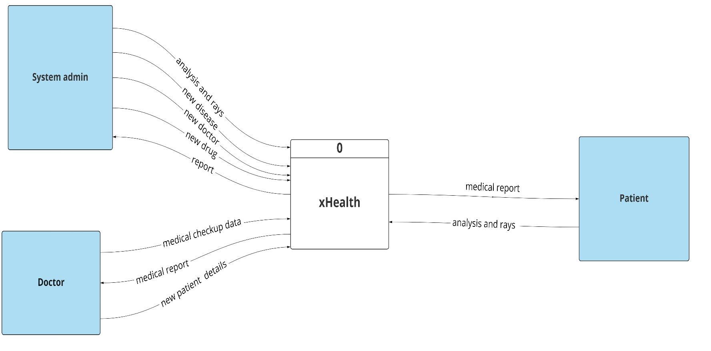

**Level Zero Diagram:**

**ERD:**

**Project Structure:**

This project is structured as two parts as

1. API Architecture
2. Mobile application

* The API architecture represents the backend with Rational DB (postgresql)
* The mobile application is made by using Flutter a framework provided by google for creating professional mobile applications

The Backend is free hosted at Heroku

<https://grad-project-fy-1.herokuapp.com>

With two interfaces to documenting the API requests:

1. Swagger UI

<https://grad-project-fy-1.herokuapp.com/docs>

1. ReDoc UI

<https://grad-project-fy-1.herokuapp.com/redoc>

The source code can be found on the attached CDs with the files of diagrams

The Blob storage is used to save both profile pictures and the results of analysis and rays, the blob storage is from portal cloud from Microsoft Azure this also can be found at:

<https://xhealth.blob.core.windows.net/profile/default.png>

**Conclusion**

We hope that at the end of the day someone’s life would get better and easier using our project, we hope that further enhancements are to come to the project and more features will be add as will.

xHealth is not just a regular graduation project to us, it’s a brand that we will try to make it get bigger and larger, we want this project to be globally and national be used and gave the needed attention and care.

Finally, we hope that we managed to put our efforts into the correct way and planned for this in a good manner under the supervision of our dear professor, we hope our efforts meets the needs of our ambitious and well-cultured prof/Dr Mohamed, and we hope this application help our local and national community.