最小二乘法拟合直线

1. 基本原理

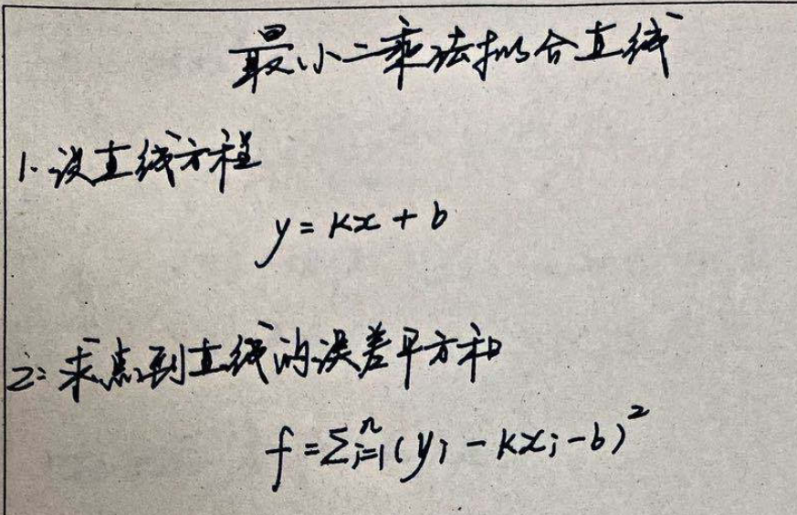

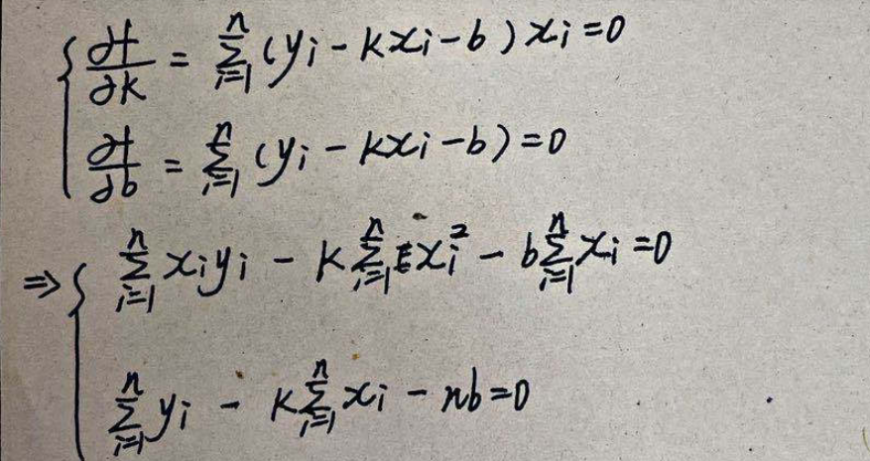

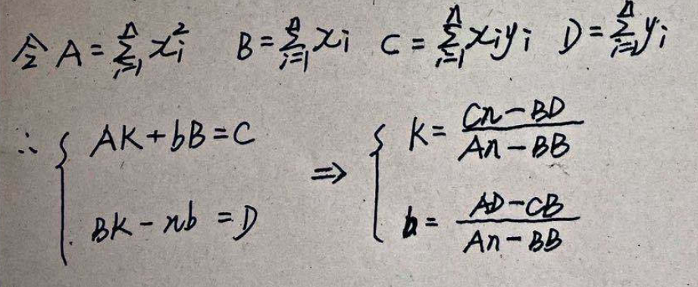

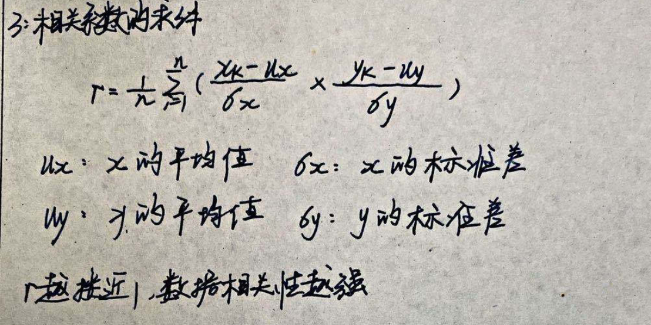

1. C++及opencv验证

void LineFitLeastFit(const std::vector<cv::Point2f> &_points,float & _k,float & _b,float & _r) {

float B = 0.0f;

float A = 0.0f;

float D = 0.0f;

float C = 0.0f;

int N = _points.size();

for (int i = 0; i < N; i++)

{

B += _points[i].x;

A += _points[i].x * _points[i].x;

D += _points[i].y;

C += _points[i].x * _points[i].y;

}

if ((N * A - B * B) == 0)

return;

_k = (N * C - B * D) / (N * A - B * B);

_b = (A * D - C * B) / (N * A - B * B);

//计算相关系数

float Xmean = B / N;

float Ymean = D / N;

float tempX = 0.0f;

float tempY = 0.0f;

float rDenominator = 0.0;

for (int i = 0; i < N; i++)

{

tempX += (_points[i].x - Xmean) * (_points[i].x - Xmean);

tempY += (_points[i].y - Ymean) * (_points[i].y - Ymean);

rDenominator += (_points[i].x - Xmean) * (_points[i].y - Ymean);

}

float SigmaXY = sqrt(tempX) * sqrt(tempY);

if (SigmaXY == 0)

return;

_r = rDenominator / SigmaXY;

}

————————————————

：https://blog.csdn.net/jjjstephen/article/details/108053148

1. Matlab实现

3.1 直接计算

clc

clear all

points_x = [1 2 3 4 5 6 7 8 9];

points_y = [110 77 80 64 57 41 34 22 15];

plot(points_x , points_y,'r*');

title('\bf 基于离散坐标的最小二乘法拟合直线，拟合方程y = kx + b');

xlabel('points_x');

ylabel('points_y');

text(9,40, 'y = kx + b');

[line_fit_k, line_fit_b] = StraightLineFitbyLeastSquare(points_x, points_y);

size_points_x = size(points_x);

size_points_y = size(points_y);

if(size_points_x == size_points_y)

fit_start_x = points_x(1,1) - 1;

fit_end_x = points_x(1,size_points_x(1,2)) + 1;

fit_x = linspace(fit_start_x, fit_end_x,10000);

fit_y = line_fit_k * fit_x + line_fit_b;

hold on

plot(fit_x,fit_y,'b.');

hold off

end

function [line_fit_k, line_fit_b] = StraightLineFitbyLeastSquare(points_vector_x, points_vector_y)

[points_num_rawx,points_num_colx] = size(points_vector_x);

[points_num_rawy,points_num_coly] = size(points_vector_y);

if ((points_num_rawx == 1) &&(points_num_rawy == 1)&& (points_num_colx == points_num_coly))

for i = 1:1:points_num_colx

calc_coef_A = points_vector_x * points_vector_x' ;

calc_coef_B = sum(points_vector_x);

calc_coef_C = sum(points_vector_x .* points_vector_y);

calc_coef_D = sum(points_vector_y);

end

calc_coef_base = points_num_colx * calc_coef_A - calc_coef_B * calc_coef_B;

if(calc_coef_base == 0)

disp('Line fit base error!');

end

line_fit_k = (points_num_colx * calc_coef_C - calc_coef_B * calc_coef_D ) / calc_coef_base;

line_fit_b = (calc_coef_A * calc_coef_D - calc_coef_B * calc_coef_C) / calc_coef_base;

else

disp('please check put_in parameter which is a vector!');

end

end

3.2 矩阵计算（原理+Matlab实现）

3.2.1 计算原理

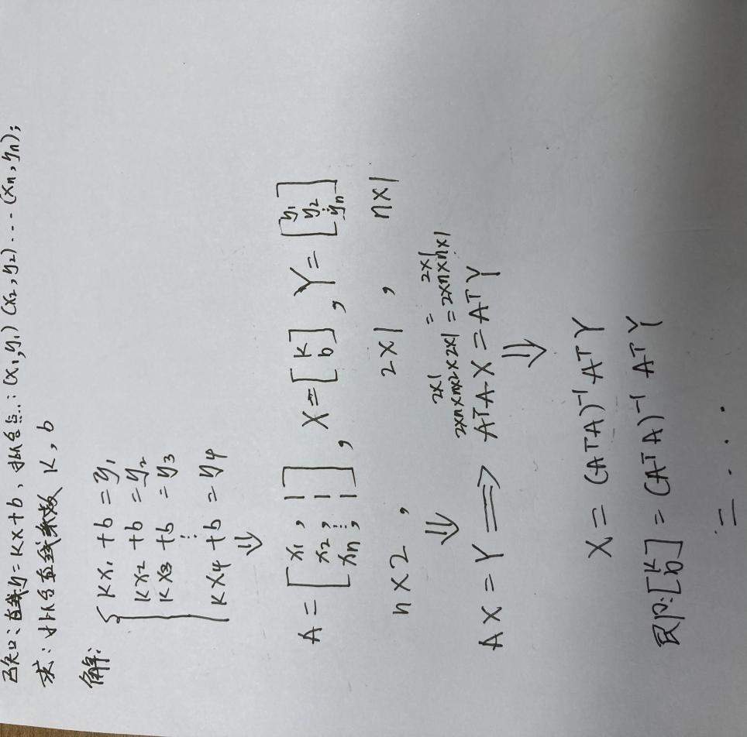

3.2.2 matlab代码实现

clc

clear all

matrix_A = [1 1; 2 1; 3 1; 4 1; 5 1; 6 1; 7 1; 8 1; 9 1];

matrix_Y = [110; 77; 80; 64; 57; 41; 34; 22; 15];

matrix_X = zeros(2,1);

plot(matrix_A(:,1) , matrix_Y,'r*');

title('\bf 基于离散坐标的最小二乘法拟合直线，拟合方程y = kx + b');

xlabel('points_x');

ylabel('points_y');

text(9,40, 'y = kx + b');

matrix_X = ((matrix_A'*matrix_A)^-1)*matrix_A'*matrix_Y;

size_matrix_A = size(matrix_A);

size_matrix_Y = size(matrix_Y);

if(size_matrix_A(1,1) == size_matrix_Y(1,1))

fit_start_x = matrix_A(1,1) - 1;

fit_end_x = matrix_A(size_matrix_A(1,1),1) + 1;

fit_x = linspace(fit_start_x, fit_end_x,10000);

fit_y = matrix_X(1,1) * fit_x + matrix_X(2,1);

hold on

plot(fit_x,fit_y,'b.');

hold off

end