CPSC 473- Project 2

Triple Triad

Section 1, Group 2 – Fighting Mongooses

Kyle Meyerhardt, Eric Donaldson, Robert Hackemack, Alec Yenter, Truong pham

Overview

Our project is a web implementation of the card game Triple Triad from Final Fantasy VIII. Our application captures the fun and experience of the original game and enhances it with additional features including:

* User registration system
* Live match making
* Global chat room
* In-game chat room

To run the project:

1. git clone https://github.com/FightingMongooses/Project2
2. cd [repo]
3. npm install
4. npm start

Game Rules

Triple Triad is played on a three-by-three (3x3) square grid of blank spaces where cards will be placed as the game progresses. Each card has four numbers (known as Ranks) placed in top left corner; each number corresponds to one of the four sides of the card. These numbers range from one to ten. Cards can have elemental alignments that affect the gameplay if there are elemental icons on the game board.

After the first card is played, the opposing player may play a card on any unoccupied space on the board. The game continues with players' turns alternating.

To win, a majority of the total ten cards played (including the one card that is not placed on the board) must be of the player's card color. To do this, the player must capture cards by placing a card adjacent to an opponent's card whereupon the 'ranks' of the sides where the two cards touch will be compared. If the rank of the opponent's card is higher than the player's card, the player's card will be captured and turned into the opponent's color. If the player's rank is higher, the opponent's card will be captured and changed into the player's color instead. Capturing can only occur during that player's turn, and no other opponent can capture a card during said turn.

Account Registration

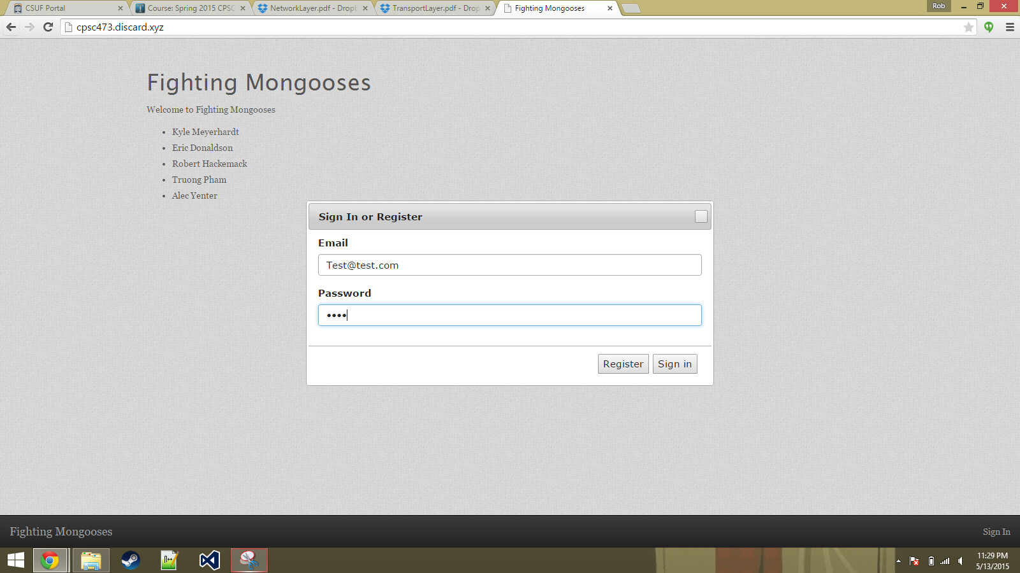

Users may register an account by clicking on the “sign in” button at the bottom right hand corner of the application. Afterwards, a registration form pops up prompting them to enter their email address and a password. The password must be alphanumeric.

Username Registration

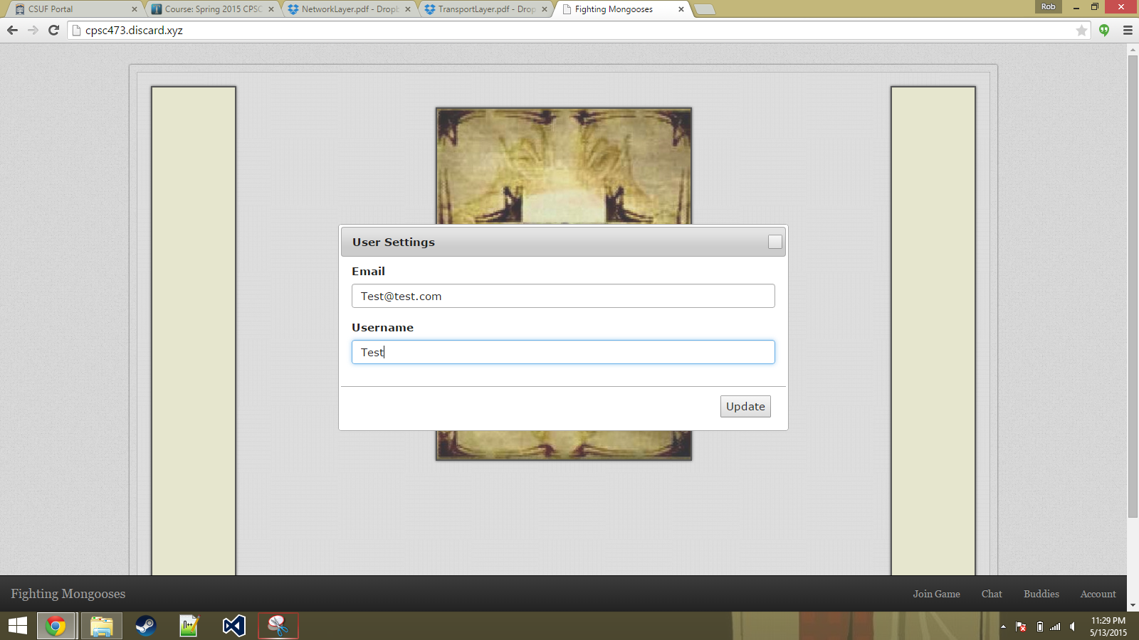

After filling out the form and clicking “register,” the user will now be able to customize a username for their account. Enter a username and then click on “update” to apply the changes.

Chat Rooms

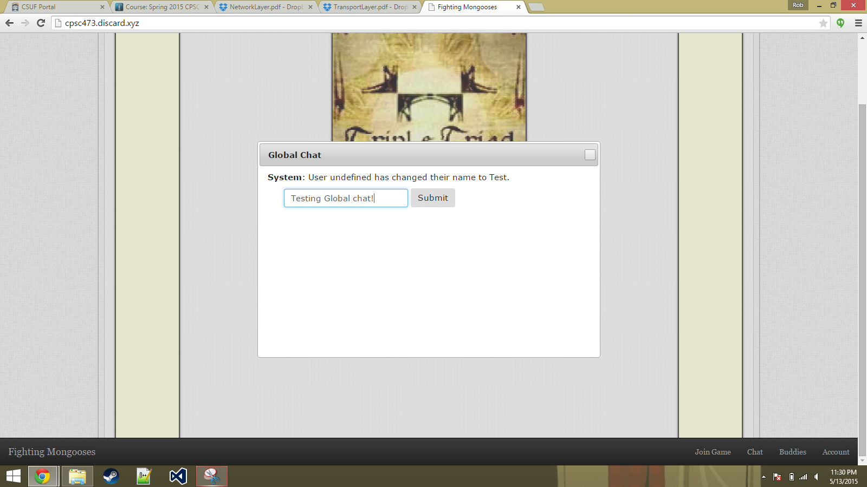

The “chat” button at the bottom menu bar allows user to communicate with all users that are currently on the server. There is also a sub-button that allows players to chat with the users in their current game (themselves and their opponents).

Game in Progress

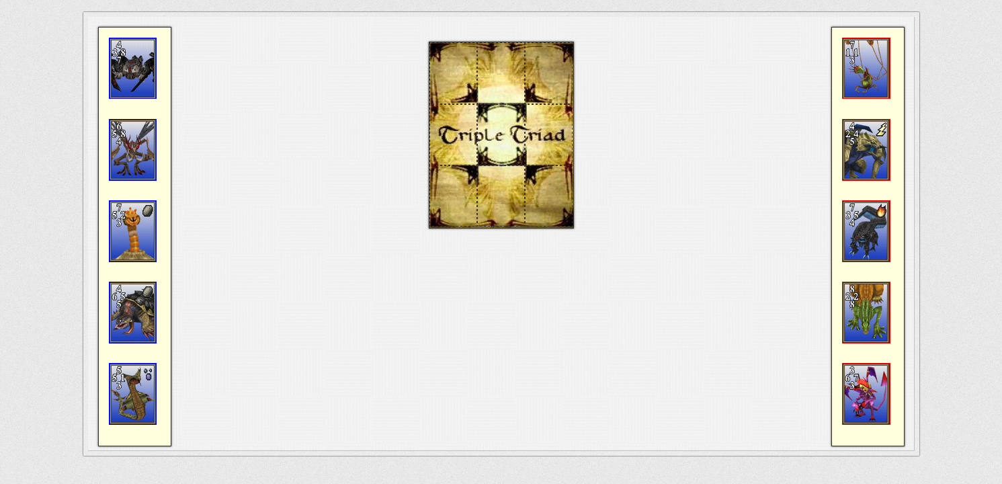

When two users click on “join game” on the menu bar, the game will match them together. The game officially starts when the two players are assigned random cards.

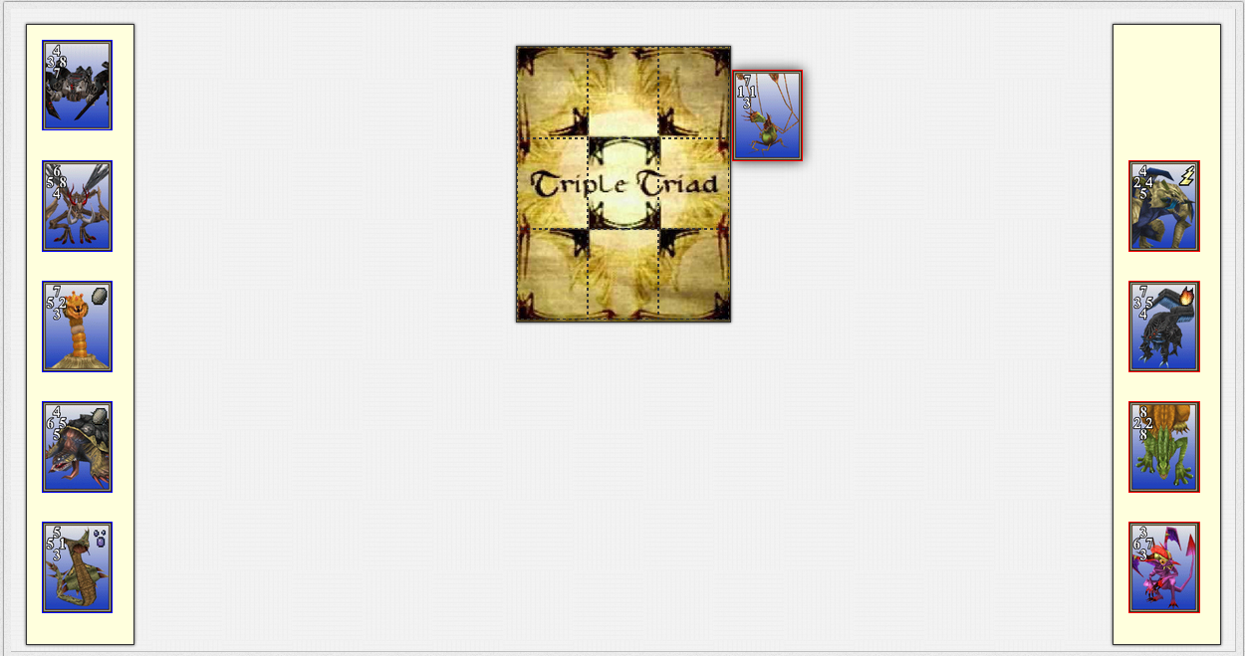

Each player can drag cards to the center positions when it is their turn.

The game ends when the last card is placed:

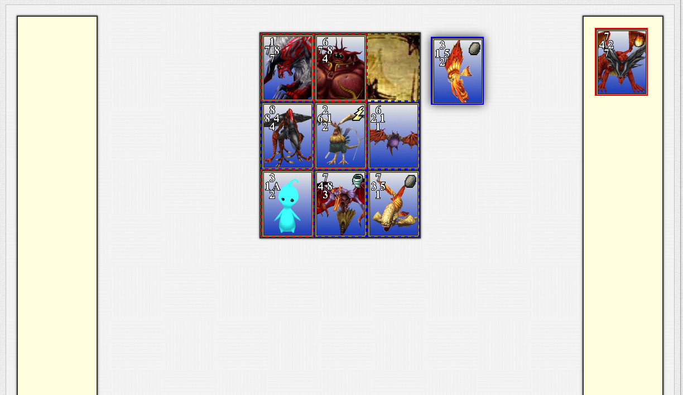

Showing a message with the name of the winner:

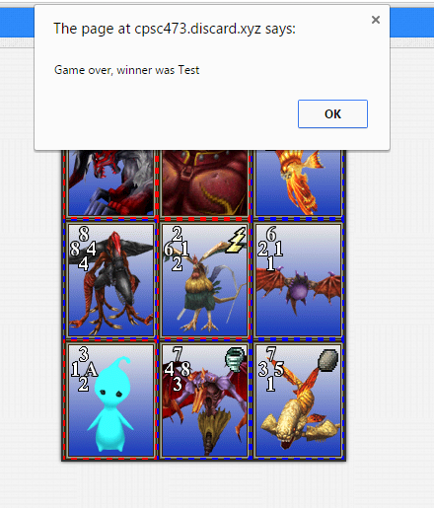

For both users.