传文件：

scp 2029-jgmes-aps-application-1.0.jar root@120.79.244.12:/root/jgMesStartJar

传文件夹

scp -r 2029-jgmes-aps-application root@120.79.244.12:/root/jgMesStartJar

查看报错日志zookeeper 启动失败日志

sh zkServer.sh start-foreground

zookeeper-3.5.5安装报错：找不到或无法加载主类 org.apache.zookeeper.server.quorum.QuorumPeerMain

<https://blog.csdn.net/jiangxiulilinux/article/details/96433560>

centos7.3上部署zookeeper集群环境

<https://blog.csdn.net/xuexi_39/article/details/82867995>

修改权限

chown -hR hadoop /usr/local/zookeeper/ # 修改所有者为hadoop

chgrp -hR hadoop /usr/local/zookeeper/ # 修改所属组为hadoop

启动hadoop，报错Error JAVA_HOME is not set and could not be found

<https://blog.csdn.net/chun19920827/article/details/74924434>

问题：在rooot用户下zookeeper启动成功在hadoop用户下面提示JAVA环境错误

解决：在zkEnv.sh文件中重新添加export JAVA_HOME=/usr/local/java/jdk-13.0.2

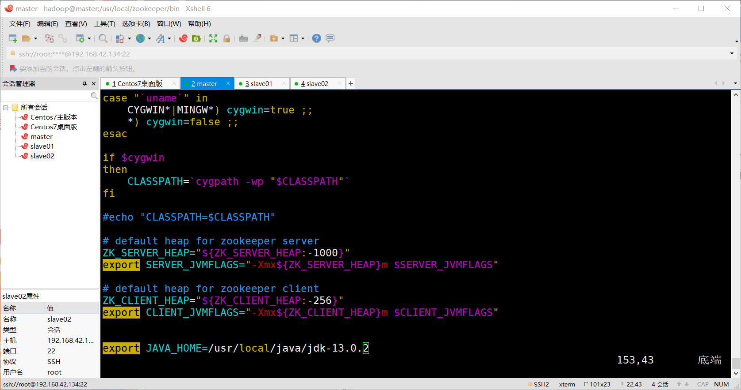

Hbase下载地址<https://mirror.bit.edu.cn/apache/hbase/stable/>

Centos 7 环境 HBase 2.1.5 完全分布式集群的搭建过程

<https://blog.csdn.net/a_bcd_123/article/details/99982394>