错误总结1：

KeeperErrorCode = ConnectionLoss for /hbase/master

错误总结2：localhost: ERROR: Cannot set priority of datanode process 3139

解决方法：

法一：权限不够，加权限

# chown -R hadoop:hadoop /usr/local/hadoop

法二：修改你的${HADOOP_HOME}/bin/hdfs

我的是:vi /root/app/hadoop-3.0.2/bin/hdfs

修改成:HADOOP_SHELL_EXECNAME="root"

重启stop-dfs.sh

start-dfs.sh

错误3：

[hadoop@master bin]$ sudo sh zkServer.sh status

ZooKeeper JMX enabled by default

Using config: /usr/local/zookeeper/zookeeper-3.4.14/bin/../conf/zoo.cfg

Error contacting service. It is probably not running. 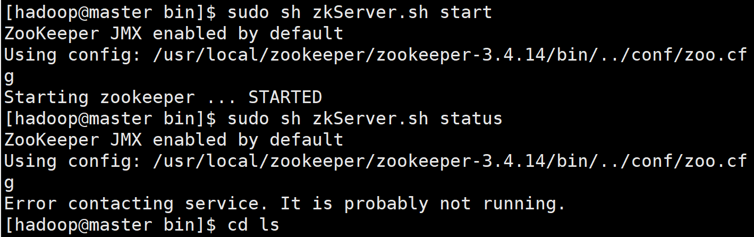解决方法：

#sudo vim /usr/local/zookeeper/zookeeper-3.4.14/bin/zkEnv.sh

添加如下内容

#JAVA_HOME

export JAVA_HOME=/usr/local/java/jdk-13.0.2

export PATH=$PATH:$JAVA_HOME/bin

启动成功如下：

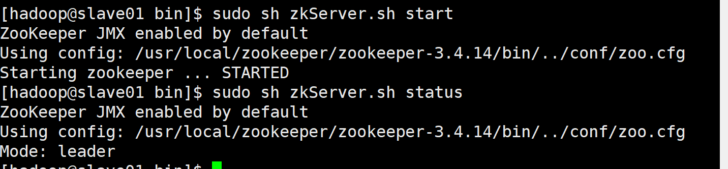

CentOS7下搭建Hadoop2.9.1完全分布式集群过程（超详细）

<https://blog.csdn.net/Hellowenpan/article/details/83351493?depth_1-utm_source=distribute.pc_relevant.none-task&utm_source=distribute.pc_relevant.none-task>

#手动同步集群各机器时间(这里三台：master、slave1、slave2)

date -s "2018-9-18 10:10:10"

yum install ntpdate

#网络同步时间

ntpdate cn.pool.ntp.org

Centos 7 环境 hadoop 3.2.0 完全分布式集群搭建

<https://blog.csdn.net/a_bcd_123/article/details/99934385>

**centOS7搭建hadoop环境（非常详细！非常适合新手！）**

<https://blog.csdn.net/yujuan110/article/details/78457259?depth_1-utm_source=distribute.pc_relevant.none-task&utm_source=distribute.pc_relevant.none-task>

[centos7下zookeeper集群安装部署](https://www.cnblogs.com/ding2016/p/8280696.html)

<https://www.cnblogs.com/ding2016/p/8280696.html>