centos7 安装hbase三节点集群笔记

<https://blog.csdn.net/nmgrd/article/details/79017005?depth_1-utm_source=distribute.pc_relevant.none-task&utm_source=distribute.pc_relevant.none-task>

**Centos7下Hbase的安装与配置**

<https://blog.csdn.net/ily666666/article/details/83052299?depth_1-utm_source=distribute.pc_relevant.none-task&utm_source=distribute.pc_relevant.none-task>

错误总结1：#start-hbase.sh

出现如下错误：

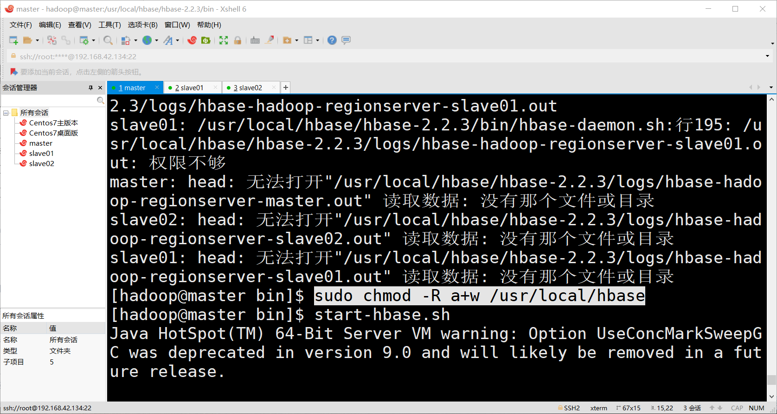

错误原因：权限不够，加权限

解决办法：先结束Hbase的所有任务

# sudo chmod -R a+w /usr/local/hbase

# Centos 7 环境 HBase 2.1.5 完全分布式集群的搭建过程

# <https://blog.csdn.net/a_bcd_123/article/details/99982394>

# Centos 7 环境 hadoop 3.2.0 完全分布式集群搭建

# <https://blog.csdn.net/a_bcd_123/article/details/99934385>

# master jps 没有namenode问题

# blog.51cto.com/13670314/2160425

# 

# 

# 

# java 国内下载镜像

# <https://repo.huaweicloud.com/java/jdk>

# CentOS7.5下搭建Hadoop2.9.1完全分布式集群

# <https://blog.csdn.net/pengjunlee/article/details/81589972?depth_1-utm_source=distribute.pc_relevant.none-task&utm_source=distribute.pc_relevant.none-task>

# Hadoop镜像下载地址：

# <http://archive.apache.org/dist/hadoop/core/hadoop-2.9.1/>

# Hadoop国内镜像下载地址:极速

# <https://blog.csdn.net/xiaoguaihu12/article/details/65628479>

# [Apache Hadoop 2.9.2 完全分布式部署](https://www.cnblogs.com/yinzhengjie/p/10687076.html)（详细）

# <https://www.cnblogs.com/yinzhengjie/p/10687076.html>

**hbase 相关文章**

# <http://www.voidcn.com/relative/p-uzylerxg-ud.html>

# CentOS之——解决非root用户用SSH不能无密码登录服务器的问题

# <https://blog.csdn.net/l1028386804/article/details/93547936?depth_1-utm_source=distribute.pc_relevant.none-task&utm_source=distribute.pc_relevant.none-task>

# hbase启动出现如下图所示

# 

# 错误原因：之前设置的是在Hadoop用户下的免密登录，使用#sudo sh start-hbase.sh命令的时候依然没用目标主机的密钥

# 解决办法：进入root用户重新设置免密登录。

# #su root

#生成ssh免密登录密钥

#ssh-keygen –t rsa (四个回车)

执行完这个命令后，会生成id_rsa(私钥)、id_rsa.pub(公钥)

将公钥拷贝到要免密登录的目标机器上

#ssh-copy-id localhost

#ssh-copy-id master

#ssh-copy-id slave01

#ssh-copy-id slave02

测试：

#ssh master 登录成功

#ssh slave01 登录成功

#ssh slave02 登录成功

# 错误：

# error: KeeperErrorCode = NoNode for /hbase/master

# <https://blog.csdn.net/renzhewudi77/article/details/83507325?depth_1-utm_source=distribute.pc_relevant.none-task&utm_source=distribute.pc_relevant.none-task>