南京工业大学 计算机网络 试题（ A ）卷（闭）
2021 - 2022学年第二学期 使用班级 计1901~10
班级: 学号: 姓名:
课程目标 | 课程目标1 |  | 课程目标2 |  | 课程目标3 |  | 课程目标4
题号 | I | II | III | IV | V | VI | VII | VIII | 总分
分数
NOTE: This is a CLOSED BOOK, 120-minute exam. No textbooks, notes or dictionaries are allowed. It consists of eight problems with a total of 100 marks. You are encouraged to WRITE YOUR ANSWERS IN ENGLISH. Thank you, and Good luck!

课程目标1题目： 物理层

I. (5 Marks) If the data transmission rate (bit rate) of a communication link is 7200 bps and 8-phase modulation (8相位调制) is used, please calculate the baud rate (波特率) of the link. Please explain the reason.

II. (15 Marks) We have a network scenario as follows. If Argon wants to send a packet to Neon with host name of "neon.tcpip-lab.edu", (1) how Argon finds the numeric IP Address of Neon's host? (2) how to determine whether the destination host is in the local network? (3) how to determine the MAC address of his default gateway?

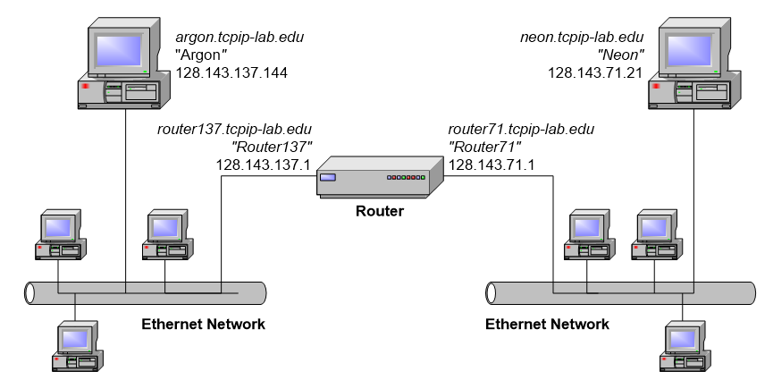

课程目标2题目： 物理层
III (5 Marks) According to Nyquist’s theorem (尼奎斯特定理),
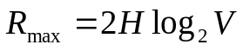
if the bandwidth is 4000Hz and we are using 8 level modulation. What is the maximum data rate (bps) we could transmit?

IV. (10 Marks) In the "store-and-forward" packet switching network shown in the figure below, the data transmission rate of all links is 100Mbps, the packet size is 520 bytes, and the packet header size is 20 bytes. If host H₁ sends a 500 KB file to host H₂, what is the minimum file transfer time? (For simplicity, packet disassembly time and propagation delay are ignored.) 链路层
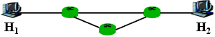

课程目标3题目： 网络层

V. (10 Marks) The IP address space of a network is 198.16.16.0/24, which is divided by fixed length subnet, and the subnet mask is 255.255.255.192. (1) What are the maximum number of subnets and the maximum number of allocable addresses (可分配地址数) in each subnet? (2) Please give the addresses of the all subnets.

VI. (20 Marks) The data link layer between the two hosts uses the “Go Back n” protocol(后退N帧协议) to transmit data. The data transmission rate is 16kbps, the round-trip propagation delay is 500ms, and the data frame size varies between 64 and 1518 bytes. The receiver always acknowledges with shortest Ethernet frame (64 Bytes). What is the minimum number of bits in the frame sequence number to maximize channel utilization (为了最大化信道利用率)? Please give the calculation process. 链路层

课程目标4题目： 网络层
VII. (15 Marks) A network topology is shown in the figure below. Router R₁ only has routes to subnet 192.168.1.0/24. To enable R₁ and R₂ to correctly route IP packets to all subnets in the figure, please add routing table entries in R₁, and R₂, including the destination network, subnet mask, and next hop. (You can use route aggregation if possible.)
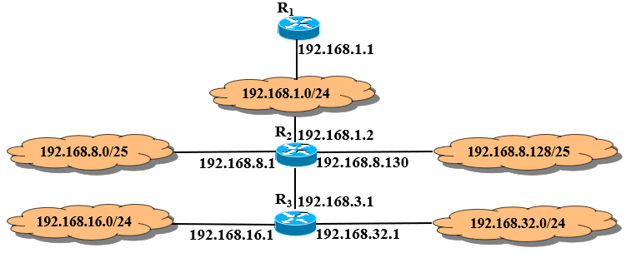

R₁
destination network | subnet mask | next hop
R₂
destination network | subnet mask | next hop

VIII. (20 Marks) Some Ethernet frames are captured from the data link layer of an Ethernet network, which carries IP packets (network layer) and TCP segments (transport layer). Please answer the following questions: 网络层
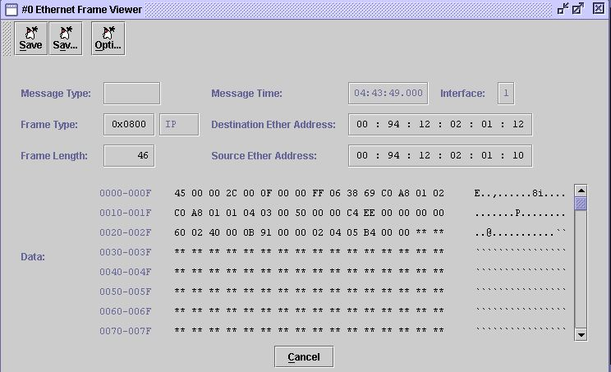
(a)
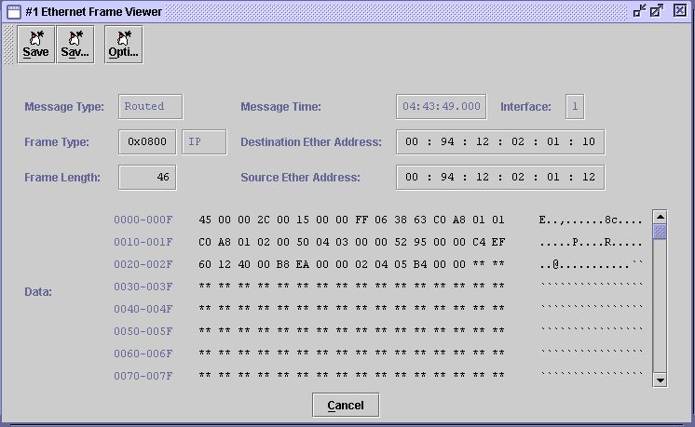
(b)
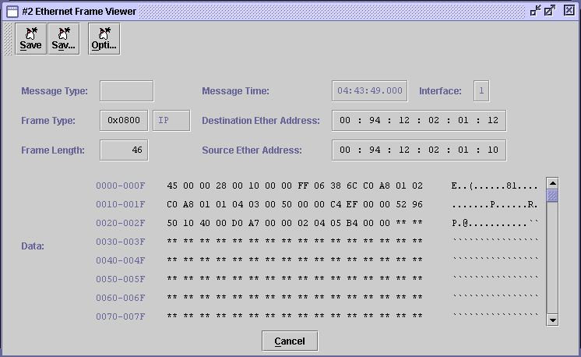
(c)
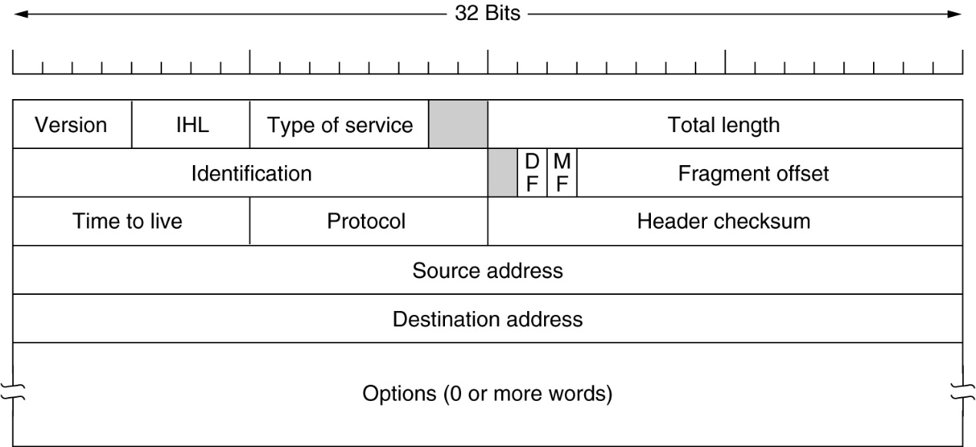
(d) The IP header
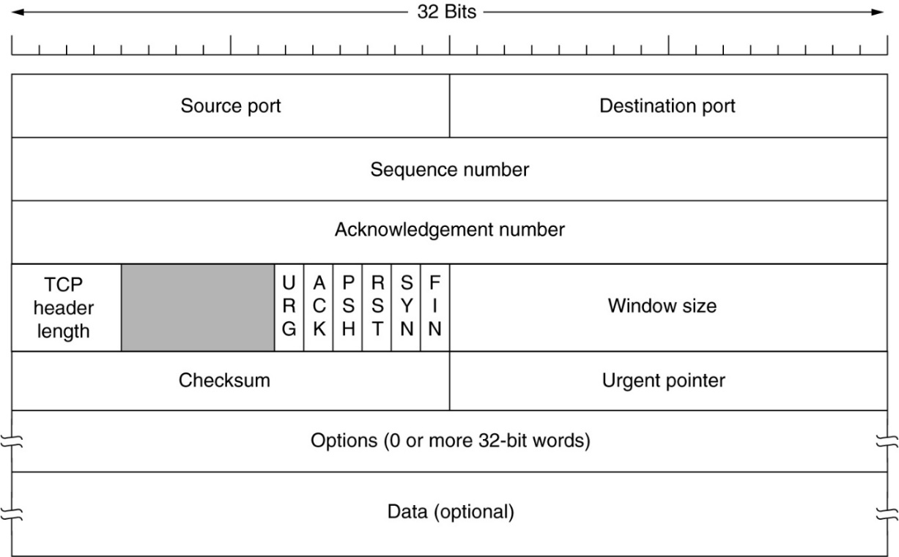
(e) The TCP header
(1) In Fig (a), what are the IP addresses of the sending host and the receiving host? (in dotted decimal notation)

(2) In Fig (a), what are the port numbers of the sending host and the receiving host? (in decimal)

(3) Please list the sequence number and Acknowledgement number (if valid) of TCP segments in Fig (a), (b) and (c), and observe their change trend;

(4) What functions of the transport layer are realized by three TCP segments in figure (a), figure (b) and figure (c)? Why?

