Assignments -- Chapter 1
1. The performance of a client-server system is influenced by two network factors: the bandwidth of the network (how many bits/sec it can transport) and the latency (how many seconds it takes for the first bit to get from the client to the server). Give an example of a network that exhibits high bandwidth and high latency. Then give an example of one with low bandwidth and low latency.

参考答案A transcontinental fiber link might have many gigabits/sec of bandwidth, but the latency will also be high due to the speed of light propagation over thousands of kilometers. In contrast, a 56-kbps modem calling a computer in the same building has low bandwidth and low latency.

2. What are two reasons for using layered protocols?

参考答案 Among other reasons for using layered protocols, using them leads to breaking
up the design problem into smaller, more manageable pieces, and layering means that protocols can be changed without affecting higher or lower ones.

3. What is the principal difference between connectionless communication and connection-oriented communication?

参考答案 Connection-oriented communication has three phases. In the establishment
phase a request is made to set up a connection. Only after this phase has been successfully completed can the data transfer phase be started and data transported. Then comes the release phase. Connectionless communication does not have these phases. It just sends the data.

4. In some networks, the data link layer handles transmission errors by requesting damaged frames to be retransmitted. If the probability of a frame's being damaged is p, what is the mean number of transmissions required to send a frame? Assume that acknowledgements are never lost.

参考答案
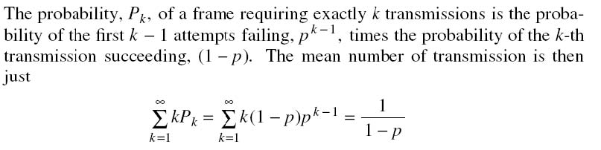

5. Which of the OSI layers and TCP/IP layers handles each of the following:
(a) Dividing the transmitted bit stream into frames.
(b) Determining which route through the subnet to use.

参考答案 (a) Data link layer. (b) Network layer.

6. If the unit exchanged at the data link level is called a frame and the unit exchanged at the network level is called a packet, do frames encapsulate packets or do packets encapsulate frames? Explain your answer.

参考答案 Frames encapsulate packets. When a packet arrives at the data link layer, the entire thing, header, data, and all, is used as the data field of a frame. The entire packet is put in an envelope (the frame), so to speak (assuming it fits).

7. What is the main difference between TCP and UDP?

参考答案 TCP is connection oriented, whereas UDP is a connectionless service.

8. An image is 1024 x 768 pixels with 3 bytes/pixel. Assume the image is uncompressed. How long does it take to transmit it over a 56-kbps modem channel? Over a 1-Mbps cable modem? Over a 10-Mbps Ethernet? Over 100-Mbps Ethernet?

参考答案
The image is 1024 × 768 × 3 bytes or 2,359,296 bytes. This is 18,874,368 bits.
At 56,000 bits/sec, it takes about 337.042 sec.
At 1,000,000 bits/sec, it takes about 18.874 sec.
At 10,000,000 bits/sec, it takes about 1.887 sec.
At 100,000,000 bits/sec, it takes about 0.189 sec.

9. 试在下列条件下比较电路交换和分组交换。要传送的报文共 x (bit)，从源站到目的站共经过 k 段链路，每段链路的传播时延为d 秒，数据率为 b (bit/s)。在电路交换时电路的建立时间为 s 秒。在分组交换时分组长度为 p (bit)，且各结点的排队等待时间可忽略不计。问在怎样的条件下，分组交换的时延比电路交换要小？

参考答案
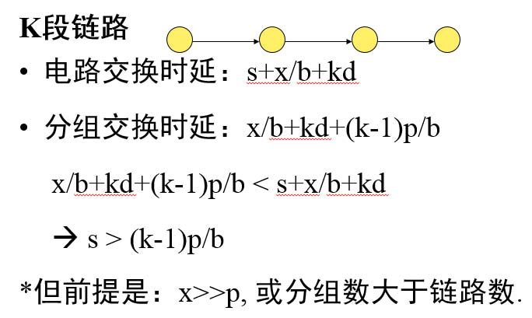

10. 在上题的分组交换网中，设报文和分组长度分别为 x 和 (p+h)(bit)，其中 p 为分组的数据部分的长度，而 h 为每个分组所带的控制信息固定长度，与 p 的大小无关。通信的两端共经过 k 段链路。链路的数据率为b(bit/s)，但传播时延和结点的排队时延均可忽略不计。若打算使总的时延为最小，问分组的数据部分长度 p 应该取多大？

参考答案
