# 汇编语言上机报告1

# 任务1：实现两个数的加减乘除运算：

## 无符号数情况

data segment  
 num1 db 30  
 num2 db 15  
 num3 db ?  
data ends  
code segment  
assume cs:code,ds:data  
 start:mov ax,data  
 mov ds,ax  
 mov al,num1  
 add al,num2  
 mov num3,al  
 mov ax,4c00h  
 int 21h  
code ends  
end start

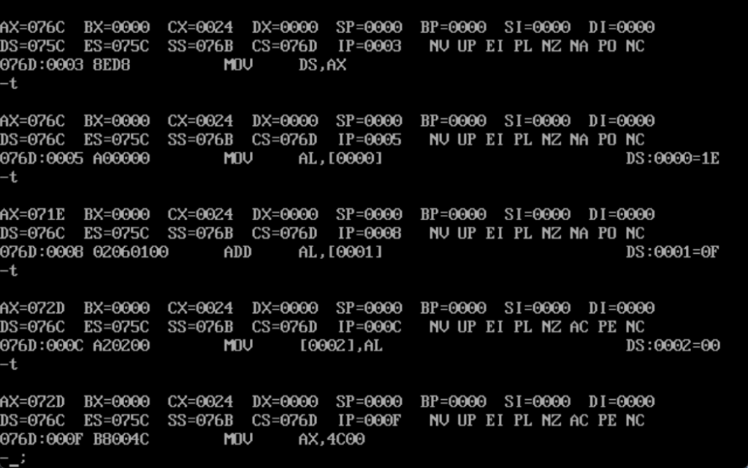

data segment  
 num1 db 30  
 num2 db 15  
 num3 db ?  
data ends  
code segment  
assume cs:code,ds:data  
 start:mov ax,data  
 mov ds,ax  
 mov al,num1  
 sub al,num2;add al,num2  
 mov num3,al  
 mov ax,4c00h  
 int 21h  
code ends  
end start

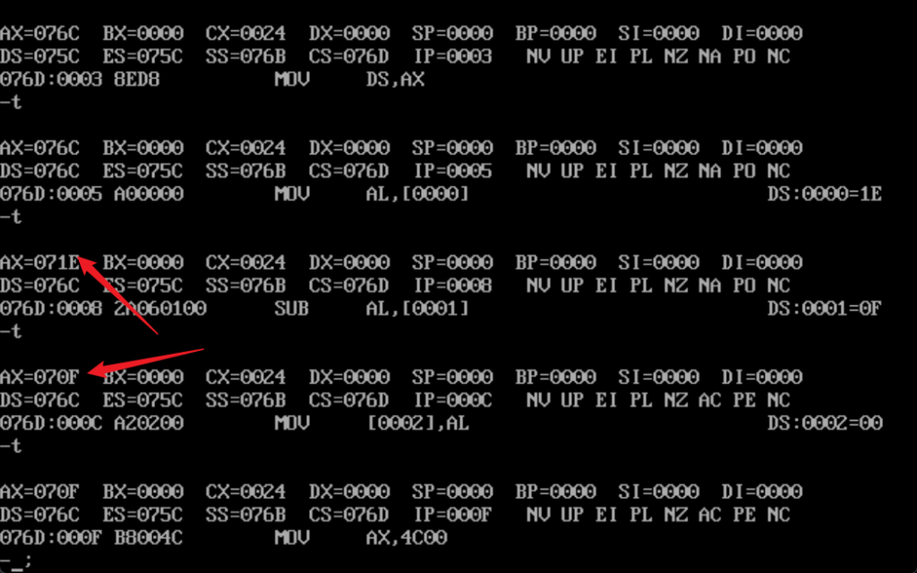

data segment  
 num1 db 30d  
 num2 db 15d  
 num3 db ?  
data ends  
code segment  
assume cs:code,ds:data  
 start:mov ax,data  
 mov ds,ax  
 mov al,num1  
 MUL num1  
 mov ax,4c00h  
 int 21h  
code ends  
end start

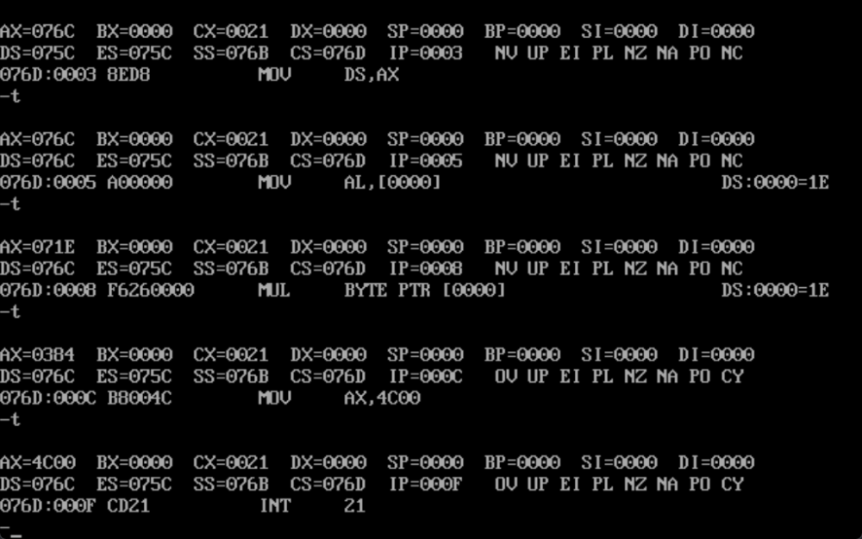

data segment  
 num1 db 001eH  
 num2 db 15d  
 num3 db ?  
data ends  
code segment  
assume cs:code,ds:data  
 start:mov ax,data  
 mov ds,ax  
 mov al,num1  
 cbw  
 DIV num2  
 mov ax,4c00h  
 int 21h  
code ends  
end start

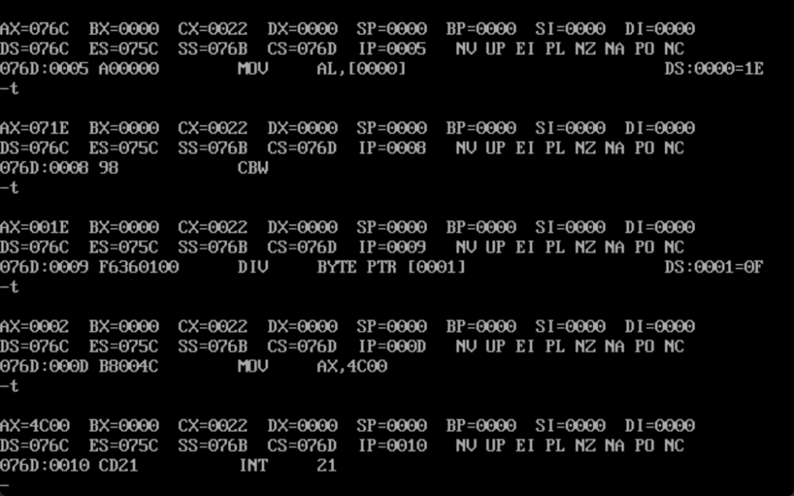

## 有符号数情况：

进行带符号运算时，负数进行的是补码的运算，需要写出负数的补码。

data segment  
 num1 dw 00001010b  
 num2 dw 11100111b;-25的补码  
 num3 dw ?  
data ends  
code segment  
assume cs:code,ds:data  
 start:mov ax,data  
 mov ds,ax  
 mov ax,num1  
 add ax,num2  
 mov ax,4c00h  
 int 21h  
code ends  
end start

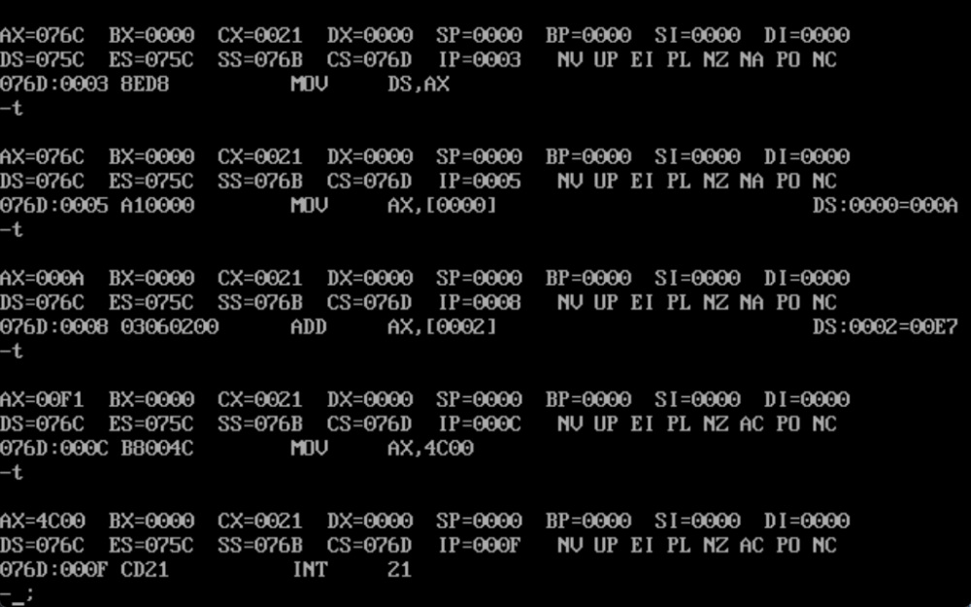

data segment  
 num1 dw 00001010b  
 num2 dw 11100111b;-25的补码  
 num3 dw ?  
data ends  
code segment  
assume cs:code,ds:data  
 start:mov ax,data  
 mov ds,ax  
 mov ax,num1  
 sub ax,num2  
 mov ax,4c00h  
 int 21h  
code ends  
end start

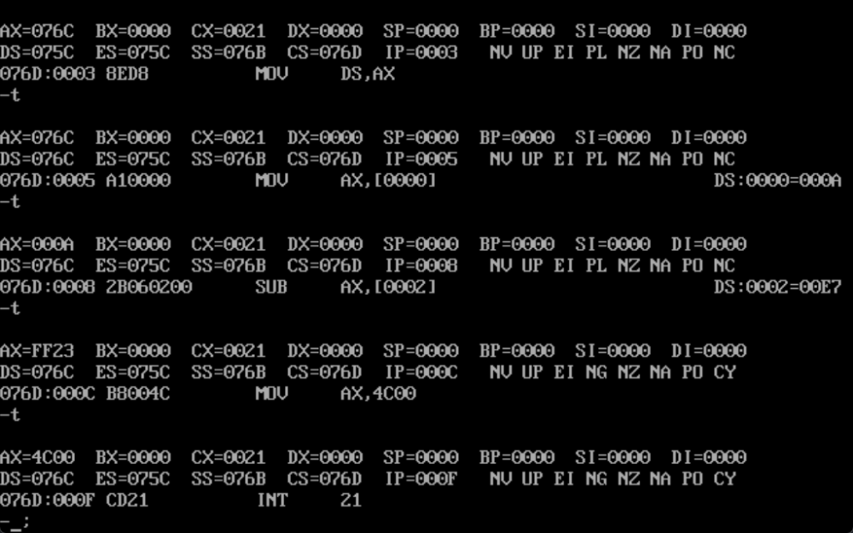

data segment  
 num1 dw 00001010b  
 num2 dw 11100111b;-25的补码  
 num3 dw ?  
data ends  
code segment  
assume cs:code,ds:data  
 start:mov ax,data  
 mov ds,ax  
 mov ax,num1  
 IMUl num2  
 mov ax,4c00h  
 int 21h  
code ends  
end start

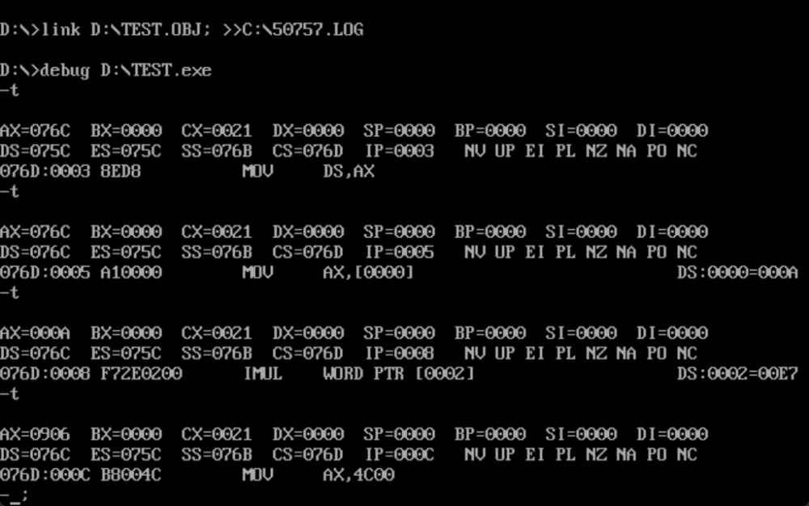

data segment  
 num1 dw 00001010b  
 num2 dw 11100111b;-25的补码  
 num3 dw ?  
data ends  
code segment  
assume cs:code,ds:data  
 start:mov ax,data  
 mov ds,ax  
 mov ax,num1  
 Idiv num2  
 mov ax,4c00h  
 int 21h  
code ends  
end start

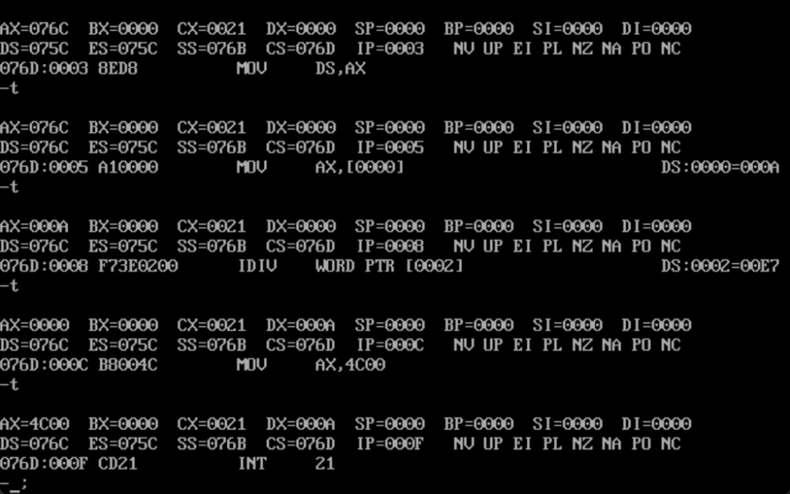

# 交换指令:

## XCHG指令实现：

data segment  
 num1 dw 00001010b  
 num2 dw 11100111b;-25的补码  
data ends  
  
code segment  
assume cs:code,ds:data  
 start:  
 mov ax,num1  
 mov bx,num2  
 xchg ax,bx  
 mov ax,4c00h  
 int 21h  
code ends  
end start

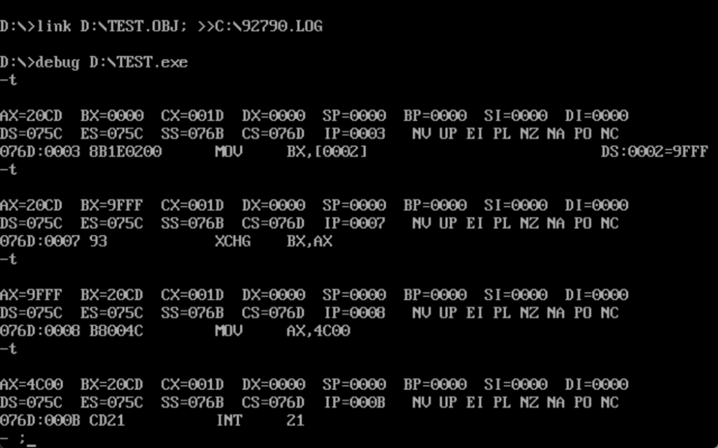

## XOR指令实现：

data segment  
 num1 dw 0011h  
 num2 dw 0022h  
data ends  
  
code segment  
assume cs:code,ds:data  
 start:   
 mov ax,num1;  
 mov bx,num2;  
   
 xor ax,bx  
 xor bx,ax  
 xor ax,bx  
   
  
 mov ax,4c00h  
 int 21h  
code ends  
end start

