**Assignments -- Chapter 1&2**

1. The performance of a client-server system is strongly influenced by two major network characteristics: the bandwidth of the network (that is, how many bits/sec it can transport) and the latency (that is, how many seconds it takes for the first bit to get from the client to the server). Give an example of a network that exhibits high bandwidth but also high latency. Then give an example of one that has both low bandwidth and low latency.

A transcontinental fiber link might have many gigabits/sec of bandwidth, but the latency will also be high due to the speed of light propagation over thousands of kilometers. In contrast, a 56-kbps modem calling a computer in the same building has low bandwidth and low latency.

横贯大陆的光纤连接可以有很多千兆位/秒带宽， 但是由于光速度传送要越过数

千公里，时延将也高。

相反，使用 56 kbps 调制解调器呼叫在同一大楼内的计算机则有低带宽和较低的

时延。

1. What are two reasons for using layered protocols? What is one possible disadvantage of using layered protocols?

Among other reasons for using layered protocols, using them leads to breaking up the design problem into smaller, more manageable pieces, and layering means that protocols can be changed without affecting higher or lower ones. One possible disadvantage is the performance of a layered system is likely to be worse than the performance of a monolithic system, although it is extremely difficult to implement and manage a monolithic system.

通过协议分层可以把设计问题划分成较小的易于处理的片段

分层意味着某一层的协议的改变不会影响高层或低层的协议

1. What is the principal difference between connectionless communication and connection-oriented communication?

主要的区别有两条。

其一：面向连接通信分为三个阶段，第一是建立连接，在此阶段，发出一个建立连接的请求。第二阶段，只有在连接成功建立之后，保持连接状态，才能开始数据传输。第三阶段，当数据传输完毕，必须释放连接。而无连接通信没有这么多阶段，它直接进行数据传输。

其二：面向连接的通信具有数据的保序性，

而无连接的通信不能保证接收数据的

顺序与发送数据的顺序一致。

1. In some networks, the data link layer handles transmission errors by requesting damaged frames to be retransmitted. If the probability of a frame's being damaged is p, what is the mean number of transmissions required to send a frame? Assume that acknowledgements are never lost.

假设某帧传到第 k 次才传输成功，起初 k-1 次传输皆尝试失败，概率为 p k-1 , 第 k

次传输成功，概率为(1-*p*) ，则发送一帧成功的平均传输次数为：



1. Which of the OSI layers and TCP/IP layers handles each of the following:

(a) Dividing the transmitted bit stream into frames.

(b) Determining which route through the subnet to use.

把传输的比特流划分为帧——数据链路层

决定使用哪条路径通过子网——网络层.

1. An image is 1024*768 pixels with 3 bytes/pixel. Assume the image is uncompressed. How long does it take to transmit it over a 56-kbps modem channel? Over a 1-Mbps cable modem? Over a 10-Mbps Ethernet? Over 100-Mbps

该图像大小为 1024 * 768 * 3 * 8 = 18,874,368 bits.

传输速率为 56Kbits/sec，需要 18,874,368 / 56,000 = 337.042 sec.

传输速率为 1Mbits/sec， 需要 18,874,368 / 106 = 18.874 sec.

传输速率为 10Mbits/sec，需要 18,874,368 / 107 = 1.887 sec.

传输速率为 100Mbits/sec，需要 18,874,368 / 108 = 0.189 sec.

1. Television channels are 6 MHz wide. How many bits/sec can be sent if four-level digital signals are used? Assume a noiseless channel.

依题有带宽 H = 6MHz，每次采样 log2V = 2bit

由尼奎斯特定理，可发送的最大数据传输率为 2Hlog2V = 24Mbps。

1. If a binary signal is sent over a 3-kHz channel whose signal-to-noise ratio is 20 dB, what is the maximum achievable data rate?

由香农定理信道比为 S/N 的有噪声信道的最大数据传输率 = Hlog2(1+S/N)。

依题知带宽 H = 3kHz，信噪比为 10lgS/N = 20 dB，知 S/N =100

由于 log2101≈6.658，该信道的信道容量为 3log2(1+100)=19.98kbps

再根据尼奎斯特定理，发送二进制信号的 3kHz 信道的最大数据传输速率为

2Hlog2V = 2*3 log22 = 6kbps 综上，可以取得的最大数据传输速率为 6kbps。

1. How much bandwidth is there in 0.1 micron of spectrum at a wavelength of 1 micron?



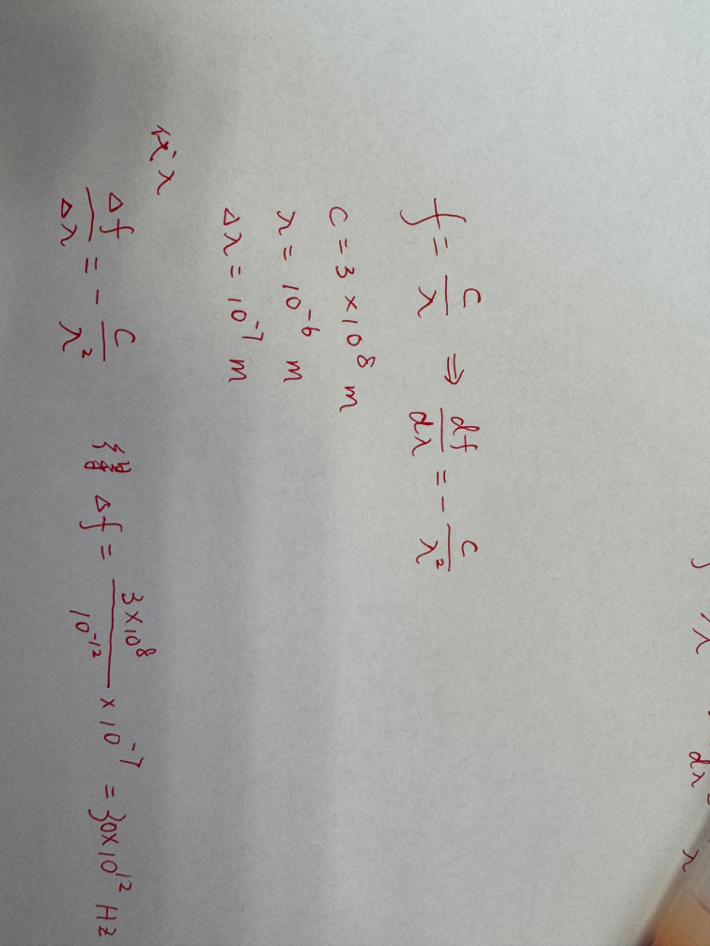

1. A simple telephone system consists of two end offices and a single toll office to which each end office is connected by a 1-MHz full-duplex trunk. The average telephone is used to make four calls per 8-hour workday. The mean call duration is 6 min. Ten percent of the calls are long-distance (i.e., pass through the toll office). What is the maximum number of telephones an end office can support? (Assume 4 kHz per circuit.)

每部电话每小时做 0.5 次通话，每次通话 6 分钟。因此一部电话每小时占用一条

电路 3 分钟，60/3=20，即 20 部电话可共享一条线路。由于只有 10%的呼叫是长途，

所以 200 部电话占用一条完全时间的长途线路。局间干线复用了 1000000/4000=250

条线路，每条线路支持 200 部电话，因此，一个端局可以支持的电话部数为

200*250=50000。.

1. Compare the delay in sending an x-bit message over a k-hop path in a circuit-switched network and in a (lightly loaded) packet-switched network. The circuit setup time is s sec, the propagation delay is d sec per hop, the packet size is p bits, and the data rate is b bps. Under what conditions does the packet network have a lower delay?

对于电路交换，

t= s 时电路建立起来；

t＝s+x/b 时报文的最后一位发送完毕；

t= s+x/b+kd 时报文到达目的地。

而对于分组交换，最后一位在 t=x/b时发送完毕。

为到达最终目的地，最后一个分组必须被中间的路由器重发 k-1 次，每次重发花

时间 p/b，所以总的延迟为



故s>(k-1)p/b

1. Ten signals, each requiring 4000 Hz, are multiplexed on to a single channel using FDM. How much minimum bandwidth is required for the multiplexed channel? Assume that the guard bands are 400 Hz wide.

对于 10 个 4000 Hz 的信号，我们需要使用 9 个防护频段来避免可能的干扰。

所需要的最小带宽为 4000 * 10 + 400 * 9 = 43,600 Hz