**Assignments -- Chapter 4**

1. A group of N stations share a 56-kbps pure ALOHA channel. Each station outputs a 1000-bit frame on an average of once every 100 sec, even if the previous one has not yet been sent (e.g., the stations can buffer outgoing frames). What is the maximum value of N?

对于纯的 ALOHA，信道利用率为 1/e 2 = 0.184，可用的带宽是 0.184×56 Kb/s =10.304 Kb/ s。每个站需要的带宽为 1000/100=10b/s。而 N=10304/10≈1030 所以，最多可以有 1030 个站，即 N 的最大值为 1030。

1. Consider the delay of pure ALOHA versus slotted ALOHA at low load. Which one is less? Explain your answer.（E）

对于纯的 ALOHA，发送可以立即开始。对于分隙的 ALOHA，它必须等待下一个 时隙。这样，平均会引入半个时隙的延迟。因此，纯 ALOHA 的延迟比较小。

1. The wireless LANs that we studied used protocols such as MACA instead of using CSMA/CD. Under what conditions, if any, would it be possible to use CSMA/CD instead?

如果所有站的发射有效范围都很大，以至于任一站都可以收到所有其他站发送的 信号，那么任一站都可以与其他站以广播方式通信。在这样的条件下，CSMA/CD 可 以工作的很好。

1. Consider building a CSMA/CD network running at 1 Gbps over a 1-km cable with no repeaters. The signal speed in the cable is 200,000 km/sec. What is the minimum frame size?

对于 1km 电缆，单程传播时间为 1/200000 =5×10 -6 s=5us ，往返传播时间为 2t =10us 。为了能够按照 CSMA/CD 工作，最小帧的发射时间不能小于 10us 。以 1Gb/s 速率工作，10us可以发送的比特数等于：（10*10 -6）/（1*10 -9）=10000 因此，最小帧是 10000 bit = 1250 字节。

1. An IP packet to be transmitted by Ethernet is 60 bytes long, including all its headers. If LLC is not in use, is padding needed in the Ethernet frame, and if so, how many bytes?

最小的以太网帧是 64 bytes，包含了以太网地址帧头，类型/长度域，以及校验和。由于帧头域占用 18 bytes，并且分组是 60 bytes，总帧长是 78 bytes，这已经超过了64-byte 的最小限制。 因此，不必再填充了

1. Four stations, A, B, C, and D, are shown. Which of the last two stations do you think is closest to A and why?

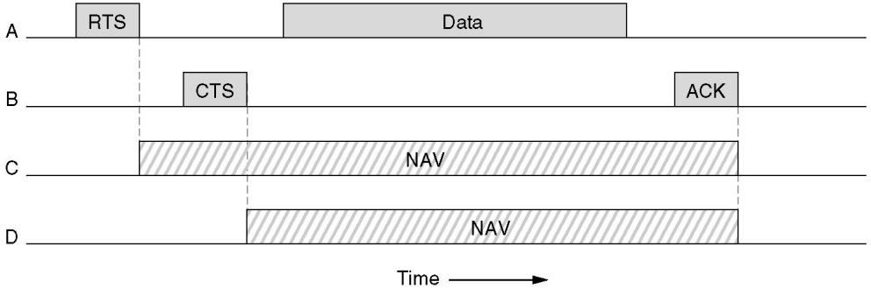

站 C 最接近 A。因为 C 最先听到 A 发出的 RTS 并且通过插入一个 NAV 信号作 为回应。D 对其没有回应，说明它不在 A 的频率范围内。

1. Consider the extended LAN connected using bridges B1 and B2 in following figure. Suppose the hash tables in the two bridges are empty. List all ports on which a packet will be forwarded for the following sequence of data transmissions:

(a) A sends a packet to C.

(b) E sends a packet to F.

(c) F sends a packet to E.

(d) G sends a packet to E.

(e) D sends a packet to A.

(f) B sends a packet to F

.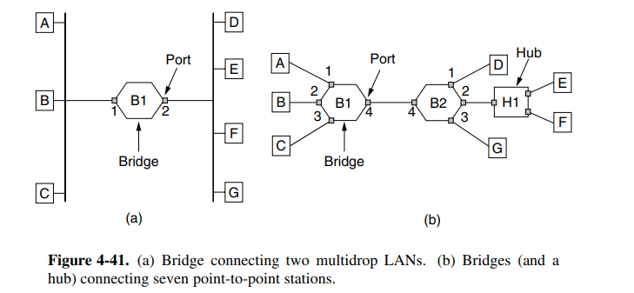

1. 所有端口
2. 所有端口
3. 端口B2-2接收，不转发
4. 端口B2-2
5. 端口B2-4，端口B1-1
6. 端口B1-4，端口B2-2
7. To make VLANs work, configuration tables are needed in the bridges. What if the VLANs of Fig. 4-47 used hubs rather than switches? Do the hubs need configuration tables, too? Why or why not?

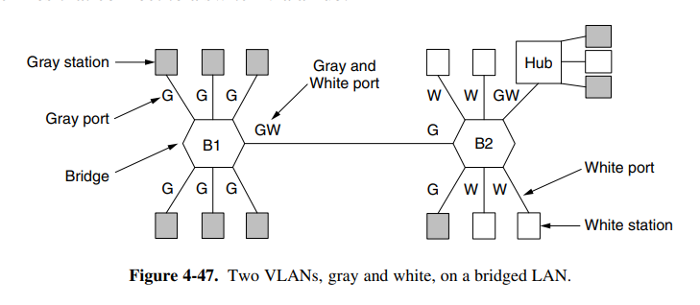

不需要，集线器只是将所有的输入线收集在一起，并没有进行配置。在集线器中 不做路由，进入到集线器的每一帧分发到所有其它的线路上。

1. What is the baud rate of the standard 10-Mbps Ethernet?

以太网使用曼彻斯特编码，这就意味着发送的每一位都有两个信号周期。标准以 太网的数据率为 10Mb/s，因此波特率是数据率的两倍，即 20MBaud。