**Assignments -- Chapter 4**

1. A group of N stations share a 56-kbps pure ALOHA channel. Each station outputs a 1000-bit frame on an average of once every 100 sec, even if the previous one has not yet been sent (e.g., the stations can buffer outgoing frames). What is the maximum value of N?
2. Consider the delay of pure ALOHA versus slotted ALOHA at low load. Which one is less? Explain your answer.（E）
3. The wireless LANs that we studied used protocols such as MACA instead of using CSMA/CD. Under what conditions, if any, would it be possible to use CSMA/CD instead?
4. Consider building a CSMA/CD network running at 1 Gbps over a 1-km cable with no repeaters. The signal speed in the cable is 200,000 km/sec. What is the minimum frame size?
5. An IP packet to be transmitted by Ethernet is 60 bytes long, including all its headers. If LLC is not in use, is padding needed in the Ethernet frame, and if so, how many bytes?
6. Four stations, A, B, C, and D, are shown. Which of the last two stations do you think is closest to A and why?

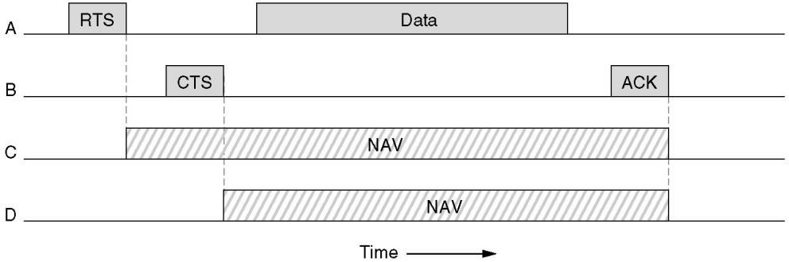

1. Consider the extended LAN connected using bridges B1 and B2 in following figure. Suppose the hash tables in the two bridges are empty. List all ports on which a packet will be forwarded for the following sequence of data transmissions:

(a) A sends a packet to C.

(b) E sends a packet to F.

(c) F sends a packet to E.

(d) G sends a packet to E.

(e) D sends a packet to A.

(f) B sends a packet to F

.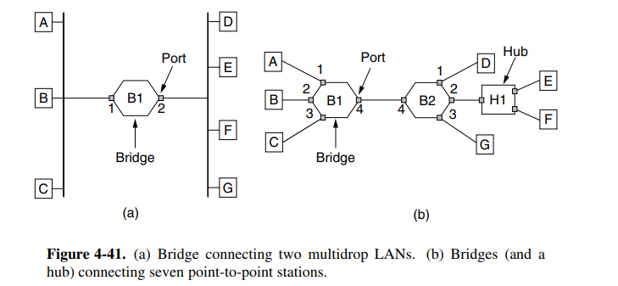

1. To make VLANs work, configuration tables are needed in the bridges. What if the VLANs of Fig. 4-47 used hubs rather than switches? Do the hubs need configuration tables, too? Why or why not?

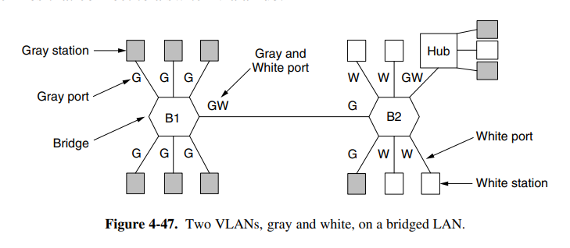

1. What is the baud rate of the standard 10-Mbps Ethernet?