**Assignments -- Chapter 5**

1. Datagram subnets route each packet as a separate unit, independent of all others. Virtual-circuit subnets do not have to do this, since each data packet follows a predetermined route. Does this observation mean that virtual-circuit subnets do not need the capability to route isolated packets from an arbitrary source to an arbitrary destination? Explain your answer.

不对。为了使分组能从任意源到达任意目的地，连接建立时要选择路由，虚电路 网络也需要这一能力。

1. Consider the network of Fig. 5-7, but ignore the weights on the lines. Suppose that it uses flooding as the routing algorithm. If a packet sent by A to D has a maximum hop count of 3, list all the routes it will take.

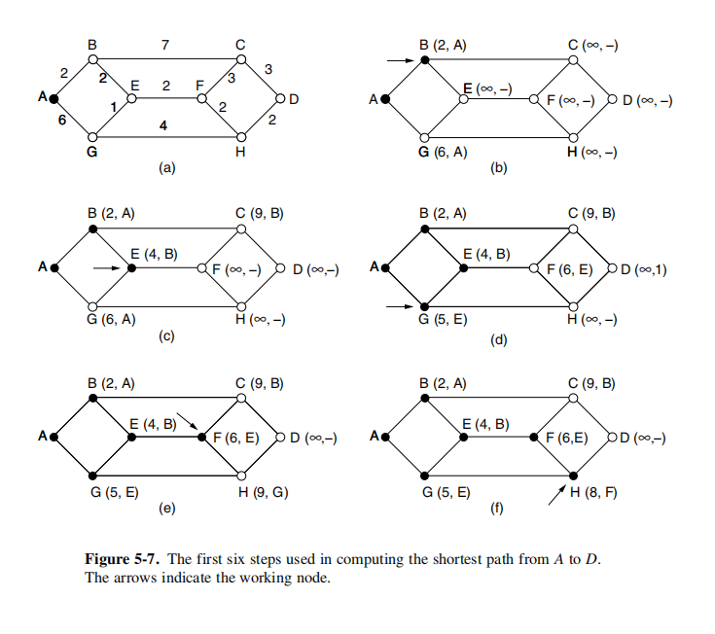

所有的路由选择如下：ABCD, ABCF, ABEF, ABEG, AGHD, AGHF, AGEB, and AGEF

1. Consider the subnet of Fig. 5-12(a), but ignore the weights on the lines. Distance vector routing is used, and the following vectors have just come in to router C: from B: (5, 0, 8, 12, 6, 2); from D: (16, 12, 6, 0, 9, 10); and from E: (7, 6, 3, 9, 0, 4). The measured delays to B, D, and E, are 6, 3, and 5, respectively. What is C's new routing table? Give both the outgoing line to use and the expected delay.

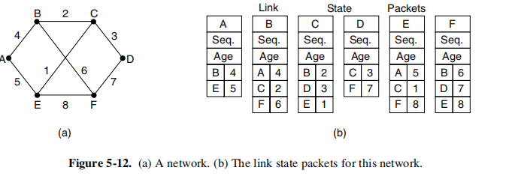

A B C D E F

通过 B 给出（11，6，14，18，12，8）

通过 D 给出（19，15，9，3，12，13）

通过 E 给出（12，11，8，14，5，9）

取到达每一目的地的最小值（C 除外）得到：（11，6，0，3，5，8）

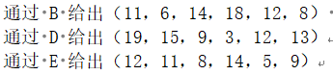

输出线路是：（B，B，-，D，E，B）

1. If delays are recorded as 8-bit numbers in a 50-router network, and delay vectors are exchanged twice a second, how much bandwidth per (full-duplex) line is chewed up by the distributed routing algorithm? Assume that each router has three lines to other routers.

路由表的长度等于 8*50=400bit。该表每秒钟在每条线路上发送 2 次，因此 400*2=800b/s，即在每条线路的每个方向上消耗的带宽都是 800 bps

1. For hierarchical routing with 4800 routers, what region and cluster sizes should be chosen to minimize the size of the routing table for a three-layer hierarchy? A good starting place is the hypothesis that a solution with k clusters of k regions of k routers is close to optimal, which means that k is about the cube root of 4800 (around 16). Use trial and error to check out combinations where all three parameters are in the general vicinity of 16.

依题可选择 15 个群、16 个区，每个区 20 个路由器时，即使得 4800=15*16*20， 这时每个路由器需要 20 个表项记录本地路由器，15 个表项记录用于到同一群内其 它区的路由，14 个表项用于远程的群，这时路由表尺寸最小为 20+15+14。