**Assignments -- Chapter 5**

1. Datagram subnets route each packet as a separate unit, independent of all others. Virtual-circuit subnets do not have to do this, since each data packet follows a predetermined route. Does this observation mean that virtual-circuit subnets do not need the capability to route isolated packets from an arbitrary source to an arbitrary destination? Explain your answer.
2. Consider the network of Fig. 5-7, but ignore the weights on the lines. Suppose that it uses flooding as the routing algorithm. If a packet sent by A to D has a maximum hop count of 3, list all the routes it will take.

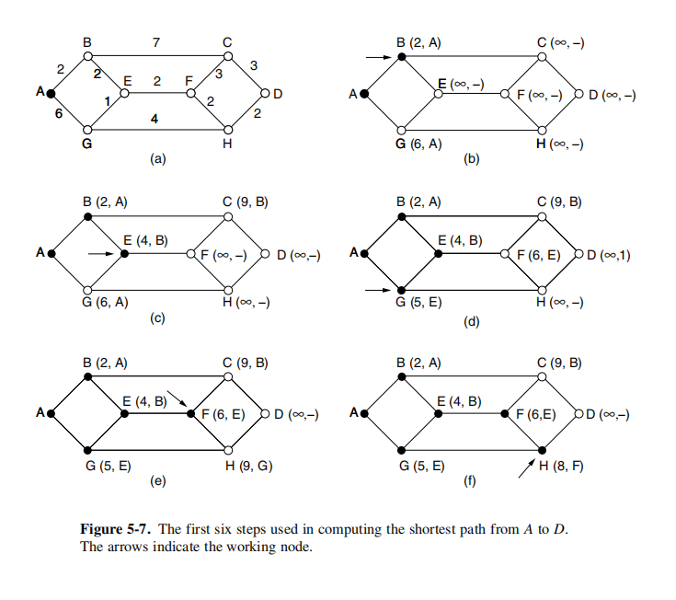

1. Consider the subnet of Fig. 5-12(a), but ignore the weights on the lines. Distance vector routing is used, and the following vectors have just come in to router C: from B: (5, 0, 8, 12, 6, 2); from D: (16, 12, 6, 0, 9, 10); and from E: (7, 6, 3, 9, 0, 4). The measured delays to B, D, and E, are 6, 3, and 5, respectively. What is C's new routing table? Give both the outgoing line to use and the expected delay.

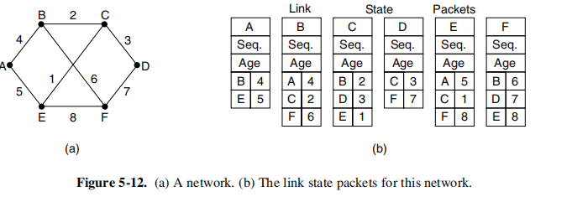

1. If delays are recorded as 8-bit numbers in a 50-router network, and delay vectors are exchanged twice a second, how much bandwidth per (full-duplex) line is chewed up by the distributed routing algorithm? Assume that each router has three lines to other routers.
2. For hierarchical routing with 4800 routers, what region and cluster sizes should be chosen to minimize the size of the routing table for a three-layer hierarchy? A good starting place is the hypothesis that a solution with k clusters of k regions of k routers is close to optimal, which means that k is about the cube root of 4800 (around 16). Use trial and error to check out combinations where all three parameters are in the general vicinity of 16.