**Assignments -- Chapter 5-2**

1. As an intermediate device, what is the difference between a repeater, a network bridge, a router, and a gateway?

1)转发器、网桥、路由器、和网关所在的层次不同。

转发器是物理层的中继系统。

网桥是数据链路层的中继系统。

路由器是网络层的中继系统。

在网络层以上的中继系统为网关。

2)当中继系统是转发器或网桥时，一般并不称之为网络互连，因为仍然是一个网络。路由器其实是一台专用计算机，用来在互连网中进行路由选择。一般讨论的互连网都是指用路由器进行互连的互连网络。

1. Suppose that host A is connected to a router R1, R1 is connected to another router, R2, and R2 is connected to host B. Suppose that a TCP message that contains 900 bytes of data and 20 bytes of TCP header is passed to the IP code at host A for delivery to B. Show the Total length, Identification(ID = x), DF, MF, and Fragment offset fields of the IP header in each packet transmitted over the three links. Assume that link A-R1 can support a maximum frame size of 1024 bytes including a 14-byte frame header, link R1-R2 can support a maximum frame size of 512 bytes, including an 8-byte frame header, and link R2-B can support a maximum frame size of 512 bytes including a 12-byte frame header.

.

在 最初的 IP 数据报会被分割成两个 IP 数据报，以后不会再分割了。

链路 A-R1：Length = 940; ID = x; DF = 0; MF = 0; Offset = 0

链路 R1-R2：

(1) Length = 500; ID = x; DF = 0; MF = 1; Offset = 0

(2) Length = 460; ID = x; DF = 0; MF = 0; Offset = 60

链路 R2-B:

(1) Length = 500; ID = x; DF = 0; MF = 1; Offset = 0

(2) Length = 460; ID = x; DF = 0; MF = 0; Offset = 60

1. A large number of consecutive IP address are available starting at 198.16.0.0. Suppose that four organizations, A, B, C, and D, request 4000, 2000, 4000, and 8000 addresses, respectively, and in that order. For each of these, give the first IP address assigned, the last IP address assigned, and the mask in the w.x.y.z/s notation.

始地址，尾地址，和子网掩码如下：

A：198.16.0.0 –198.16.15.255 子网写作 198.16.0.0/20

B：198.16.16.0 – 198.16.23.255 子网写作 198.16.16.0/21

C：198.16.32.0 – 198.16.47.255 子网写作 198.16.32.0/20

D：198.16.64.0 – 198..16.95.255 子网写作 198.16.64.0/19

1. 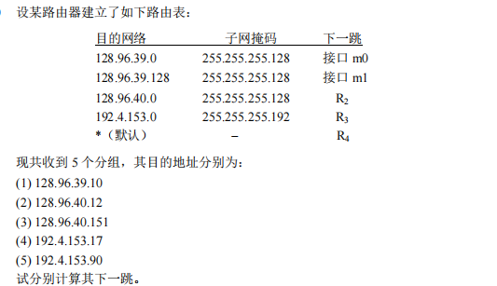

(1)分组的目的站IP地址为:128.96.39.10。先与子网掩码 255.255.255.128相与，得128.96.39.0，可见该分组经接口0转发。

(2)分组的目的 IP地址为:128.96.40.12。与子网掩码 255.255.255.128相与得 128.96.40.0，不等于 128.96.39.0。3与子网掩码 255.255.255.128相与得 128.96.40.0，经查路由表可知，该项分组经 R2 转发。

(3)分组的目的 IP地址为:128.96.40.151，与子网掩码 255.255.255.128 相与后得128.96.40.128，与子网掩码 255.255.255.192 相与后得 128.96.40.128，经查路由表知，该分组转发选择默认路由，经 R4 转发。

(4)分组的目的 IP地址为:192.4.153.17。与子网掩码 255.255.255.128 相与后得192.4.153.0。与子网掩码 255.255.255.192 相与后得 192.4.153.0，经查路由表知，该分组经 R3 转发。

(5)分组的目的 IP地址为:192.4.153.90，与子网掩码 255.255.255.128 相与后得192.4.153.0。与子网掩码 255.255.255.192相与后得192.4.153.64，经查路由表知，该分组转发选择默认路由，经 R4 转发

1. 