**Assignments -- Chapter 5-2**

1. As an intermediate device, what is the difference between a repeater, a network bridge, a router, and a gateway?
2. Suppose that host A is connected to a router R1, R1 is connected to another router, R2, and R2 is connected to host B. Suppose that a TCP message that contains 900 bytes of data and 20 bytes of TCP header is passed to the IP code at host A for delivery to B. Show the Total length, Identification(ID = x), DF, MF, and Fragment offset fields of the IP header in each packet transmitted over the three links. Assume that link A-R1 can support a maximum frame size of 1024 bytes including a 14-byte frame header, link R1-R2 can support a maximum frame size of 512 bytes, including an 8-byte frame header, and link R2-B can support a maximum frame size of 512 bytes including a 12-byte frame header.

.

1. A large number of consecutive IP address are available starting at 198.16.0.0. Suppose that four organizations, A, B, C, and D, request 4000, 2000, 4000, and 8000 addresses, respectively, and in that order. For each of these, give the first IP address assigned, the last IP address assigned, and the mask in the w.x.y.z/s notation.
2. 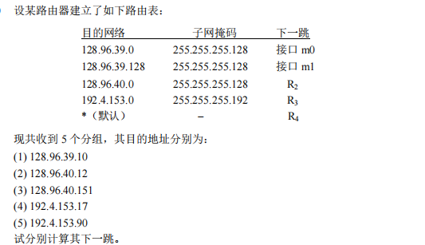
3. 