**Assignments -- Chapter 5**

1. A network on the Internet has a subnet mask of 255.255.240.0. What is the maximum number of hosts it can handle?

参考答案：

24010=111100002

The mask is 20 bits long, so the network part is 20 bits. The remaining 12 bits are for the host, so 4096 host addresses exist.

2. The IP address space of a network is 192.168.5.0/24, which is divided by fixed length subnet, and the subnet mask is 255.255.255.248. (1) What are the maximum number of subnets and the maximum number of allocable addresses in each subnet? (2) Please give the addresses of the first four subnets.

参考答案

1. The IP address space of a network is 192.168.5.0/24

**XXXXXXXX XXXXXXXX XXXXXXXX** XXXXX**XXX**

the subnet mask is 255.255.255.248

**11111111 11111111 11111111** 11111**000**

Therefore

The maximum number of subnets is 32

the maximum number of allocable addresses in each subnet is 23-2=6

1. the addresses of the first four subnets

**192.168.5.0 192.168.5.00000XXX (000 – 111)**

**192.168.5.8 192.168.5.00001XXX (000 – 111)**

**192.168.5.16 192.168.5.00010XXX (000 – 111)**

**192.168.5.24 192.168.5.00011XXX (000 – 111)**

3. A large number of consecutive IP address are available starting at 198.16.0.0. Suppose that four organizations, *A*, *B*, *C*, and *D*, request 4000, 2000, 4000, and 8000 addresses, respectively, and in that order. For each of these, give the first IP address assigned, the last IP address assigned, and the mask in the w.x.y.z/s notation.

参考答案

To start with, “all the requests are rounded up to a power of two”. That is, the number of addresses actually assigned to a organization must be an exponential power of 2. This is determined by the number of digits of the network prefix; The network prefix bits of address blocks assigned to the same organization should be the same.

Organizations *A, B, C* and *D* want to have 4000, 2000, 4000, and 8000 addresses, respectively, so the address for them must have a *host-id* of 12, 11, 12 and 13 bits long,

the *net-prefix* is 20, 21, 20, 19 bits long, respectively.

**Organization *A*** wants 4000 addresses, so the host address should be 12 bits (212 = 4096) , written as 198.16.0.0/20. Since 4000 / 256 = 15.625, the last address is 198.16.15.255. *i.e.*

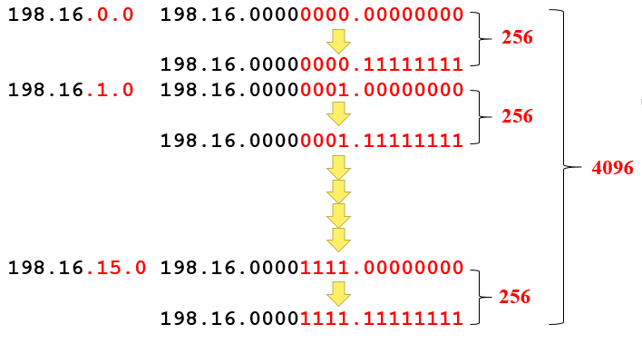

The first IP address assigned: 198.16.0.0, the last IP address assigned: 198.16.15.255, written as 198.16.0.0/20

Therefore, The starting address, ending address, and mask are as follows:

A: **198.16.0.0 –198.16.15.255,** written as 198.16.0.0/20

B: **198.16.16. 0--198.16.23.255,** written as 198.16.16. 0/21

C: **198.16.32. 0--198.16.47.255,** written as 198.16.32. 0/20;

D: **198.16.64. 0--198.16.95.255**, written as 198.16.64. 0/19

4. The topology of a network is shown in the figure below. Router *R1* only has routes to the subnet 192.168.1.0/24.

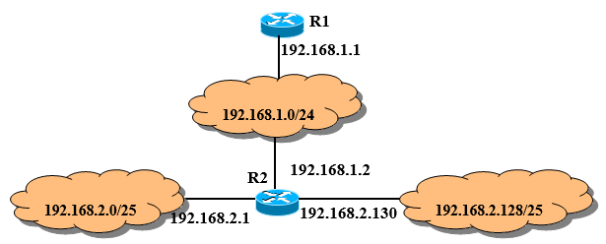

To enable *R1* to route IP packets correctly to all subnets in the graph, an additional routing table entry (destination network, subnet mask, next hop) in *R1* is

1. **192.168.2.0 255.255.255.128 192.168.1.1**
2. **192.168.2.0 255.255.255.0 192.168.1.1**
3. **192.168.2.0 255.255.255.128 192.168.1.2**
4. **192.168.2.0 255.255.255.0 192.168.1.2**

参考答案 **D**

5. A router has just received the following new IP addresses: 57.6.96.0/21, 57.6.104.0/21, 57.6.112.0/21, and 57.6.120.0/21. If all of them use the same outgoing line, can they be aggregated? If so, to what? If not, why not?

参考答案

They can be aggregated to 57.6.96/19. The reasons are as follows.

096 0110 0000

104 0110 1000

112 0111 0000

120 0111 1000

Therefore, the common prefix of four address blocks: 57.6.011* ****

6. A router has the following (CIDR) entries in its routing table:

|  |  |
| --- | --- |
| Address/mask | Next hop |
| 135.46.56.0/22 | Interface 0 |
| 135.46.60.0/22 | Interface 1 |
| 192.53.40.0/23 | Router 1 |
| default | Router 2 |

For each of the following IP addresses, what does the router do if a packet with that address arrives?

a. (a) 135.46.63.10

b. (b) 135.46.57.14

c. (c) 135.46.52.2

d. (d) 192.53.40.7

e. (e) 192.53.56.7

参考答案

The packets are routed as follows:

(a) Interface 1

(b) Interface 0

(c) Router 2

(d) Router 1

(e) Router 2