DigiWallet – Your Smart Wallet

**Category:** Smart Wearables

**Problem Statement & Solution:** Ever misplaced your wallet? Or Lost your Wallet? Have a habit of forgetting it behind?

Now don’t worry about losing or misplacing your wallet, coz we are introducing Digiwallet- your smart wallet. Your wallet will now be friend with your smartphone.

**Components:   
 DigiWallet**

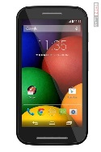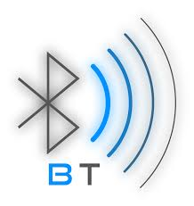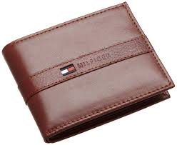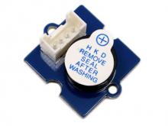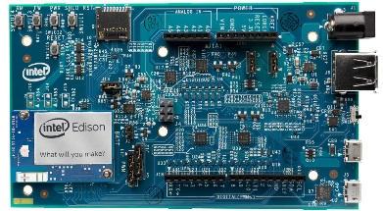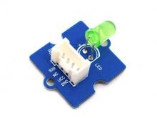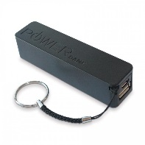

Wallet Power Source

Smart Phone  
 with DigiWalletApp Buzzer Module  
 communicating over  
 Bluetooth

LED Module

Intel Edison Board

**Features:**

* Pair your wallet with your smart phone, using Bluetooth.
* Get notification on your phone if your wallet is out of range.
* Locate your wallet from your smartphone app by pressing the locate button. This will trigger the buzzer on the wallet.

**System Flow:**

1. Smart Wallet Setup: We will stick an ordinary wallet with the Intel Edison Board, connected with a Buzzer and Led module.
2. DigiWallet Mobile App will do the Bluetooth pairing with Intel Edison board. Now the Smartphone and DigiWallet will be in constant connection.
3. If the wallet is out of the Bluetooth range, the DigiWallet app will send an alert to the user, that it has been lost.
4. If the wallet is misplaced within the range, the user can use Locate feature to trigger the buzzer alarm and led on the DigiWallet.

**Technical Specifications:**

|  |  |
| --- | --- |
| Board | Intel Edison |
| BLE Module | Bluetooth 4.0 |
| Bluetooth Range | 10m |
| Buzzer Module | Grove Buzzer |
| LED Module | Grove LED |
| Power Consumption |  |
| Power Source |  |
| Android App Compatibility | Android 4.3 or higher |

**Advance Features:**

* GPS tracking of DigiWallet, logging all the location details where the wallet was opened & last used. This will also help in locating the wallet using google maps.
* Alert if the wallet is Empty (No money in the wallet)
* Alert if the Cards are missing from the card slot.

**Resources:**

<http://www.dfrobot.com/index.php?route=DFblog/blog&id=178>  
  
Bluetooth PXP: https://developer.bluetooth.org/TechnologyOverview/Pages/PXP.aspx

Intel:

<https://software.intel.com/en-us/articles/intel-edison-board-getting-started-with-bluetooth>

<https://github.com/mashery/edison-guides/wiki/Configure-Intel-Edison-for-BLE---Bluetooth-Smart-Development>

[https://communities.intel.com/search.jspa?q=bluetooth*&facet=content&place=%2Fplaces%2F247185](https://communities.intel.com/search.jspa?q=bluetooth*&facet=content&place=%2Fplaces%2F247185)

<https://software.intel.com/en-us/articles/connecting-to-intel-edison-from-android-with-bluetooth-le-ble>

<http://www.digit.in/apps/how-do-i-connect-from-my-android-phone-to-intel-edison-using-bluetooth-25308.html>

<http://blog.dimitridiakopoulos.com/2014/09/10/hands-on-intel-edison/>