得到一个 SensorManager（磁场传感器）对象
SensorManager mSensorManager = (SensorManager)
getSystemService(SENSOR_SERVICE);
注册传感器
boolean result = mSensorManager.registerListener(this, sensors,
SensorManager.SENSOR_DELAY_FASTEST);
取消传感器注册
mSensorManager.unregisterListener(this);
SensorEventListener 有两个接口方法
在传感器值更改时调用
onSensorChanged(SensorEvent event);
SensorEvent 对象包括一组浮点数
float x = event.values[SensorManager.DATA_X];
float y = event.values[SensorManager.DATA_Y];
25
float z = event.values[SensorManager.DATA_Z];
在传感器的精准度发生改变时调用
参数 accuracy 表示传感器新的准确值
onAccuracyChanged(Sensor sensor, int accuracy)

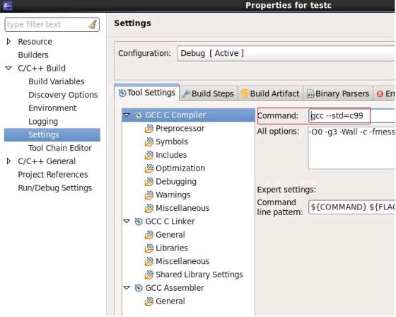

主要事件（数值反馈）源代码：
package com.kc.Sensor;
import android.app.ActionBar;
import android.app.Activity;
import android.content.Context;
import android.hardware.Sensor;
import android.hardware.SensorEvent;
import android.hardware.SensorEventListener;
import android.hardware.SensorManager;
import android.os.Bundle;
import android.widget.TextView;
public class MainActivity extends Activity implements SensorEventListener {
26
private TextView etOrientation, etMagnetic, etTemerature, etLight, etPressure;
private SensorManager sensorManager;
DialChart05View chart5 = null;
@Override
protected void onCreate(Bundle savedInstanceState) {
super.onCreate(savedInstanceState);
// 得到 ActionBar
ActionBar actionBar = getActionBar();
// 隐藏
actionBar.hide();
setContentView(R.layout.activity_main);
//初始化 UI 控件
etTemerature = (TextView) findViewById(R.id.etTemerature);
etLight = (TextView) findViewById(R.id.etLight);
chart5 = (DialChart05View)findViewById(R.id.circle_view2);
// 获取真机的传感器管理服务
// sensorManager = (SensorManager) getSystemService(Context.SENSOR_SERVICE);
// 获取传感器模拟器的传感器管理服务
sensorManager = (SensorManager) getSystemService(Context.SENSOR_SERVICE);
//Sensor sensor = sensorManager.getDefaultSensor(Sensor.TYPE_ALL);
// SwitchButton sb = (SwitchButton) findViewById(R.id.wiperSwitch1);
// sb.setOnChangeListener(new OnChangeListener() {
//
// @Override
// public void onChange(SwitchButton sb, boolean state) {
// if (state==true) {
// start();
// }else {
// onPause();
// }
//// Log.d("switchButton", state ? "开":"关");
//// Toast.makeText(MainActivity.this, state ? " 开 ":" 关 ",
Toast.LENGTH_SHORT).show();
// }
// });
}
public void start(){
// 为系统的磁场传感器注册监听器
sensorManager.registerListener(this,
sensorManager.getDefaultSensor(Sensor.TYPE_MAGNETIC_FIELD),
SensorManager.SENSOR_DELAY_GAME);
// 为系统的光传感器注册监听器
27
sensorManager.registerListener(this,
sensorManager.getDefaultSensor(Sensor.TYPE_LIGHT),
SensorManager.SENSOR_DELAY_GAME);
}
@Override
protected void onResume() {
// if (SwitchButton.mSwitchOn==true) {
start();
// }
super.onResume();
}
@Override
protected void onStop() {
// 程序退出时取消注册传感器监听器
sensorManager.unregisterListener(this);
super.onStop();
}
@Override
protected void onPause() {
// 程序暂停时取消注册传感器监听器
sensorManager.unregisterListener(this);
super.onPause();
}
@Override
protected void onDestroy() {
// 程序销毁时取消注册传感器监听器
sensorManager.unregisterListener(this);
super.onDestroy();
}
@Override
public void onSensorChanged(SensorEvent event) {
float[] values = event.values;
// 真机上获取触发 event 的传感器类型
// Sensor sensorType = event.sensor;
// 模拟器上获取触发 event 的传感器类型
Sensor sensorType = event.sensor;
StringBuilder sb = null;
sb = new StringBuilder();
// 判断是哪个传感器发生改变
28
//光照传感器
if (sensorType == sensorManager.getDefaultSensor(Sensor.TYPE_LIGHT)) {
sb.append("当前光的强度为：");
sb.append(values[0]);
etLight.setText(sb.toString());
}
//磁场传感器
if (sensorType == sensorManager.getDefaultSensor(Sensor.TYPE_MAGNETIC_FIELD))
{
sb.append("X 方向上的电磁通量：");
sb.append(values[0] + "\n");
sb.append("Y 方向上的电磁通量：");
sb.append(values[1] + "\n");
sb.append("Z 方向上的电磁通量：");
sb.append(values[2]);
etTemerature.setText(sb.toString());
float x = Math.abs(values[0]);
float y = Math.abs(values[1]);
float z = Math.abs(values[2]);
}
}
@Override
public void onAccuracyChanged(Sensor sensor, int accuracy) {
}
}
仪表盘动画源代码：
package com.kc.Sensor;
import java.util.ArrayList;
import java.util.List;
import org.xclcharts.chart.DialChart;
import org.xclcharts.view.GraphicalView;
import android.content.Context;
import android.graphics.Canvas;
import android.graphics.Color;
import android.util.AttributeSet;
import android.util.Log;
public class DialChart05View extends GraphicalView {
29
private String TAG = "DialChart05View";
private DialChart chart = new DialChart();
private float mPercentage = 0.1f;
float mP1 = 0.0f;
float mP2 = 0.0f;
public DialChart05View(Context context) {
super(context);
// TODO Auto-generated constructor stub
initView();
}
public DialChart05View(Context context, AttributeSet attrs){
super(context, attrs);
initView();
}
public DialChart05View(Context context, AttributeSet attrs, int defStyle) {
super(context, attrs, defStyle);
initView();
}
private void initView()
{
chartRender();
}
@Override
protected void onSizeChanged(int w, int h, int oldw, int oldh) {
super.onSizeChanged(w, h, oldw, oldh);
chart.setChartRange(w ,h );
}
public void chartRender()
{
try {
//设置标题背景
chart.setApplyBackgroundColor(true);
chart.setBackgroundColor( Color.rgb(28, 129, 243) );
//绘制边框
chart.showRoundBorder();

