 **ACCRA TECHNICAL UNIVERSITY**

**DESIGN AND IMPLEMENTATION OF EMPLOYEE ATTEDANCE AND LEAVE MANAGEMENT SYSTEM FOR ROCKWELL DISTRIUTION COMPANY**

**By**

**MICHAEL QAUICOE**

**(01191303D)**

**CHRISTIANA ARKORFUL**

**(01191304D)**

**CHRISTIAN KUMAH**

**(01194196D)**

**AND**

**ELIJAH AFIDENYO**

**(01191287D)**

**RESEARCH PROJECT REPORT/ THESIS Submitted to the**

**DEPARTMENT OF COMPUTER SCIENCE,**

**FACULTY OF APPLIED SCIENCE,**

**In Partial Fulfilment of the Requirements for the**

**AWARD OF HIGHER NATIONAL DIPLOMA (HND)**

**In**

**COMPUTER SCIENCE**

**MAY, 2022**

# DECLARATION

This project is submitted as part of fulfillment for the award of a **Higher National Diploma** in **Computer Science**: The work is a result of our investigation. All sections of the text and results which have been obtained from other works/ sources are fully referenced. We understand that cheating and plagiarism constitute a breach of Accra Technical University and will be dealt with accordingly.

**NAME SIGNATURE DATE**

**MICHEAEL QAUCOE ……………… ………………**

**(CANDIDATE)**

**CHRISTIANA ARKORFUL ……………… ………………**

**(CANDIDATE)**

**CHRISTIAN KUMAH ……………… ………………**

**(CANDIDATE)**

**ELIJAH AFIDENYO ……………… ……………… (CANDIDATE)**

**DECLARATION BY SUPERVISOR**

I hereby confirm that the above students are HND students in the **Department of Computer Science** under my academic and research supervision in accordance with the requirements in Accra Technical University. The students are currently in their final year of study and are expected to complete in 2022.

**NAME SIGNATURE DATE**

**MR. AGYIRI JOSEPH ……………… ………………**

# 

# DEDICATION

We dedicate this project work to God Almighty in heaven for his immense mercies, protection and direction to us, throughout our stay in school and also to our supervisor and head of the department for their help.

# ACKNOWLEDGMENTS

We wish to express our profound gratitude to our parents for their encouragement and their advice, may God bless them.

Exceptional gratitude goes to our supervisor in the person of Mr. Joseph Agyiriwho was always there for us in time of assistance and advice to make this project a successful one.

We also extend our gratitude to the HOD of the computer science department in the person of Mr. Tony Adegboyiga and other lecturers in these departments.

We will not forget our good friends, well-wishers and loved ones who in one way or the other contributed immensely to the success of this project, we ask almighty God to bless you all Amen.

Table of Contents

**CONTENTS PAGES**

**DECLARATION 1**

**DEDICATION 2**

**ACKNOWLEDGMENTS 3**

**TABLE OF CONTENT 4**

**CHAPTER ONE 6**

**INTRODUCTION 6**

1.1 BACKGROUND OF STUDY 6

1.2 PROBLEM STATEMENT 6

1.2.1 Research Questions 7

1.3 RESEARCH OBJECTIVES 7

1.3.1 Aim of the Project 8

1.4 SIGNIFICANCE OF STUDY 8

1.5 ORGANIZATION OF THE STUDY 8

**CHAPTER TWO** 10

**LITERATURE REVIEW AND LELATED WORKS** 10

2.0 INTRODUCTION 10

OVERVIEW OF ATTENDANCE AND LEAVE MANAGEMENT SYSTEM 10

2.2 CONCEPT OF THE ATTENDANCE AND LEAVE MANAGEMENT SYSTEM 12

2.3 BENEFIT OF ATTENDANCE AND LEAVE MANAGEMENT SYSTEM 12

2.4 REVIEW OF OTHER RELATED WORKS 13

2.5 ANALYSIS OF THE PROPOSED ATTENDANCE AND LEAVE MANAGEMENT SYSTEM 14

2.7 TECHNOLOGY ACCEPTANCE MODEL (TAM) 16

References 17

# 

# CHAPTER ONE

# INTRODUCTION

## 1.1 BACKGROUND OF STUDY

Employees are the backbone of every company therefore their management plays a major role in deciding the success of an organization (Simaanya, 2014). Large, medium and even small sized companies have always implemented a way to be able to manage its employees effectively and such is the employee records. Every organization requires these records to calculate pay, manage workforce and see performance of employees. The effective management of these records ensures sound decisions based on full, accurate and up-to-date information to be made. This also ensures that any decision made can be traced, scrutinized and justified if necessary (J. Phiri, 2016). The ever-changing trend in technology brought the necessity for the automation of everything from paper-and-pen based to absolute computer domination. Management of all these records is a tedious task and a time-consuming process for the Human Resource team which can be solved by using technological processes.

The Human Resource segment have long used such information to track employees’ performance, attendance, incentives, problems etc. to streamline the company’s input and consequently, maximize its productivity, yet there are still potholes that need to be filled. Empirical studies conducted reveals that the attendance management aspect of Employee Management System that keeps track of the presence or absence of an employee from an event or place (Patel & Priya, 2014) need to be updated.

These needs paved way to probe into the employee management system and to add to this debate by focusing on the value of attendant management and the direct effects it has on organizations. Studies specifically relating to attendance management system have shown that, most system have lenient features that check attendance of employees allowing employees do their own thing hence, the need to advance this system to generate various report such as attendance record, monthly attendance record and employee attendance analysis to ensure that the employees are punctual and do their work on time.

## 1.2 PROBLEM STATEMENT

Currently, Rockwell Distribution Company with a total of hundred and five (105) employees at Tema has a membership registration system for managing it employees, this system lacks the essential attribute for proper managing of employees at Rockwell Distribution Company. The system only stores personal information of employees leaving the others manual. Manual handling of employee information at Rockwell Distribution Company poses a number of challenges. This is evident in procedures such as leave management where an employee of Rockwell Distribution Company is required to fill in a form which may take several weeks or months to be approved. Also, most leaves are verbal hence making it difficult to retrieve leave reports of an employee when needed.

Secondly, another problem is observing and recording the attendance of employees in the company using attendance book and due to that, employees put wrong time that he/she arrived at the company and also departure. The use of paper work in handling some of these processes could lead to human error, papers may end up in the wrong hands and not forgetting the fact that this is time consuming. The above identified problems can be resolved using the technological processes.

## 1.2.1 Research Questions

In order to achieve the aim of the study, the following questions were asked

* What is the current method of managing employees at Rockwell Distribution Company?
* What are the challenges of the existing employee management system at Rockwell Distribution Company?
* How can the challenges associated with the existing system at Rockwell Distribution Company be resolved?

## 1.3 RESEARCH OBJECTIVES

The main objectives of this research work are as follows:

* To identify the current method of managing employees at Rockwell Distribution Company.
* To investigate and analyze the challenges associated with the existing employee management system at Rockwell Distribution Company.
* To propose and develop Attendance and Leave Management System for Rockwell Distribution Company.

## 1.3.1 Aim of the Project

To design an Attendance and Leave Management System.

* To allow the system administrator track/locate an employee when signed in.
* To enable employee request for leave.
* To allow the system generate employee’s attendance report.

## 1.4 SIGNIFICANCE OF STUDY

The study of the usability of Attendance and Leave Management System at Rockwell Distribution Company at Tema is very important looking at the numerous problems it will solve. The successful development and implementation of the attendance and leave management System will take away the stress of the HR manager by having easy access to data as well as services such as online leave management, timely report generation, project management and employee tracking. This system will also eliminate some problems of employees especially when applying for a leave. Without an attendance management system, it is very tedious for the human resource department to keep track of each and every employee and even harder for a project manager to assign tasks to the project team. The attendance and leave management system will be developed to provide information of employees and many other facilities at the click of a button.

The system will store and maintain employee record in a database with privacy only accessed by the admin. The system makes it easy for the admin to monitor the attendance of the employee consistently. The employee can only clock in and clock out using the PC keyboard with the clock program which generate the location of the employee when clocked in.

## 1.5 ORGANIZATION OF THE STUDY

There are essentially two aspects to this project’s organization, the first being the project document or write-up and the other part is the system development. The entire write-up of the research project is divided into five Chapters; a summary of the content contained in each chapter is described below:

* **Chapter One-Introduction:** This chapter comprises of the project‘s Introduction, Background of theStudy, Problem Statement, Aims and Objectives, Significance of the study as well as the Organization of the Study.
* **Chapter Two-Literature Review:** Talks about related works of the study (Literature Review). At this stage,critical examination is done with respect to other related works vis-à-vis the current project under development and current trends of the project under development. Evaluation is also done on previous systems or existing systems of similar nature enumerating possible features which the current project had identified.
* **Chapter Three-Methodology**: This chapter elaborates on the research methodological approach and highlights the research strategy and paradigms. There is a discussion on the sampling techniques employed as well as the sample size utilized. The instrument for data collection and the methods used as well as data analysis and presentation are expanded in this chapter.
* **Chapter Four-Proposed System and Implementation**: This chapter seeks to address the execution of the system itself. This iswhere the actual system development and implementation is discussed, producing screenshots of the system interface and functionalities to address the system’s prescribed requirements.
* **Chapter Five-Conclusion and Recommendation**: It captures the conclusion of both the write-up and system development.The chapter summarizes the entire project, including the challenges encountered; personal experiences that pave way for the areas about the system that can be further researched and developed.

# CHAPTER TWO

# LITERATURE REVIEW AND LELATED WORKS

## 2.0 INTRODUCTION

This chapter summarizes the evaluation of the literature relevant to the Attendance and Leave Management System. It examines theories, concepts, approaches, methods and techniques relevant to the project. Similar existing technologies relating to the development the system discussed.

## OVERVIEW OF ATTENDANCE AND LEAVE MANAGEMENT SYSTEM

**2.1.1 MANAGEMENT SYSTEM**

Management system is a management technique used to communicate to employees what is required to produce the desired quality of products and services and to influence employee actions to complete tasks according to the quality specifications.

**2.1.2 ATTENDANCE MANAGEMENT**

Attendance is the state of going regularly to or being present at a place or event. It is also the approach to tracking employee time and performance in an organization. Research has shown that attendance management is equally important as any managerial services since it helps sanction employees who are culpable in having poor attendance reports in an organization.

**2.1.3 TYPES OF ATTENDANCE**

1. **Employee Attendance Registers:**

It is utilized to protect records of the closeness, absence, sick leave, etc. related to each employee for payroll/ salary reason.

1. **Student Attendance Registers:**

It is used to check which students are going to the lesson. It helps lectures maintain the record of students absent, present, on leave, etc.in the class for an entire academic year.

1. **Timesheet Attendance Registers:**

Timesheet Participation Registers record the man-hours of representatives that are paid on an hourly premise. These installments can be every day, bi-weekly, or week after week. These registers record the number of hours went through by the representative on the work. Traditionally, it could be a sheet of paper with the information organized in unthinkable arrange. Record the man-hours of representatives that are paid on an hourly premise.

**2.1.4 LEAVE MANAGEMENT**

Leave Management involves the processes employees use to request time away from work and how supervisors or HR use to grant or deny leave based on organization policies. Leave management is one of the simplest yet crucial HR activities that often consumes a significant portion of the HR team’s time (Afsana, H., 2018).

* + 1. **TYPES OF LEAVE**

**Sick leave:** Is a time off given by the company to permit employees to recover from their illness and manage their wellbeing

**Casual leave:** It is a taken by an employee for travel, excursion, rest, and family occasions such as weddings.

**Maternity leave:** A period given to mothers by an organization to be absence from work before and after the birth of her child.

12week of maternity leave with full pay.

**Sabbatical leave:** Is a period where employees take an extended break from the professional work duties. Time off can be used for physical and mental health concerns, or to pursue any interest they may have studying for a graduate or undergraduate degree.

**Unpaid leave:** Is a time off given by the company to permit employee retain their job duties, but does not receive salary.

## 

## 2.2 CONCEPT OF THE ATTENDANCE AND LEAVE MANAGEMENT SYSTEM

In today’s world, the process of Attendance and leave management can be automated to enhance the efficiency of work in every organization. The Online Attendance and Leave Management Application is a desktop-based application that can be used to help organizations in optimizing the time and effort spent in the whole process of marking attendance and availing a leave. This app automates the workflow of Attendance and leaves applications and their approvals by means of PC. To use this system, the members of faculty need to be registered in the app by the administrator. The registered members of faculty can login into the app using their username and password given to them by the admin. This will enable an employee to mark attendance and apply leaves by specifying from and to dates, type of leave, and reason. This information is sent to the HR concerned.

If an employee requests leave, HR is supposed to accept or reject the leave request considering the detail specified in the leave application. If the leave request is accepted or rejected, it alerts the applicant by sending a message via the employee’s account and his or her email address. An employee can track the attendance and leave status and cancel their leave application at any time during this process. Moreover, employees are allowed to check their leave balance. The app gives HR the opportunity to apply for leave. The leave request thus generated by HR is sent to the Director which can be accepted or rejected. The HR and Director have privileges to view employees and HR attendance and leave reports.

## 2.3 BENEFIT OF ATTENDANCE AND LEAVE MANAGEMENT SYSTEM

1. **Employee Information Management:** This module provides a solidified database for application tracking, employee demographics, compensation and benefits options, time tracking, and more. It's also the central location for all of your work force information, counting the foremost up-to-date performance on your organization's contracting and maintenance patterns (Julius, 2022).

**2. Employee Schedule Monitoring:** Employee schedule monitoring involves the utilization of an assortment of working environment reconnaissance strategies to get data on an employees’ whereabout. Businesses keep tabs on staffs in arrange to boost effectiveness and defend company resources.

**3. Monitor Working Days and Events:** This is the practice of managers observing over their employees' activities within the working environment and working days in order to ensure that they are profitable. It will also help them to be aware of when should their employees be active or take a break by referring to their leave balance.

1. **Set Leave Processing:** Employee leave request, approval, and monitoring will be aided by leave management in an organization's administrative processes and controls. With the help of this module, this task would be much lighter and more manageable for the admin.
2. **Generate Leave Reports:** It's useful for keeping track and securing the leave information of the employees. This could also help in problem-solving and maintaining a strategic distance form misunderstanding. Generating these leave reports will help the manager in charge in updating details with respect to vital information.

## 2.4 REVIEW OF OTHER RELATED WORKS

(Rao, S., & Satoa, K. J., 2013) proposed a fingerprint-based attendance management system for an educational organization that had one fingerprint sensor and LCD screen placed at a suitable place of the institution. The main advantage of this proposal is the students can be used the fingerprint sensor in order to give their attendance. To maintain the attendance a dedicated server is implemented by the system and from time to time when a student places his/ her fingerprint on the sensor it can identify the particular student and his /her attendance is updated on the system server. The main feature of this system is to decrease the problem of manual work and also the time consume is saved by the automatic attendance system.

(Feng, D., Wang, P., & Zu, L., 2020) also proposed a recognition or identification system for student attendance or for college administration by using a minutiae-based fingerprint system with the help of GPS communication. In this paper, they proposed an attendance maintenance system that uses a face recognition module along with a fingerprint sensor used also for the objective of identifying a missing person with the aid of GPS.

(Dutta, R., Tamang, T., & Paul, P., 2020) proposed another portable fingerprint attendance system designed using Arduino board based on ATmega1280. The fingerprint scanner ZFM 20 is used alone with its own processor and memory. A user-friendly interface named TFT touch screen provides to show the report and an SD card is used for storage of student’s records. To extract attendance date and time an RTC (real-time clock) is used. Caesar Cipher cryptographic technique is used so that data cannot be accessed or modified by an illegitimate person. From the research review, it can be summarized that a fingerprint-based attendance system is very simple, fast, secure, and cost-effective.

## 

## 2.5 ANALYSIS OF THE PROPOSED ATTENDANCE AND LEAVE MANAGEMENT SYSTEM

The Employee Attendance and Leave Management system is to be developed for Rockwell Distribution Company to apply for leave online and to mark attendance at the location stored in the database. This application gives easy-to-use and dependable employee attendance and leave monitoring. It allows employees to clock in and clock out using the computer keyboard with the clock program. The employee also can apply for leave and check leave through the system. The leave application forms in the system have been designed to be user-friendly. Hence, filling in is easy and there will be no time-wasting and fewer expenses on books and other stationery as compared to the manual process of applying. The system is to be developed on web bases and required to use web technologies appropriately. In the proposed system of Employee Attendance and Leave Management System, the registered employee of the organization can simply generate a leave request anytime providing the required details.

**2.6** MODULE OF THE NEW SYSTEM

**2.6.1 Clock In and Out Tracker**

Employees are required to clock in at or before their scheduled start time. If they are late, they must notify their manager per Rockwell policy. Employees are not allowed to clock out when work is not over unless authorized in advance by HRClick or tap here to enter text.

Team Views and other PC remote control are not to be used when clocked in or out. It will be allowed if only HR approves of it.

**2.6.2 Geofencing**

Location is fetched and the server marks the attendance. It provides the time and information of employees or students. It also provides “IN” and “OUT” details of the employee. The main idea is to mark the attendance based on geolocation using the virtual boundary of the geographical area. If the employee is present within the virtual boundary of the geographical area stored in the database, then the system will allow attendance to be marked else will be marked absent. The proposed system requires a PC to be installed with no additional hardware which ultimately results in enhanced efficiency and reduces hardware cost at the same time.

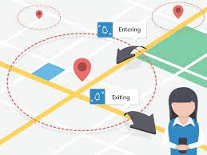

**2.6.3 reCAPTCHA VERIFICATION**

ReCAPTCHA is basically a Completely Automatic Public Turing test. It is a verification mechanism that provides protection against fraud, spam or abuse caused by robots. This test is utilized to differentiate humans and bots (computer programs) apart. It is a Challenge-Response Test used to enhance security in applications. CAPTCHA test is generated by computers and this test is easy to pass by humans whereas difficult for the bots (Singh & Kumar, 2019).

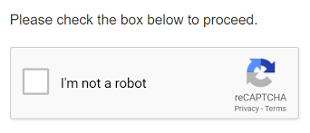

**2.6.4 QR Code**

The Quick Response (QR) Code present on the Identification card is scanned first using a QR Code Scanner. The proposed attendance system in this project is developed by scanning the QR code using a webcam attached to a computer. Subsequently, the data is recorded and deposited in a database for further retrieval and reporting purposes (Hendry et al., 2017). This code can be scanned either vertical or horizontal. A QR code can be read by almost all mobile phones. The QR code is often used in a number of fields, for instance in newspapers, magazines, journals, websites, advertisements, business advertisement boards, restaurants, clothes stores, and many more to store website addresses, content information, and miscellaneous data.

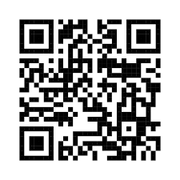

## 2.7 TECHNOLOGY ACCEPTANCE MODEL (TAM)

With the ever-increasing development of technology and its integration into users’ private and professional life, a decision regarding its acceptance or rejection still remains an open question. A respectable amount of work dealing with the technology acceptance model (TAM), from its first appearance more than a quarter of a century ago, clearly indicates the popularity of the model in the field of technology acceptance. Originated in the psychological theory of reasoned action and theory of planned behavior, TAM has evolved to become a key model in understanding predictors of human behavior toward potential acceptance or rejection of the technology (Marangunić & Granić, 2014).

(Davis, 1985) Advances in computer technology have clearly been a major force driving this growth, making powerful end-user systems economically attractive. Coupled with this is the growing emphasis that system designers are placing on transforming raw computing capability into systems that fit the needs of end-users (Gould & Lewis, 1983; Norman, 1983). In attempting to design more successful systems, developers have found that testing system prototypes with actual prospective users is an effective way of evaluating and refining proposed designs (e.g., Bewley et al., 1983; Card, English & Burr, 1978; Gould, Conti & Hovanyecz, 1983). Although existing prototype testing methodologies are considered valuable (Gould & Lewis, 1985), but they suffer from limitations in the techniques used to measure user responses to prototype systems.

Namely, current approaches generally do not assess whether users will use the new systems, instead of focusing on objective performance criteria (see review in Chapter 3 below) as the

basis for choosing among design alternatives. Since end-user systems are primarily used at the discretion of the user (DeSanctis, 1983; ives, Olson & Baroudi, 1983; Robey, 1979),

an important evaluation criterion in many system design situations is whether or not the system under consideration will be used by the target user population. Although actual organizational performance gains are the desired outcome from the use of new information systems, these gains will not be obtained if users fail to adopt the new system. The present research is concerned with the relationship between design characteristics and system use, leaving the use-performance issue aside for the moment. The actual use or non-use of an information system is an important and overlooked issue in the design and selection of information systems.

**CHAPTER THREE**

# RESEARCH METHODOLOGY

**3.1 INTRODUCTION**

This chapter gives a detailed outline of the software development methodology used, the methodology applied in the research project to collect the applicable data for effective analysis. Information in relation to the population and sample of the study, research/data collection instrument, as well as the results of the study, are discussed in this section. This section also elaborates on a detailed analysis of data which provides an insight into the findings of the study, accompanied by numerical and graphical representations of the data and interpretation of results.

## 3.2 RESEARCH METHODOLOGY AND DATA COLLECTION INSTRUMENT

A system method, on the other hand, is a systematic procedure for a set of activities, and methodology is the underlying principles and rules that govern it. As a result of these definitions, a methodology refers to the methods employed in a research project. The research methodology employed in this research is the quantitative method.

The quantitative technique, which included the use of questionnaires, was chosen because it provided the benefit of reaching out to a big number of individuals and getting additional information.

In other to measure the probability of substituting the current system and adopting the proposed system for managing employees at Rockwell Distribution Company, a questionnaire was designed for all employees and staff of Rockwell Distribution Company. The questionnaire was distributed electronically using google forms since the population is computer literate and well familiar with online platforms.

## 3.3 POPULATION AND SAMPLE OF THE STUDY

The population under study were all staffs of the Rockwell Distribution Company at Tema. The questionnaire was distributed to employees that voluntarily wants to fill the forms.

## 3.4 DATA COLLECTION AND ANALYSIS

The population under consideration are the employees of Rockwell Distribution Company. The targeted population size is Ninety (N = 105). We disseminate 90 questionnaires and we received 85 responses which represent approximately 94.44% response rate. These show that we received

enough responses for data analysis. To ensure the reliability and validity of our sample size we utilized a standard formula/equation shown below from (Kothari, 2004) as follows

 (1)

where *n* = Sample Size, *Z* = Confidence Level, *p* = Probability of Success, *q* = 1-*p*, *N* = Population and e = Level of Precision. We therefore computed our estimated sample size (*n*) using the equation stated above. In our computation for *n*, we employed the following in the above equation, *Z* = 1.96, *p* = 5% (0.05), *q* = 1-0.05 = 0.95, *N* = 105 and e = 0.02. This computation is shown in equation below.

$n=\frac{1.96^{2}×0.05×0.95×105}{0.02^{2}×(105-1)+1.96^{2}×0.05×0.95}=\frac{19.15998}{0.2259968}=84.7798729894$ (2)

The result from the second equation (2) gave us an estimated sample value of $84.7798729894$ which we approximated to 85.

In the Tables below, the effective data analysis from the data collected.

Table 3.1: Respondent Profile

|  |  |  |  |
| --- | --- | --- | --- |
| Variables | Category | N | Percentage |
| Gender | Male | 60 | 71 |
| Female | 25 | 29 |
| Total | 85 | 100 |
| Department | Account | 8 | 9 |
| Procurement | 15 | 18 |
| IT | 4 | 5 |
| Sales/Marketing | 36 | 42 |
| Transport | 24 | 28 |
| Other(s ) | 6 | 7 |
| Total | 93 | 109 |
| In two Departments | 8  Hence; 93-8=85 | 9  109-9=100 |
| Total | 85 | 100 |

**3.5 RESULTS OF THE STUDY**

### **3.5.1 Profile of Respondents**

With reference to the above table, 71% constituting 60 of 85 were males and the remaining 29% constituting 25 were females.

Table 3.2: Management System at Rockwell Distribution Company.

|  |  |  |  |
| --- | --- | --- | --- |
| **Variables** | **Category** | **N** | **Percentage (%)** |
| **What is current Attendance system at Rockwell Distribution Company?** | Book logging attendance system | 82 | 96 |
| Microsoft excel attendance system | 4 | 5 |
| Total | 86 | 101 |
| Multiple choice | 1  Hence; 86-1=85 | 1  101-1=100 |
| Total | 85 | 100 |
| **What is current Leave system at Rockwell Distribution Company?** | Leave Letter | 65 | 77 |
| Verbal Leave system/Request | 42 | 49 |
| Self-service portal for employee leave request | 1 | 1 |
| Total | 108 | 127 |
| Multiple choice | 23  Hence;108-23=85 | 27  127-27=100 |
| Total | 85 | 100 |
| **What are the challenges you face when using the existing system?** | Incorrect entering of time | ✓ | ✓ |
| Queues to mark attendance | ✓ | ✓ |
| Difficulty in getting the HR when requesting for a leave | ✓ | ✓ |
| A lot of paper work | ✓ | ✓ |

**Table 3.2** above displays the frequency analysis of attendance and leave management at Rockwell Distribution Company. The respondents were asked series of questions. From Table 3.2, 5% representing 4 of 85 employees say they use Microsoft excel attendance system in their department. 96% representing 82 of the employees affirm they use book logging attendance system. 49% representing 42 of 85 confirm they apply for leave through the verbal method and 77% representing 65 says they apply for leave using leave letter. We have 85 staffs responding to the questions about the current attendance and leave management system in Rockwell Distribution Company and every employee has at least a problem or difficulty in using the current system. Some of the problems faced by the staffs are;

* Incorrect entering of time
* Queues to mark attendance
* A lot of paper work
* Difficulty in getting the HR when requesting for a leave

Table 3.3: Acceptance of new mode/technology

|  |  |  |  |
| --- | --- | --- | --- |
| **Variables** | **Category** | **N** | **Percentage** |
| **Are you familiar with using online platforms?** | Yes | 75 | 88 |
| No | 10 | 12 |
| Total | 85 | 100 |
| **Will an online platform for managing employees in Rockwell Distribution Company be better?** | Agree | 34 | 40 |
| Strongly agree | 38 | 45 |
| Disagree | 0 | 0 |
| Strongly disagree | 13 | 15 |
| Total | 85 | 100 |
| **Will you accept an online platform for managing staffs at Rockwell Distribution Company?** | Yes | 83 | 98 |
| No | 2 | 2 |
| **Total 85 100** | | | |

In Table 3.3 above, employees were asked how familiar they are with online platforms. 75 of the total 85 representing 88% of the responses to this question say they are familiar and 10 representing 12% say they are not familiar. 72 of 85 constituting 85% agree to an online platform being used to manage employees at Rockwell Distribution Company. 13 respondents representing 15% disagree with the statement. To the question, “will you accept an online platform for managing staffs at Rockwell Distribution Company?” 83 representing 98% says Yes and 2 constituting 6% says No.

# 3.6 REVIEWS ON SEVERAL SOFTWARE METHOLOGIES.

A software development methodology is a collection of procedures, techniques, tools, and documentation aids which will help the systems developers in their efforts to implement a new information system.

There are a number of software development methodology each of which are adopted based on a number of factors associated to the project e.g. Time, cost, incorporation of requirement changes during the development process, system complexity, communication between customers and developers, software criticality, size of the development team (Sommerville, 2011). Below are a selected number of models:

1. **THE WATERFALL MODEL:**

The waterfall model is a sequential design process, often used in software development processes. It takes the fundamental process activities of specification, development, validation, and evolution and represents them as separate process phases such as requirements specification, software design, implementation, testing, and so on.

**Figure 3.1 the Waterfall Model**

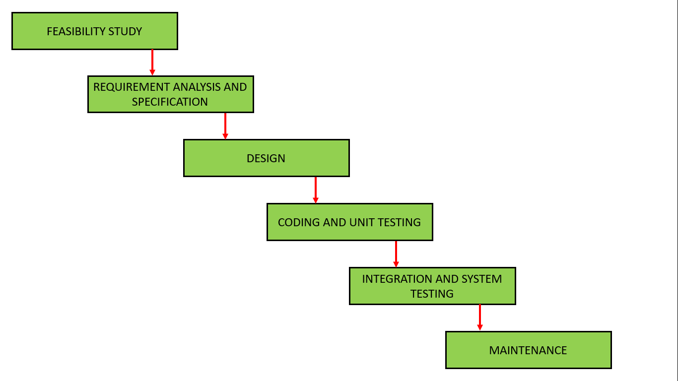

1. **INCREMENTAL MODEL:**

This approach interleaves the activities of specification, development, and validation. The system is developed as a series of versions (increments), with each version adding functionality to the previous version.

**Figure 3.2 Incremental Model**

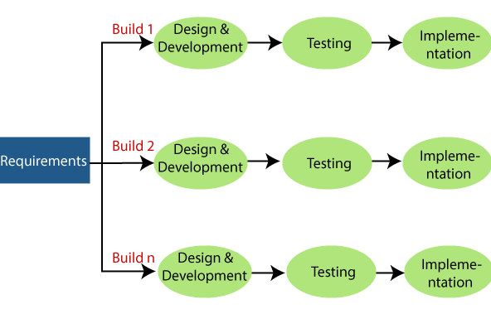

1. **REUSE-ORIENTED METHODOLOGY:**

This approach is built on the existence of important number of reusable components. The system development process focuses on integrating these components into a system rather than developing them from scratch.

**Figure 3.3 Reuse-oriented software engineering**

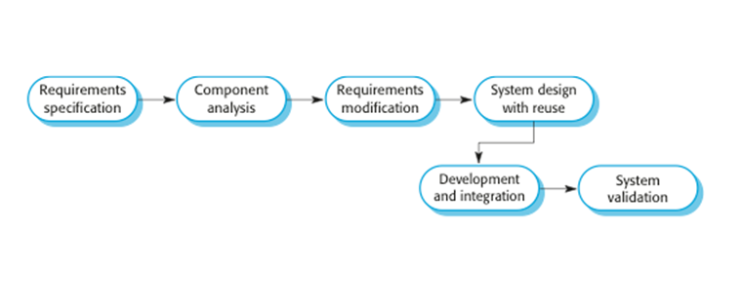

**3.7 SOFTWARE DEVELOPMENT METHODOLOGY OF CHOICE**

Having briefly discussed a few software development methodologies above, the incremental method was satisfied for the following reasons:

* Risk of changing requirements is reduced
* Customers get important functionality early
* Each release delivers an operational product
* Customer can respond to each build
* Uses “divide and conquer” breakdown of tasks
* Lowers initial delivery cost
* Initial product delivery is faster

# CHAPTER FOUR

# PROPOSED SYSTEM AND IMPLEMENTATION

1. **INTRODUCTION**

This chapter builds on the work done in the Analysis Chapter and gives documentation for both the existing system and Design of the Employee Attendance and Leave Management System (EALMS). The EALMS is modeled in terms of PHP and html and their interactions with each other. Explanation of the proposed system is done as well structure of the Entity Relationship Diagram (ERD). Design of the User Interface is also discussed.

* 1. **THE EXISTING SYSTEM**

The existing system in Rockwell Distribution Company is a manual entry for the managers and staff information in the company. Here, the attendance will be carried out in handwritten and leave will also be taken as a form and be written or verbal. It will be a tedious job to maintain the record for the company and also time consuming. The system requires more human effort. The retrieval of the information is not easy because records are maintained in hand written forms. This application requires correct feed in the respective input field. Supposed there were wrong inputs entered, the application resists requiring the user to input correct data.

* + 1. **ATTENDANCE MANAGEMENT SYSTEM**

Write Reporting time and sign with a pen

Report to Work

* + 1. **LEAVE MANAGEMENT SYSTEM**

HR asks the applicant to bring letter

HR informs Director

Applicant request leave verbally from HR

HR sends the letter to the Director for Approval

Applicant brings the leave letter to HR

Applicant then goes back to prepare the letter

HR then gives the response she had from the Director to the applicant

The Director Approve or declines and report it back to the HR verbally

* 1. **SCOPE OF THE EXISTING SYSTEM**

The system covers all the managers and the staffs of Rockwell Distribution company. The system is applicable for helping both the managers and the staff to check their attendance and the leave. It is limited only to staffs who have been monitored from time to time and who are officially enrolled and to the Managers who are employed in Rockwell Distribution company.

* 1. **CONCEPT OF OPERATIONS**

The implementation plan will be enhanced and updated as new actions are introduced and implemented to the system. The system tracks the performance of employees regarding their attendance and leave system on a regular basis. The System Overview Attendance Monitoring and Leave System provides a foolproof solution for the existing problems of the system.

1. **EXPLANATION OF THE PROPOSED SYSTEM**

The proposed system is designed to eliminate all the drawbacks of the existing attendance and leave management system. The system shall be responsible for maintaining information about employees, thus their personal profile. The system shall incorporate leave and attendance management all the way from application to acceptance/rejection of leave requests as well as all employee projects with close monitoring of the projects from creation to completion and trainings to assist in monitoring active and inactive employees.

The main features to be added include:

*Employee profiles

*Attendance

*Leave management

* Employee Self-Service (ESS)

* 1. **SEQUENCE**

Sequence help in the identification of a detailed level of the operations required to implement the functionality depicted by a use case.

* 1. **Scenario 1: Admin add new employee**

1. The user logs in by providing correct username and password.

2. If username and password are not found on the database access into the system is denied.

3. If the credentials are identical to the ones found on the database, access is granted.

4. User enters the details of the new employee.

5. The user input is written to the database.

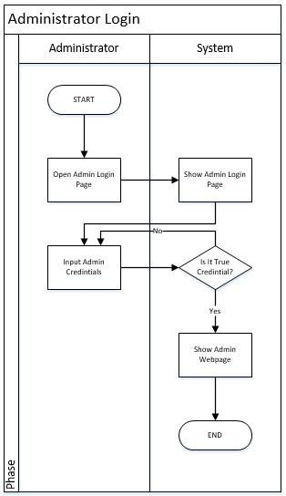

* 1. **Scenario 2: Employee leaves application**

LOGIN

Email Valid

USER

APPLY FOR LEAVE

Password

DB

USER

DB

APPLY

1. The user logs in by providing correct username and password.

2. If the username and password are not found in the database access into the system is denied.

3. If the credentials are identical to the ones found on the database, access is granted.

4. User requests for leave by selecting from the checklist.

5. User upload and enters leave description.

6. Details are written to the database by the Apply button.

7. A message confirming details have been submitted is displayed to the user.

* 1. **Scenario 3: Employee Attendance**

ATTENDANCE MANAGEMENT SYSTEM

PORTAL

USER

**DATABASE**

1. The user login by providing correct username and password
2. If the username and password are not found in the database access into the system is denied it.
3. If the credentials are identical to the ones found on the database, access is granted.
4. User sign in or clock in for work.
5. After signing work start.
6. **INTERFACE DESIGN**

The web application was created with the following design considerations in mind:

* Consistent. The website should have a similar look and feel on every page. Every page should have the same header/logo, heading style, fonts, navigations etc.

*Efficient and easy to maintain. This refers to the fact that there is need to separate content from layout, so that you can easily change your page design without editing every page on the site.

*Layout. The layout of each page should have a good contrast between the text and background area. This helps considerably with visibility as it will be difficult to read the text if it is almost the same color as the background. Monitor size should also be taken into consideration.

* Easy to navigate and use. Users should not have a hard time trying to navigate the site. Navigation links should be consistent and clearly labeled. All navigation links should also be working properly and should point to the intended page/site.

* Browser compatible. When designing the site consider different browser environments. Extensive testing should be done on each page in all the major browsers and the design changed appropriately to cater for all.

* Visually appealing. The use of color, text, fonts and graphics should be carefully considered and used to ensure that the site is visually appealing to its visitors.

**4.8 SYSTEM REQUIREMENTS**

To run the Employee Attendance and Leave Management System application the following are necessary:

**4.8.1 Minimum Server Hardware Requirements**

* 2 GB RAM
* GHz processor
* 50GB of hard disk space

**4.8.2 Server Software Requirements**

* Any Operating System

**4.8.3 Minimum Client Hardware Requirements**

* 1 GB RAM
* 2.0GHz processor

**4.8.4 Client Software Requirements**

* A graphical web browser

**4.8.5 Functional Requirements**

**4.8.5.1 User Requirements**

* Users will be able to login with their emails and password
* Users will be able to view their profiles after registration
* Users will be able to take attendances
* Users will be able to apply for leave
* Users will be able to view attendance and leave histories

**4.8.5.2 Admin requirements**

* Admin will be able to add, update and delete users
* Admin will be able to assign courses to lecturers

**4.8.6 Non-functional Requirements**

* The system should be able to work on any computer device with minimum RAM of 1GB
  + 1. **SUMMARY**

This Chapter has specified the design of the EALMS. The aspects of the design that have been discussed are system design, interface design, and database design by providing the DFD and ERD. The next chapter looks at the implementation of the EALMS. This depends on the design specification given in this chapter.

# CHAPTER FIVE

# CONCLUSION AND RECOMMENDATION

1. **CONCLUSION**

The study was done to find ways to improve employees’ attendance records management and leave requests at Rockwell Distribution Company.

Basing on our Findings and Analysis, attendance and leave management system is a venture worth investing in. Once taken seriously and embraced, there are a lot of benefits that can be realized therein.

The proposed system has three basic types of users; the Employee, the Manager and the Administrator (Note that an employee can also be the Manager and Admin) each of which would have their independent tasks). And all these users will be beneficiaries of the system proposed.

1. **RECOMMENDATIONS.**

A full-scale study is highly recommended to understand the advantages of the proposed system in the labor sector. This System being web-based, needs to be thoroughly tested to find out any security gaps. Training for simple computer operations is necessary for the users of the system which is also recommended.

## References

Afsana, H. (2018). *“EMPLOYEE LEAVE MANAGEMENT SYSTEM IN METLIFE BANGLADESH.”*

Davis, F. D. (1985). A Technology Acceptance Model for Empirically Testing New End-User Information Systems: Theory and Results. Massachusetts Institute of Technology. <http://hdl.handle.net/1721.1/15192>

Davis, F. D. (1985). A technology acceptance model for empirically testing new end-user information systems: Theory and results (Doctoral dissertation, Massachusetts Institute of Technology).

Davis, F. D. (1987). User acceptance of information systems: the technology acceptance model (TAM).

Davis, F. D. (2015). On the relationship between HCI and technology acceptance research. In Human-computer interaction and management information systems: Foundations (pp. 409-415). Routledge.

Dutta, R., Tamang, T., Paul, P., Kumar, N., Chetri, C., & Dutta, P. K. (2020, December). Smart and Secure Fingerprint Attendance System using Arduino UNO with GSM Alert. In 2020 3rd International Conference on Intelligent Sustainable Systems (ICISS) (pp. 1086-1090). IEEE.

Feng, D., Wang, P., & Zu, L. (2020, August). Design of Attendance Checking Management System for College Classroom Students Based on Fingerprint Recognition. In 2020 Chinese Control And Decision Conference (CCDC) (pp. 555-559). IEEE.

Hendry, M. R. M., Rahman, M. N. A., & Seyal, A. H. (2017, May). Smart attendance system applying QR code. In 12th International Conference on Latest Trends in Engineering and Technology May (pp. 22-24).

Julius. (2022, April 1). What is a human resource information system, and why do you need one? - HRM-educate. HRM. Retrieved May 19, 2022, from <https://www.hrmeducate.com/what-is-a-human-resource-information-system-and-why-do-you-need-one/>

Marangunić, N., & Granić, A. (2015). Technology acceptance model: a literature review from 1986 to 2013. Universal access in the information society, 14(1), 81-95.

Marangunić, N., & Granić, A. (2015). Technology acceptance model: a literature review from 1986 to 2013. *Universal Access in Information Society,* 14(1)**,**81–95.

Patel, U. A., & Priya, S. (2014). Development of a Student Attendance Management System Using RFID and Face Recognition: A Review Computer Science and Management Studies Development of a Student Attendance Management System Using RFID and Face Recognition: A Review. In *International Journal of Advance Research in* (Vol. 2, Issue 8).

Phiri, M. J. (2016). Managing university records and documents in the world of governance, audit and risk: Case studies from South Africa and Malawi (Doctoral dissertation, University of Glasgow).

Phiri, M.J. (2015). *Managing university records and documents in the world of governance, audit and risk Case Studies from South Africa and Malawi*.

Rao, S., & Satoa, K. J. (2013). An attendance monitoring system using biometrics authentication. International Journal of Advanced Research in Computer Science and Software Engineering, 3(4), 379-383.

Simaanya, M. (2014). The University of Zambia School of Natural Sciences Department of Computer Studies Employee Management System. *Project Thesis*, 1–79.