- the number of permutations of a given number n having exactly k permutation cycles, all of which are of length r=2 or greater
- How many permutations with k cycles and j fixed points are there? J fixed points means j one length cycles.
= or 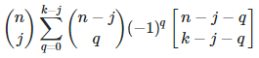 where [] is the stirling numbers of the first kind
- Permutations without any cycle of length k
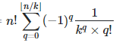 and GF 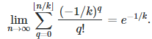

- Permutations with largest cycle length = k
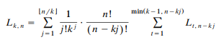

- An r-associated Stirling number of the second kind is the number of ways to partition a set of n objects into k subsets, with each subset containing at least r elements. It is denoted by S_{r}( n , k ) and obeys the recurrence relation
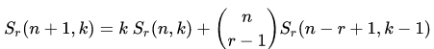
- Denote the n objects to partition by the integers 1, 2, ..., n. Define the reduced Stirling numbers of the second kind, denoted S^{d}(n, k), to be the number of ways to partition the integers 1, 2, ..., n into k nonempty subsets such that all elements in each subset have pairwise distance at least d. That is, for any integers i and j in a given subset, it is required that |i-j| >= d. It has been shown that these numbers satisfy
- For any pair of sequences, f_{n} and g_{n}, related by a finite sum Stirling number formula given by 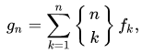

for all integers n >= 0, we have a corresponding inversion formula for f(n) given by 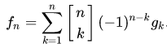 where {} is the second kind and [] is the first kind
- 