

**Name:**

Mahnoor Atique

**Roll no.:**

SP23-BAI-023

**Teacher Name:**

Sir Aksam Iftikhar

**Semester:**

SP24 (Semester 4)

**Section:**

SP23-BAI-A

**Dataset Description:**

**California Housing (Regression)**

* **Size**: 20,640 data points.
* **Features**: 8 features (e.g., latitude, longitude, median income, etc.).
* **Target Variable**: Median house value (regression task).
* **Train/Test Split**: 80% training, 20% testing.

**MNIST (Classification + CNN)**

* **Size**: 60,000 training images, 10,000 test images.
* **Features**: 28x28 grayscale images (784 pixels).
* **Classes**: 10 categories (digits 0-9).
* **Train/Test Split**: 60,000 training, 10,000 test images.

**Model Details**

**Regression (ANN)**

* **Model Architecture:**
  + **Input Layer:** Size = 10
  + **Hidden Layer 1:** 128 neurons, ReLU activation.
  + **Hidden Layer 2:** 64 neurons, ReLU activation.
  + **Output Layer:** 1 neuron.

**Classification (ANN)**

* **Model Architecture:**
* Model 1:
  + **Input Layer:** Size = 784 neurons (28x28 pixels).
  + **Hidden Layer 1:** 512 neurons, Relu activation.
  + **Hidden Layer 2:** 256 neurons, Relu activation.
  + **Hidden Layer 3:** 128 neurons, Relu activation.
  + **Output Layer:** 10 neurons, Softmax activation.
* Model 2:
  + **Input Layer:** Size = 784 neurons (28x28 pixels).
  + **Hidden Layer 1:** 128 neurons, Relu activation.
  + **Hidden Layer 2:** 64 neurons, Relu activation.
  + **Output Layer:** 10 neurons, Softmax activation.
* Model 3:
  + **Input Layer:** Size = 784 neurons (28x28 pixels).
  + **Hidden Layer 1:** 64 neurons, Relu activation.
  + **Hidden Layer 2:** 32neurons, Relu activation.
  + **Output Layer:** 10 neurons, Softmax activation.

**Classification (CNN)**

* **Model Architecture:**
* Model 2 ( Best performance Model):
  + **Convolutional Layer 1:** 32 filters, 3x3 kernel, ReLU activation.
  + **Max Pooling:** 2x2.
  + **Convolutional Layer 2:** 64 filters, 3x3 kernel, ReLU activation.
  + **Max Pooling:** 2x2.
  + **Flatten Layer:** Converts 3D output to 1D.
  + **Dense Layer:** 128 neurons, ReLU activation.
  + **Dropout Layer:** 0.3
  + **Output Layer:** 10 neurons, Softmax activation.
* Model 1:
  + **Convolutional Layer 1:** 16 filters, 3x3 kernel, ReLU activation..
  + **Max Pooling:** 2x2.
  + **Flatten Layer**
  + **Dense Layer:** 32 neurons, ReLU activation.
  + **Output Layer:** 10 neurons, Softmax activation for multi-class classification.

**Training Configurations**

**Regression Model (ANN)**

* **Optimizer:** SGD
* **Learning Rate:** 0.01
* **Batch Size:** 64
* **Epochs:** 100
* **Loss Function:** Mean Squared Error (MSE)

**Classification Model (ANN)**

* **Optimizer:** Adam
* **Learning Rate:** 0.001,0.01,0.0005
* **Epochs:** 30 per model
* **Loss Function:** Cross-Entropy Loss

**Classification Model (CNN)**

* **Optimizer:** Adam
* **Learning Rate:** 0.01,0.001
* **Batch Size:** 32
* **Epochs:** 10 per model
* **Loss Function:** Categorical Cross-Entropy Loss

**Performance Metrics**

**Regression Model (ANN)**

* **MSE (Mean Squared Error):** 0.37
* **MEA (Mean Absolute Error):** 0.43
* **R2:** 0.72

**Classification Model (ANN)**

* **Model 1 Accuracy**: 0.9814
* **Model 2 Accuracy**: 0.9413
* **Model 3 Accuracy**: 0.9490

**Classification Model (CNN)**

* **Model 1 Accuracy** 0.974
* **Model 2 Accuracy**: 0.9909

**Visualizations:**

**Regression Plot:**

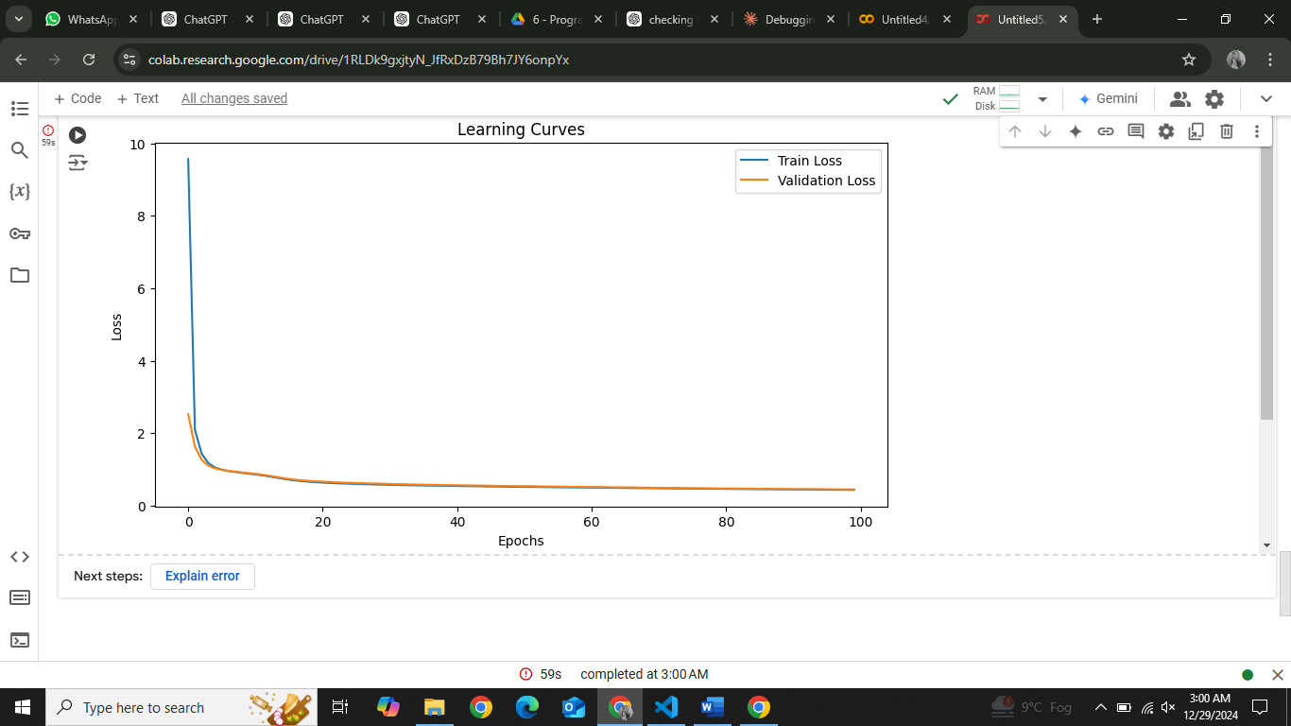

**Classification (ANN):**

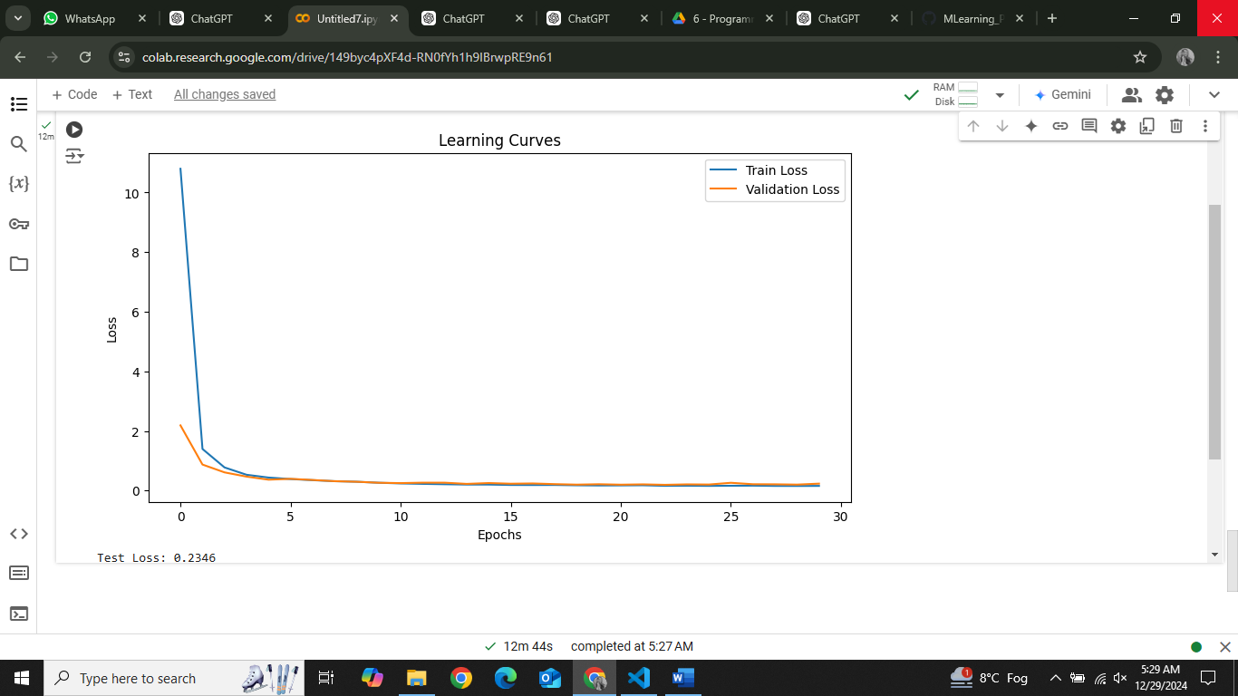

**Confusion Matrix:**

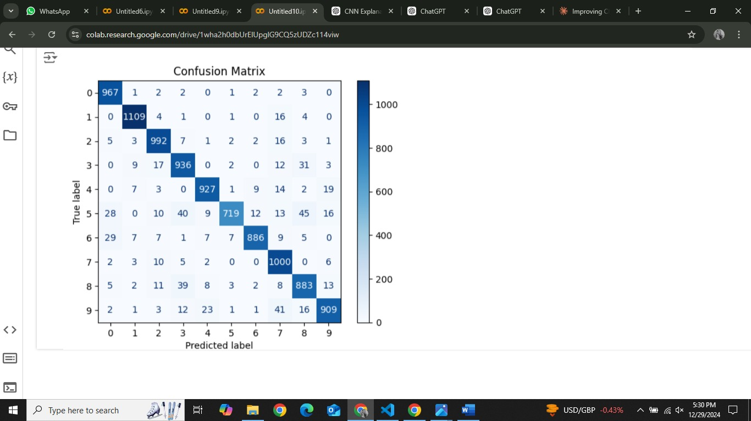

**Classification (CNN):**

**Model 1:**

**Confusion Matrix:**

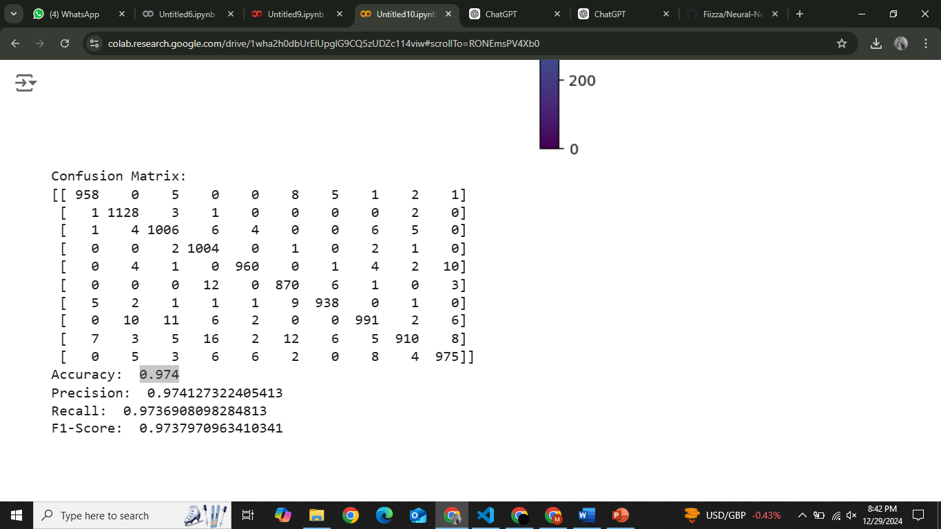

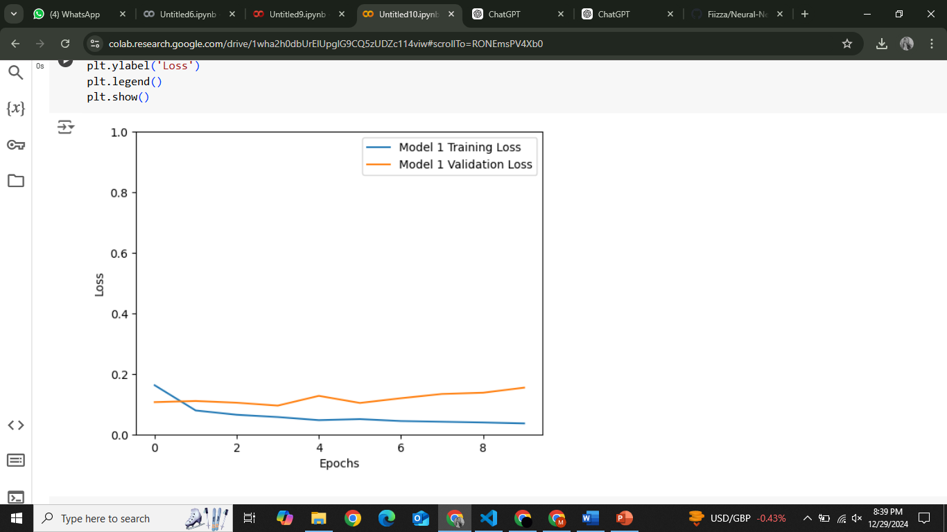

**Model 2:**

**Confusion Matrix:**

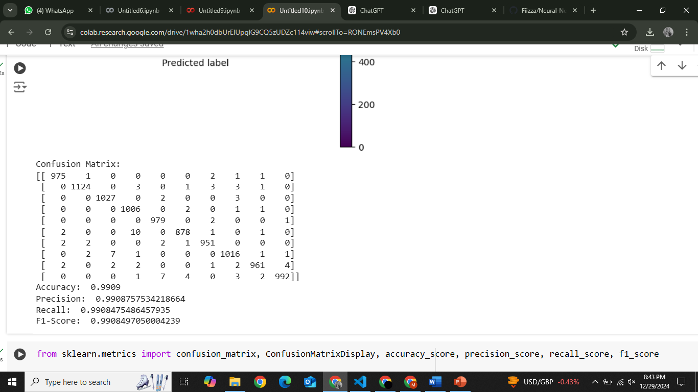

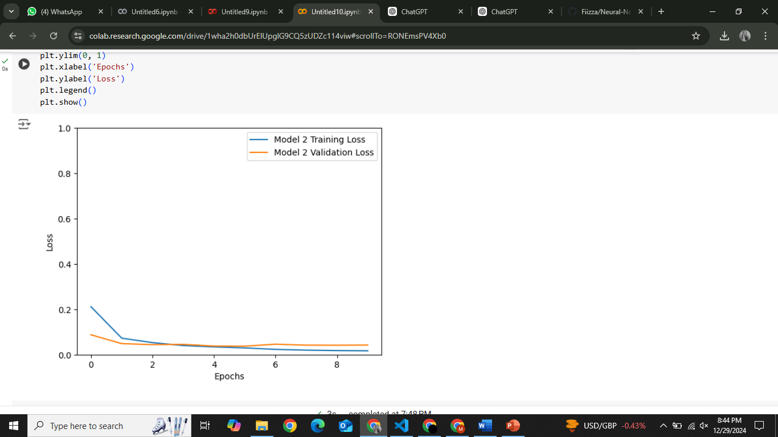

**Comparative Table:**

|  |  |  |  |
| --- | --- | --- | --- |
| **Model** | **Dataset** | **Key Hyperparameters** | **Final Metric** |
| Regression (ANN) | California Housing | LearningRate=0.01  Epoch=100 | MEA:0.43  MSE:0.37 |
| Classification (ANN) | MNIST | LearningRate=0.0005  Epoch=5/model | Accuracy:94% |
| Classification (CNN) | MNIST | LearningRate=0.0005  Epoch=5/model | Accuracy:99% |

**Strengths and Weaknesses of Each Model**

**Regression Model (ANN):**

**Strengths:** The model demonstrated strong predictive power with a MAE ,MSE, indicating good performance for regression tasks.  
**Weaknesses:** It may not generalize well to unseen data due to limited complexity and potential overfitting on small datasets.

**Classification Model (ANN):**

**Strengths:** Achieved high accuracy with a relatively simple architecture, making it computationally efficient.  
**Weaknesses:** Struggles with misclassifications, especially for visually similar classes.

**Classification Model (CNN):**

**Strengths:** Good performance on image classification tasks, leveraging convolutional layers for robust feature extraction. **Weaknesses:** While the model is highly effective, it is more computationally expensive to train compared to simpler models like ANNs.