**StudentApp**

Home.js

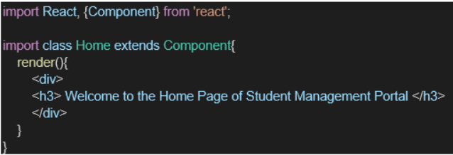

App.jsx

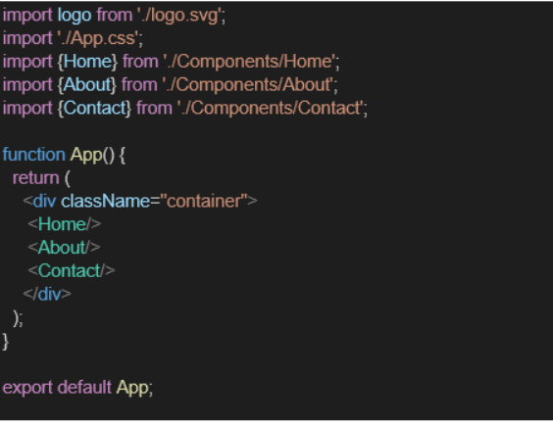

**About.js**

import React, { Component } from 'react';

class About extends Component {

render() {

return (

<div>

<h3>Welcome to the About Page of Student Management Portal</h3>

</div>

);

}

}

export default About;

[Contact.js](http://contact.js)

import React, { Component } from 'react';

class Contact extends Component {

render() {

return (

<div>

<h3>Welcome to the Contact Page of Student Management Portal</h3>

</div>

);

}

}

export default Contact;

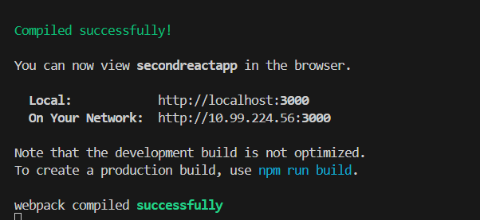

Output

