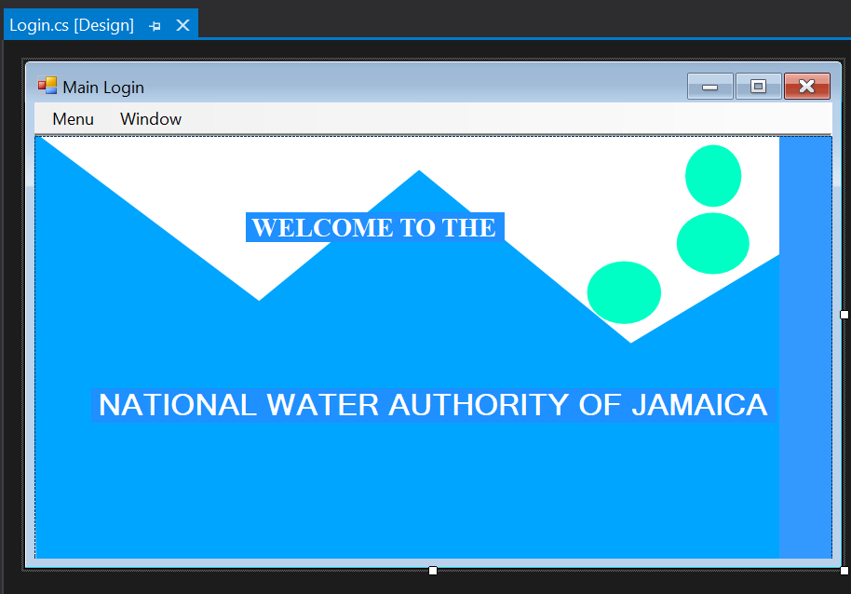

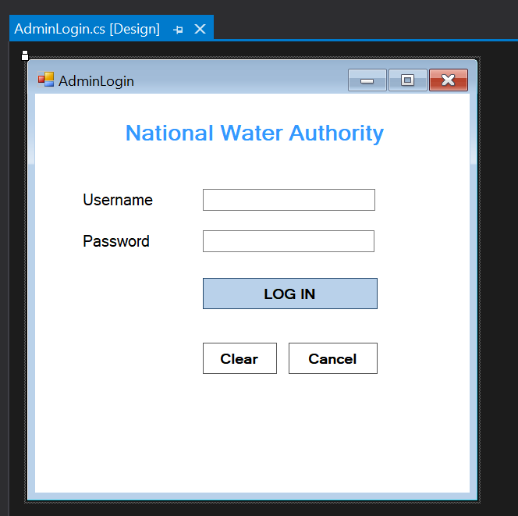

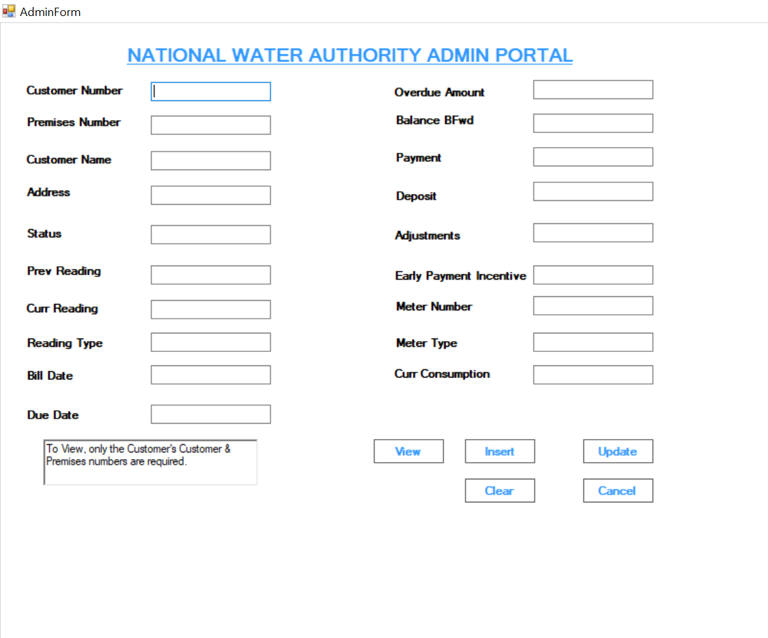

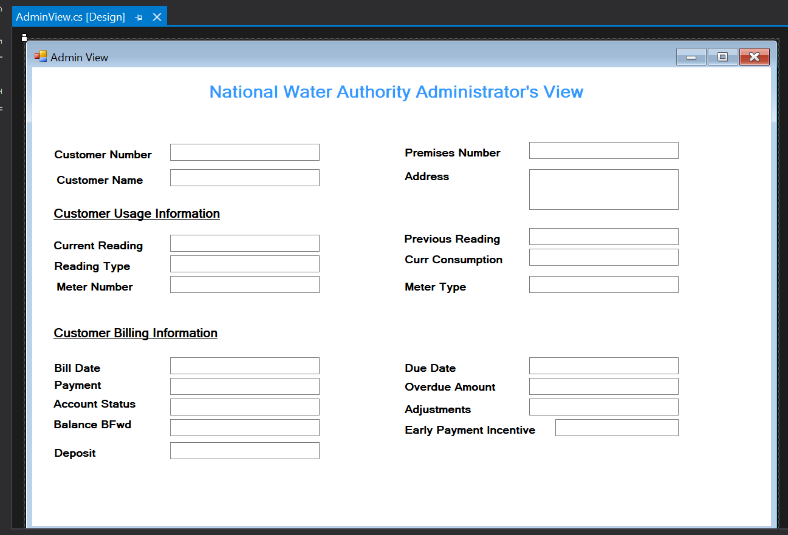

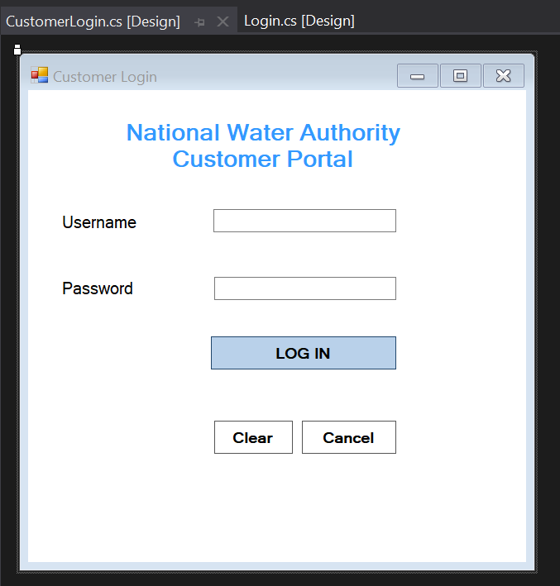

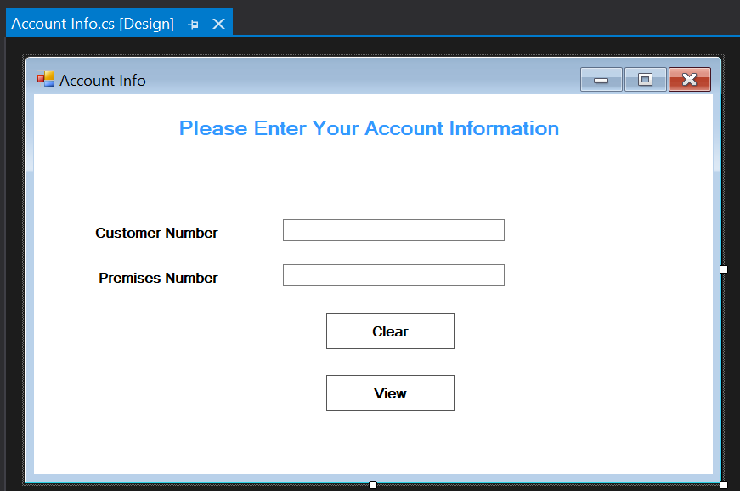

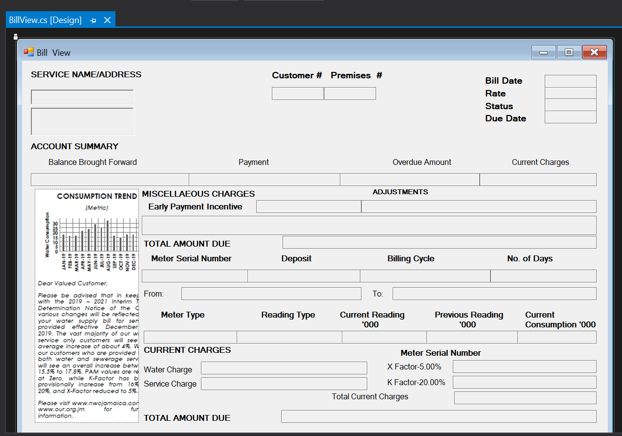

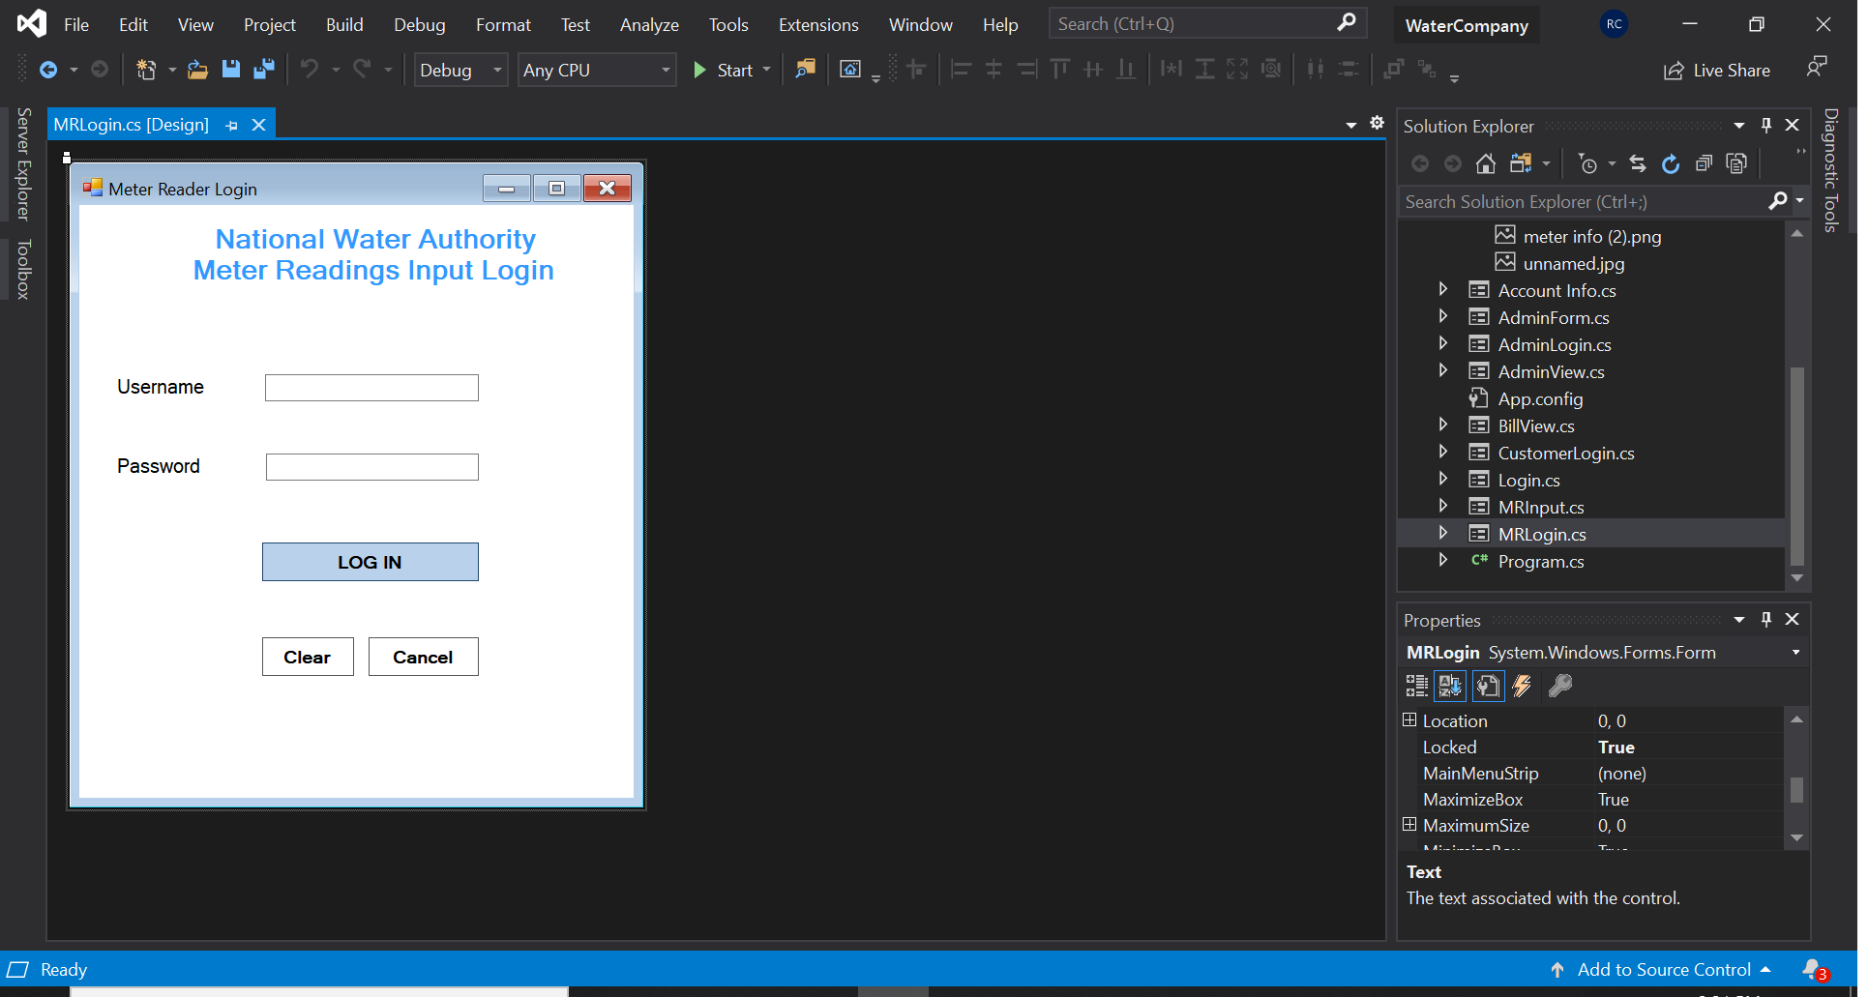

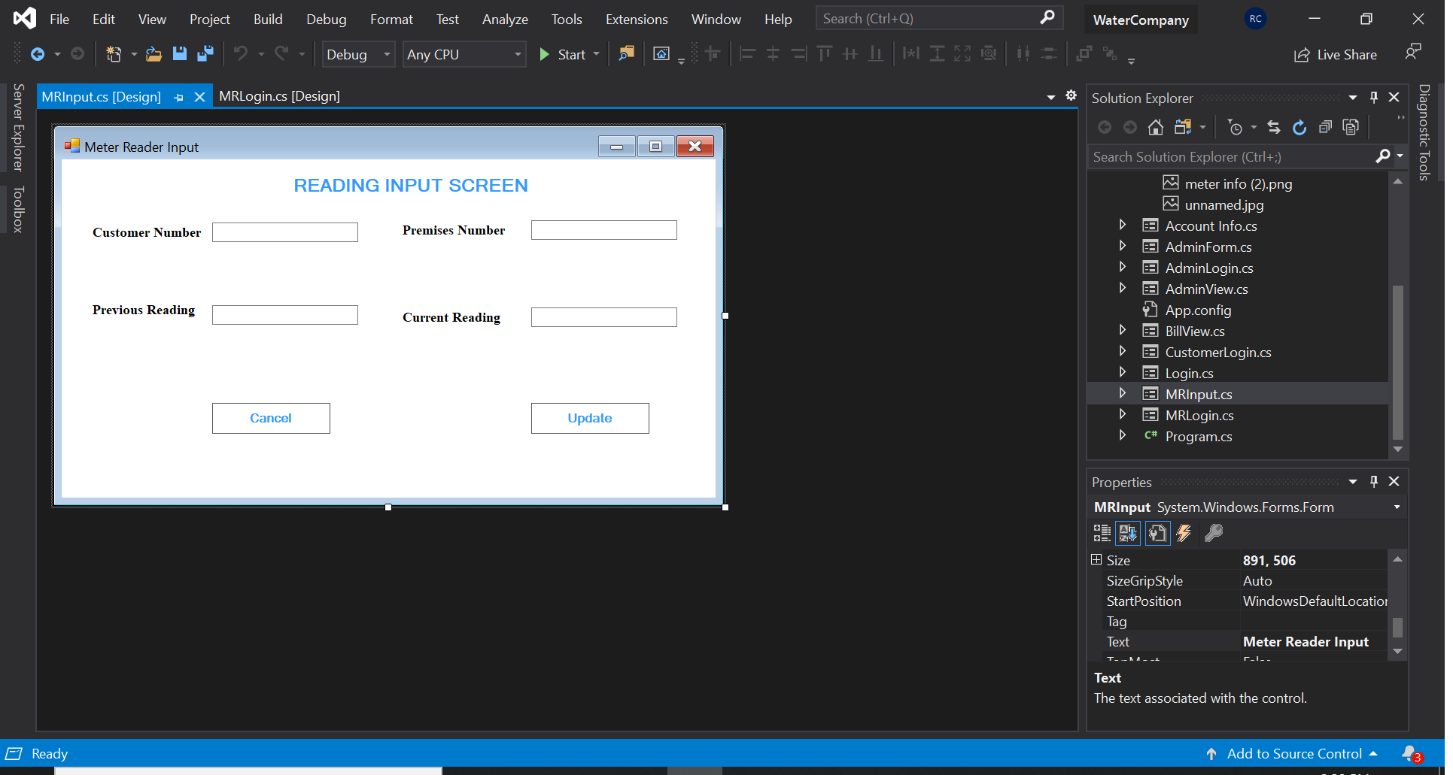

**SQL DATABASE TABLES**

**Admin Login Table**

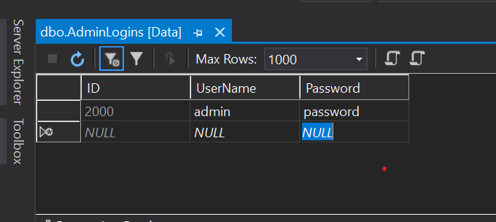

**User Login Table**

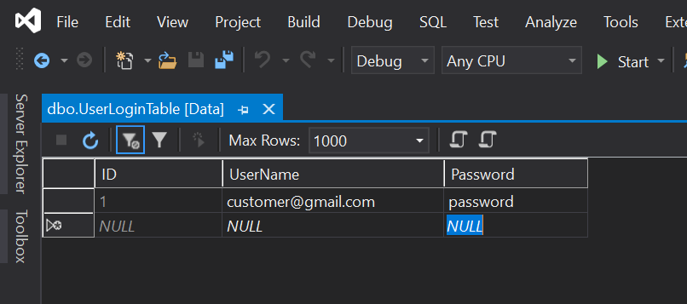

**Meter Reader Login Table**

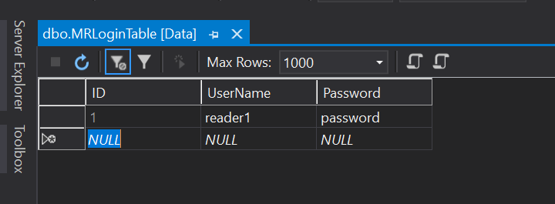

**Customer Data Table Part 1**

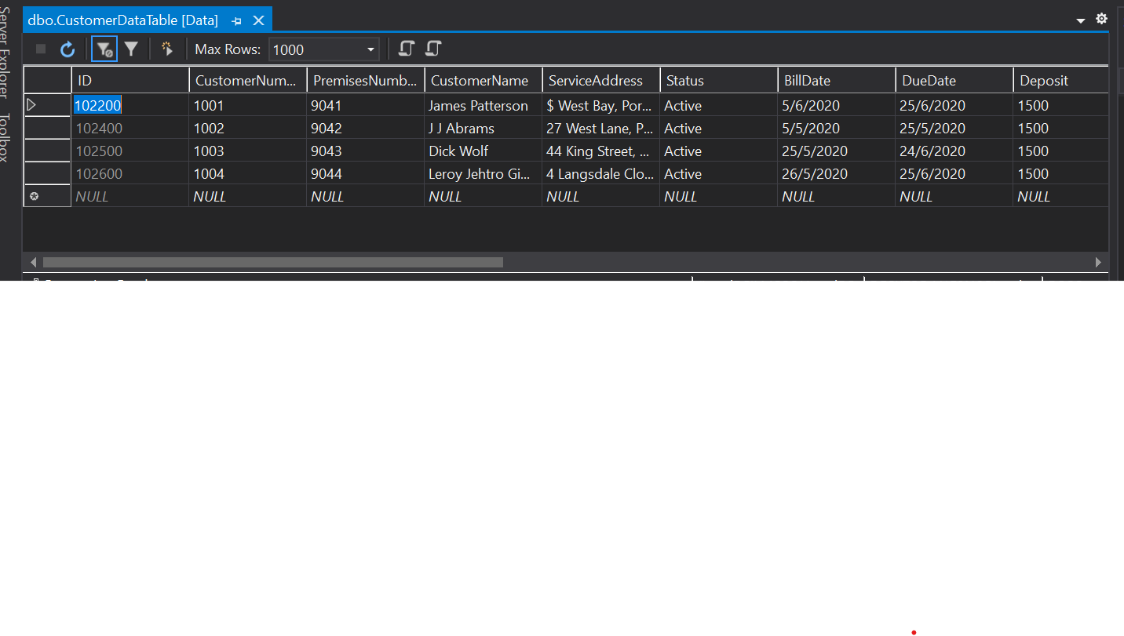

**Customer Data Table Part 2**

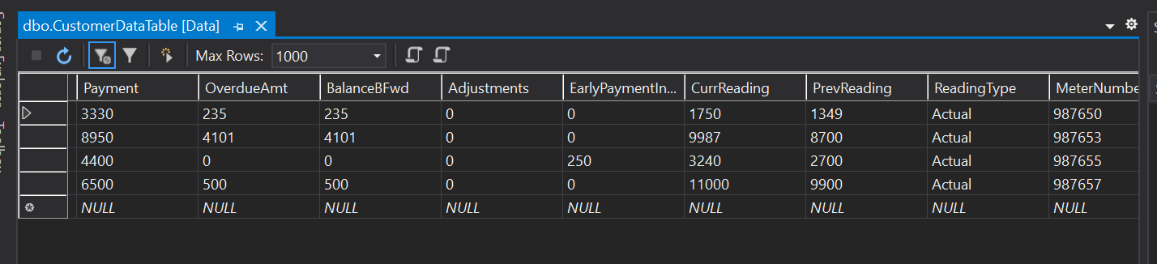

**Customer Data Table Part 3**

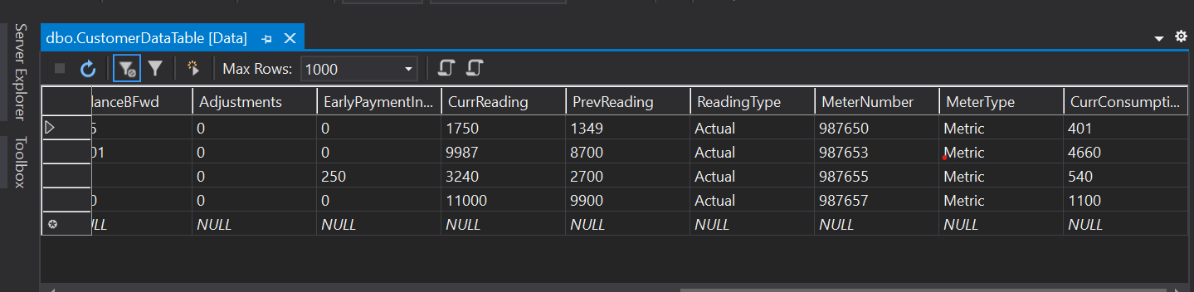

**SQL AdminLogin Table Creation**

CREATE TABLE [dbo].[AdminLogins] (

[ID] INT IDENTITY (2000, 100) NOT NULL,

[UserName] NVARCHAR (50) NOT NULL,

[Password] NVARCHAR (50) NOT NULL,

CONSTRAINT [PK_AdminLogins] PRIMARY KEY CLUSTERED ([ID] ASC)

);

**SQL UserLogin Table Creation**

CREATE TABLE [dbo].[UserLoginTable] (

[ID] INT IDENTITY (1, 1) NOT NULL,

[UserName] NVARCHAR (50) NOT NULL,

[Password] NVARCHAR (50) NOT NULL,

PRIMARY KEY CLUSTERED ([ID] ASC)

);

**SQL Meter Reader Input Login Table Creation**

CREATE TABLE [dbo].[MRLoginTable] (

[ID] INT IDENTITY (1, 1) NOT NULL,

[UserName] NVARCHAR (50) NOT NULL,

[Password] NVARCHAR (50) NOT NULL,

PRIMARY KEY CLUSTERED ([ID] ASC)

);

**SQL CustomerDataTable Creation**

CREATE TABLE [dbo].[CustomerDataTable] (

[ID] INT IDENTITY (2000, 100) NOT NULL,

[CustomerNumber] INT NOT NULL,

[PremisesNumber] INT NOT NULL,

[CustomerName] NVARCHAR (50) NOT NULL,

[ServiceAddress] NVARCHAR (MAX) NOT NULL,

[Status] NVARCHAR (50) NOT NULL,

[BillDate] NVARCHAR (50) NOT NULL,

[DueDate] NVARCHAR (50) NOT NULL,

[Deposit] DECIMAL (18) NOT NULL,

[Payment] DECIMAL (18) NOT NULL,

[OverdueAmt] DECIMAL (18) NOT NULL,

[BalanceBFwd] DECIMAL (18) NOT NULL,

[Adjustments] DECIMAL (18) NOT NULL,

[EarlyPaymentIncentive] DECIMAL (18) NOT NULL,

[CurrReading] INT NOT NULL,

[PrevReading] INT NOT NULL,

[ReadingType] NVARCHAR (50) NOT NULL,

[MeterNumber] INT NULL,

[MeterType] NVARCHAR (50) NULL,

[CurrConsumption] INT NULL,

CONSTRAINT [PK_CustomerDataTable] PRIMARY KEY CLUSTERED ([ID] ASC),

CONSTRAINT [U_CustomerDataTable_CustomerNumber] UNIQUE NONCLUSTERED ([CustomerNumber] ASC),

CONSTRAINT [U_CustomerDataTable_PremisesNumber] UNIQUE NONCLUSTERED ([PremisesNumber] ASC)

);