Heart Disease Prediction Using Data Mining and Machine Learning Classification Models
Data Mining Mini Project Report
Student Name: [Your Name]
Course: Data Mining
Instructor: [Instructor Name]
Date: [Submission Date]

Abstract
Heart disease is a major health problem, and early prediction can support faster medical decision-making. This project applies data mining and machine learning classification methods to predict whether a patient has heart disease using the UCI Heart Disease dataset. The original multiclass diagnosis was converted into a binary target, where 0 represents no heart disease and 1 represents heart disease. The cleaned dataset contains 920 patient records, 15 columns, and no missing values. The project follows a complete data mining workflow: data cleaning, stratified train/test splitting, exploratory data analysis, feature engineering, baseline comparison, dimensionality reduction using PCA, model training, cross-validation, and final model evaluation. Four supervised learning models were compared: K-Nearest Neighbors, Logistic Regression, Decision Tree, and Random Forest. The results show that KNN achieved the highest accuracy, recall, and F1-score, while Logistic Regression achieved the highest ROC-AUC and provided strong interpretability. These results show that simple, well-preprocessed models can perform strongly on structured clinical data.

Table of Contents
- Introduction
- Problem Statement
- Dataset Description
- Data Cleaning
- Train/Test Split Strategy
- Exploratory Data Analysis
- Feature Engineering
- Feature Importance Discussion
- Baseline Comparison
- Dimensionality Reduction Using PCA
- Experiment Without Dataset Source Feature
- Machine Learning Models
- Experimental Setup
- Results and Discussion
- Model Comparison
- Conclusion
- Future Work
- References

1. Introduction
Heart disease prediction is a useful classification problem in healthcare data mining. Medical datasets often contain patient information such as age, cholesterol level, resting blood pressure, chest pain type, maximum heart rate, and exercise-related symptoms. By learning patterns from these features, machine learning models can estimate whether a patient is likely to have heart disease.
The purpose of this project is to build and evaluate a complete machine learning workflow for heart disease prediction. The project does not attempt to replace medical professionals. Instead, it demonstrates how data mining techniques can be used as a decision-support tool for early risk prediction.
The main contribution of this project is that it does not only train models. It also includes proper data preparation, leakage prevention, cross-validation, baseline comparison, PCA dimensionality reduction, feature importance analysis, and an additional experiment to check whether the dataset source feature affects model performance.

2. Problem Statement
The task is a binary classification problem:
Predict whether a patient has heart disease or not.
The target variable is:
0 = No heart disease
1 = Heart disease
The main research question is:
Which machine learning classification model performs best for predicting heart disease on this cleaned and preprocessed dataset?
The secondary questions are:
- Do the machine learning models perform better than a simple baseline classifier?
- Does PCA improve model performance?
- Are the results strongly affected by the dataset source feature?
- Which medical features appear most important for prediction?

3. Dataset Description
The dataset used in this project is based on the UCI Heart Disease dataset. The UCI repository describes the task as a classification problem and states that the goal field represents the presence of heart disease, with values from 0 for absence to 1-4 for presence. In this project, those values were converted into a binary target.
The cleaned dataset contains records from multiple UCI heart disease sources, including Cleveland, Hungary, Switzerland, and VA Long Beach.
Item | Value
Rows | 920
Columns | 15
Missing values after cleaning | 0
Target classes | 2
The final cleaned columns are shown below.
Feature | Description
age | Patient age
sex | Patient sex
dataset | Source dataset location
cp | Chest pain type
trestbps | Resting blood pressure
chol | Serum cholesterol
fbs | Fasting blood sugar
restecg | Resting ECG result
thalch | Maximum heart rate achieved
exang | Exercise-induced angina
oldpeak | ST depression induced by exercise
slope | Slope of peak exercise ST segment
ca | Number of major vessels
thal | Thalassemia result
target | Binary heart disease diagnosis
The target distribution was reasonably balanced, with 411 patients in class 0 and 509 patients in class 1.
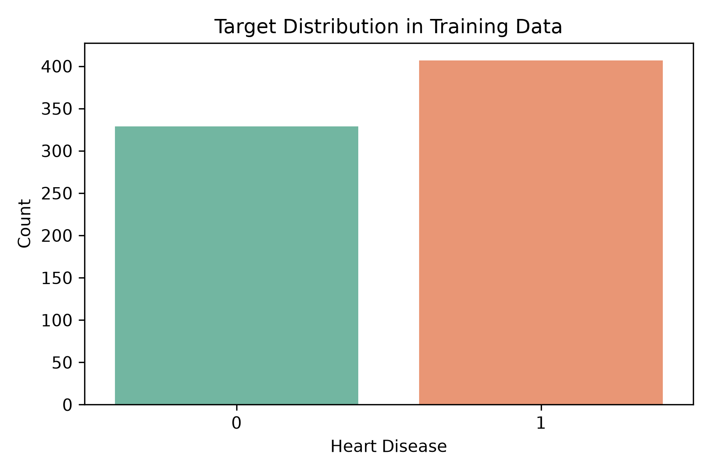
Figure 1. Target distribution after cleaning.
Figure 1. Target distribution after converting the original diagnosis into binary classification.

4. Data Cleaning
The raw dataset required cleaning before model training. The main data cleaning steps were:
- Loaded the original heart disease dataset.
- Checked rows, columns, missing values, and duplicates.
- Removed irrelevant columns such as id.
- Converted the original diagnosis column into a binary target variable.
- Filled missing numerical values using median values.
- Filled missing categorical values using mode values.
- Cleaned and standardized categorical text values.
- Saved the cleaned dataset as data/processed/heart_cleaned.csv.
After cleaning, the dataset contained 920 rows, 15 columns, and 0 missing values.
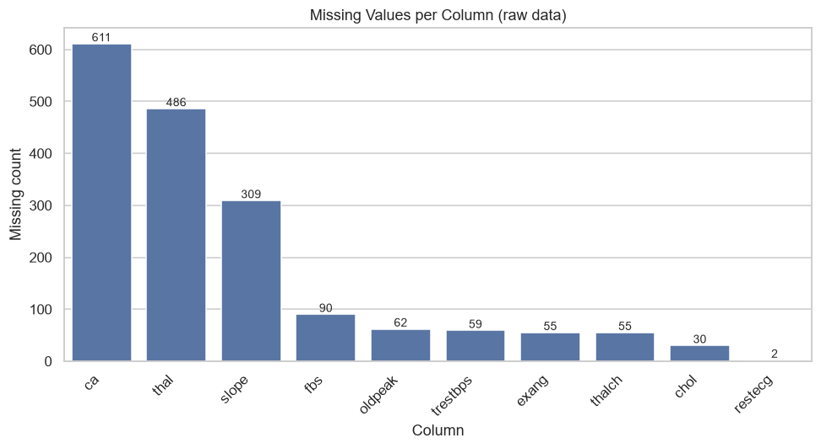
Figure 2. Missing values after data cleaning.
Figure 2. Missing value check after the cleaning process.

5. Train/Test Split Strategy
The cleaned dataset was split before feature engineering and model training. This is important because preprocessing steps such as scaling, encoding, and PCA must not learn from the test set.
A stratified 80/20 split was used with random state 42.
Split | Rows | Target 0 | Target 1
Training | 736 | 329 | 407
Testing | 184 | 82 | 102
The training set was used for cross-validation and model selection. The test set was kept untouched until final evaluation.
This design improves the reliability of the experiment because the final test metrics estimate how the models perform on unseen data.

6. Exploratory Data Analysis
EDA was performed on the training data only. The goal was to understand important patterns before modeling.

6.1 Numerical Features
The numerical features were:
age, trestbps, chol, thalch, oldpeak
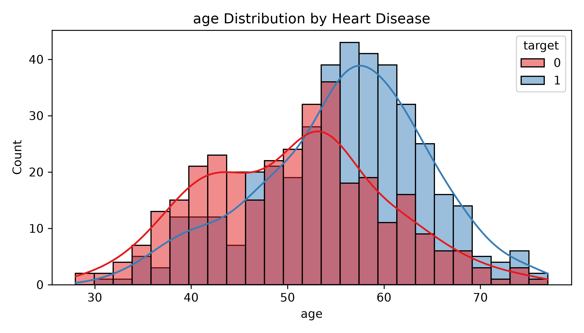
Figure 3. Age distribution by target class.
Figure 3. Age distribution for patients with and without heart disease.
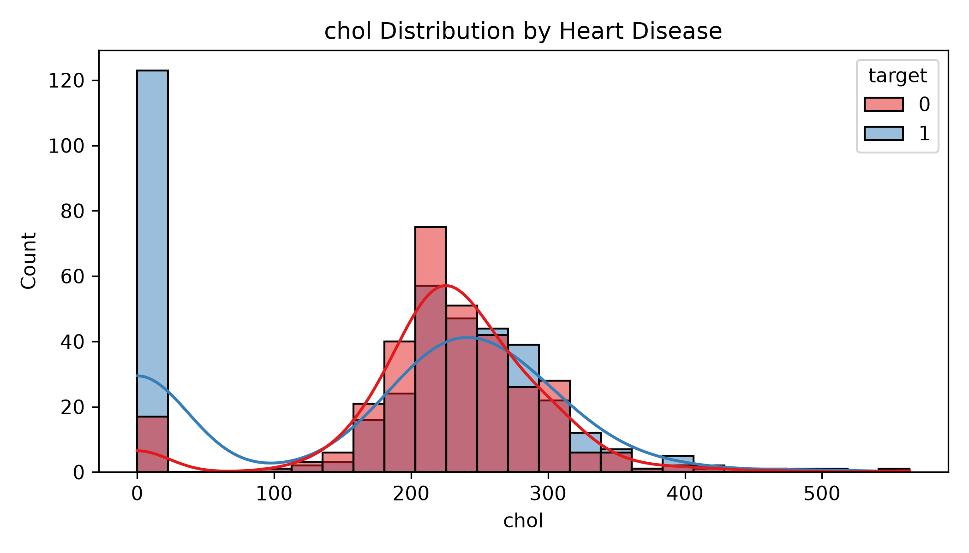
Figure 4. Cholesterol distribution by target class.
Figure 4. Serum cholesterol distribution by target class.
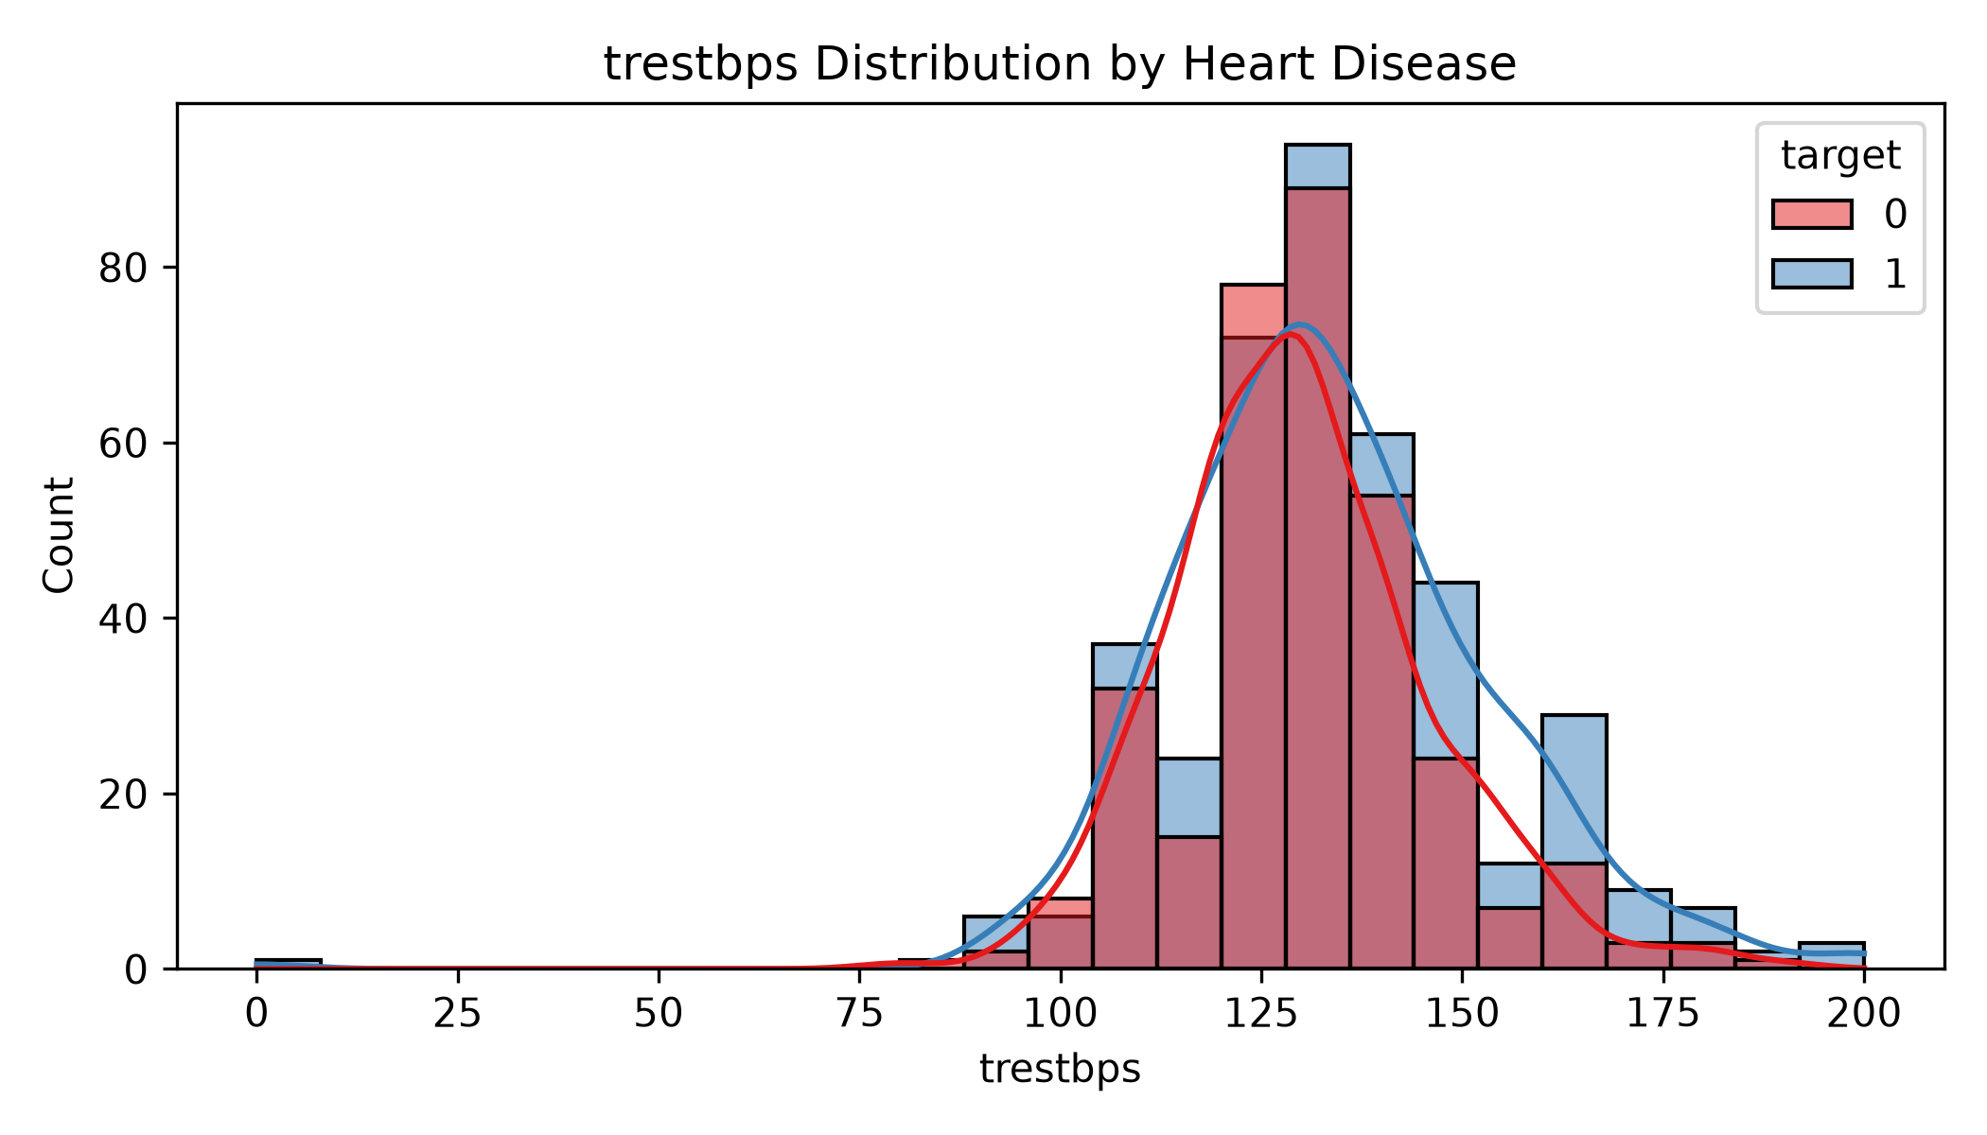
Figure 5. Resting blood pressure distribution by target class.
Figure 5. Resting blood pressure distribution by target class.
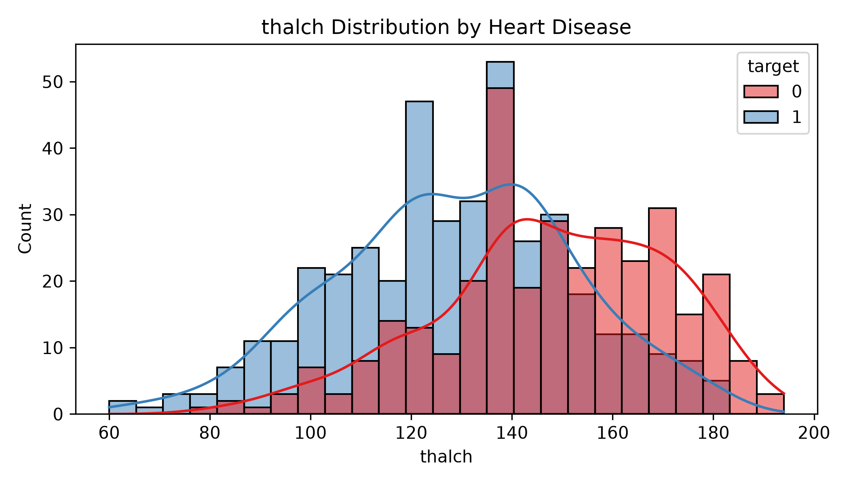
Figure 6. Maximum heart rate distribution by target class.
Figure 6. Maximum heart rate achieved by target class.
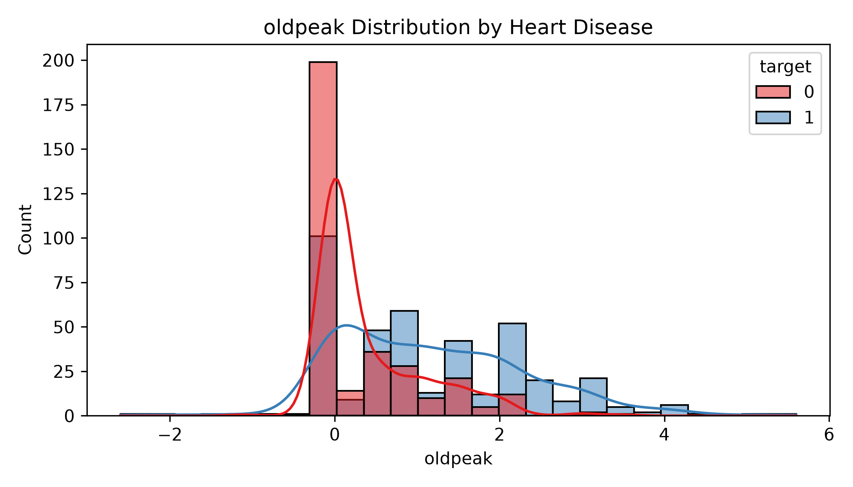
Figure 7. Oldpeak distribution by target class.
Figure 7. ST depression induced by exercise compared across target classes.

6.2 Categorical Features
The categorical features were:
sex, dataset, cp, restecg, slope, thal
Chest pain type was especially informative. Patients with asymptomatic chest pain were more commonly associated with heart disease.
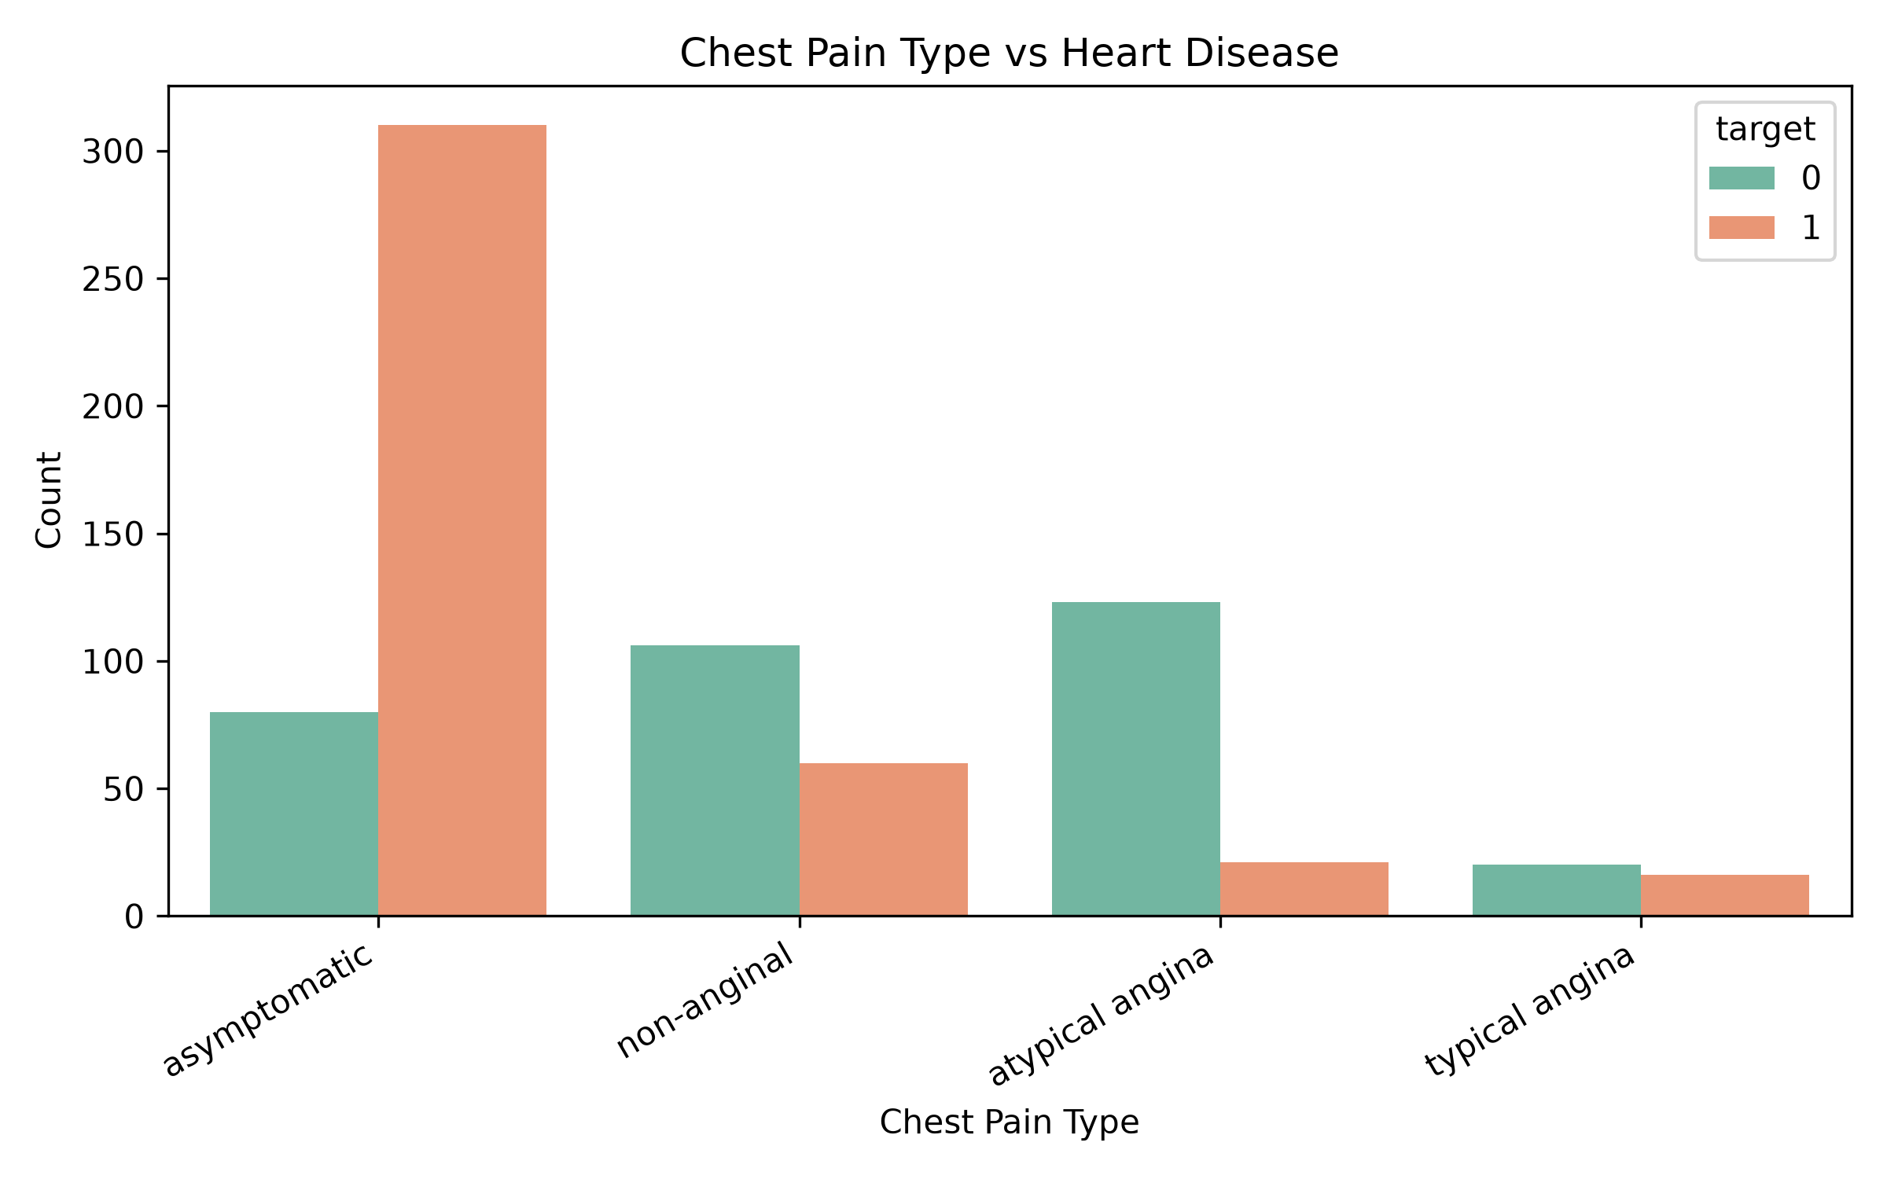
Figure 8. Chest pain type compared with target.
Figure 8. Chest pain type distribution across target classes.
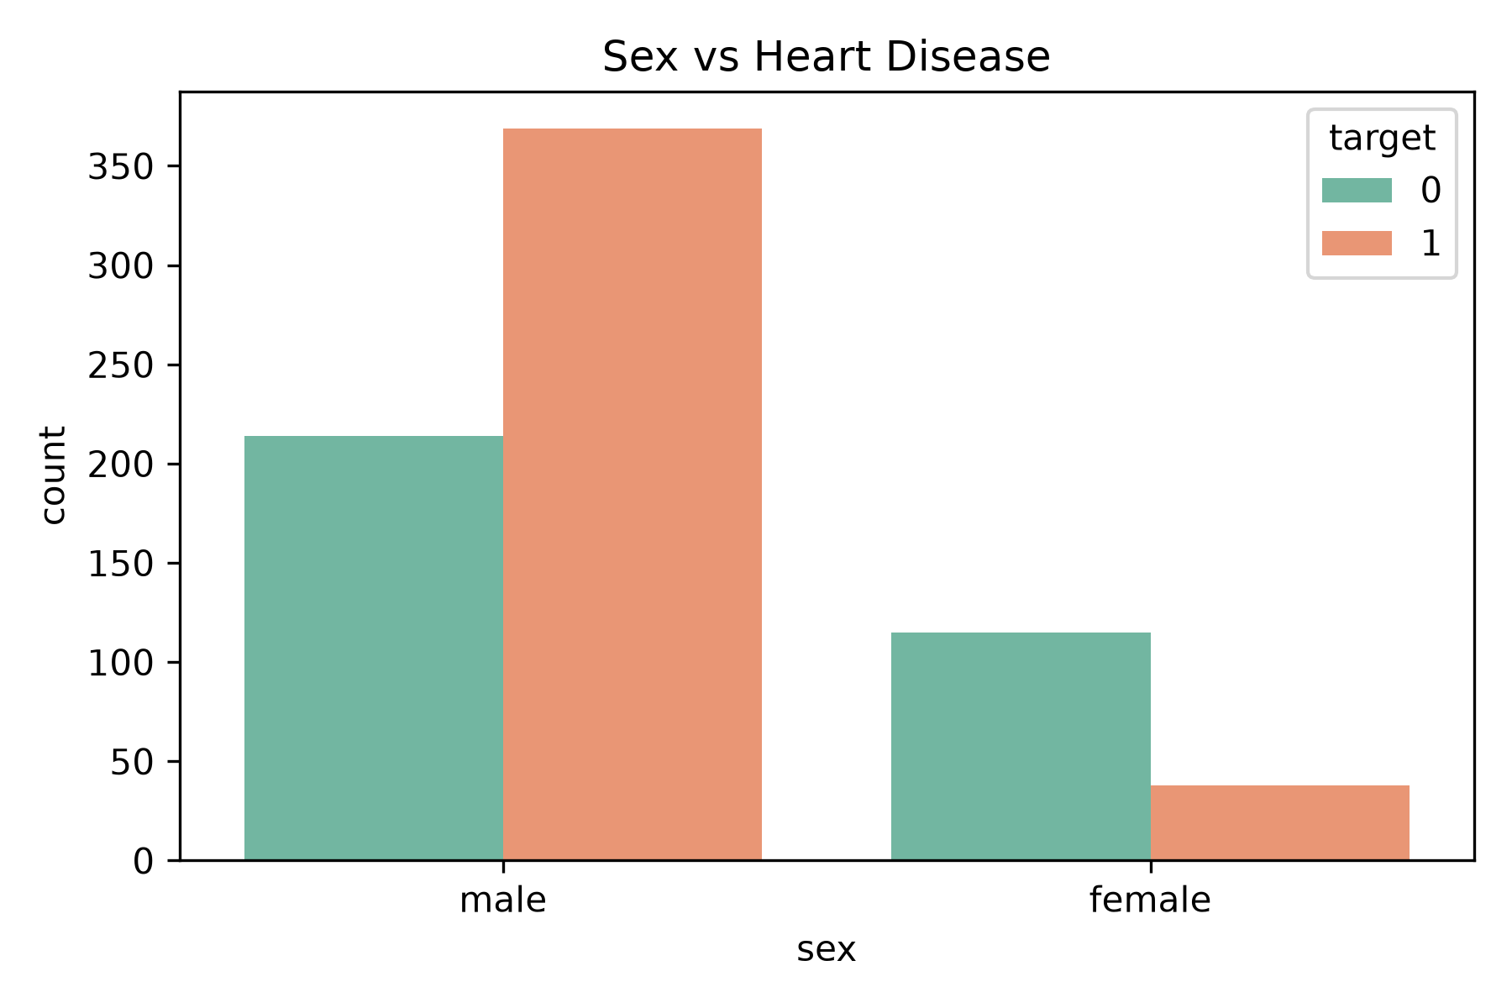
Figure 9. Sex compared with target.
Figure 9. Sex distribution across target classes.
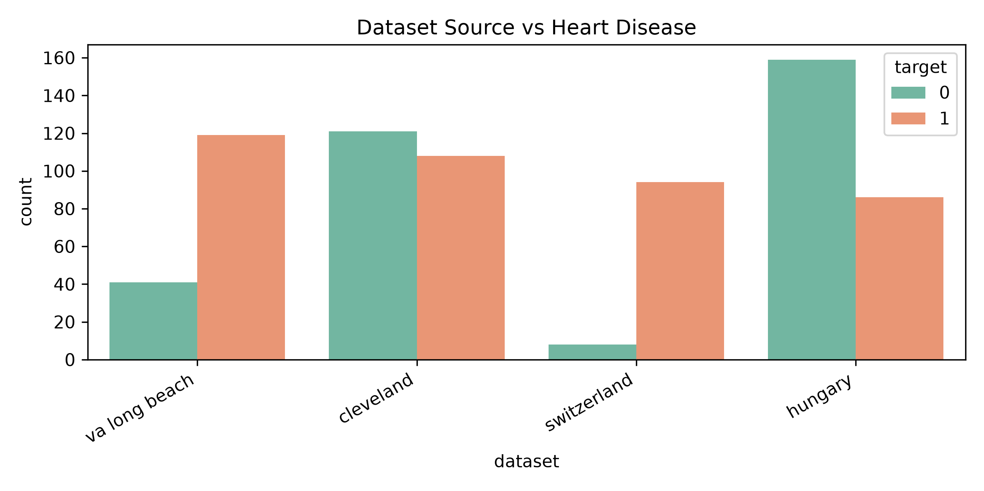
Figure 10. Dataset source compared with target.
Figure 10. Target distribution across dataset sources.

6.3 Correlation Analysis
A correlation heatmap was created after encoding categorical variables. It helped show relationships between processed features and the target variable.
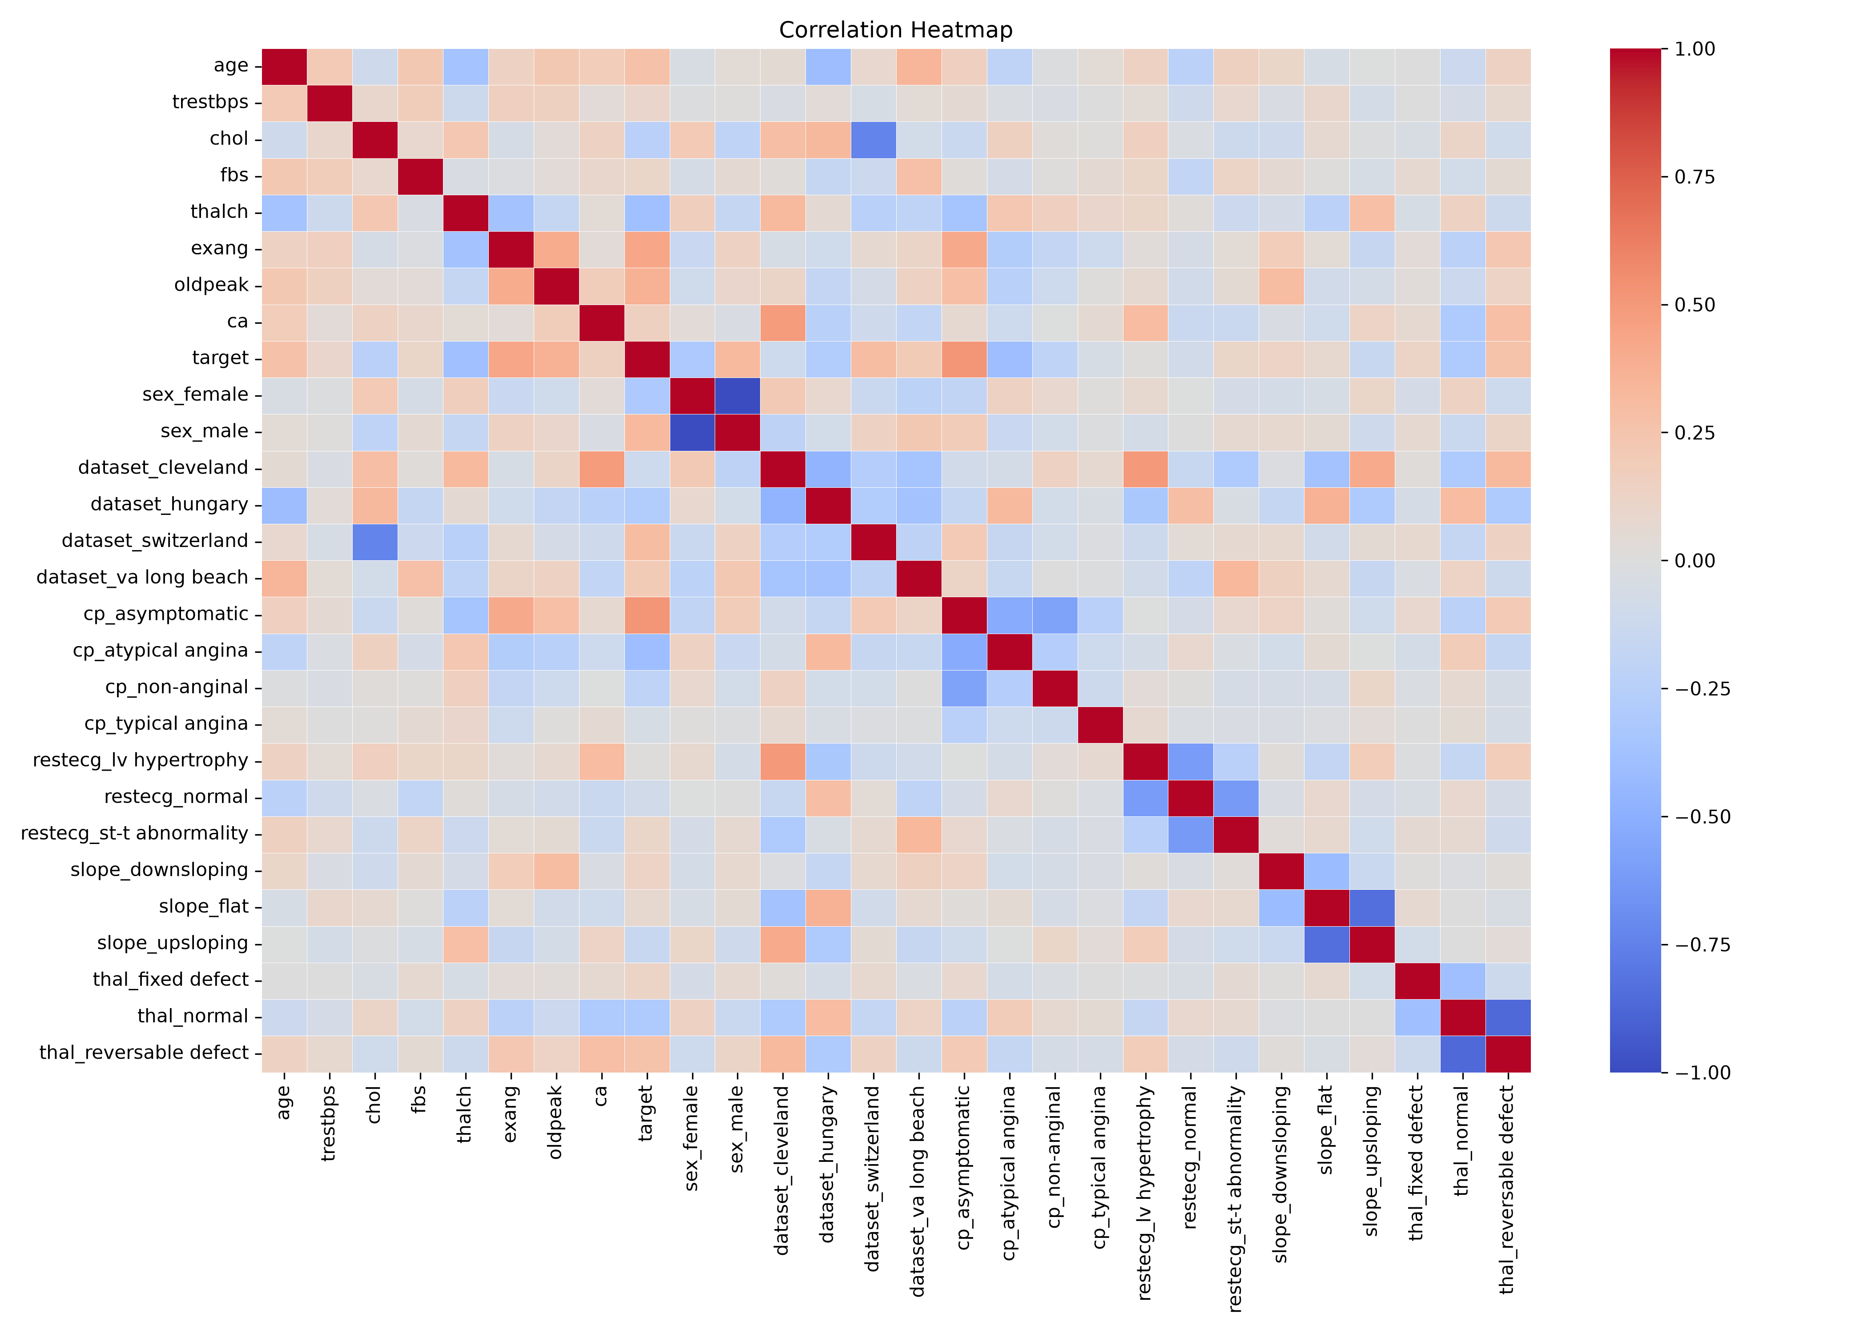
Figure 11. Correlation heatmap.
Figure 11. Correlation heatmap for processed training features.

7. Feature Engineering
Feature engineering converted the cleaned dataset into a format suitable for machine learning.
Feature group | Features | Processing method
Numerical | age, trestbps, chol, thalch, oldpeak | StandardScaler
Categorical | sex, dataset, cp, restecg, slope, thal | OneHotEncoder
Binary/discrete | fbs, exang, ca | Passthrough
The preprocessing pipeline was fitted only on X_train. The same fitted pipeline was then used to transform both X_train and X_test. This avoids data leakage and keeps the evaluation fair.

8. Feature Importance Discussion
Feature importance was interpreted using Random Forest feature importance and Logistic Regression coefficients.
The strongest Random Forest features were:
Rank | Feature | Importance
1 | cp_asymptomatic | 0.1168
2 | oldpeak | 0.1068
3 | thalch | 0.0971
4 | chol | 0.0940
5 | age | 0.0814
6 | exang | 0.0734
7 | trestbps | 0.0590
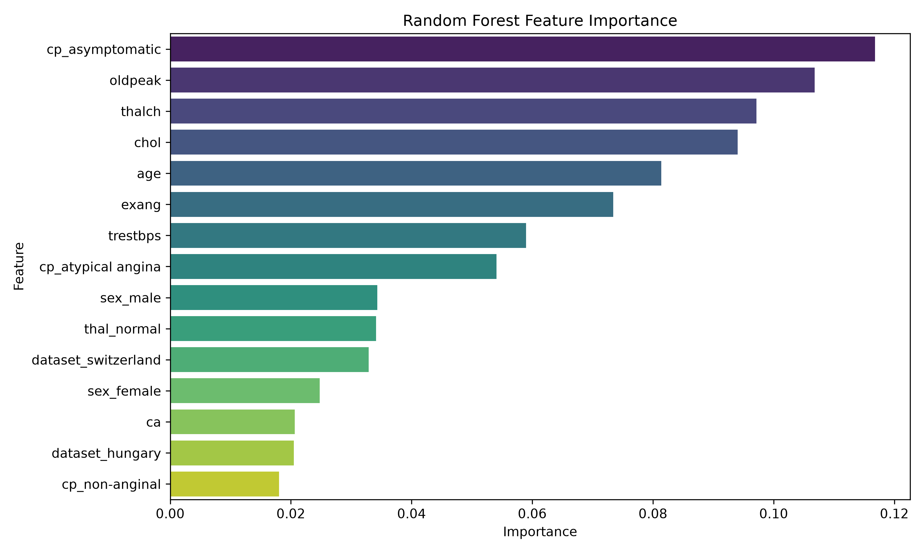
Figure 12. Random Forest feature importance.
Figure 12. Top features ranked by the Random Forest model.
These features are reasonable for a heart disease prediction task. Chest pain type, ST depression, maximum heart rate, cholesterol, age, exercise-induced angina, and resting blood pressure are all medically meaningful variables.
Logistic Regression also highlighted important features such as cp_asymptomatic, exang, ca, oldpeak, and thal_normal. Some dataset-source features also appeared with high coefficient values, which motivated the additional experiment without dataset source columns.
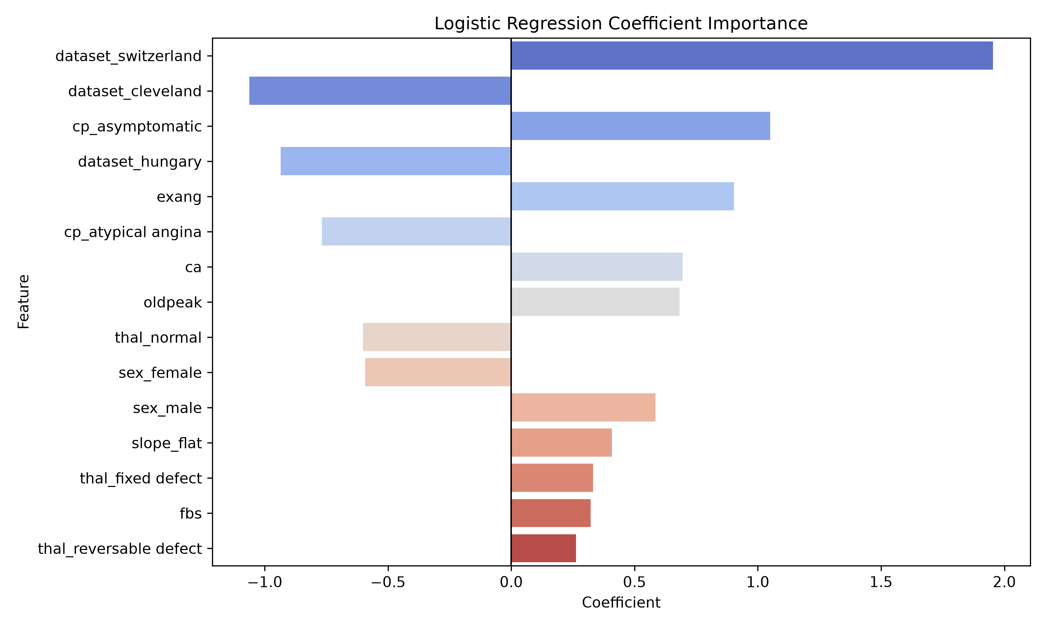
Figure 13. Logistic Regression coefficient importance.
Figure 13. Logistic Regression coefficients ranked by absolute coefficient size.

9. Baseline Comparison
A DummyClassifier baseline was trained using the most frequent class strategy. This model ignores all input features and always predicts the majority class. The baseline is useful because it shows whether the machine learning models actually learn useful patterns.
Model | Accuracy | Precision | Recall | F1 | ROC-AUC | CV Mean | CV Std
Dummy Baseline | 0.554 | 0.554 | 1.000 | 0.713 | 0.500 | 0.553 | 0.003
The baseline recall is 1.000 because the majority class is heart disease, so the baseline predicts class 1 for every patient. However, its ROC-AUC is only 0.500, which means it has no real ability to separate patients with and without heart disease. All trained machine learning models performed better than this baseline overall.
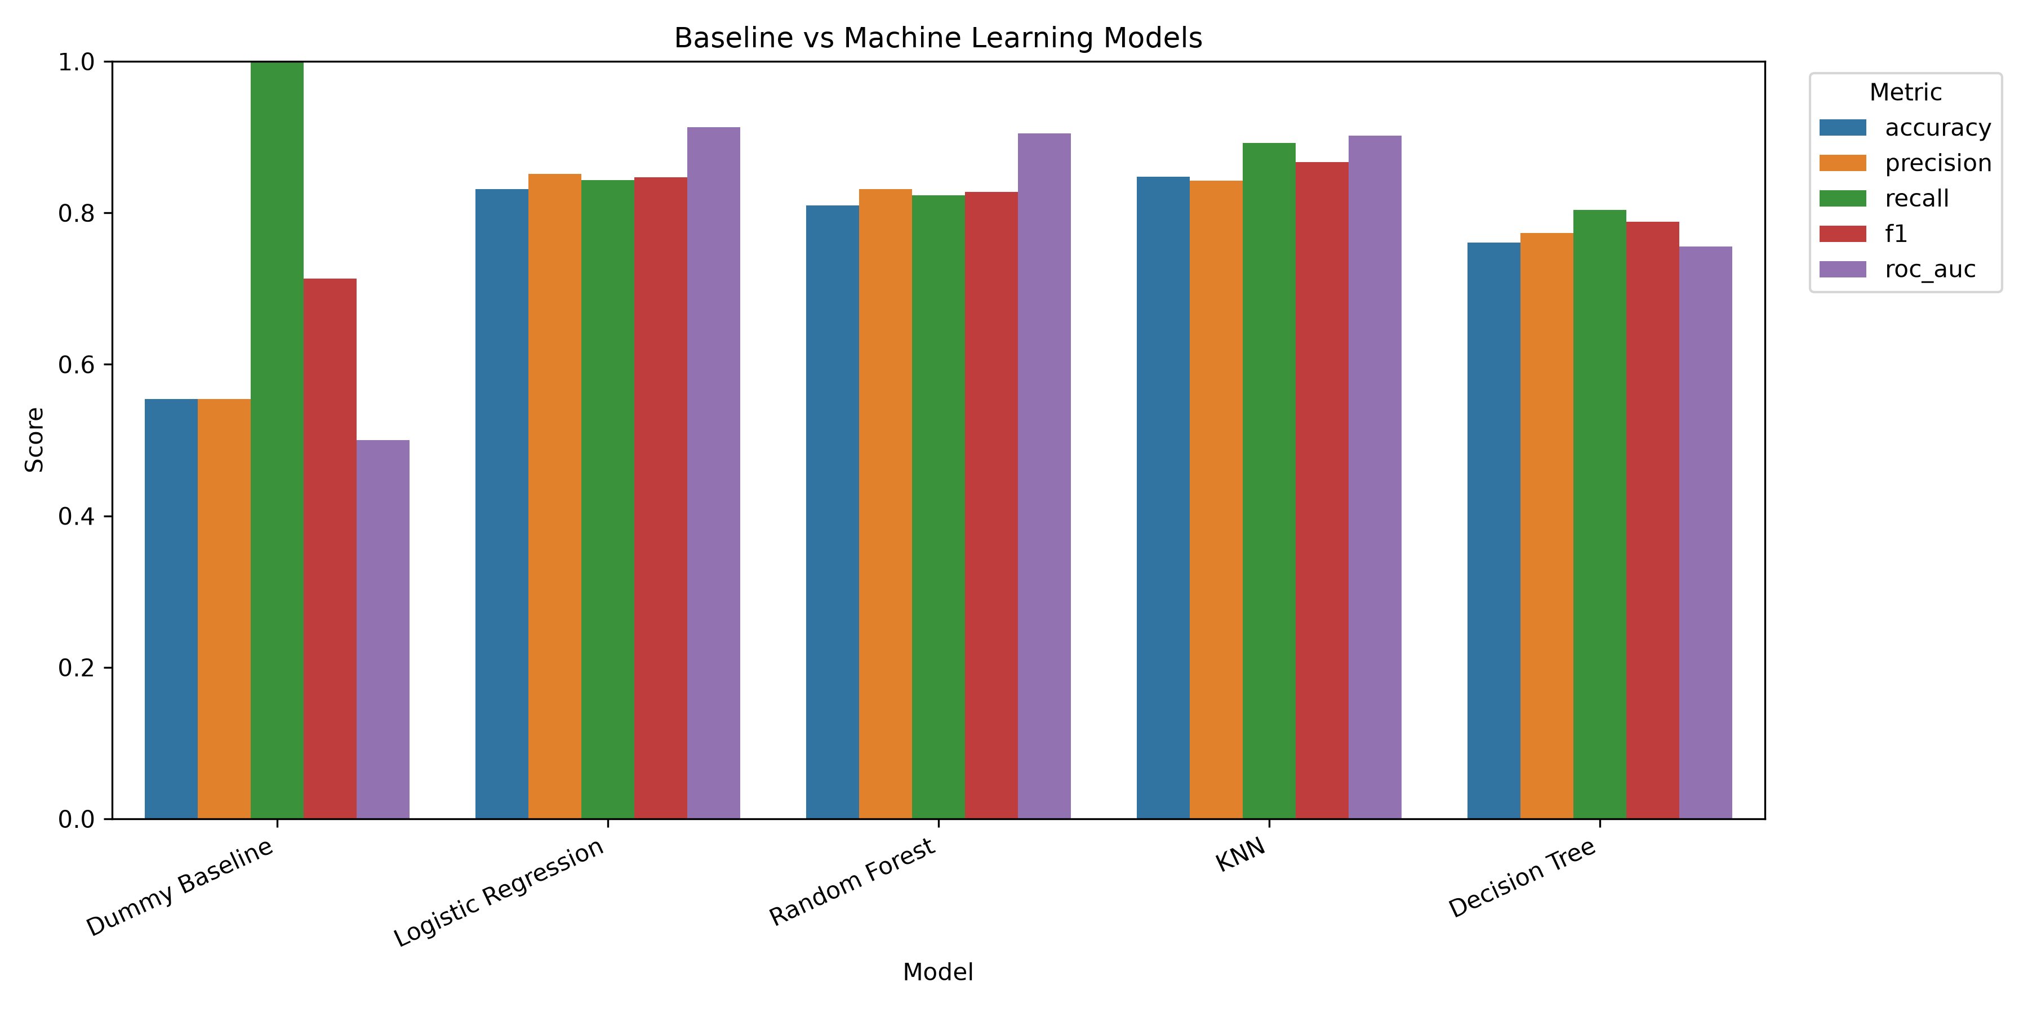
Figure 14. Baseline comparison.
Figure 14. Dummy baseline compared with the trained machine learning models.

10. Dimensionality Reduction Using PCA
Principal Component Analysis was tested as a dimensionality reduction method. PCA was fitted only on the training data, then the fitted PCA transformation was applied to the test data.
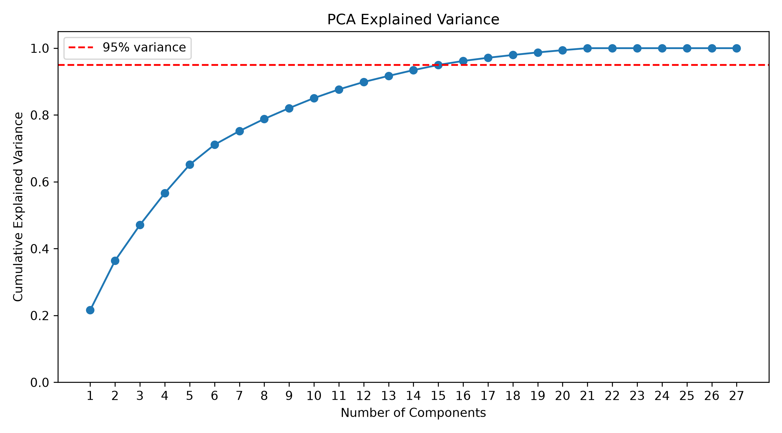
Figure 15. PCA explained variance.
Figure 15. Cumulative explained variance from PCA components.
The PCA results were:
Model | Accuracy | Precision | Recall | F1 | ROC-AUC | CV Mean | CV Std
KNN | 0.842 | 0.835 | 0.892 | 0.863 | 0.912 | 0.827 | 0.022
Logistic Regression | 0.826 | 0.843 | 0.843 | 0.843 | 0.898 | 0.814 | 0.032
Random Forest | 0.832 | 0.832 | 0.873 | 0.852 | 0.894 | 0.831 | 0.024
Decision Tree | 0.766 | 0.792 | 0.784 | 0.788 | 0.764 | 0.751 | 0.019
PCA did not improve the best overall ROC-AUC compared with the original processed features. Therefore, the original processed feature set was kept as the main modeling approach.
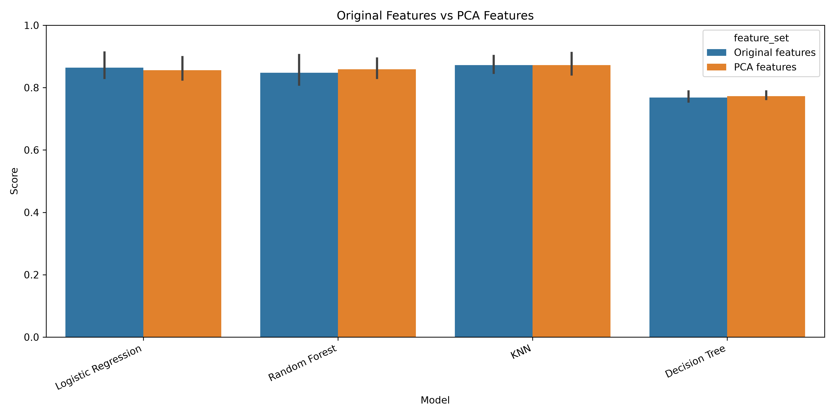
Figure 16. Original features compared with PCA features.
Figure 16. Model performance using original processed features compared with PCA-transformed features.

11. Experiment Without Dataset Source Feature
The encoded dataset source columns were removed to check whether the models depended too strongly on source location. The removed columns were:
dataset_cleveland
dataset_hungary
dataset_switzerland
dataset_va long beach
The results were:
Model | Accuracy | Precision | Recall | F1 | ROC-AUC | CV Mean | CV Std
Random Forest | 0.826 | 0.824 | 0.873 | 0.848 | 0.893 | 0.832 | 0.029
Logistic Regression | 0.815 | 0.827 | 0.843 | 0.835 | 0.893 | 0.804 | 0.042
KNN | 0.821 | 0.805 | 0.892 | 0.847 | 0.877 | 0.833 | 0.023
Decision Tree | 0.761 | 0.774 | 0.804 | 0.788 | 0.756 | 0.760 | 0.021
The performance dropped moderately, but the models still performed clearly above the baseline. This suggests that the prediction was not based only on dataset source; the medical features still contained useful predictive information.
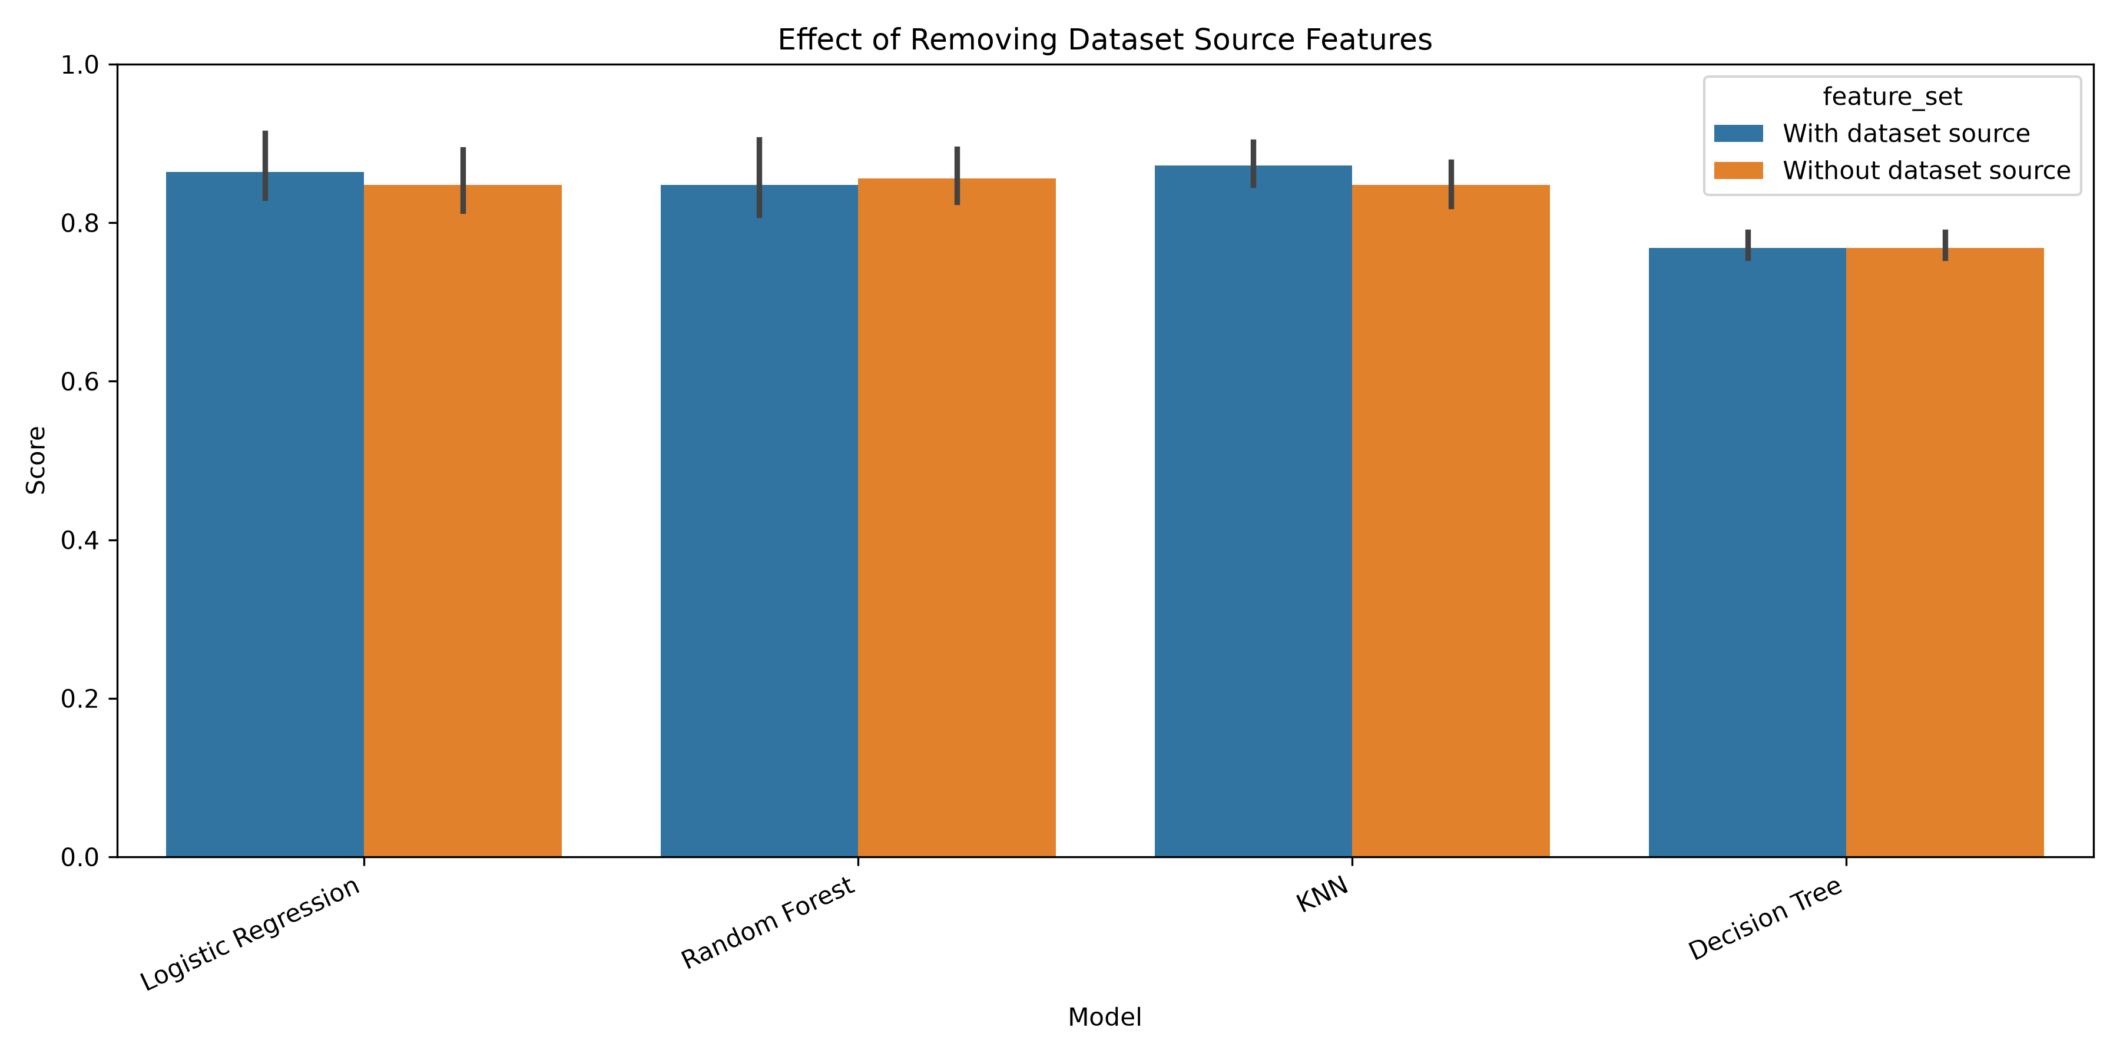
Figure 17. Dataset source experiment comparison.
Figure 17. Performance comparison with and without dataset source features.

12. Machine Learning Models
Four supervised classification models were trained and evaluated.

12.1 K-Nearest Neighbors
KNN classifies a patient using the labels of the most similar patients in the training set. Values of k from 1 to 20 were tested using 5-fold cross-validation. The best value was:
k = 7
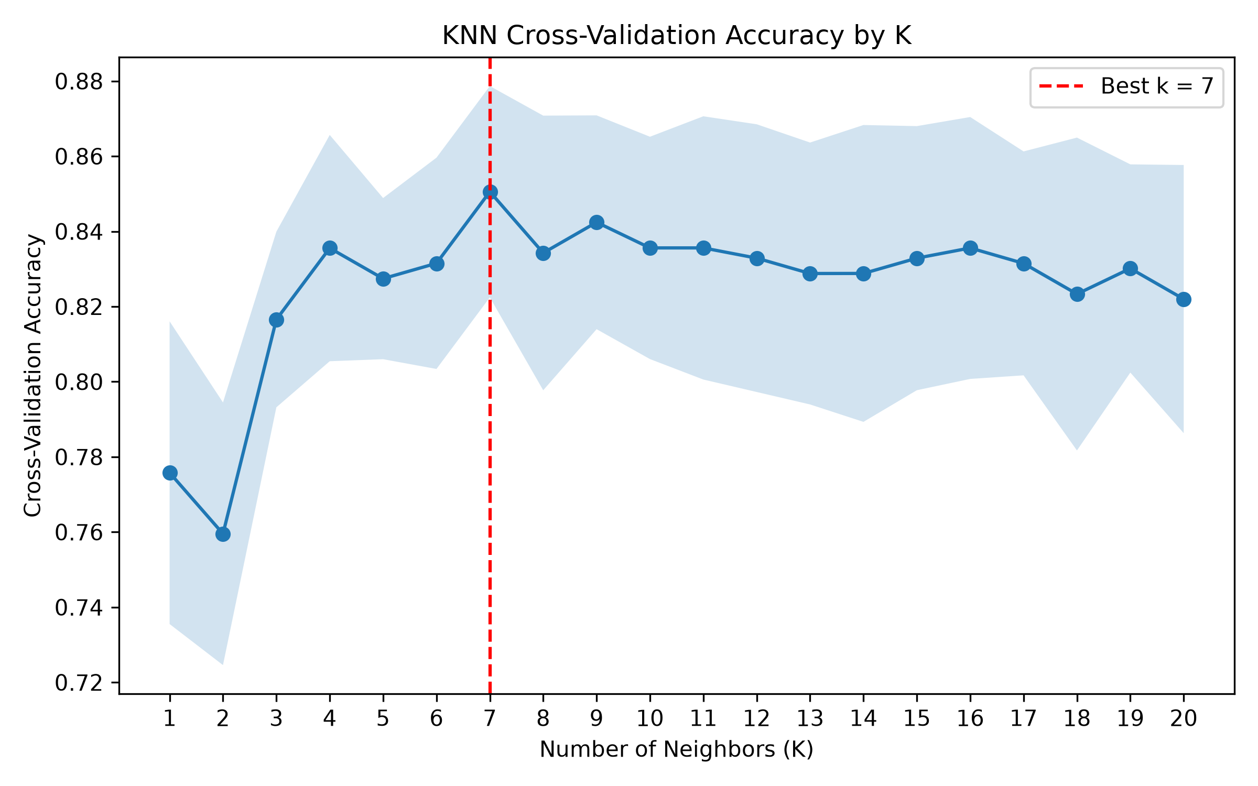
Figure 18. KNN accuracy by k value.
Figure 18. Cross-validation accuracy for KNN values from 1 to 20.
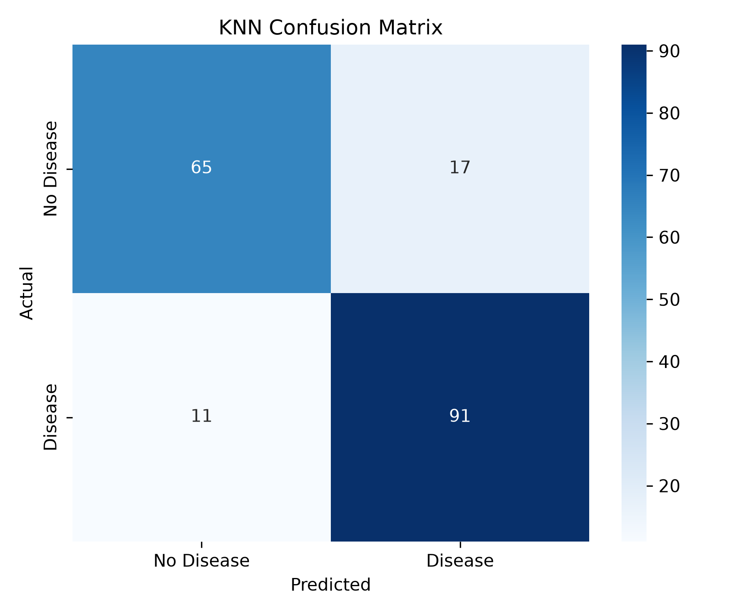
Figure 19. KNN confusion matrix.
Figure 19. KNN confusion matrix on the untouched test set.
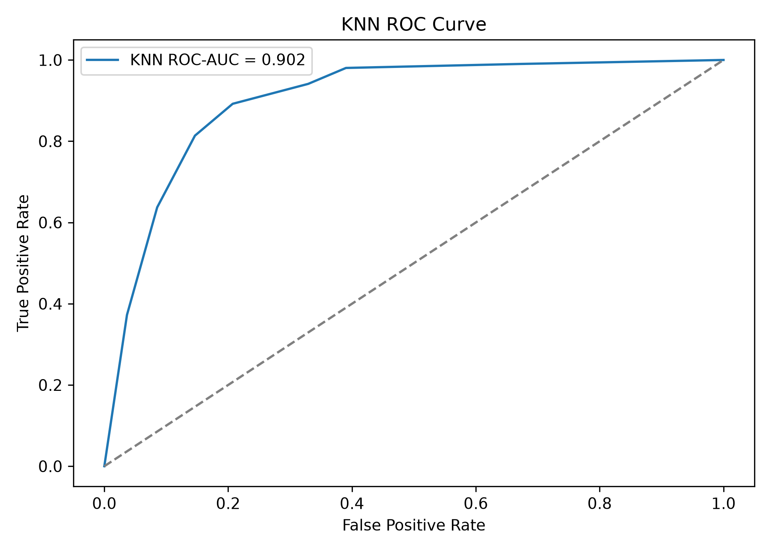
Figure 20. KNN ROC curve.
Figure 20. KNN ROC curve on the untouched test set.

12.2 Logistic Regression
Logistic Regression was included because it is a strong and interpretable model for binary classification. It achieved the highest ROC-AUC score, meaning it separated the two classes better across probability thresholds.
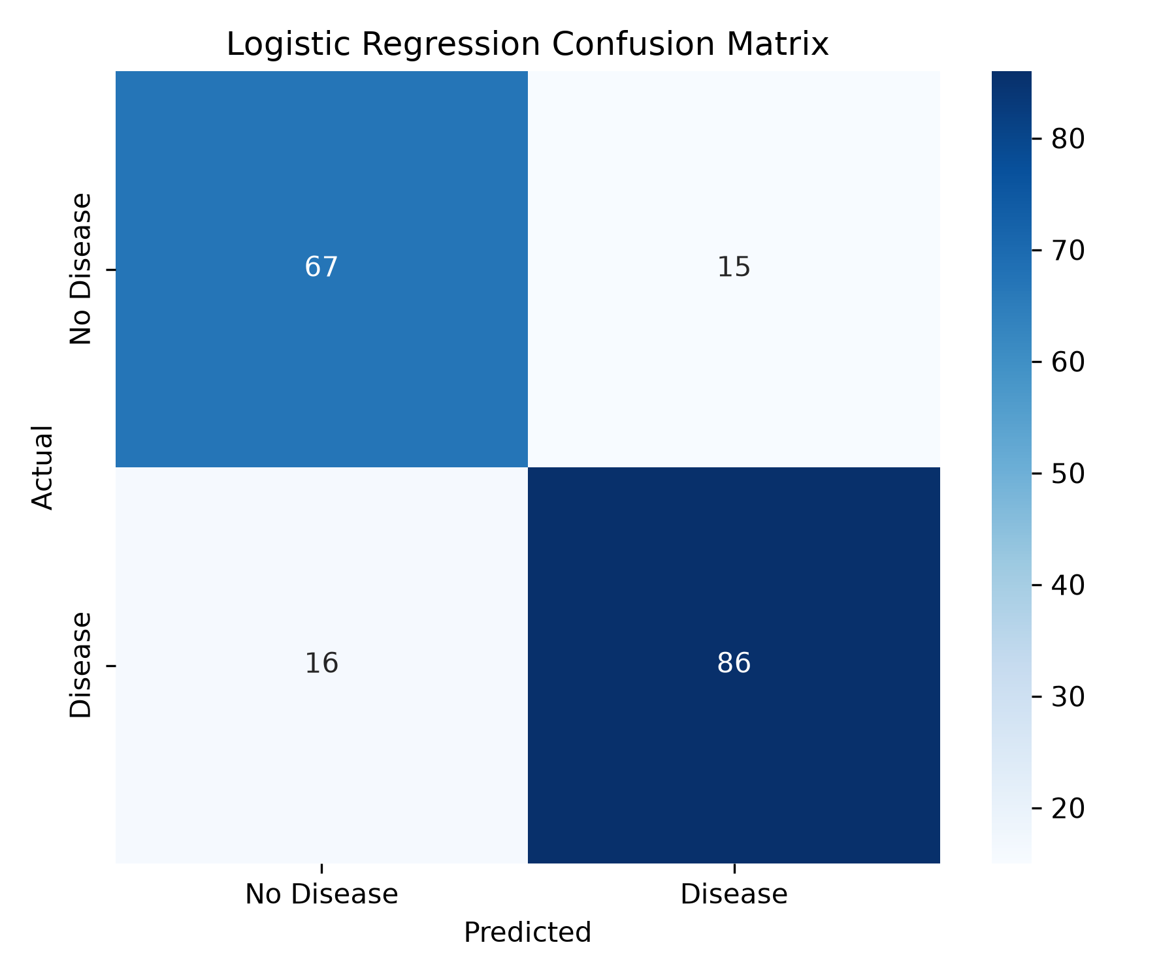
Figure 21. Logistic Regression confusion matrix.
Figure 21. Logistic Regression confusion matrix on the untouched test set.
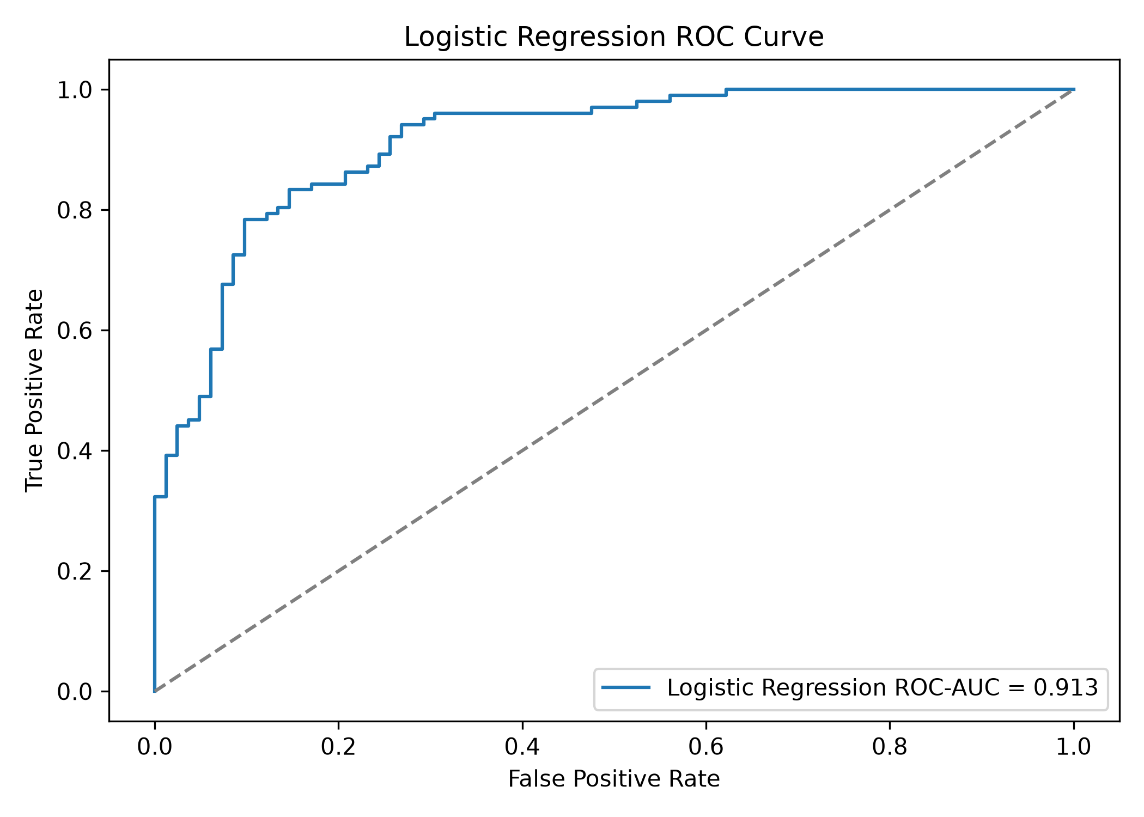
Figure 22. Logistic Regression ROC curve.
Figure 22. Logistic Regression ROC curve on the untouched test set.

12.3 Decision Tree
Decision Tree was included because it is easy to visualize and explain. It had the weakest performance among the trained models, which is reasonable because a single tree can be less stable than an ensemble model.
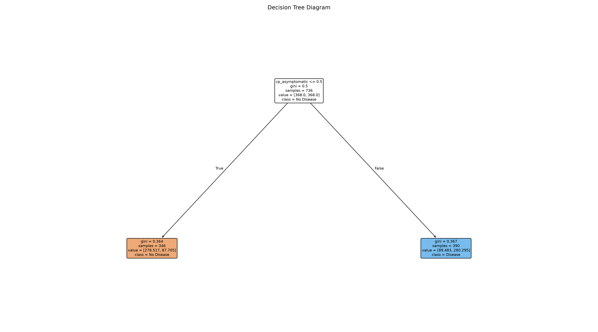
Figure 23. Decision Tree diagram.
Figure 23. Visualized Decision Tree model.
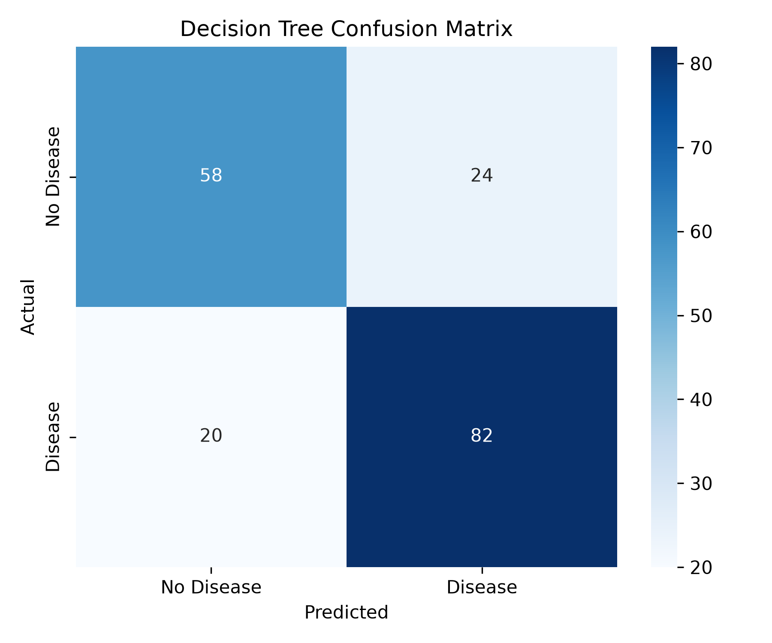
Figure 24. Decision Tree confusion matrix.
Figure 24. Decision Tree confusion matrix on the untouched test set.
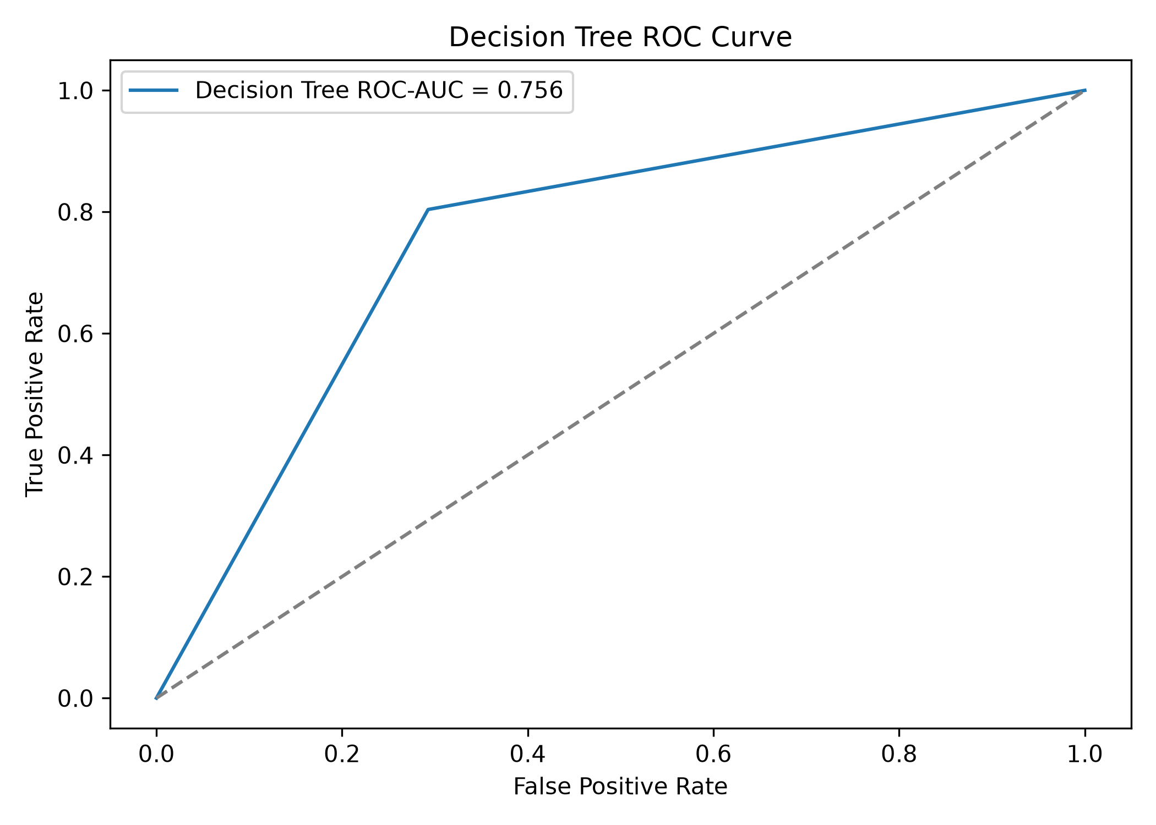
Figure 25. Decision Tree ROC curve.
Figure 25. Decision Tree ROC curve on the untouched test set.

12.4 Random Forest
Random Forest was included as the ensemble model. GridSearchCV was used to tune the model on the training set. The best parameters were:
max_depth = 10
min_samples_leaf = 1
min_samples_split = 2
n_estimators = 300
Random Forest performed strongly and provided useful feature importance results, but it did not outperform KNN or Logistic Regression on the main test metrics.
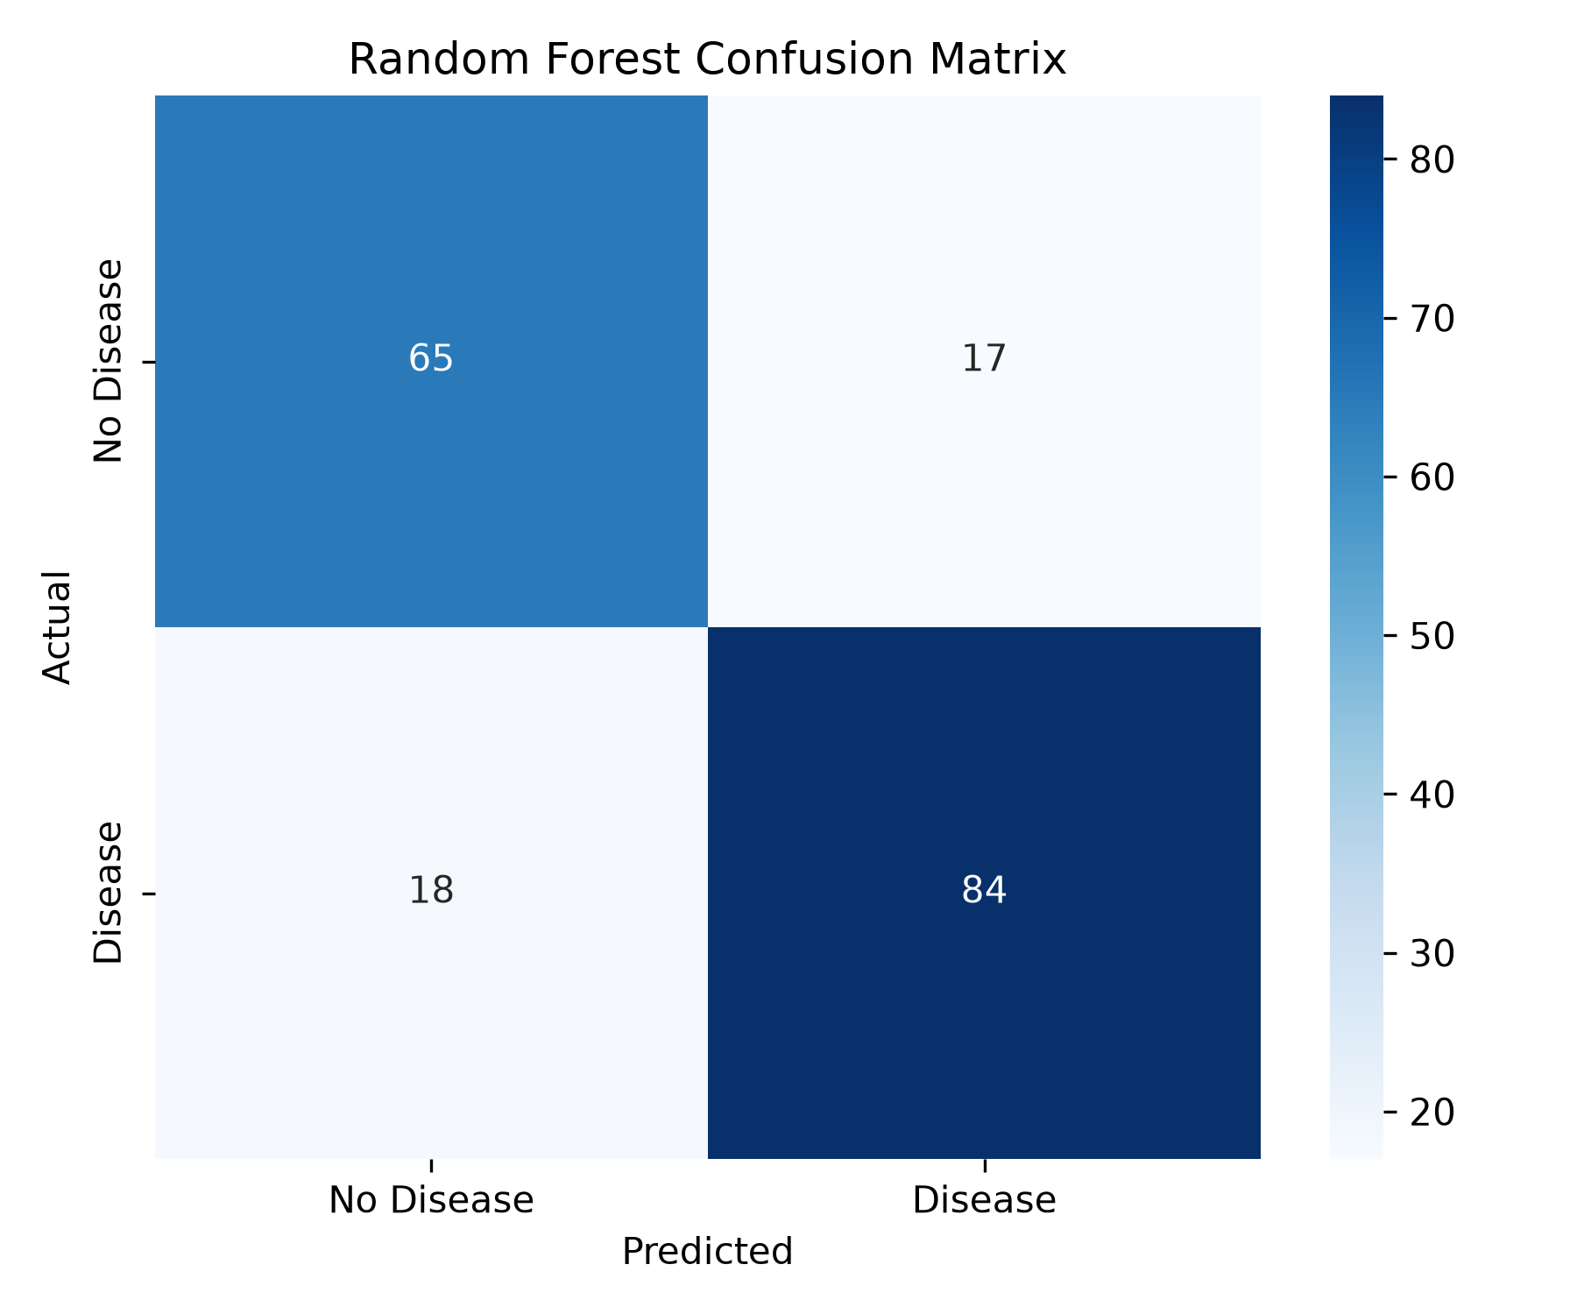
Figure 26. Random Forest confusion matrix.
Figure 26. Random Forest confusion matrix on the untouched test set.
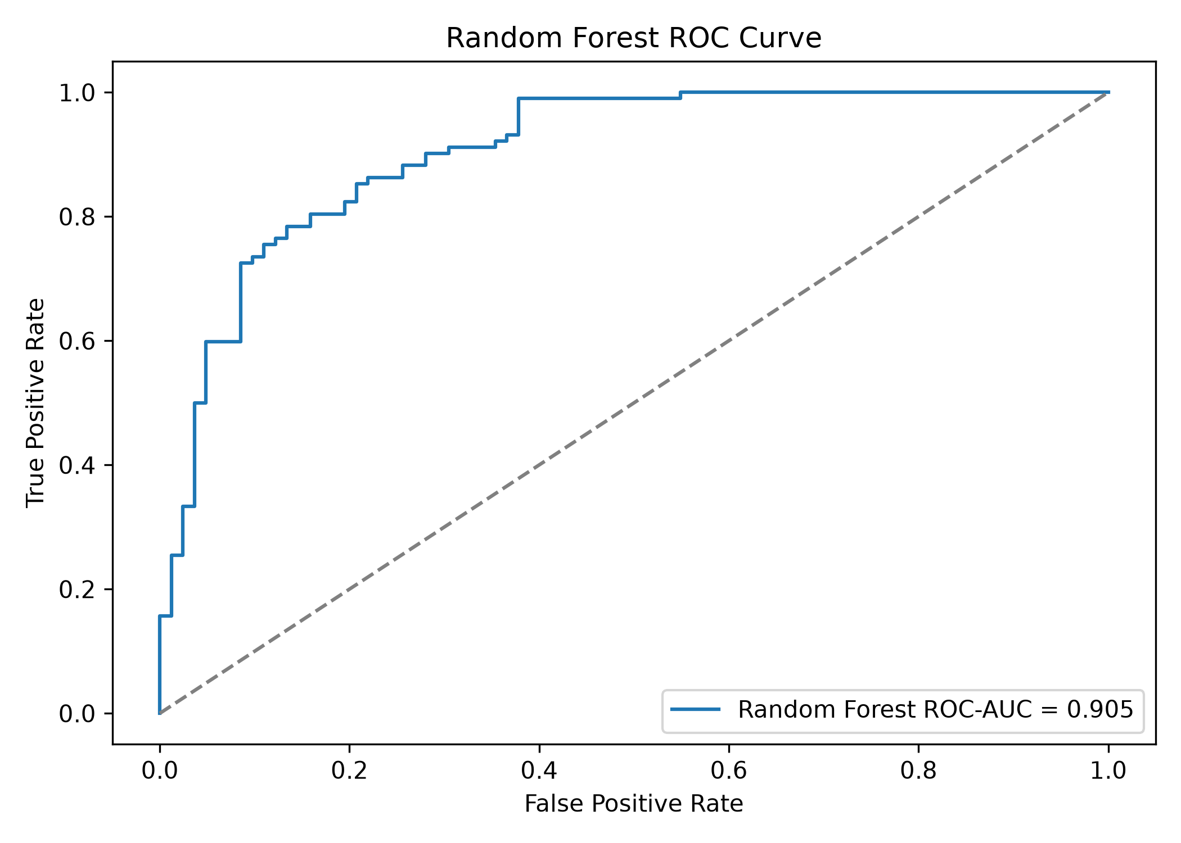
Figure 27. Random Forest ROC curve.
Figure 27. Random Forest ROC curve on the untouched test set.

13. Experimental Setup
The experiment followed these rules:
- Data was cleaned before modeling.
- The train/test split was performed before model training.
- The test set was kept untouched until final evaluation.
- Cross-validation was performed only on the training set.
- Hyperparameter selection was based on cross-validation.
- Encoders and scalers were fitted only on training data.
- PCA was fitted only on training data.
- Final results were reported using the untouched test set.
The evaluation metrics were:
Accuracy
Precision
Recall
F1-score
ROC-AUC
Cross-validation mean score
Cross-validation standard deviation

14. Results and Discussion
The final model comparison is shown below.
Model | Accuracy | Precision | Recall | F1 | ROC-AUC | CV Mean | CV Std
Logistic Regression | 0.832 | 0.851 | 0.843 | 0.847 | 0.913 | 0.827 | 0.035
Random Forest | 0.810 | 0.832 | 0.824 | 0.828 | 0.905 | 0.833 | 0.036
KNN | 0.848 | 0.843 | 0.892 | 0.867 | 0.902 | 0.851 | 0.028
Decision Tree | 0.761 | 0.774 | 0.804 | 0.788 | 0.756 | 0.760 | 0.021
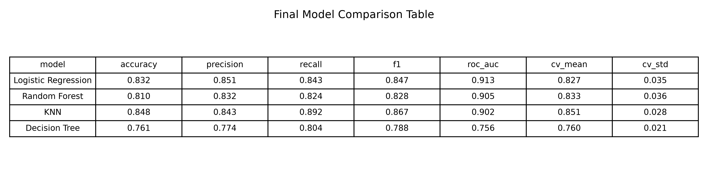
Figure 28. Final results table.
Figure 28. Final test-set model comparison table.
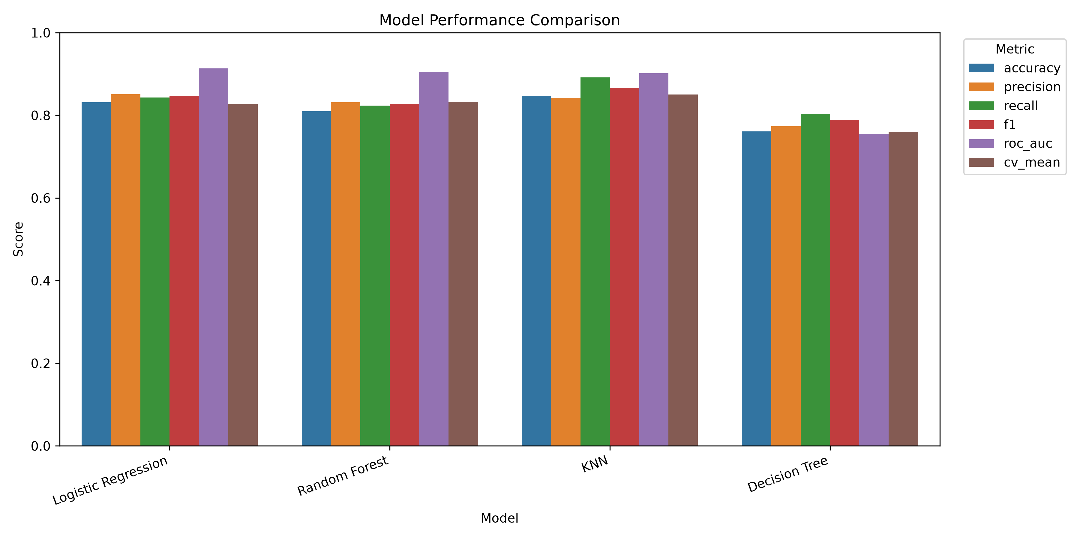
Figure 29. Model performance comparison.
Figure 29. Comparison of model performance across evaluation metrics.
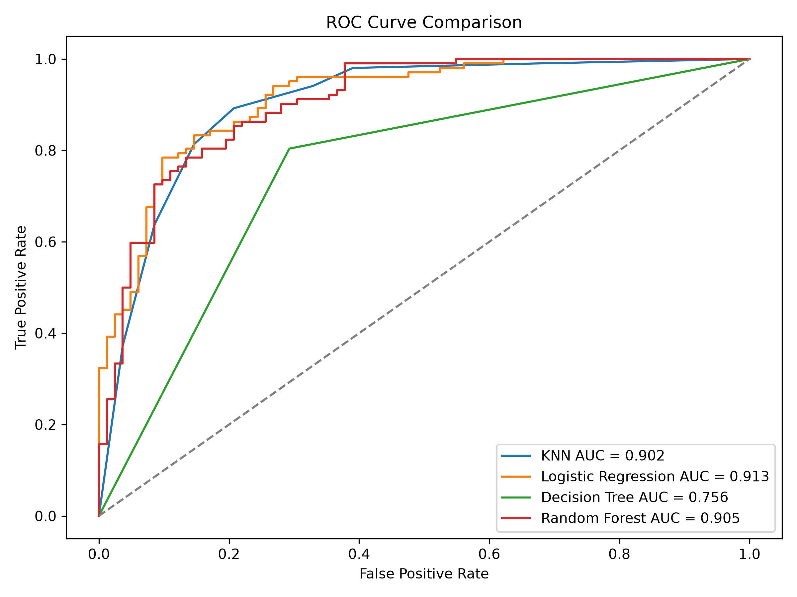
Figure 30. ROC curve comparison.
Figure 30. ROC curve comparison for all trained models.
KNN achieved the highest accuracy, recall, and F1-score. This is important because recall is especially meaningful in a medical prediction task: a false negative means the model predicts no heart disease when the patient may actually have heart disease.
Logistic Regression achieved the highest ROC-AUC. This indicates that it had the best overall class-separation ability across different probability thresholds. It is also highly interpretable because its coefficients show the direction and strength of feature effects.
Random Forest was expected to perform very strongly because it is a more complex ensemble model. However, it did not outperform the simpler models. This result is still reasonable. The dataset is relatively small, structured, and well-preprocessed, so simple models can capture the main patterns effectively. Complex models do not always win, especially when the feature space is clean and the sample size is limited.
Decision Tree performed weakest. This is expected because a single tree can be more sensitive to small changes in the data and may not generalize as well as Random Forest.

15. Model Comparison
The best model depends on the priority.
Priority | Best Model | Reason
Highest accuracy | KNN | Accuracy = 0.848
Highest recall | KNN | Recall = 0.892
Highest F1-score | KNN | F1 = 0.867
Highest ROC-AUC | Logistic Regression | ROC-AUC = 0.913
Best interpretability | Logistic Regression | Coefficients can be explained
Best feature importance analysis | Random Forest | Provides ranked feature importances
For this project, KNN can be justified as the best predictive model because it achieved the highest accuracy, recall, and F1-score. Logistic Regression can be justified as the strongest interpretable model because it achieved the highest ROC-AUC and provides clear coefficients.

16. Conclusion
This project successfully applied a complete data mining workflow to heart disease prediction. The dataset was cleaned, split correctly, explored through EDA, transformed using a preprocessing pipeline, and evaluated using multiple classification models.
The DummyClassifier baseline confirmed that the trained machine learning models performed better than a naive majority-class classifier. PCA was tested as a dimensionality reduction method, but the original processed features remained better for final modeling. The experiment without dataset source features showed that the models still performed well using medical features, although some performance was lost.
The final results showed that KNN achieved the best accuracy, recall, and F1-score, while Logistic Regression achieved the best ROC-AUC and provided strong interpretability. Random Forest also performed strongly and helped identify important features, but it was not the overall best model in this experiment.
Overall, the project demonstrates that machine learning can support early heart disease risk prediction when the data is carefully cleaned, properly split, and evaluated using fair metrics.

17. Future Work
Future improvements could include:
- Testing additional algorithms such as Support Vector Machine, Gradient Boosting, or XGBoost.
- Using a larger and more recent clinical dataset.
- Applying more advanced feature selection methods.
- Optimizing classification thresholds to improve recall.
- Deploying the best model in a simple web application.
- Validating the model on an external dataset.

18. References
- Janosi, A., Steinbrunn, W., Pfisterer, M., & Detrano, R. (1989). Heart Disease. UCI Machine Learning Repository. https://archive.ics.uci.edu/dataset/45/heart+disease
- UCI Machine Learning Repository. Heart Disease Dataset DOI: https://doi.org/10.24432/C52P4X
- Scikit-learn Developers. DummyClassifier documentation. https://scikit-learn.org/stable/modules/generated/sklearn.dummy.DummyClassifier.html
- Scikit-learn Developers. train_test_split documentation. https://scikit-learn.org/stable/modules/generated/sklearn.model_selection.train_test_split.html
- Scikit-learn Developers. KNeighborsClassifier documentation. https://scikit-learn.org/stable/modules/generated/sklearn.neighbors.KNeighborsClassifier.html
- Scikit-learn Developers. LogisticRegression documentation. https://scikit-learn.org/stable/modules/generated/sklearn.linear_model.LogisticRegression.html
- Scikit-learn Developers. DecisionTreeClassifier documentation. https://scikit-learn.org/stable/modules/generated/sklearn.tree.DecisionTreeClassifier.html
- Scikit-learn Developers. RandomForestClassifier documentation. https://scikit-learn.org/stable/modules/generated/sklearn.ensemble.RandomForestClassifier.html
- Scikit-learn Developers. Principal Component Analysis documentation. https://scikit-learn.org/stable/modules/generated/sklearn.decomposition.PCA.html

