Smart Room Light System with Automatic and Manual Control (Arduino Project)
Firkət Qurbanov
Verified by: Physics Teacher Azerbaijan Telman Askeraliyev (Fizika Muellimi, Azerbaijan, Baku)

Circuit Diagram:
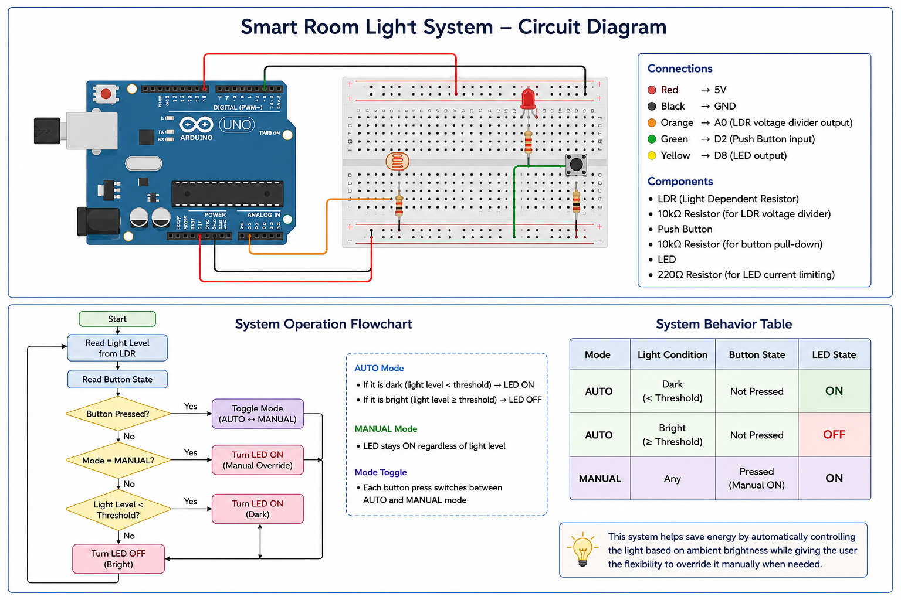
1. Introduction
In modern smart environments, automation plays a crucial role in improving efficiency, energy saving, and user comfort. One of the most common applications of automation is smart lighting systems. These systems can automatically control lights based on environmental conditions such as ambient light levels, while also allowing manual user interaction.

This project focuses on designing and implementing a Smart Room Light System using an Arduino Uno, a Light Dependent Resistor (LDR), and a push button. The system operates in two modes:

Automatic Mode – light is controlled based on ambient brightness
Manual Mode – user overrides the system and keeps the light ON

The project was initially developed at a basic level (2.5), and later improved to a more advanced level (2.6) by introducing manual control logic and system optimization.

2. Project Objective
The main objectives of this project are:
* To design a system that automatically turns ON a light in dark conditions
* To allow manual override using a push button
* To understand analog and digital input handling in Arduino
* To implement real-time decision-making logic
* To improve system design by reducing unnecessary complexity

3. System Overview
The system consists of the following components:
* Arduino Uno
* Breadboard
* LDR (Light Sensor)
* Resistors
* LED (representing room light)
* Push Button
The system reads light intensity using the LDR and decides whether the LED should be ON or OFF. Additionally, the push button allows switching between automatic and manual modes.

4. Level 2.5 Implementation
4.1 Description
At level 2.5, the system operates purely in automatic mode. The LED turns ON when the environment is dark and turns OFF when it is bright.
4.2 Working Principle
* The LDR provides an analog value between 0–1023
* A threshold value (e.g., 500) is used
* If light level < threshold → LED ON
* If light level > threshold → LED OFF
4.3 Advantages
* Simple and efficient
* Fully automatic
* Energy saving
4.4 Limitations
* No user control
* Cannot override system behavior
* Not flexible for real-world use

5. Level 2.6 Implementation
5.1 Description
In level 2.6, the system is upgraded by introducing a **manual control feature** using a push button. This allows switching between:
* **AUTO mode**
* **MANUAL mode**
5.2 New Features
* Button-based mode switching
* Manual override
* Serial monitor feedback
* State tracking (previous button state)

6. System Logic

6.1 Automatic Mode
* LED depends on light level
* Dark → LED ON *
Bright → LED OFF
6.2 Manual Mode
* LED remains ON regardless of light level
* User has full control
6.3 Mode Switching
* Each button press toggles mode
* Implemented using edge detection:
* Detect transition from LOW → HIGH

7. Hardware Design
The circuit is built using a breadboard and includes:
* Voltage divider using LDR and resistor
* LED connected with current-limiting resistor
* Button connected to digital input pin
The design ensures stable readings and reliable input detection.

8. Software Design
The Arduino program performs the following steps:
1. Read LDR value using analogRead()
2. Read button state using digitalRead()
3. Detect button press (edge detection)
4. Toggle mode
5. Apply logic based on mode
6. Print data to Serial Monitor

9. Why Relay Was Removed
Initially, a relay module was considered to control a real lamp. However, during development, the relay was intentionally removed for the following reasons:
9.1 Increased Complexity
* Relay adds wiring complexity
* Requires additional components (transistor, diode in real setups)
* Makes debugging harder
9.2 Not Necessary for Core Functionality
* The main goal of the project is:
* sensor reading
* logic implementation
* user interaction
These goals are already achieved using an LED.
9.3 Safety Considerations
* Real lamp control involves high voltage
* Not suitable for basic simulation environments like Tinkercad
9.4 Design Decision
The relay was removed as a conscious engineering decision to:
* Keep the system simple
* Focus on core logic
* Ensure stability

10. Learning Resources
During the development of this project, external learning resources were used. In particular, a YouTube channel was used for understanding:
* LDR usage
* Arduino logic design
* Button handling
* Mode switching techniques
These resources significantly improved understanding and helped implement a cleaner and more efficient system.

11. System Output
* The system provides output in two ways:

11.1 Visual Output
* LED indicates light state

11.2 Serial Monitor Output
Displays:
* Light level
* Current mode (AUTO / MANUAL)

12. Testing and Results
The system was tested under different lighting conditions:
| Condition | Mode | Result |
| Dark | Auto | LED ON |
| Bright | Auto | LED OFF |
|Any | Manual | LED ON |
All functionalities worked correctly and consistently.

13. Advantages
* Simple and efficient
* User-friendly
* Flexible (auto + manual)
* Stable and reliable
* Easy to expand

14. Limitations
* No real lamp (relay removed)
* No display interface (LCD not included)
* Threshold is fixed

15. Future Improvements
The system can be improved by adding: * Relay module for real lamp control * LCD display for status * Mobile control (Bluetooth/WiFi) * Adjustable threshold (potentiometer)

16. Conclusion
This project successfully demonstrates a smart lighting system using Arduino. The system evolved from a simple automatic model (2.5) to a more advanced version (2.6) with manual control. The decision to remove the relay improved system simplicity and stability, while still achieving all learning objectives. The final system is efficient, functional, and suitable as a foundational smart system.

