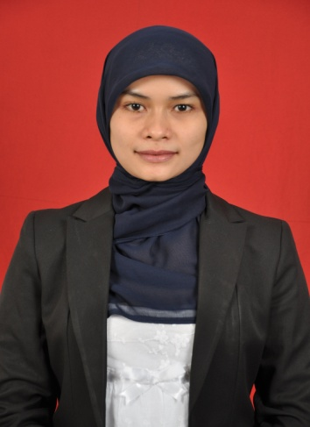
CURRICULUM VITAE

Name : KUMILA HANIK
Place/Date of Birth : Demak / 22th November 1983
Gender : Female
Nationality : Indonesia
Language : Indonesian and English
Marital Status : Single
Physical Detail : Height : 158 cm
Weight : 48 kg
Hair : Black
Eye : Black
Religion : Moslem
Cultural : Javanese
Address : Komp. Pas Pam Pres F 59
Kramat Jati – Jakarta Timur.

Contact Number : 081390107873 (Mobile)
E-mail : hanik39@kap3b.net
mila_hanik@yahoo.co.id

EDUCATION
2010 – 2011  2002 – 2006 | Magister Management Marine Transportation, STMT TRISAKTI  (Title: M.MTr.)  Merchant Marine Polytechnic of Semarang  Major in Port and Shipping Management Department.  (Title: S.Si.T.)
1999 – 2002 | Senior High School at SMU FUTUHIYYAH MRANGGEN – DEMAK
1996 – 1999 | Junior High School at SMP FUTUHIYYAH MRANGGEN – DEMAK
1990 – 1996 | Elementary School SDN III KARANGAWEN – DEMAK

EXPERIENCES
March 2007 – March 2008 |  | Company | PT. SUMI ASIH, Jakarta.
 |  | Position | Administration Officer
 |  | Job Desc. | - To supervise receiving fuel from the  Tanker to the storage tanks.  - To control and calculate of fuel in the  Storage tanks.  - To control out-going of trucking tanks.
March 2008 – June 2011 |  | Company | PT. Maju Lancar Sentosa Abadi, Jakarta
 |  | Position | Operation Assistant Manager
June 2011 – 21 March 2012  March 2012 – February 2013  February 2013 – Until Now |  | Job Desc.  Company  Position  Job Desc.  company  Position  Company  Position | - To calculate the demurrage  - To control and coordinate all fleet under proper insurance.  - To control and coordinate all fleet must be in valid documents/ certifications  - To extend all the expired documents/ certificates directly to the General Sea Transportation.  - To assist Manager to get a new Customers.  - To schedule all fleet to match with cargo availability.  - To strictly control/ manage, no time is wasted for fleet scheduling.  - Representing the Company if any meetings with the local authorities  - Arrangement dock  PT.Elangindo Mahesa  Operation Agency Manager  - Representing the Company with new customer  - To get new customer  - Controller Sea Freight cargo to delivery  - To information ship schedule with customer  PT. Asmin Koalindo Tuhup  Manager Crewing  PT. Adnyana, Andhika Group.  Assistant Manager Safety & Operation
SKILLS
Shipping course | BST ( Basic safety Training )  CSO ( Company Security Officer )
Foreign Language | English speaking and correspondence

PERSONAL PROFILE
A highly motivated and enthusiastic individual, good interpersonal skill, reliable, accountability, responsible to task at hand, well organized, easy going, self improvement, adaptable to the changing needs of the industry/field.

INTEREST
- Listening to Music
- Swimming and Jogging
- Master of Ceremonies (M.C)

