# Explanation of the Ruiz Integral K-squared (RIK) model

## 1.1 General source model properties

Let the source model be a rectangle of dimensions *L*×*W* (assuming *W*<*L*) with scalar seismic moment *M*0. The source model is composed of circular subsources with fractal number-size distribution, where the number of subsources with radius larger than or equal to *R* is given by

, (1)

The sizes range from effectively zero to *W*/2, where for the latter *N*(*r*=*W*/2)=*L*/*W*. Each subsource of radius *R* has crack-model slip distribution,

if ; otherwise. (2)

The subsources are distributed randomly over the rupture dimension, or following prescribed spatial PDF function (e.g., built from the inverted slip model). The constant of proportionality of slip on the subsources is determined so that the total seismic moment fits the target value *M*0.

The rupture is assumed to propagate in form of a slip pulse of width *L*0. Rise time of subsources with radius *R* is given by

if ; otherwise. (3)

If a subsource has radius *R*>*L*0, each point starts to rupture upon arrival of the rupture front. Otherwise, the rupture times are a sum of rupture front arrival time to a random point on the subsource and a time delay corresponding to the rupture propagation from the random point to the point for which the rupture time is being evaluated, *a* is a free parameter with value around 1.

To obtain the slip rate function on a given position of the fault, slip rates from all subsources are summed up.

## 1.2 Details of numerical implementation

The fault geometry is shown in Figure 1.1. We consider a fault plane of size *LF*x*WF*. On this fault plane, a strong-motion generation area with dimensions *L*x*W* is prescribed. The latter dimensions are considered when evaluating the Equation (1). The slip rates are evaluated either for a regular grid of parameters, or for a user supplied list of points on the fault.

We consider discrete values of subsource radius *W*/(2*n*), where *n* is an integer value, denoting the so-called subsource level. Level *n* typically starts from *n*=2, which corresponds to a subsources with diameter equal to half of the width of the strong-motion generation area. The number of subsources at level *n* is

. (4)

Note that the smallest subsource size should correspond to a fraction of the minimum wavelength in the computational model. If it is chosen inappropriate, the source spectrum and the generated ground spectra will exhibit deviation from the omega-squared model.

Kinematic properties for each subsource are given by equations (2) and (3). Brune pulse is considered as the slip rate function *s*(*t*). Assuming rupture time τ,

, (5)

where *H*(*t*) is the Heavyside step function. An example of the slip rate function for τ=2s is shown in Figure 1.2.

Rupture velocity can be composed of homogeneous layers with values increasing with depth (to avoid triplications due to low-velocity layers). Geometric mean of rupture velocity over the width extent of the subsource is considered in equation (3) and when evaluating the time delay between the random point on the subsource and the point for which the slip rates are being determined. This way, one avoids unrealistically strong ground motions for subsurface ruptures.

The rupture velocity is perturbed by random variations with hard-coded standard deviation. The rupture times are numerically evaluated from the rupture velocities using the eikonal solver by Podvin and Lecomte (1991), so that the causality of the rupture front is satisfied.

*Remarks*: there is seemingly no tuning parameter for the high-frequency radiation. If needed, one can play with the rupture velocity, even the rupture velocity on the subsources can differ from the ‘macroscopic’ one, constant of proportionality *a* in equation (3) can be varied, or perhaps changing the constant of proportionality in equation (1) could save the day (not implemented).

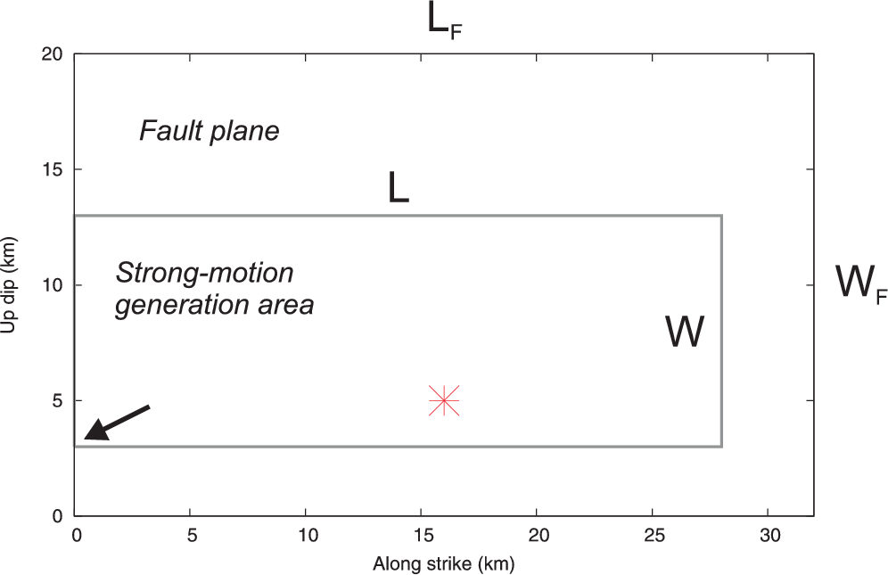

*Figure 1.1*: Fault geometry (black rectangle). The grey rectangle is the strong-motion generation area, which is considered in the RIK model. Red symbol represents the nucleation point and the arrow denotes the bottom left corner of the strong-motion generation area that defines its position on the fault plane.

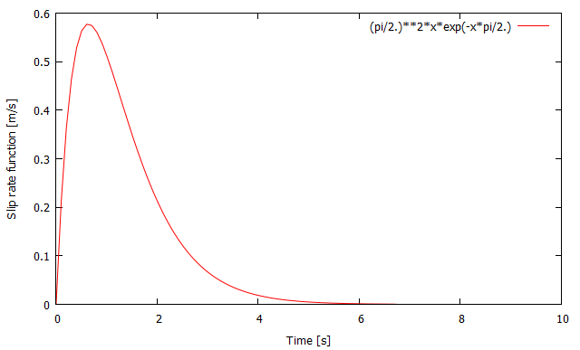

*Figure 1.2*: Slip velocity function (equation (5)) for rise time τ=2s.

# Examples by figures

The RIK code consists of a single Fortran 90 file called RIKsrf.f90. Apparent source time functions can be obtained by the other code called seissimul.f90.

Here is an example of input file RIKsrf.in that results in a model of the Emilia earthquake:

# Size (length, width) of the complete fault plane

32. 20.

# Size (length, width) of the strong-motion generation area, location of bottom left corner.

28. 10. 0. 3.

# Seismic moment (Nm)

1.2589e18

# Slip rate points on the fault (1: Regular grid used also for rupture times followed by no. of points along strike and dip, M and N resp., and const. mu; if mu==0, mu is evaluated from crustal.dat. 2: Irregular followed by regular grid for rupture times and number of slip rate points in the file)

1

500 300 3.7e10

# Nucleation point position (along length and width)

16. 5.

# Hypocentral depth and fault dip (used only when mu==0 and/or number of rupture velocity layers==0)

0 0

# Pulse width (ratio between L0 and W), multipl. factor for subsources’ rupture velocity, param. a

0.2 1. 1.

#SUBMIN SUBMAX (typically SUBMIN=2, SUBMAX=min(M,N)/2)

2 100

#PDF for subsource distribution (1: uniform, 2: Gaussian - specify location and width, 3: read from file - specify discretization and filename)

3

21 13 Emilia_Atzori29052012.srcmod

# Random seed for slip (idum1) and rupture velocity variations (idum2)

-1235 -12356

# Slip rate time step, number of time steps

0.025 512

# Rupture velocities (number of layers nlayers; if nlayers>0, follow with a list of layer positions and rupture velocities (from bottom to top); otherwise, vr are evaluated from crustal.dat assuming constant vp/vs specified below)

Rupture velocity layers (number of layers and then list of layer position (from bottom) and rupture velocities vr; otherwise, vr are evaluated from crustal.dat assuming constant vp/vs specified below)

1

20. 2.8

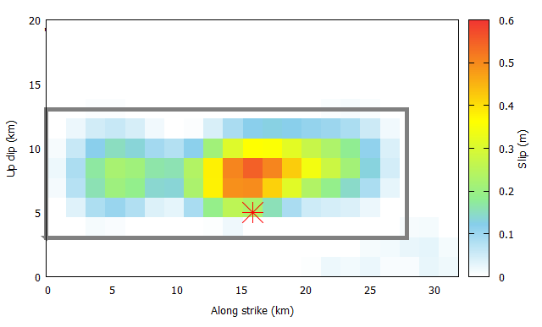

*Figure 2.1*: Pezzo et al (2013) slip model of the Mw 6.1 29.05.2012 Emilia earthquake.

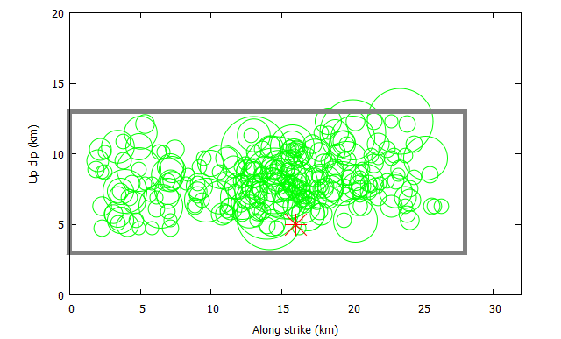

*Figure 2.2*: Distribution of subsources up to level *n*=10 (green circles), scaled according to their size.

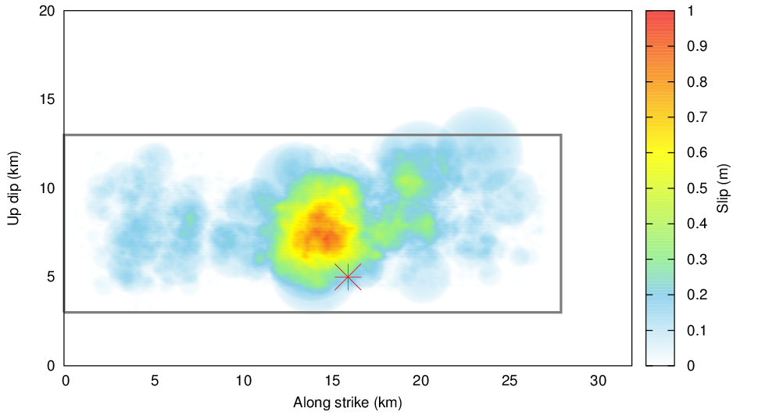

*Figure 2.3*: Slip distribution constituted from the contribution from the subsources. Note that the slip model follows the prescribed the inverted slip distribution (see Figure 2.1).

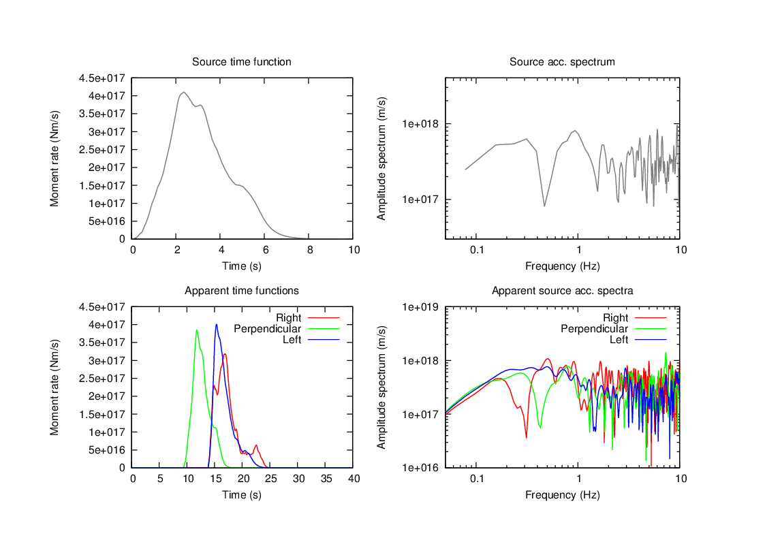

*Figure 2.4*: Moment rate function and apparent time functions for three receivers (left) and their Fourier spectra (right).

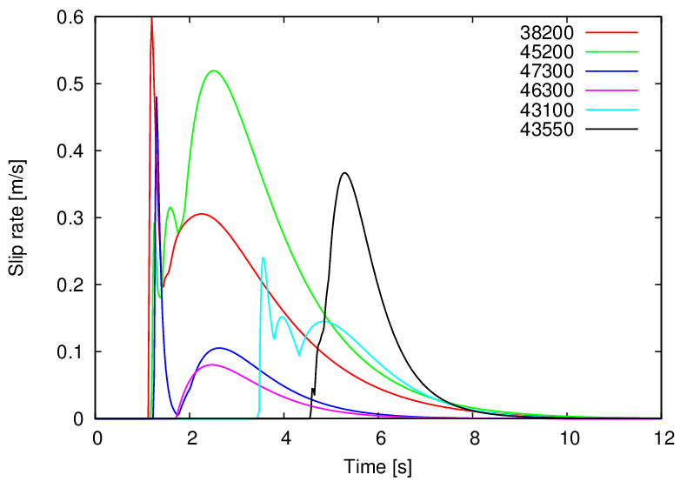

*Figure 2.5*: Example of slip rates on the fault.

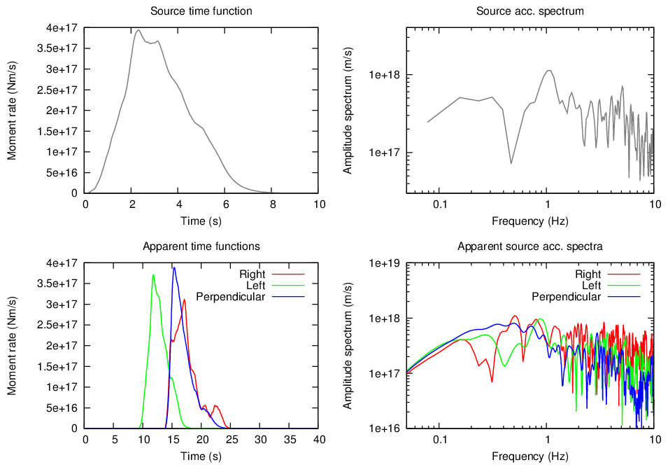

*Figure 2.6*: Same as Figure 2.4 but for SUBMAX=30. This case demonstrates that if the *minimum size of the subsources is not small enough*, the spectra show *artificial* decay at high frequencies instead of a plateau.

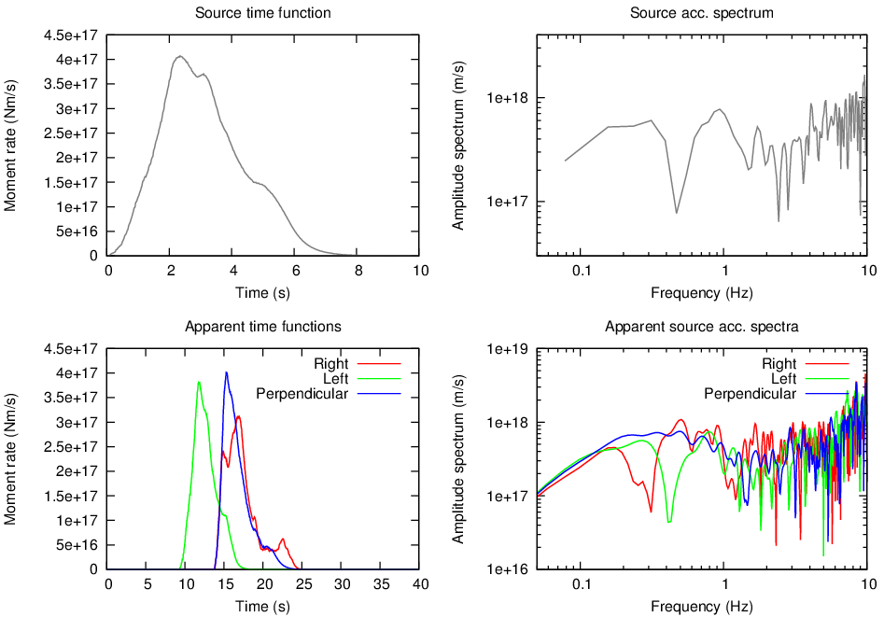

*Figure 2.7*: Same as Figure 2.4 but for coarses fault discretization (200x100 points). This case demonstrates that if the *fault is disretized insufficiently*, the source spectra show *artificial* increase at high frequencies instead of a plateau.

# Minimal parametric study

We consider a 20x10 km large fault with uniform PDF for distribution of subsources. Parameters of the reference model: *vr*=2.8km/s, *L*0=0.2L, *a*=1, *vrsubfact*=1, *submin*=2. We calculate 50 realizations of the subsource distribution and evaluate the RMS source spectra and apparent source spectra. The fault-station geometry is shown in Figure 3.1., the resulting spectra are shown in Figure 3.2 (note that the spectral oscillations are diminished by using the mean over the realizations).

To perform a parametric study, we change one of the parameters and evaluate the spectra in the same way as for the reference model. Figure 3.2 shows the comparison of the resulting spectra with those for the reference model.

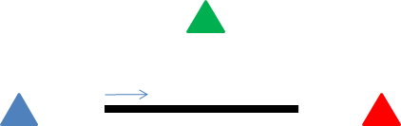

*Figure 3.1*: Geometry of fault, rupture propagation and stations to analyze the directivity effect of the RIK model. The station colors are used in the following figures.

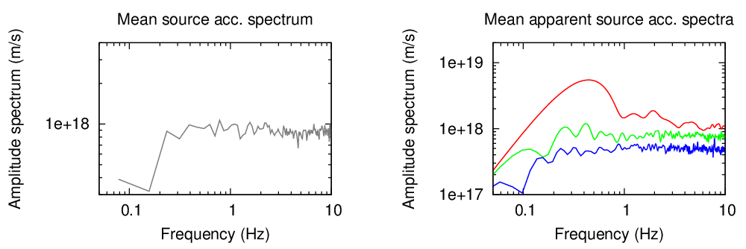

*Figure 3.2*: Source spectrum and apparent source spectra for the reference model, which is used for comparison with respective spectra when one of the parameters is altered (see further). Parameters of the reference model: *vr*=2.8km/s, *L*0=0.2L, *a*=1, *vrsubfact*=1, *submin*=2. Station positions are shown in Figure 3.1.

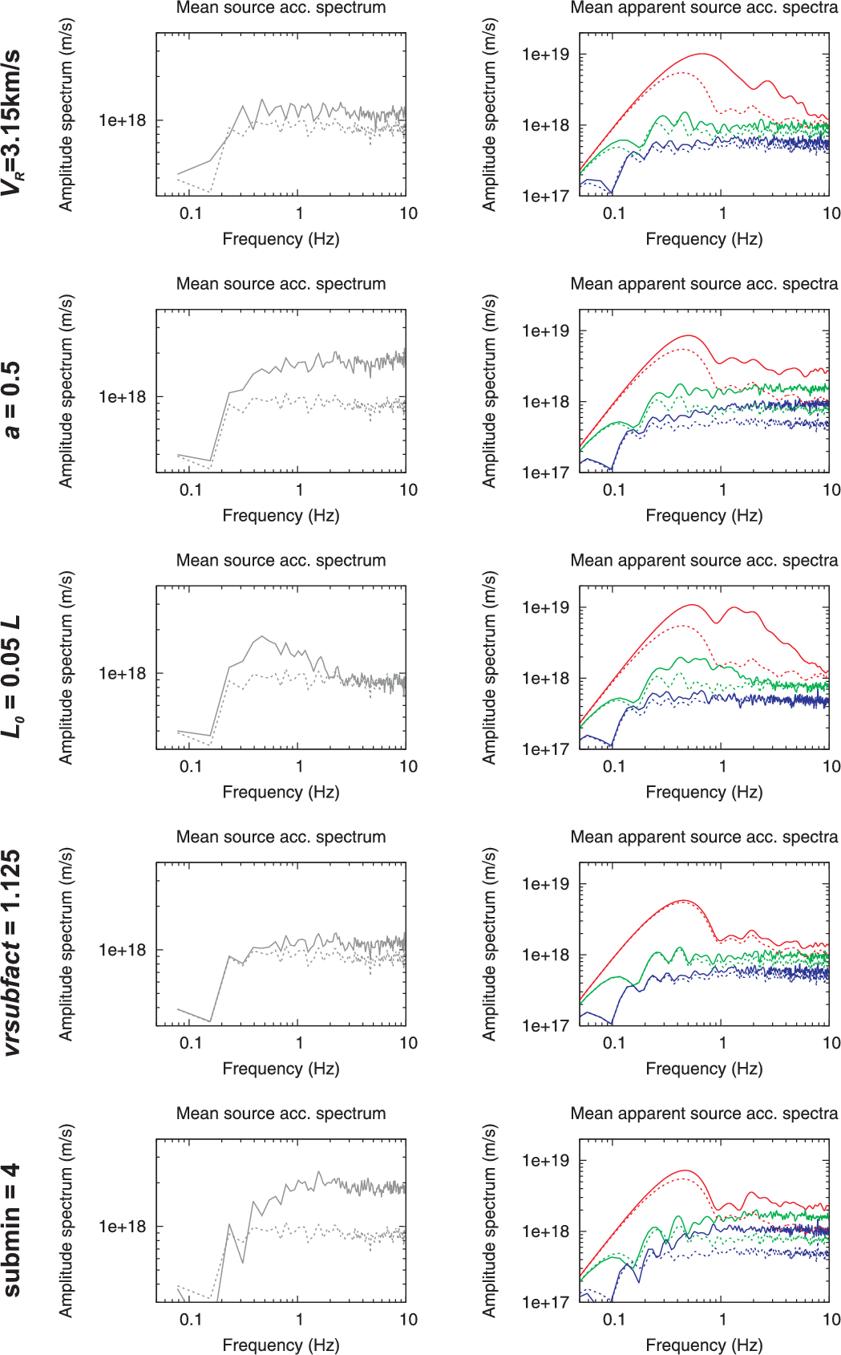

*Figure 3.3*: Source spectra and apparent source spectra for models with altered parameter (solid lines, see legend on left) with respect to the reference model (dashed lines). Parameters of the reference model: *vr*=2.8km/s, *L*0=0.2L, *a*=1, *vrsubfact*=1, *submin*=2. Station positions are shown in Figure 3.1.

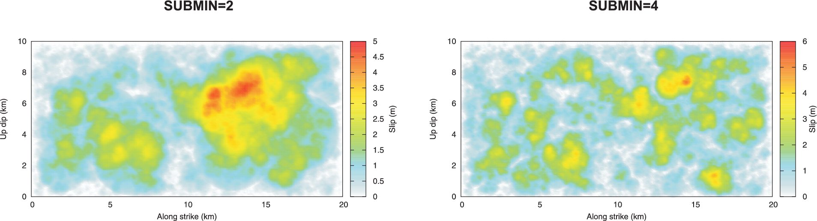

*Figure 3.4*: Slip distribution for cases with SUBMIN equal to 2 and 4, illustrating that the SUBMIN value controls the size of the largest slip patch. Source spectra corresponding to these two cases are shown in bottom row of Figure 3.3. The case with SUBMIN=4 has larger corner frequency and stronger high-frequency radiation due to the fact that the seismic moment is released by subsources with larger stress drops than in the other case.

## References

Bernard, P., Herrero, A., 1994. Slip heterogeneity, body-wave spectra, and directivity of earthquake ruptures. Ann. Geofis. 37, 1679–1690.

Bernard, P., Herrero, A., Berge, C., 1996. Modeling directivity of heterogeneous earthquake ruptures. Bull. Seism. Soc. Am. 86, 1149–1160.

Gallovič, F. (2016). Modeling velocity recordings of the Mw6.0 South Napa, California, earthquake: unilateral event with weak high-frequency directivity, Seism. Res. Lett. 87, 2-14.Gallovič, F., Burjánek, J. (2007). High-frequency Directivity in Strong Ground Motion Modeling Methods, Annals of Geophysics, Vol. 50, N. 2, 203-211.

Gallovič, F., Brokešová, J. (2007). Hybrid k-squared Source Model for Strong Ground Motion Simulations: Introduction, Phys. Earth Planet. Interiors, 160, 34-50.

Gallovič, F., Brokešová, J. (2004). On strong ground motion synthesis with k^-2 slip distributions, J. Seismology, 8, 211-224.

Herrero, A., Bernard, P., 1994. A kinematic self-similar rupture process for earthquakes. Bull. Seism. Soc. Am. 84, 1216–1228.

Pezzo, et al. (2013). Coseismic Deformation and Source Modeling of the May 2012 Emilia (Northern Italy) Earthquakes, Seism. Res. Lett. 84, 645-655.

Podvin, P., Lecomte, I. (1991), Finite difference computation of traveltimes in very contrasted velocity models: a massively parallel approach and its associated tool, Geophys. J. Intern. 105, 271-284.

Ruiz, J. A., D. Baumont, P. Bernard, and C. Berge-Thierry (2011). Modeling directivity of strong ground motion with a fractal, k-2, kinematic source model, Geophys. J. Int. 186, 226–244.