# Web Development Project

# Created on December 10 2023

# Table of Contents

1.0. Homepage

2.0. Characters Page

# 1.0. Homepage

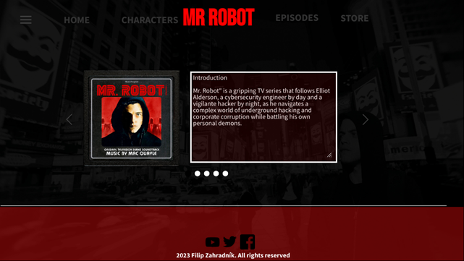

# 2.0. Characters Page

