# 代码质量分析报告

## 1.自动分析质量报告

1.

严重程度: MINOR

简要描述:Cast one of the operands of this multiplication operation to a "long":将此乘法的一个操作数转换为long类型

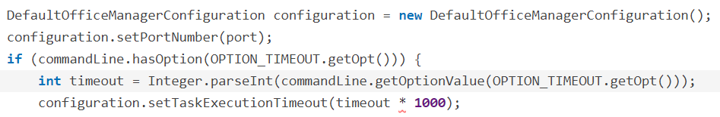

详细描述: 将int类型整数乘法的结果赋值给long类型，可能在赋值之前已经发生溢出

2.

严重程度:BLOCKER

简要描述: Use try-with-resources or close this "BufferedReader" in a "finally" clause,资源未关闭

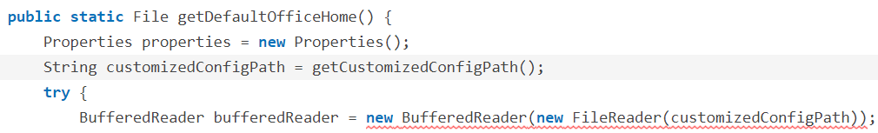

详细描述:打开文件应该使用Try-Catch-Finally模式，应该在finally语句中手动关闭资源

3.

严重程度:MAIN

简要描述：Either re-interrupt this method or rethrow the "InterruptedException"

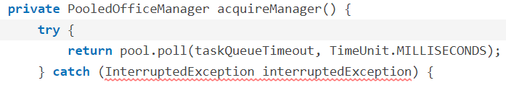

详细描述：if the exception is not handled properly the fact that the thread was interrupted will be lost. Instead, InterruptedExceptions should either be rethrown - immediately or after cleaning up the method's state - or the thread should be re-interrupted by calling Thread.interrupt() even if this is supposed to be a single-threaded application.InterruptedException处理不当，应当在捕获之后立即重新抛出