CSE 444 Software Engineering II
Project Report
for
Online Quiz and Exam System
1.0
June 19, 2026
Prepared by
Alper Kaan Güler
Furkan Filicioğlu
Ömer Faruk Koç
Yunus Emre Türk

TABLE OF CONTENTS
1. Introduction 4
1.1 Project Title 4
1.2 Team Members and Contributions 4
1.3 Project Overview 4
1.4 Problem Statement 5
1.5 Project Objectives 5
1.6 Target Users 6
2. Requirements Analysis 6
2.1 Functional Requirements 6
2.2 Non-Functional Requirements 7
2.3 Top-Priority Use Cases 8
2.4 Assumptions and Constraints 9
3. System Design 9
3.1 System Architecture 9
3.2 Domain Model and Class Design 10
3.3 Database Design 12
3.4 User Interface Design 12
3.5 Traceability to Requirements 13
4. Implementation 13
4.1 Technologies, Frameworks, and Tools 13
4.2 Development Environment 14
4.3 Major Components and Modules 15
4.4 Key Implementation Decisions 15
4.5 AI Tools Used During Development 16
5. Testing and Validation 16
5.1 Testing Strategy 16
5.2 Test Activities 16
5.3 Representative Defects and Resolutions 16
5.4 Defects Identified and Outstanding 17
6. Deployment and Usage 17
6.1 Deployment Approach 17
6.2 Installation and Execution 18
6.3 System Screenshots 18
6.4 Demonstration Scenario 18
7. Maintenance and Future Improvements 19
7.1 Known Limitations 19
7.2 Potential Enhancements 19
7.3 Scalability and Maintainability Considerations 19
8. Reflection on AI Usage 20
8.1 AI Tools Utilized 20
8.2 Tasks Supported by AI Across the Lifecycle 20
8.3 What We Delegated vs. What We Kept 21
8.4 Benefits Obtained 21
8.5 Challenges Encountered 21
8.6 Critical Evaluation of AI-Generated Outputs 22
9. Conclusion 22
9.1 Summary of Achievements 22
9.2 Lessons Learned 23
9.3 Final Remarks 23

1. Introduction

1.1 Project Title
Online Quiz and Exam System (internal product name: *QuizLab*) — a web-based platform for creating, delivering, and evaluating online quizzes and exams for university and school courses.

1.2 Team Members and Contributions
The project was developed by a four-person team. To keep responsibilities coherent, the system was decomposed into four subsystems, with one member owning each end to end while collaborating on shared interfaces. Cross-cutting decisions — the domain model, the API contract, the security model, and the design system — were made jointly and reviewed by the whole team.
Member | Subsystem Ownership | Key Contributions
Furkan Filicioğlu | Platform foundation & identity | Project skeleton and build setup; Keycloak integration and the authentication flow; login page; foundation of the admin and student panels; cross-cutting bug fixes.
Ömer Faruk Koç | Backend architecture & design system | Backend refactor and service-layer structure; the *Academic Precision* design system applied across all role flows; security hardening with @PreAuthorize; audit-log subsystem; analytics/statistics engine.
Alper Kaan Güler | Exam authoring & grading | Exam creation, scheduling, and management screens; automatic and partial-credit manual grading; question-management improvements; class-level statistics.
Yunus Emre Türk | Classes, assignment & documentation | Classroom, enrollment, and exam-assignment subsystem (class-based access control); Keycloak login theme and realm seed script; contributions to the frontend redesign; SRS and project documentation.

All AI-assisted output was reviewed and approved by the team before being merged; no security-critical code was integrated without human review (see Section 8).

1.3 Project Overview
The Online Quiz and Exam System is a client–server web application that manages the full assessment lifecycle: instructors build a categorized question bank, compose and schedule exams, assign them to classes of students, and review results; students join classes with a code, take exams under a countdown timer, and view their graded results; administrators monitor the platform through system statistics and an audit log.
The system is organized around three roles — Student, Instructor, and Admin — that share a single identity layer provided by Keycloak. The frontend is a React/Vite single-page application; the backend is a Spring Boot REST API; PostgreSQL stores persistent data; and Keycloak handles authentication and role-based access. The end-to-end flow is:
question bank → exam → assign to class → student takes exam → automatic / manual grading → statistics dashboard.
The prototype implements the complete assessment lifecycle, including bulk CSV question import, image-based questions, randomized question pools, automatic and partial-credit manual grading, per-exam and per-question analytics, a notification system, and an audit log.

1.4 Problem Statement
Instructors at individual or small-to-medium-scale institutions lack an assessment tool that fits their needs:
- General-purpose form tools (e.g. Google Forms) have no concept of a course-scoped question bank, exam scheduling, or role management, and offer only limited automatic grading.
- Full learning-management platforms (e.g. Moodle, Canvas) are heavyweight — more than an individual instructor or a small department needs, with scattered role and access management and a steep setup cost.
As a result, instructors struggle to control *which students can access which exam*, to reuse questions across exams, to combine automatic and manual grading, and to obtain meaningful item analytics. The Online Quiz and Exam System addresses this gap with a focused, identity-integrated platform built around course question banks, class-based exam assignment, and combined automatic/manual grading.

1.5 Project Objectives
The project set out to deliver:
- Identity-integrated access. Institutional single-sign-on via Keycloak, with role-based access control for students, instructors, and admins.
- Course-scoped question bank. A reusable, categorized question bank supporting multiple question types and bulk import.
- Class-based exam delivery. A *class → student → exam* assignment flow so that access is controlled per class rather than globally.
- Combined grading. Automatic grading for objective questions and a partial-credit manual-grading workflow for open-ended answers.
- Secure exam taking. Timed exams with auto-submit and protection against retaking a submitted exam.
- Insightful reporting. Per-exam and per-question analytics (difficulty, discrimination, distractor and score distributions).
- Accountability. An append-only audit log and a notification system for key events.
A secondary, course-specific objective was to apply software-engineering practice across the full SDLC and to document — transparently and critically — how AI tools were used throughout development (Section 8).

1.6 Target Users
The system serves three roles through three interface flows over one common identity layer:
- Instructor. Creates categories and questions (single or bulk), composes exams from those questions, organizes students into classes, assigns exams to classes, and analyzes results and item statistics.
- Student. Joins courses/classes with a join code, takes the exams and quizzes assigned to them within the allotted time window, and immediately views their results and per-question breakdown.
- Admin. Performs platform-wide oversight: system-wide statistics, role distribution, global category management, and an audit log of key actions.

2. Requirements Analysis
Requirements were elicited through AI-assisted question-and-answer sessions over the shared project brief, reviewed and validated by the team, and finally reconciled against the implemented system. The complete catalogue — 56 functional requirements (FR-001…FR-056), 19 non-functional requirements (NFR-001…NFR-019), 21 use cases, and 26 user stories with a full requirement-traceability matrix — is maintained in the project's *Software Requirements Specification* (docs/yetdocs/SRS.md). This section summarizes the requirements that drive the architecture and the highest-priority use cases.

2.1 Functional Requirements
Functional requirements are grouped into the following feature areas. Each row lists the area, representative requirements, and implementation status in the prototype.
Area | Representative Functional Requirements | Status
Authentication & roles | Authenticate via Keycloak; read roles from JWT; role-based navigation; Student/Instructor/Admin roles; account settings page. (FR-001–004, FR-056) | Implemented
Question bank | Create/edit/delete questions with ownership checks; multiple-choice, true/false, short-answer types; categories; per-question image upload. (FR-006–011, FR-055) | Implemented
Exam management | Create exams with title, description, duration, start/end time; add questions; publish/unpublish (requires ≥1 question); random question pool. (FR-012–017) | Implemented
Exam taking | List available exams; start an attempt only within the time window and with access; continue an in-progress attempt; prevent retakes; submit answers; auto-save. (FR-018–023) | Implemented
Grading & results | Auto-grade objective questions; partial-credit manual grading with feedback; compute and store scores; student/instructor result views with PDF export. (FR-024–029) | Implemented
Reporting & analytics | Result summaries; question-level statistics (difficulty, discrimination, distractor analysis); instructor analytics; admin system reports. (FR-030–033) | Implemented (admin reports partial)
Administration | View system-wide users/exams/questions/submissions; manage global categories; audit log of key actions; (in-app user activation/role assignment planned). (FR-034–038) | Partial
Academic integrity & reliability | Randomized delivery; preserve progress on interruption; atomic submission with time-expiry auto-submit; (proctoring planned). (FR-039–042) | Implemented (proctoring planned)
Notifications | Notify on new/assigned exam, graded result, upcoming exam, system announcement; unread count; mark-as-read. (FR-043–045) | Implemented
Bulk operations & export | Bulk-import questions via CSV; export result pages as PDF. (FR-046–047) | Implemented
Classes, enrollment & assignment | Instructor-owned classes; unique join code; student self-enrollment (no duplicates); view/remove members; PUBLIC vs. CLASSES exam visibility; server-side class-based access enforcement; targeted notifications. (FR-048–054) | Implemented

2.2 Non-Functional Requirements
Category | Key Non-Functional Requirements
Security | Authenticate before protected operations; enforce role-based access for student/instructor/admin functions; validate JWTs from the configured Keycloak realm; prevent any student from accessing another student's attempts or results. (NFR-001–004)
Reliability | Preserve submitted answers; avoid duplicate attempts after submission; recover gracefully from temporary token expiry; support auto-save to reduce data loss. (NFR-005–008)
Usability | Clear role-based navigation; an understandable exam-taking interface; comprehensible error messages. (NFR-009–011)
Performance | Load dashboards and exam pages acceptably for class-sized datasets; grade objective questions quickly after submission. (NFR-012–013)
Maintainability | Keep business logic in services; centralize frontend API access through helpers; keep documentation in sync with setup, auth, routes, and workflows. (NFR-014–016)
Accessibility | Usable across common desktop browsers; readable text and predictable navigation; keyboard-friendly exam and form screens. (NFR-017–019)

2.3 Top-Priority Use Cases
The three use cases below were prioritized because they cover the system's core value proposition — secure, class-scoped exam delivery with combined grading.

UC-A — Take and Submit an Exam (Student)
- Actor: Student
- Requirements: FR-018, FR-019, FR-020, FR-021, FR-022, FR-042, FR-053
- Preconditions: The student is authenticated and enrolled in a class to which the exam is assigned (or the exam is PUBLIC); the current time is within the exam's window.
- Main flow:
- The student opens the dashboard and selects an available exam.
- The system verifies access (visibility/enrollment) and the time window on the server.
- If an in-progress attempt exists, the system resumes it; otherwise it creates a new attempt and delivers the question set (a random subset when a pool is configured).
- The student answers questions under a countdown timer; answers are auto-saved client-side.
- The student submits, or the timer expires and triggers an auto-submit.
- The system atomically persists all answers and marks the attempt as submitted, preventing any retake.

UC-B — Assign an Exam to Classes (Instructor)
- Actor: Instructor
- Requirements: FR-052, FR-053, FR-054
- Preconditions: The instructor owns the exam and at least one class.
- Main flow:
- The instructor opens an exam's detail page.
- The instructor sets visibility to *Selected classes* and chooses one or more owned classes (or chooses *Public*).
- The system saves the visibility setting and the class assignments.
- The server thereafter enforces, for both listing and attempt-start, that only enrolled students of the assigned classes can access the exam.
- A "new exam" notification is targeted to enrolled students of the assigned classes (or all students when PUBLIC).

UC-C — Grade an Exam: Automatic and Manual (System & Instructor)
- Actors: System (objective), Instructor (subjective)
- Requirements: FR-024, FR-025, FR-026, FR-027, FR-029
- Preconditions: A submitted attempt exists.
- Main flow:
- On submission, the system auto-grades multiple-choice and true/false answers by comparing them to the correct answers.
- A short answer that exactly matches the key (case- and whitespace-insensitive) is auto-graded; otherwise it is routed for manual review.
- The instructor reviews pending short answers and awards full, partial, or zero points with written feedback.
- The system recomputes per-answer points and the total score and stores the graded result, which becomes visible to the student.

2.4 Assumptions and Constraints
Constraints
- The backend must use Java and Spring Boot; the frontend must use React and TypeScript.
- Authentication must be integrated with Keycloak.
- Student, instructor, and admin responsibilities must remain separated.
- Documentation is a required project deliverable.
- The prototype is developed within a limited academic-project timeline.
Assumptions
- Keycloak is available and configured with the required realm, clients, and roles.
- PostgreSQL is available through Docker Compose during local development.
- Students and instructors have valid accounts.
- Instructors are responsible for authoring valid questions and exam configurations.
- A subset of advanced admin features (in-app user activation/deactivation and role assignment) is handled via the Keycloak admin console rather than the app UI.

3. System Design

3.1 System Architecture
The system follows a layered client–server architecture with a clear separation between presentation, business logic, identity, and persistence. The frontend is a single-page application that talks to the backend exclusively over REST/JSON; identity is fully delegated to Keycloak; and PostgreSQL is the system of record.
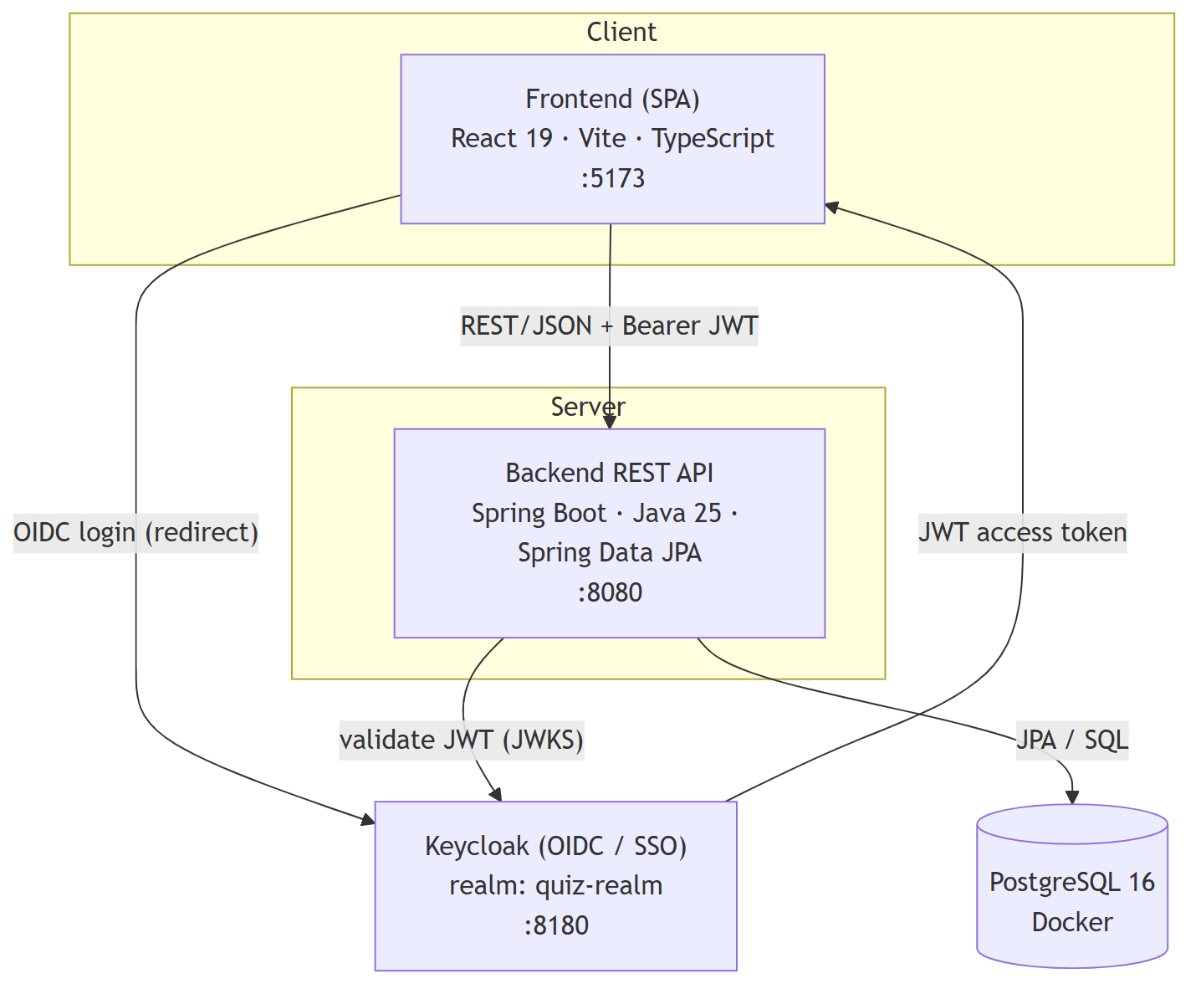
Figure 3.1 — System architecture
Design principles
- REST-only frontend–backend coupling. The SPA reaches the backend only through REST endpoints with a bearer JWT; there is no direct database or server-side session coupling.
- Identity delegated to Keycloak. The application stores no passwords and keeps no server-side session — it only *validates* JWTs issued by the configured realm (OAuth2 resource server). Roles are read from the token.
- Stateless backend. Each request carries its own credentials; the backend authorizes via Spring Security method security (@PreAuthorize) plus per-resource ownership checks.
- One-command developer environment. docker compose up brings up PostgreSQL and a pre-seeded Keycloak realm together, so the system is reproducible from a clean checkout.
The implemented system comprises 14 domain entities, 12 REST controllers exposing 72 endpoints, 8 service classes, 14 JPA repositories, and a 24-page frontend.

3.2 Domain Model and Class Design
The domain is organized around three clusters: identity & content (User, Category, Question), exam composition (Exam, ExamQuestion, ExamQuestionPool), and delivery & assessment (Classroom, Enrollment, ExamAssignment, StudentExam, StudentExamQuestion, Answer). AuditLog and Notification are cross-cutting. The class diagram below covers the entities behind the top-priority use cases (exam taking, class assignment, grading).
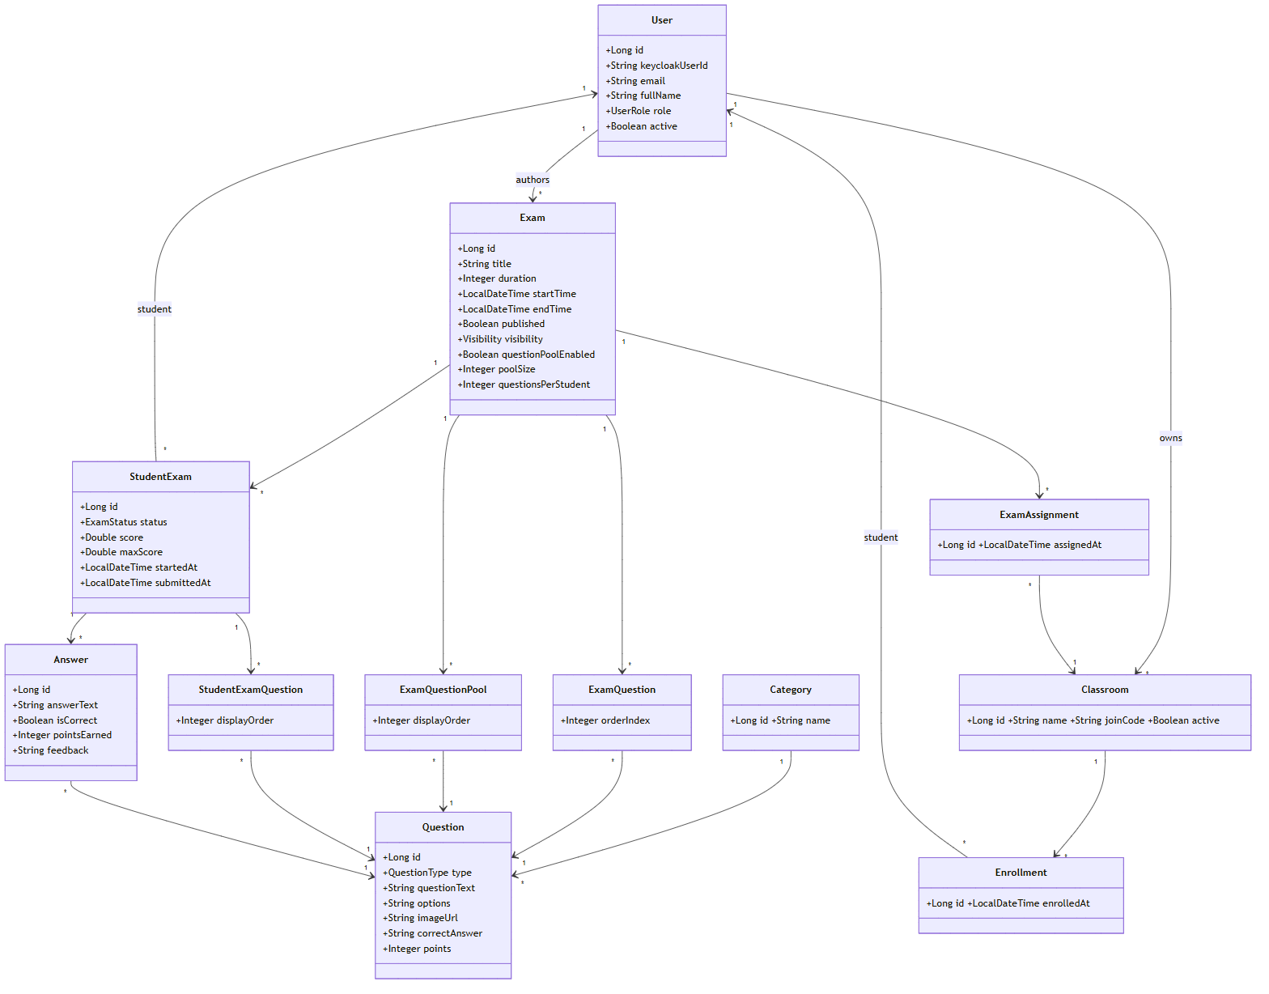
Figure 3.2 — Domain class diagram
Key design notes
- Dual identity. Each user is anchored to a Keycloak subject (keycloakUserId); exams, questions, classes, attempts, and enrollments also store the relevant Keycloak id (keycloakInstructorId, keycloakCreatorId, keycloakUserId). Keycloak subject IDs and local numeric IDs are treated as distinct identity concepts.
- `ExamAssignment` as a link entity. Rather than coupling exams directly to classrooms, a dedicated ExamAssignment join entity models the many-to-many *exam ↔ class* relationship, keeping assignment independent of exam content and supporting a clean PUBLIC/CLASSES visibility switch.
- Per-student question delivery. When a question pool is enabled, ExamQuestionPool holds the full pool and StudentExamQuestion records the randomized subset actually delivered to each student, so each attempt is reproducible and independently gradable.
- Enumerations. UserRole {STUDENT, INSTRUCTOR, ADMIN}, QuestionType {MULTIPLE_CHOICE, TRUE_FALSE, SHORT_ANSWER}, Exam.Visibility {PUBLIC, CLASSES}, StudentExam.ExamStatus {NOT_STARTED, IN_PROGRESS, SUBMITTED, GRADED}, and a four-value NotificationType.

3.3 Database Design
The relational schema in PostgreSQL maps one table per entity (JPA/Hibernate). The core tables and relationships are:
Table | Purpose | Key Relationships / Constraints
users | Local mirror of Keycloak identities | unique keycloak_user_id, unique email, role enum
categories | Question categories | referenced by questions
questions | Question bank | FK → categories; type enum; options (JSON text); image_url
exams | Exam definitions | FK → users (instructor); visibility enum; pool fields
exam_questions | Fixed exam ↔ question links | FK → exams, questions; order_index
exam_question_pool | Pool of candidate questions | FK → exams, questions; display_order
classrooms | Instructor-owned classes | unique join_code; FK → users (instructor)
enrollments | Student ↔ class membership | FK → classrooms; unique (class, student) to block duplicates
exam_assignments | Exam ↔ class assignment | FK → exams, classrooms
student_exams | A student's attempt | FK → exams, users; status enum; score, max_score
student_exam_questions | Per-attempt delivered questions | FK → student_exams, questions; display_order
answers | Submitted answers | FK → student_exams, questions; is_correct, points_earned, feedback
notifications | Per-user notifications | keycloak_user_id; type enum; is_read, is_archived
audit_logs | Append-only action trail | entity_type, entity_id, actor_*, action, payload (indexed)

The audit log records the actor (Keycloak id and name), the action, the affected entity, and a timestamp for each key operation — CREATE · UPDATE · DELETE · PUBLISH · GRADE · ASSIGN.

3.4 User Interface Design
The UI applies a single design system — "QuizLab / Academic Precision" — across all role flows: the Manrope typeface, a navy/indigo palette, and a role-aware sidebar/shell that surfaces only the actions permitted for the signed-in role. The 24 pages are organized by role:
- Common: Home/login entry, Settings (profile + link to the Keycloak account console), Notifications.
- Student: Dashboard, Student Classes (join by code), Take Exam, My Results, Exam Result (with PDF export).
- Instructor: Dashboard, All Exams, Create Exam, Exam Detail (question assignment + visibility/class assignment), Add Questions to Exam, Exam Preview, Question Bank (with image upload), Bulk Import, Category Management, Instructor Classes, Class Detail, Manual Grading, Exam Results, Exam Statistics.
- Admin: Admin Dashboard, Admin Exam Detail.
The exam-taking screen prioritizes reliability and clarity: a visible countdown timer, client-side auto-save, a submit confirmation, and an auto-submit on expiry.

3.5 Traceability to Requirements
Design decisions trace directly back to requirements:
Design Element | Satisfies
Keycloak OIDC + JWT resource server; @PreAuthorize + ownership checks | FR-001–005, NFR-001–004
ExamAssignment link entity + Visibility enum + server-side access guard | FR-052, FR-053, UC-B
ExamQuestionPool + StudentExamQuestion (per-student random subset) | FR-016, FR-039, UC-A
StudentExam.status lifecycle + atomic submission service | FR-020, FR-021, FR-042, UC-A
GradingService + manual-grading recompute on answers | FR-024–027, UC-C
Analytics over answers / student_exams | FR-031, FR-032
AuditLog entity + audit service | FR-038, NFR-001
Notification entity + targeted dispatch | FR-043–045, FR-054
Role-aware UI shell (24 pages) | FR-003, NFR-009

4. Implementation

4.1 Technologies, Frameworks, and Tools
Layer | Technology | Version
Frontend | React | 19.2
 | TypeScript | 6.0
 | Vite (build/dev server) | 8.0
 | React Router | 7.1
 | Axios (HTTP client) | 1.7
 | keycloak-js (OIDC adapter) | 23.0
 | lucide-react (icons) | 1.11
 | Styling | Hand-authored CSS with design tokens (Manrope typeface; no utility framework)
Backend | Java | 25
 | Spring Boot | 4.0.6
 | Spring Web MVC, Spring Data JPA, Bean Validation | (Spring Boot starters)
 | Spring Security + OAuth2 Resource Server | (JWT validation)
 | Spring WebSocket | (starter present; reserved for future real-time features)
 | keycloak-admin-client | 23.0
 | Lombok | (boilerplate reduction)
Identity | Keycloak (realm quiz-realm, custom login theme + seed) | 23
Database | PostgreSQL | 16
Infrastructure | Docker Compose (PostgreSQL + Keycloak) | —
Build | Maven (backend), npm (frontend) | —
AI assistants | Claude Code, Codex, Google Stitch | —

Note: although an earlier presentation listed Tailwind CSS, the implemented frontend uses hand-authored CSS (design tokens / CSS variables), not a utility-class framework.

4.2 Development Environment
The project is designed to run from a clean checkout with minimal setup:
- Infrastructure — docker compose up -d starts PostgreSQL 16 and Keycloak 23. The quiz-realm (clients, roles, and default test users) is seeded automatically, and Spring Boot's spring-boot-docker-compose integration wires the backend to these containers during local runs.
- Backend — ./mvnw spring-boot:run builds and starts the Spring Boot API on http://localhost:8080. On first run, a DataInitializer creates local test users if the database is empty.
- Frontend — npm install then npm run dev starts the Vite dev server on http://localhost:5173.
Default local endpoints: frontend :5173, backend :8080, Keycloak :8180. Source control is Git/GitHub; the team worked on feature branches integrated through pull requests, with line endings normalized via .gitattributes to avoid cross-platform churn.

4.3 Major Components and Modules
Backend (12 controllers, 8 services, 14 repositories, 14 entities).
- Controllers expose the REST surface (72 endpoints): Exam, Question, ExamQuestion, QuestionPool, StudentExam, Answer, Result, Classroom, Notification, Category, Upload, and Admin.
- Services hold the business logic kept out of controllers:
  - GradingService — automatic grading for objective questions and score computation.
  - ExamSubmissionService — atomic submission and grading of an attempt.
  - QuestionPoolService — per-student random subset selection.
  - ClassroomService — classes, join codes, enrollment, and exam assignment.
  - NotificationService — event notifications with targeted dispatch.
  - AuditLogService — append-only audit trail.
  - KeycloakService / UserSyncService — identity lookups and local-user synchronization.
- Persistence — 14 Spring Data JPA repositories, one per entity, over the PostgreSQL schema described in §3.3.
- Security — SecurityConfig configures the OAuth2 resource server (JWT validation against the realm) and method security; sensitive endpoints are guarded with @PreAuthorize plus per-resource ownership checks.
Frontend (24 pages).
- App.tsx defines the routes; AuthContext initializes Keycloak and exposes auth state; api/axios.ts centralizes the HTTP client and injects the bearer token on every request.
- A role-aware shell (sidebar/top bar) renders navigation per role, and pages are grouped by role as described in §3.4. Larger pages delegate data fetching to custom hooks to keep view logic thin.

4.4 Key Implementation Decisions
- Delegate identity entirely to Keycloak. The application validates JWTs and never stores passwords or server-side sessions. This simplified the security model and enabled SSO, at the cost of a dual-identity mapping between Keycloak subjects and local user rows.
- Enforce access on the server, not just the UI. Class-based exam access (Visibility.CLASSES) is enforced server-side for both listing exams and starting an attempt, so route hiding in the SPA is a convenience, not the security boundary.
- Make submission atomic. A dedicated submission service persists all answers and finalizes the attempt in one operation, with a time-expiry auto-submit, to prevent partial saves and data loss (FR-042).
- Reproducible per-student exams. When a pool is enabled, the delivered subset is recorded in StudentExamQuestion, so the exact exam a student saw can be re-graded and analyzed deterministically.
- Keep business logic in services. Grading, pooling, classroom, notification, and audit logic live in service classes (NFR-014), keeping controllers thin and testable.
- Audit by default. Sensitive actions (CREATE/UPDATE/DELETE/PUBLISH/GRADE/ASSIGN) write an audit entry with actor and timestamp, supporting accountability without scattering logging across controllers.

4.5 AI Tools Used During Development
Three AI tools were used, each with a distinct role (analyzed critically in Section 8):
- Claude Code — the primary pair-programmer: backend and frontend code, refactoring, debugging, documentation, security hardening, and tooling. The most heavily used tool across the project.
- Codex — architecture discussions and decision points: "X vs. Y" alternatives, entity-relationship trade-offs, and API-contract decisions (e.g. the choice to model exam–class assignment via a dedicated ExamAssignment link entity).
- Google Stitch — UI/UX generation: the QuizLab design-system layout, palette suggestions, and page mockups, which the team approved and then translated into React with Claude Code.
In all cases, AI produced drafts; the team reviewed, decided, and validated. No code — especially security-critical code — was merged without human review.

5. Testing and Validation

5.1 Testing Strategy
Testing on this project was primarily manual and exploratory rather than driven by a formal, up-front test plan. As features were built, team members exercised the application end to end through each role (instructor, student, admin), reproducing realistic workflows and recording the problems they found. A single backend smoke test (SystemApplicationTests) verifies that the Spring application context loads; beyond that, the project does not yet have an automated test suite.
We treat this candidly as a limitation rather than a strength (see §5.4 and Section 7): automated coverage lagged behind development speed, and a CI test gate is the first item on the quality roadmap. What the manual approach *did* provide was effective defect discovery — the role-based walkthroughs surfaced concrete correctness, authorization, and usability issues that were then fixed.

5.2 Test Activities
- Role-based end-to-end walkthroughs. Each major flow was exercised by hand: question authoring and bulk import, exam creation and publishing, class creation/enrollment/assignment, exam taking under the timer, automatic and manual grading, and results/analytics.
- Authorization probing. Unauthorized-access attempts were tried manually — accessing another instructor's exam by ID, retaking a submitted exam, accessing another student's results — to confirm the server-side guards hold.
- Defect logging. Findings were collected in a manual QA checklist (docs/alperdocs/TEST_RAPORU.md), organized by role flow (Instructor / Student / Admin / General), which served as the working defect backlog.

5.3 Representative Defects and Resolutions
The manual QA pass surfaced a range of issues; the table below lists representative examples and how they were resolved. The corresponding requirements are now marked *Implemented* in the SRS.
# | Defect Found (manual QA) | Resolution | Requirement
1 | An exam with no questions could be published | Publishing now requires at least one question | FR-015
2 | Another instructor's exam could be edited by knowing its ID | Added instructor ownership checks; critical fields locked once an exam is active | FR-017
3 | A submitted exam could be retaken | Attempt status now blocks retaking a submitted/graded exam | FR-021
4 | Refreshing the page lost all in-progress answers | Added client-side auto-save with restore on reload | FR-023
5 | Short-answer questions were not graded and the student wasn't told why | Added a manual-grading workflow with partial credit and feedback; pending state shown | FR-026
6 | "Top X%" percentile label was inverted | Corrected the percentile calculation | FR-030
7 | "Export as PDF" did not work | Implemented print-friendly PDF export of result pages | FR-047
8 | Rapid repeated clicks sent duplicate requests | Buttons are disabled while a request is in flight | NFR-006

5.4 Defects Identified and Outstanding
Most functional and authorization defects from the manual pass were resolved and are reflected in the current requirement statuses. The known remaining gaps are quality-of-engineering rather than feature defects:
- No automated regression/integration test suite (only a context-load smoke test) and no CI test gate.
- Some date/time comparisons rely on the browser clock rather than a synchronized server clock.
- Server-side persistence of in-progress answers is not yet implemented (auto-save is client-side only).
These are carried forward as future work in Section 7.

6. Deployment and Usage

6.1 Deployment Approach
The project targets a containerized local/development deployment. Infrastructure dependencies — PostgreSQL and Keycloak — are provisioned through Docker Compose, while the backend and frontend run as standard Spring Boot and Vite processes. Spring Boot's spring-boot-docker-compose integration automatically connects the backend to the Compose-managed database and Keycloak during local runs, and the quiz-realm is seeded (clients, roles, default users) so the environment is reproducible from a clean checkout.
A production deployment would build the frontend to static assets served behind a web server/CDN, package the backend as an executable JAR (or container image), point both at a managed PostgreSQL instance and a hardened Keycloak deployment, and serve everything over HTTPS. Production hardening (tightened CORS, secrets management, externalized configuration) is noted as future work in Section 7.

6.2 Installation and Execution
Prerequisites: Docker, Java 25 (JDK), and Node.js + npm.
- Start infrastructure (PostgreSQL + Keycloak):
cd backend
docker compose up -d
- Run the backend (Spring Boot API on http://localhost:8080):
cd backend
./mvnw spring-boot:run
- Run the frontend (Vite dev server on http://localhost:5173):
cd frontend
npm install
npm run dev
Default endpoints — frontend http://localhost:5173, backend http://localhost:8080, Keycloak http://localhost:8180. Default seeded test accounts include an instructor, a student, and an admin (credentials are documented in KEYCLOAK_SETUP.md).

6.3 System Screenshots
Full-resolution screenshots of the QuizLab interface across all main role flows are provided as supporting artifacts in the submission ZIP, under the directory:
design/ — one subfolder per screen (e.g. design/quizlab_landing_page/screen.png, design/quizlab_öğrenci_paneli/screen.png, design/quizlab_eğitmen_paneli/screen.png, design/quizlab_soru_bankası/screen.png, design/quizlab_yeni_sınav_oluştur/screen.png, design/quizlab_sınav_çözme_çoktan_seçmeli/screen.png, design/quizlab_sınav_sonucu/screen.png, design/quizlab_sınav_i_statistikleri/screen.png, design/quizlab_admin_paneli/screen.png).
These screens reflect the implemented "Academic Precision" design system; the frontend was built as an exact-match implementation of them. They are referenced rather than embedded here to keep the report concise; the corresponding screens are listed by name in §3.4. The system architecture and domain-model diagrams (Figures 3.1 and 3.2) are retained inline as they are essential to understanding the design.

6.4 Demonstration Scenario
A representative end-to-end demonstration (~3–4 minutes) exercises all three roles and the full assessment lifecycle:
- Admin login (Keycloak SSO) — single sign-on and role-based redirection to the admin panel; system statistics and audit log.
- Instructor — select/create a category, author questions, create an exam, and assign it to a class (visibility = CLASSES).
- Student — log in, see the assigned exam, and take it under the countdown timer; submit before time expires.
- Automatic grading → result screen — the student immediately sees their score with a per-question and category breakdown; export to PDF.
- Instructor analytics — open *Exam Statistics* to review discrimination index, item difficulty, and class average; demonstrate manual grading of an open-ended answer with partial credit and feedback.
This scenario demonstrates the complete flow — *question bank → exam → class assignment → student attempt → automatic/manual grading → analytics* — and the role-based access boundaries between the three user types.

7. Maintenance and Future Improvements

7.1 Known Limitations
The prototype covers the full assessment lifecycle, but the following limitations are acknowledged:
- In-app admin user management is incomplete. Activating/deactivating users and assigning roles is currently done through the Keycloak admin console rather than the application UI.
- Auto-save is client-side only. In-progress answers are preserved in browser localStorage; server-side persistence of in-progress answers is not yet implemented.
- No proctoring/live monitoring during exams.
- Admin reporting is basic — system totals plus the audit log, short of a full reporting suite.
- Time handling relies on the browser clock in places, rather than a synchronized server clock.
- No automated test suite or CI gate beyond a context-load smoke test (see Section 5).
- Production hardening is pending — e.g. some permissive development settings and CORS configuration should be tightened before a real deployment.

7.2 Potential Enhancements
- Real-time exam notifications and anti-cheat controls — live, exam- and system-related notifications and integrity safeguards during active exams (the WebSocket starter is already in place for this).
- Question-bank analytics over time — grow the question pool and track each item's difficulty and discrimination metrics longitudinally.
- PDF gradebooks and class-level reports — exportable, class-level reporting for instructors.
- Multi-tenant architecture — isolation across institutions/departments to move the platform from single-institution to multi-institution use.
- Server-side auto-save and server-clock synchronization — close the reliability gaps noted above.
- Automated testing and CI — a regression/integration suite with a CI test gate, defined as a per-phase exit criterion.

7.3 Scalability and Maintainability Considerations
- Stateless, horizontally scalable backend. Because authentication is delegated to Keycloak and the API holds no server-side session, backend instances can be scaled out behind a load balancer without sticky sessions.
- Clear layering. Business logic is concentrated in service classes and persistence in JPA repositories, so behavior can evolve without leaking into controllers or the UI (NFR-014). Frontend API access is centralized through a single Axios client, keeping token handling and endpoints in one place (NFR-015).
- Decoupled assignment model. Modeling exam–class assignment through a dedicated link entity keeps assignment independent of exam content, easing future changes to visibility and targeting rules.
- Reproducible environment. Docker Compose plus a seeded realm makes environments reproducible and onboarding fast, which supports long-term maintainability.
- Documentation as a deliverable. The SRS, setup guides, and this report are kept in-repo and updated alongside the code (NFR-016).
The most important maintainability investment going forward is the automated test suite and CI gate: the project's own experience (Section 5, Section 8) showed that without it, regressions are caught late and manually.

8. Reflection on AI Usage
AI tools were central to how this project was built, and we use this section to document — transparently and critically — what they did well, where they fell short, and what we learned about working with them.

8.1 AI Tools Utilized
Tool | Role | Where it was used
Claude Code | Primary pair-programmer | Backend and frontend code, refactoring, debugging, documentation, security hardening, and translating approved designs into React. The most heavily used tool.
Codex | Architecture sounding board | "X vs. Y" alternatives, entity-relationship trade-offs, and API-contract decisions.
Google Stitch | UI/UX generation | Design-system layout, palette suggestions, and page mockups for the QuizLab interface.

8.2 Tasks Supported by AI Across the Lifecycle
AI was applied at every SDLC phase, but with deliberately different levels of trust:
- Requirements analysis. We fed the shared project brief into AI and, through back-and-forth discussion, derived user stories and the SRS. Every generated document was reviewed and approved by the whole team.
- Architecture design. Starting from the requirements, the backend team decided the architecture; AI helped enumerate alternatives and trade-offs (entity relationships, layering, API contract).
- UI/UX design. Design direction (dark/light theme, palette, academic tone) was debated by the team; Stitch then generated home-page variations from AI-written prompts, one was chosen, and the rest of the pages were produced from it — downloaded as both visuals and code for team approval.
- Implementation. AI drafted CRUD endpoints, boilerplate, and test skeletons, which humans reviewed and corrected.
- Testing. Errors and stack traces were given to AI for root-cause hypotheses; humans then verified and fixed.
- Documentation (continuous). The SRS, API notes, Keycloak seed docs, and handover notes were produced with AI assistance.
The governing rule was constant: *AI prepared drafts; the team reviewed and decided; nothing was merged unread.*

8.3 What We Delegated vs. What We Kept
AI-heavy | Human-controlled
CRUD endpoints | Grading logic
Test skeletons | Architectural decisions
Documentation | Authorization checks
Boilerplate | "Why is it this way" decisions

Security-critical code — authorization, token handling, audit trails, and grading logic — was written and carefully reviewed by humans rather than left to AI defaults.

8.4 Benefits Obtained
- Speed and parallelism. AI let us write backend and frontend in parallel and move quickly through boilerplate, CRUD, and scaffolding.
- Design acceleration. Stitch produced a coherent visual language (Manrope, navy/indigo) far faster than designing from scratch, which Claude Code then turned into a consistent, role-aware UI across 24 pages.
- Better-informed decisions. Using Codex as a sounding board surfaced trade-offs (e.g. modeling exam–class assignment as a dedicated link entity) that improved the design.
- Documentation leverage. A substantial, consistent documentation set (SRS, setup, handover) was produced alongside the code rather than after it.

8.5 Challenges Encountered
The project's real story was one of three phases, and the challenges are best understood through it:
- Phase 1 — Fast start. We began coding before scope and roles were settled. AI made parallel, rapid progress feel safe ("we'll fix it later").
- Phase 2 — Problems surface. The first end-to-end tests revealed inconsistent UI, ambiguous permissions, and undefined scope. The problems were not one-offs — they were architectural: each fix spawned another.
- Phase 3 — Recovery. A full code review, the introduction of the QuizLab/Academic Precision design system, role clarification, and the audit log brought the project back to a coherent state.
Concretely, the recurring challenges were:
- Scope creep. Class-based access control was not in the initial plan; adding it mid-development disrupted the existing entity model.
- Late role clarity. Instructor/student/admin permission boundaries were only written down once they began to clash in end-to-end testing.
- UI/UX inconsistency. Different members wrote different pages; without a design system, components visually diverged.
- Integration/merge friction. A stable API contract was defined late, so frontend and backend expected different things from the same endpoints.
- Testing discipline lagged. Automated testing fell behind the pace of AI-accelerated coding — the clearest evidence of why a "spec-first" approach matters when coding fast with AI.

8.6 Critical Evaluation of AI-Generated Outputs
Working this way taught us where AI-assisted development is risky, and we record these as deliberate cautions:
- Plausible-but-wrong output. AI confidently produces code that compiles and reads well but is semantically wrong or misses an edge case. Example: the first draft of the StudentExam submit endpoint looked correct, but the team caught a race-condition risk and fixed it manually before merging.
- Automation bias. As AI output proves useful, the team starts trusting it by default; review becomes a formality and subtle bugs slip through.
- Domain decisions are not delegable. AI does not know your users, your pedagogy, or your institutional rules. Scope and value decisions must stay with humans — for instance, the entity-relationship decision for exam–class assignment was made by the team after weighing Codex's options, not handed to the tool.
- Security-critical code is risky to delegate. Authorization, token management, and audit trails are not AI defaults; they require human authorship and careful review.
- Dependency and cost. API cost, latency, rate limits, and vendor lock-in are real risks; over-reliance on a single AI tool is itself a technical risk.
If we did it again, we would adopt an AI-native but discipline-first workflow: use AI Q&A to produce a project vision document and an explicit in-scope/out-of-scope list *first*; write no code until roles are clear; proceed phase by phase (spec → implement → test → demo → approve) before starting the next; and run a short retro after each phase asking "what did we delegate to AI, and which of those were wrong?" The core lesson is that *gaining speed with AI does not replace planning discipline — it makes it more critical.*

9. Conclusion

9.1 Summary of Achievements
The team delivered a working Online Quiz and Exam System that covers the complete assessment lifecycle for three roles. Measured against the objectives of Section 1.5, the prototype provides: Keycloak-based SSO with role-based access; a categorized question bank with three question types, bulk CSV import, and image-based questions; exam authoring with scheduling and randomized question pools; a class → student → exam assignment model with server-side, class-based access control; combined automatic and partial-credit manual grading; per-exam and per-question analytics; a notification system; an append-only audit log; and a consistent, role-aware UI.
In numbers, the implemented system comprises 14 domain entities, 12 controllers exposing 72 REST endpoints, 8 service classes, 14 repositories, and 24 frontend pages — built and documented over a single academic term.

9.2 Lessons Learned
- Spec first, then phase. Define scope and roles before coding, split the work into phases, and finish and test each phase before moving on. Skipping this is what produced our mid-project recovery effort.
- "AI can build it" ≠ "we need it." Scope decisions cannot be delegated to AI.
- A stable API contract and branch isolation saved our parallel work — and defining the contract late was a recurring source of friction.
- A mid-project code review is expensive — but, done in time, it rescued the project.
- Testing discipline is the contract for closing a phase, not a separate phase — and it was the one we most underinvested in.

9.3 Final Remarks
The project succeeded both as a product — a focused, identity-integrated assessment platform that fills a real gap between lightweight form tools and heavyweight LMS platforms — and as a learning experience in AI-assisted software engineering. AI tools made the team dramatically faster, but the project's value came from human judgment: deciding scope, owning the architecture, securing the critical paths, and reviewing every AI-generated change. The most durable takeaway is that AI amplifies a team's engineering discipline rather than substituting for it — and that the discipline we add next (a spec-first workflow and an automated test/CI gate) is exactly what will make the next iteration of this system both faster and safer to build.

