Sorama

Atlas Redesign

Project Plan

Afbeelding met zwart, duisternis

Door AI gegenereerde inhoud is mogelijk onjuist.

**Version Control**

|  |  |  |
| --- | --- | --- |
| 0.1 | 1-9-2025 | Setting up the document structure and filling out the project assignment and goal of the project. |
| 0.2 | 2-9-2025 | Adding the Assignment, scope, conditions, Research Questions, Approach, Test approach, research methods, Team members, |
| 1.0 | 3-9-2025 | Filling out the rest of the topics and finishing the first version of the project plan. |
| 1.1 | 4-9-2025 | Refined research questions |
| 1.2 | 9-9-2025 | Processed feedback from Sorama mentor |

Contents

Project assignment 4

Context 4

Goal of the project 5

The Assignment 6

Scope 6

Conditions 7

Products Finished 7

Research Questions 8

Approach and Planning 9

Approach 9

Test approach 9

Research methods 9

Learning outcomes 10

Professional Duties 10

Situation Orientation 10

Professional Standard 10

Personal Leadership 10

Time plan 10

Project Organization 11

Team Members 11

Communication 12

Test environment 12

Configuration Management 12

Finance and Risks 12

Cost Budget 12

Risks and fallback activities 12

# Project assignment

## Context

Sorama is a high-tech company founded in 2009 in Eindhoven, the Netherlands. Its mission is to “make the world sound right” by providing innovative solutions for visualizing sound and vibrations. Sorama develops advanced acoustic cameras and software platforms that transform sound waves into heatmap-like visuals. These visualizations allow engineers, researchers, and professionals in various industries to pinpoint the source of noise and vibration issues with high precision. The applications of Sorama’s technology range from improving product design and enhancing sustainability, to creating quieter, more pleasant urban environments.

Over the years, Sorama has established itself as a leader in acoustic imaging and has worked with a wide range of clients across industries such as automotive, construction, electronics, and urban development. The company combines cutting-edge technology with a strong focus on sustainability, ensuring that its solutions not only solve immediate problems but also contribute to long-term improvements in sound quality and environmental impact.

During my internship, I will be working within the Sustainable Design team. This team focuses on developing solutions and projects that emphasize sustainability, innovation, and efficiency. While most teams at Sorama are already using React as their standard framework, the Sustainable Design team still uses Aurelia, a less commonly used JavaScript framework. This creates challenges for collaboration with other teams and limits the availability of shared libraries, resources, and support. Therefore, there is strong motivation within the team to make the transition from Aurelia to React, aligning with company-wide best practices and fostering greater synergy across departments.

Alongside its core technology, Sorama also relies on internally developed tools to support daily operations. One such tool is Atlas, an application designed to track and report on employee working hours. Atlas was originally built by a former intern as a Minimum Viable Product (MVP). Its primary purpose is to streamline the process of logging hours, generating sprint-based reports, and submitting them to team leaders.

The current workflow in Atlas requires employees to first log into Jira, followed by Tempo (a Jira plugin used to record hours). After this, employees can view the hours worked within a sprint, generate a report through Atlas, and sign the report using Digisigner (see Figure 1). While functional, this process is not always smooth.

|  |
| --- |
| Figure 1: Time Writing and time Reporting process Diagram (Kristin Peneva, 2023) |

Because Atlas was designed as a MVP, the application lacks refined UI design and usability. Sorama has already created a new design concept for Atlas, but this has never been implemented into the live application.

This situation creates an opportunity during my internship to contribute both to the technical modernization of the Sustainable Design team’s projects (by supporting the migration from Aurelia to React) and to the improvement of internal tools like Atlas, by exploring ways to enhance usability and align the application with the company’s standards.

## Goal of the project

The goal of this project is to redesign and rebuild the front-end of the Atlas application in React, based on the improved design concept that Sorama has already created. Since the current version of Atlas was developed in Aurelia, the project requires a complete rebuild to ensure long-term maintainability, usability, and alignment with the company’s technology standards.

By implementing the new Figma design into code, the project aims to create a modern and user-friendly interface that improves the overall user experience for Sorama employees. A better design and more intuitive workflow will encourage employees to use the tool more efficiently, ultimately speeding up the process of logging and reporting hours and reducing frustration caused by usability issues in the current version.

Another important goal is to ensure that the new Atlas front-end is built in a way that makes it easier for future developers at Sorama to maintain and extend. Moving from Aurelia to React provides access to a much larger developer community, a wide range of ready-to-use libraries, and stronger long-term support. This transition not only benefits Atlas directly but also ensures consistency across Sorama’s teams, as most of the company’s applications are already developed in React.

In summary, the project has two key goals:

1. Enhancing usability and design by implementing the new, modern UI in React.
2. *Improving maintainability and collaboration by migrating from Aurelia to React, aligning Atlas with company-wide development practices.*

## The Assignment

The assignment is to rebuild the front-end of the Atlas application in React, based on the new Figma design created for Sorama. The current version, built in Aurelia, lacks usability and modern UI design, which has led to complaints from employees. By implementing the new design, Atlas will become more user-friendly and improve the workflow of logging and reporting hours. Additionally, migrating to React ensures better maintainability, broader library support, and alignment with Sorama’s company-wide development standards.

My Focus will be on migrating Atas to React, not the other applications of the team develop.

## Scope

|  |  |
| --- | --- |
| **In Scope** | **Out of Scope** |
| Rebuilding the **front-end** of Atlas in React. | Redesigning or rewriting the **back-end** of Atlas. |
| Implementing the **new Figma design** into the application. | Creating entirely new features outside of the approved design. |
| Improving **usability** and **user interface design**. | Maintaining or updating the existing Aurelia version. |
| Ensuring React code is well-documented and maintainable for future developers. | Integration with other Sorama systems beyond what already exists (e.g., Jira, Tempo, Digisigner). |

|  |
| --- |
|  |
| **Figure 2: Context diagram Scope Atlas Redesign project.** |

## Conditions

* Usage of react
* Jira for scrum/agile

## Products Finished

* **Rebuilt Atlas Front-End in React**
  + Core features of the Atlas app fully implemented in React.
  + Includes time logging, task tracking, and main navigation pages.
* **Figma Design Implementation**
  + The new design from the Figma prototype fully translated into React components.
  + UI/UX is aligned with Sorama’s modern design standards.
* **Research Reports and Documentation**
  + Desk research on React libraries, frameworks, and state management options.
  + Recommendations for CSS frameworks, component libraries, and testing approaches.
  + Documentation of coding decisions, tools used, and best practices.
* **Working Process Documentation**
  + Sprint planning and review logs.
  + Task management records (e.g., Jira or equivalent).
  + Notes on how Sorama’s workflow was applied and adapted.
* **Codebase Structure and Guidelines**
  + *maintainable React code with proper folder organization.*
  + *Comments and documentation for future developers.*
* **Tested Front-End Features**
  + Functionality tested locally to ensure working UI components.
  + Validation that new React version maintains usability of the original Aurelia app.

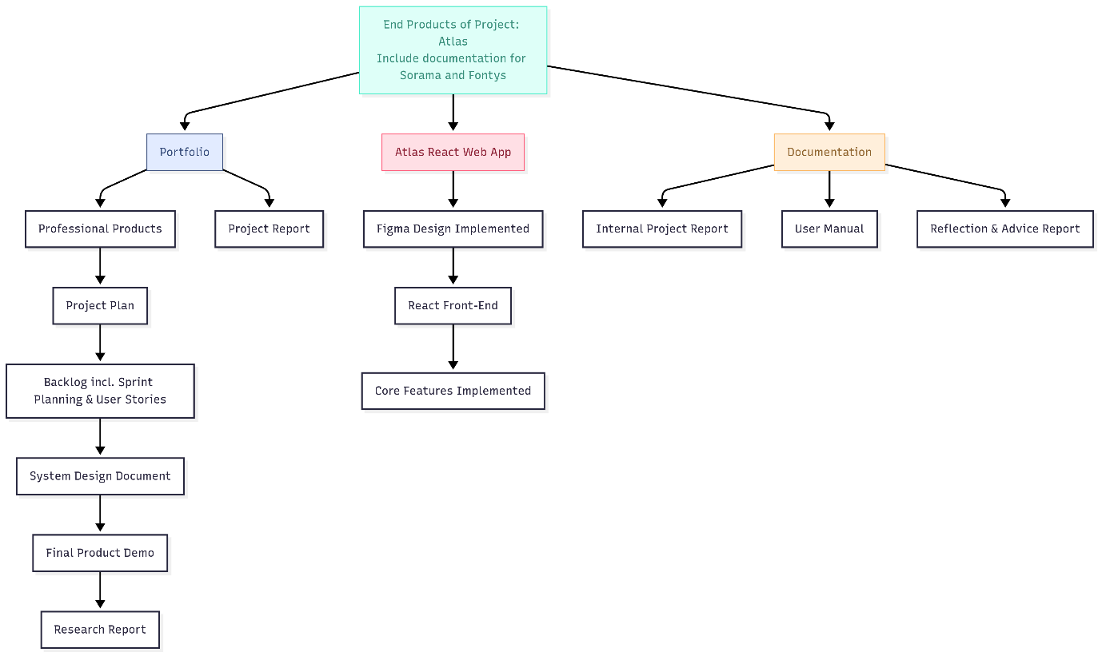

## Research Questions

How can the Sustainable Design team of Sorama switch the atlas code base from Aurelia to React while maintaining good user experience.

* What are the main differences between Aurelia and React, in terms of structure and maintainability?
* Which React-based framework (such as Next.js, Remix, Gatsby, etc.) would be the best fit for the Atlas project?
* How should the project Architecture be organized to ensure room for expansion when needed?
* What styling approach is most effective for this project?
* How can Sorama’s new Atlas design be translated into an good user-friendly react interface?
* What accessibility standards need to be considered
* What testing strategies should be applied to ensure the quality during migration

# Approach and Planning

## Approach

For this project, I will follow the Scrum methodology, which I am already familiar with from my previous semesters at Fontys. Since Sorama also uses Scrum, this approach allows me to align with the company’s existing workflow and gain practical insight into a professional working environment.

I will work in two-week sprints. At the start and end of each sprint, Kristin and I will hold meetings to discuss progress, challenges, and next steps. This ensures clear communication and keeps the project on track.

Additionally, Sorama hosts weekly “Demo and Drinks” sessions every Friday, where all teams share their progress. I will periodically present my updates on the Atlas project during these sessions, allowing me to gather feedback from colleagues and adjust the project as needed.

## Test approach

To ensure the quality and usability of the migrated Atlas front-end, I will use a combination of manual testing and user feedback throughout development. During each sprint, I will manually test new and updated UI components to verify that they work as intended and match the Figma design. Regular code reviews will be conducted with my mentor and other developers to maintain consistency and catch issues early. At the end of the project, I will organize user testing sessions with Sorama employees to evaluate the overall user experience, gather feedback, and make final improvements before delivery.

## Research methods

* What are the main differences between Aurelia and React, in terms of structure and maintainability?
* What react Framework would fit the atlas project best?
* How should the project Architecture be organized to ensure room for expansion when needed?
* What styling approach is most effective for this project?
* How can Sorama’s new Atlas design be translated into an good user-friendly react interface?
* What accessibility standards need to be considered
* How can i as an intern involve the Sustainable Design team in validating the react Prototype.
* What testing strategies should be applied to ensure the quality during migration

## Learning outcomes

### Professional Duties

A comprehensive documentation of the migration process from Aurelia to React, including a clear comparison report, selection rationale for the chosen React framework, and detailed guidelines for styling and accessibility tailored to the Sorama Atlas project.

### Situation Orientation

An analysis brief outlining the current state of the project, anticipated expansion needs, and integration plan for Sustainable Design team input; includes a risk assessment and stakeholder feedback summary.

### Professional Standard

A handbook of coding standards and best practices for the React-based Atlas interface, along with accessibility compliance documentation and quality assurance protocols, ensuring long-term maintainability.

### Personal Leadership

A reflective portfolio detailing active involvement with the Sustainable Design team, leadership in organizing prototype validation sessions, and a summary of key decisions and their positive impact on the project's outcome.

## Time plan

| Phasing | Effort | Start | Ready |
| --- | --- | --- | --- |
| Sprint 0 | 2 weeks | 8 September | 19 September |
| Sprint 1 | 2 weeks | 22 September | 3 October |
| Sprint 2 | 2 weeks | 6 October | 17 October |
| Sprint 3 | 2 weeks | 20 October | 31 October |
| Sprint 4 | 2 weeks | 3 November | 14 November |
| Sprint 5 | 2 weeks | 17 November | 28 November |
| Sprint 6 | 2 weeks | 1 december | 19 december |
| Sprint 7 | 2 weeks | 22 december | 2 january |
| Sprint 8 | 2 weeks | 5 january | 16 january |
| Sprint 9 | 2 weeks | 19 january | 30 january |
| Sprint 10 | 2 weeks | 2 february | 13 february |

# Project Organization

## Team Members

|  |  |  |  |  |
| --- | --- | --- | --- | --- |
| Name | Abbr | Role | Availability |  |
| Kristin Peneva | Sustainable Design | Software engineer, Sorama mentor | Teams, email, meetings | kristin.peneva@sorama.eu |
| Iva Dimitrova | Sustainable Design | UX/UI designer | Teams, Email |  |
| Pepijn Latour | Intern at Sorama |  | Teams, Email, Meetings, Phone | [pepijnlatour@gmail.com](mailto:pepijnlatour@gmail.com)  [p.latour@student.fontys.nl](mailto:p.latour@student.fontys.nl)  [Pepijn.latour@sorama.eu](mailto:Pepijn.latour@sorama.eu) 0647269575 |
| Evert van der Grift | Intership Coach |  |  | Prefers Teams, [e.vandergrift@fontys.nl](mailto:e.vandergrift@fontys.nl) |
|  |  |  |  |  |

## Communication

Every 2 weeks 2 meetings of roughly 30 minutes, one at the beginning of the sprint where we discuss what I will do, what my goals are. And one meeting at the end of the sprint talking about how the sprint went and what went well and what could be improved.

## Test environment

The backend of the Atlas application will be deployed on Sorama’s Azure development environment, allowing me to access live backend services remotely during development and testing. The new React front-end will be run locally on my laptop using Visual Studio Code. This setup enables me to test the integration between the locally hosted front-end and the remotely deployed backend, ensuring that all features work correctly in a realistic development environment.

## Configuration Management

I will be using Sorama’s Bitbucket as version control, here I will work within my own branch. For feedback I will create a pull request that will then be reviewed by Kristin, and other developers inside the Sorama Team.

# Finance and Risks

## Cost Budget

For the project I won’t need a budget since it is an internal tool and Sorama has its own servers. React has a lot of open-source libraries that are free to use.

## Risks and fallback activities

|  |  |  |  |
| --- | --- | --- | --- |
| Risk | Impact | Likelihood | Fallback / Mitigation |
| Migration complexity – Aurelia to React may be harder than expected | Delays in development, unfinished features | Medium | Research migration strategies early Prioritize must-have features before nice-to-have. |
| Lack of knowledge about React libraries / tools | Slower development and technical debt | Medium | Reserve research sprints, use peer reviews with Sorama devs, consult documentation and community. |
| Figma design doesn’t fully match backend data structures | Features cannot be implemented as designed | Medium | Align with stakeholders early, validate design against API before coding. |
| Usability issues after migration | Low adoption, frustration from employees | High | Regular feedback sessions with employees, showroom method after each sprint. |
| Limited time during internship | Project not fully finished | High | Prioritize core functionalities (time logging, login, navigation). Document future steps clearly. |
| Local environment configuration issues | Blocked progress | Low | Use Git for versioning, document setup in README, ask devops team for help if needed. |