HOTELPEEK
-Kotlin-

Created by:
Filimon Paula-Elena
ORADEA 2025
HotelPeek app description
HotelPeek is a mobile application developed in Kotlin using Jetpack Compose that allows users to search for accommodation deals in various cities, view hotel details, and save their favorite hotels. The application works both online and offline by caching the results. The emulator used to demonstrate its functionality is the Pixel Fold API 35.

Application navigation and pages
1. Authentication screen (Login/Register)
- It allows the user to sign in or create an account.
- Uses Firebase Authentication.
- After signing in, the user is redirected to the main screen.
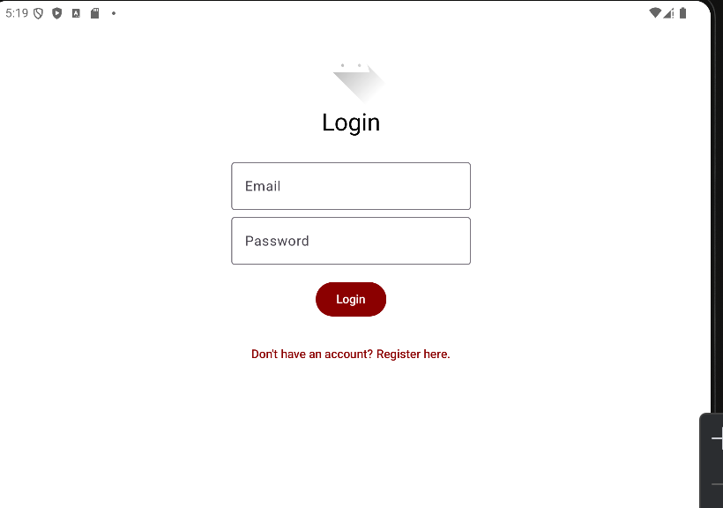

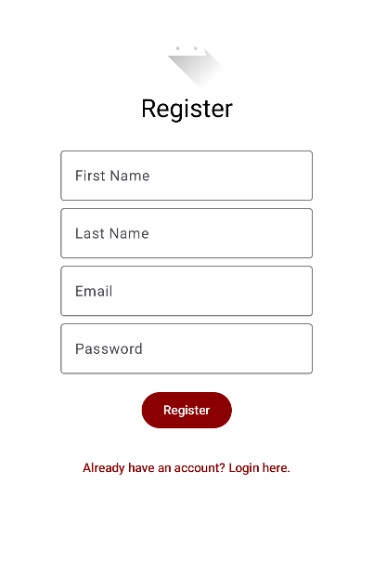

LoginScreen.kt:
• Jetpack Compose components are used (Column, OutlinedTextField, Button, etc.).
• FirebaseUtils is imported — a custom utility for Firebase authentication.
Login button
Button(onClick = {
loading = true
error = null
FirebaseUtils.login(email, password) { success, errMsg -> ... }
})

• When pressed, it sets loading = true, then attempts to log in.
• If successful: onLoginSuccess() — navigates to Home.
• If it fails: error = errMsg displays the error.

RegisterScreen.kt:
Register button

Button(onClick = {
loading = true
FirebaseUtils.register(...) { success, errMsg -> ... }
})

- Calls FirebaseUtils.register(...), which:
o Creates the Firebase Auth account.
o Saves firstName and lastName in Firestore.
- If successful, it continues navigation through onRegisterSuccess().
- If it fails, it sets the error message.

2. Main screen – HomeScreen
- Displays a personalized welcome message (the user’s name from Firestore).
Contains a form with 4 fields:
  - Location (code city, ex: PAR)
  - Check-in Date
  - Check-out date
  - Number of guests
- Find Button:
  - Searches for hotels through the Amadeus API.
  - Saves the results locally in cache (SharedPreferences).
  - Navigates to HotelResultsScreen.
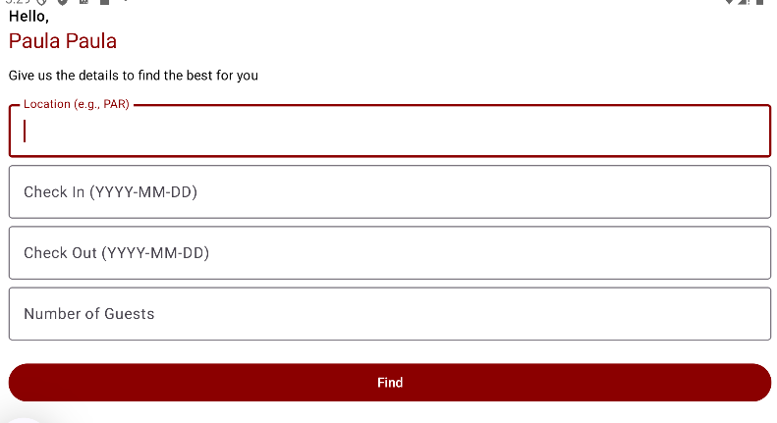
HomeScreen.kt:
Displaying the user’s name
val user = FirebaseAuth.getInstance().currentUser

- Checks whether the user is authenticated.
- If so, it retrieves the first name and last name from Firestore (users.document(uid)).Butonul „Find”
Button(onClick = { ... }) { Text("Find") }

- Checks whether all fields are filled in.
- If they are:
  - Calls AmadeusService.searchHotels(...).
  - If the API responds successfully:
    - Saves the JSON result in SharedPreferences (cache).
    - Navigates to HotelResultsScreen.
  - If there is a network error:
    - Checks whether saved cache data exists.
    - If yes, displays the previously saved hotels (offline functionality).
    - If not, shows an error message.
3. Results screen– HotelResultsScreen
- Displays the list of found hotels.
- If you are offline, it loads the most recently saved results.
- Displays:
  - Hotel name
  - Room type
  - Price
  - “View Details” button → takes the user to the details screen
Data retrieval
val result = navController.previousBackStackEntry
?.savedStateHandle
?.get<String>("hotelResultsJson")

- Receives the JSON result from HomeScreen through savedStateHandle.
- f it does not receive anything (for example, when the user is offline), it tries to load the data from cache (SharedPreferences).
Parses the JSON data into a list of objects
val json = JSONObject(jsonString)
val dataArray = json.getJSONArray("data")

- Iterates through each element in the array and extracts:
  - hotel name
  - address
  - total price
  - room type
  - description
- Creates a HotelOffer object for each item and adds it to the hotelList.

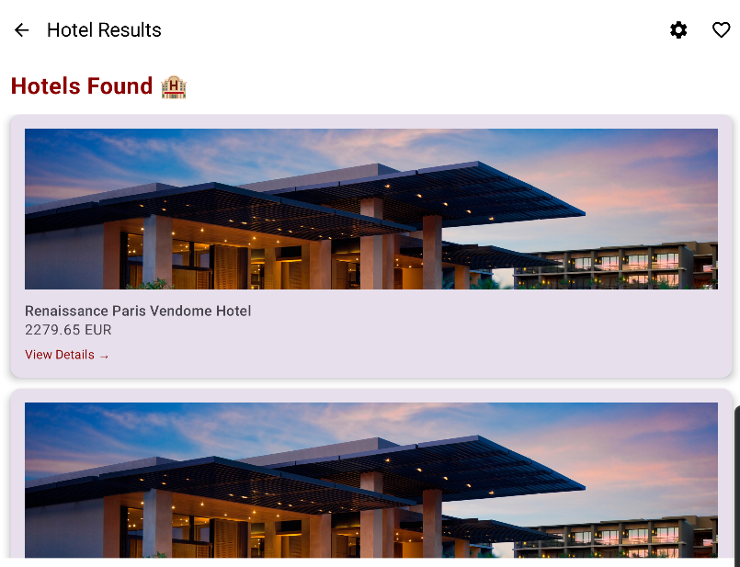

It is worth mentioning that the Amadeus API, in its test version (the free tier), does not provide images—only the price, hotel name, and a short description. For the visual appearance of the application, I added a placeholder image, which is used both in the hotel search results and in the hotel details section.

4. Hotel details screen– HotelDetailsScreen
- Displays complete information about the selected hotel:
  - Description, address, room, price, etc.
- You can add the hotel to the favorites list (saved in Firestore).
HotelDetailsScreen.tsx:

Receiving the selected hotel
val offer = navController.previousBackStackEntry
?.savedStateHandle?.get<HotelOffer>("selectedHotel") ?: return

- Retrieves the HotelOffer object sent from HotelResultsScreen through savedStateHandle.

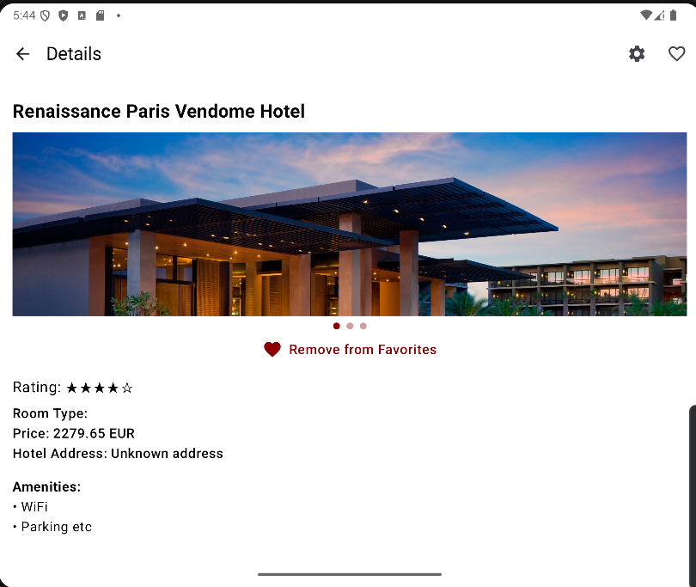

5. Favorites screen– FavoritesScreen
- Displays the list of hotels saved by the user.
- Loads from cache first, then tries the server.
- Also works offline, showing the previously saved favorites.
FavoritesScreen.kt:
Checking the logged-in user
val user = FirebaseAuth.getInstance().currentUser

- The page loads only if there is a logged-in user.
- If the user is not logged in, an error is shown.
Loading data from Firestore
- Step 1: Cache (offline mode)
It first tries to retrieve the favorite hotels from Source.CACHE:
.get(Source.CACHE)

If successful, the data is displayed immediately.
- Step 2: Server (online mode)
Then it also tries to fetch the most recent data from the server:
.get(Source.SERVER)

If there is new data, it overwrites the cached data.

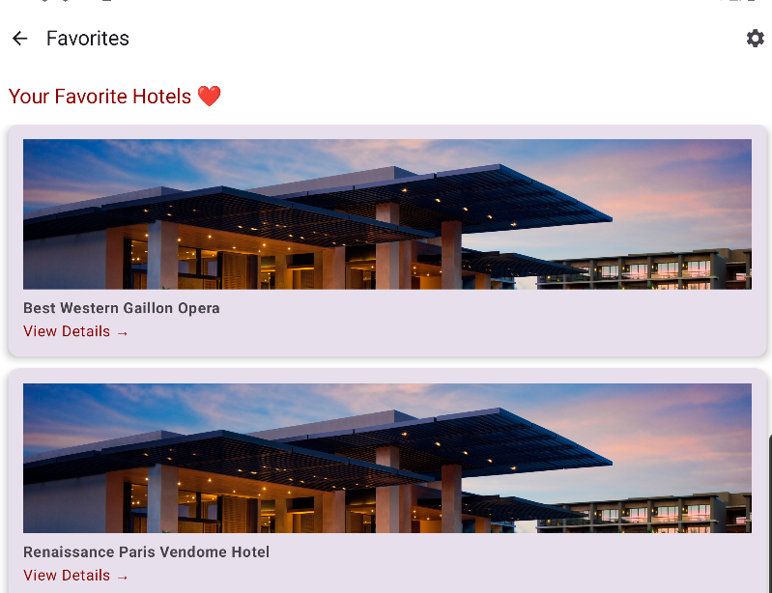

6.Settings screen – SettingsScreen
- Allows:
  - Enable/disable dark mode.
  - Navigate to „My Account”.
  - Log out (Firebase logout)
  - Clear cache (optional).
Dark Mode Toggle
Switch(
checked = isDarkTheme,
onCheckedChange = { onToggleTheme() }
)

- Displays a switch to toggle between light mode and dark mode.
- isDarkTheme is passed as a parameter from the main application.
- onToggleTheme changes the global theme.

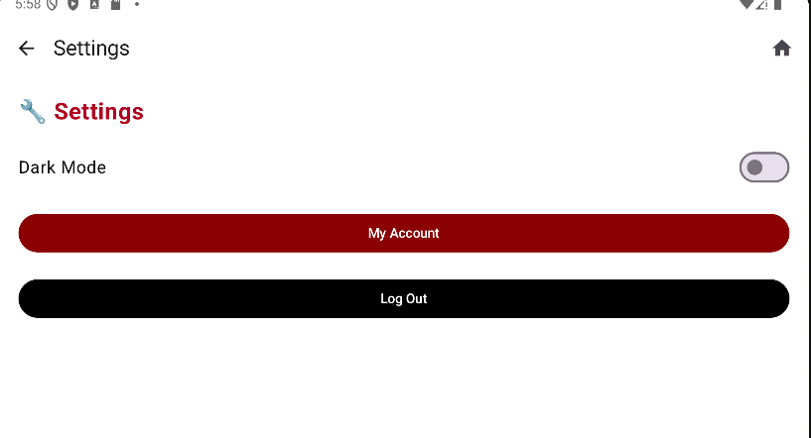

7. My Account screen – MyAccountScreen
- Displays the user’s email and other data from Firestore.
- It may include password change options in the future.
MyAccountScreen.kt:
Displayed data
val user = FirebaseAuth.getInstance().currentUser

The currently logged-in user is retrieved from Firebase. If the user is authenticated, the following are displayed:
- Email (user.email)
- Firebase UID (user.uid)

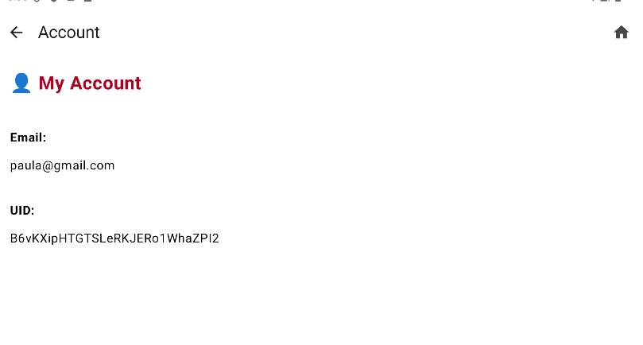

Relationships between screens
- LoginScreen → HomeScreen (after authentication)
- HomeScreen → HotelResultsScreen (after search)
- HotelResultsScreen → HotelDetailsScreen (selected hotel)
- HotelResultsScreen → FavoritesScreen / SettingsScreen (from the top bar)
- SettingsScreen → MyAccountScreen sau HomeScreen (direct navigation)

Offline functionality
- The results of the most recent search are saved locally.
- If the application detects that you are offline:
  - In HomeScreen, the results are loaded from cache.
  - In HotelResultsScreen, the previous list is displayed.
  - In FavoritesScreen, the local favorites are loaded.
- No error is displayed; the application adapts automatically.
Dark/Light Mode
- It can be changed in the application settings
- Examples of Dark Mode pages:
