
AO WebAPI – Technical Specification

AdInsure 2.5 Technical Specification

Triglav International
Written By: | Sonja Milićević
Version: | 1.0
Date: | August 13, 2025

Introduction
This document is the technical documentation for the AdInsure product.
Document Changes
Version | Author | Date | Changelog
1.0 | Sonja Milićević | 13.08.2025 | Document created
2.0 | Sonja Milićević | 31.10.2025 | Updated examples

Table of Contents
1. Introduction and Scope 4
2. Technologies Used 4
3. Development Environment and Tools 5
4. Database 5
5. Logging 5
6. Security 6
7. Solution Architecture 10
8. Design Specification 11
8.1. Sample AO API Methods 11
8.1.1. get-policy (/api/public/v1/policies/NV0450001B2B/get-policy) 11
8.1.2. create-policy (/api/public/v1/policies/NV0450001B2B/create-policy) 11
8.1.3. get-premium (/api/public/v1/policies/NV0450001B2B/get-premium) 14
8.1.4. print (/api/public/v1/policies/NV0450001B2B/print) 15
8.1.5. copy-from-info-policy(/api/public/v1/policies/NV0450001B2B/copy-from-info-policy) 16
8.1.6. get-policy-document-infos(/api/public/v1/policies/NV0450001B2B/get-policy-document-infos) 16
8.1.7. get-external-documents-list(/api/public/v1/policies/NV0450001B2B/get-external-documents-list) 16
8.1.8. search-address(/api/public/v1/policies/NV0450001B2B/search-address) 16
8.1.9. get-previous-policy-data(/api/public/v1/policies/NV0450001B2B/get-previous-policy-data) 17
9. Software and Hardware Requirements 18
9.1. WebAPI Server 18
9.2. Database Server 18
9.3. Client Application 18
10. Configuration Management 19
10.1. Database Settings 19
10.2. Log Settings 19
11. Data types 21
11.1. AO data types 21
11.2. Code list 23
11.4. Error AO data types 24
12. Error response 25

Introduction and Scope
The goal of this document is to present the technical information for AdInsure WebAPI framework. This framework was developed as part of the Triglav International 2.5 release. It enables external applications to utilize core AdInsure functionalities for user authentication, premium calculation, and policy issuing processes.
WebAPI consists of two different API layers:
- The generic (core) WebAPI layer, which provides shared functionalities such as user authentication, person search, and waybill integration. This generic WebAPI layer also provides generic methods for calculating premium, creating policies, and returning policy data. However, these generic methods require in-depth understanding of the AdInsure product engine (“jedro”), core objects, and class model.
- In order to simplify the generic methods and enable easier 3rd party application integration, Adacta included the mapping WebAPI layer and provided sample mapping for one insurance product – AO insurance. This layer provides a set of product-specific methods (get policy, create policy, get premium, print, and get-policy-detail) and acts as a template that can be used by Triglav for developing additional mappings for other products according to business needs.
Additionally, Adacta also developed a demo web client to provide an illustration of WebAPI use. This demo web client is included with the 2.5 code, but its description is outside the scope of this document.
A more detailed overview of the architecture is provided in the Solution Architecture chapter.

Technologies Used
The application was developed in Microsoft .NET 4.5 framework.
WebAPI was developed using ASP.NET Web API framework for RESTful applications on .NET Framework.
WebAPI is dependent on the AdInsure 2.5 codebase.

Development Environment and Tools
The following software tools are required for WebAPI development:
- Visual Studio 2022
- SoapUI for testing
- Swagger web browser plugin
- Postman web browser plugin

Since WebAPI uses core AdInsure objects, all software tools required for AdInsure development are also required for creating new product mappings and debugging WebAPI (but are not required for WebAPI development itself).

Database
WebAPI does not have a separate database. Instead, it connects to the AdInsure database which utilizes MS SQL Server 2014 or newer as its RDBMS.

Logging
WebAPI can utilize the standard AdInsure error logging principles (just like the AdInsure web service and AdService) if appropriate logging is turned on in the configuration.
All requests and errors generated by the core AdInsure engine are logged on the server side.
WebAPI requests and responses are not logged at this time.

Security
WebAPI was developed as a separate application that can be installed on the same server as the existing AdInsure web service or on a separate server (for increased security). WebAPI service supports the HTTPS protocol, which enables secure client/server communication.
WebAPI utilizes token-based authentication. Every WebAPI service request except for the authentication (Login) request requires a security token to be submitted. Login method returns the token after successfully authenticating the user using standard AdInsure authentication methods.
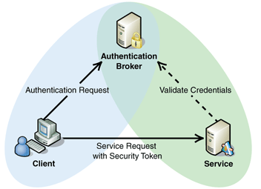
The token is valid for a predefined time period.
The following BPM diagram describes the process flow and interaction between different applications and services.
- External system must request authentication, receive the security token, and store the token within a local store
- API receives the request, invokes the AdInsure core authentication module, generates the security token, and sends the token to the external system
- AdInsure handles authentication in the same manner as if it received a request from the AdInsure Windows client. Submitted user must be an active, existing AdInsure user – no special privileges are required for authorization at this time

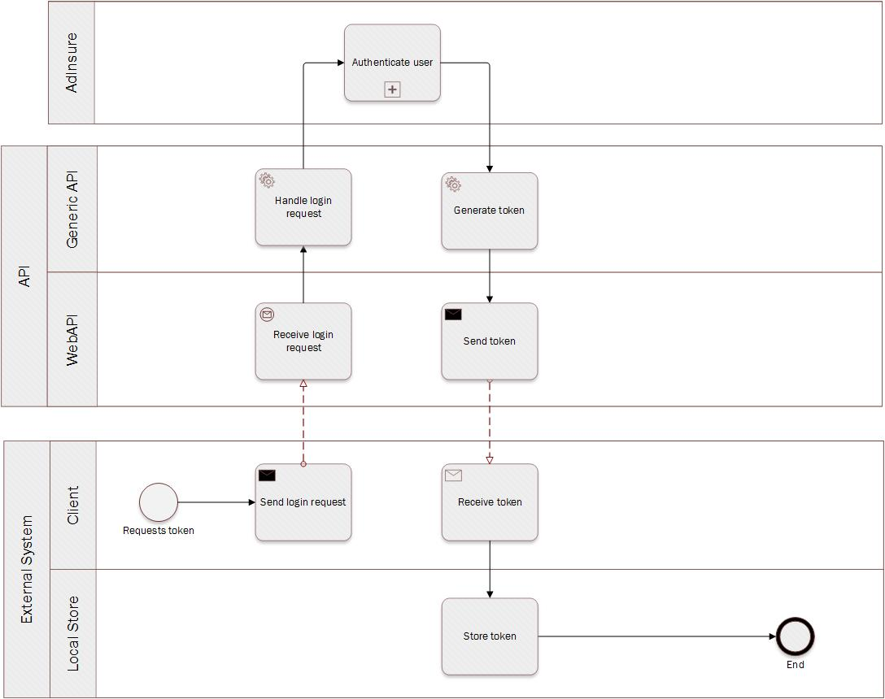
The Angular TypeScript code for the login service and token generation is presented below:
import {
Headers,
Http
} from '@angular/http';
import {
Injectable
} from '@angular/core';
import 'rxjs/add/operator/toPromise';

@Injectable()
export class LoginService {
private apiUrl: string = 'http://localhost/AdInsure.Triglav.Osiguranje.API.Server/';

constructor(private http: Http) {}

public login(username: string, pass: string): Promise < void > {

var body = 'grant_type=password&username=' + username + '&password=' + pass;

var headers = new Headers();
headers.append('Content-Type', 'application/x-www-form-urlencoded');
headers.append('Access-Control-Allow-Origin', '*');

return this.http.post(this.apiUrl + 'Token', body, {
headers: headers
})
.toPromise()
.then(response =>
localStorage.setItem('token', response.text())
)
.catch(this.handleError);
}

private handleError(error: any): Promise < any > {
console.error('An error occurred', error); // for demo purposes only
return Promise.reject(error.message || error);
}
}

/*********************************/

import {
Component,
OnInit
} from '@angular/core';
import {
Router
} from '@angular/router'
import {
LoginService
} from './login.service';

@Component({
selector: 'login-component',
templateUrl: './login.component.html',
providers: [LoginService]
})
export class LoginComponent implements OnInit {
public username: string;
public password: string;
private token: string;
private msg: string;

constructor(private loginService: LoginService, private router: Router) {}

ngOnInit(): void {}

public login(): void {
this.msg = '';

this.loginService.login(this.username, this.password).then(() => {
this.router.navigateByUrl('/travel-vo');
}, (reason: any) => {
this.msg = 'Invalid username or password.';
});
}
}

The following code demonstrates how the token is used:
import {
Headers,
Http,
ResponseContentType
} from '@angular/http';
import {
Injectable
} from '@angular/core';
import {
Router
} from '@angular/router';
import 'rxjs/add/operator/toPromise';

import {
NV0450001Type
} from './domain/interfaces.gen';

@Injectable()
export class TravelService {
private apiNV0450001Url: string = 'http://localhost/AdInsure.Triglav.Osiguranje.API.Server/api/public/v1/policies/NV0450001B2B/';

constructor(private http: Http, private router: Router) {}

public save(policyData:): Promise < NV0450001Type> {

return this.http.post(this.apiNV0450001Url + 'create-policy', policyData, {
headers: this.createHeaders()
})
.toPromise()
.then(response =>
JSON.parse(response.text()) as NV0450001Type
)
.catch(this.handleError);
}

private handleError = (error: any): Promise < any > => {

if (error.status === 401) {
this.router.navigateByUrl('/login');
} else {
alert(error.json().Message);
}

return Promise.reject(error.message || error);
}

private getAuthorizationHeader(): string {
let ret: string = null;
let tokenData: any = JSON.parse(localStorage.getItem('token'));
if (tokenData) {
ret = tokenData.token_type + ' ' + tokenData.access_token;
}

return ret;
}

private createHeaders(): Headers {
var headers = new Headers();
headers.append('Access-Control-Allow-Origin', '*');
headers.append('Authorization', this.getAuthorizationHeader());

return headers;
}
}

Solution Architecture
The diagram below presents the logical architecture of the solution.
- External client (web, mobile…) uses the http(s) protocol to send requests to the API layer along with the generated token (see Security chapter above).
  - The client can invoke mapped methods for a specific sales product. In this case, the mapping API then maps the request to the generic (core) API. Mapping API must be developed for each product separately, allowing the input to be tailor-made for the product and thus easier for 3rd party clients to provide.
  - The client can also invoke generic (core) methods, which do not require a mapped product. These methods require considerably more complex input which must be tailored to the AdInsure product core, but the methods are completely flexible and allow the handling of any product.
- API layer uses the business logic handler in AdInsure, which converts the mapped request to the core object model based on the PogodbaBase class.
- Once the PogodbaBase object is instantiated and validated according to core product rules, data can be saved to the database and/or returned via JSON/XML to the invoking client.
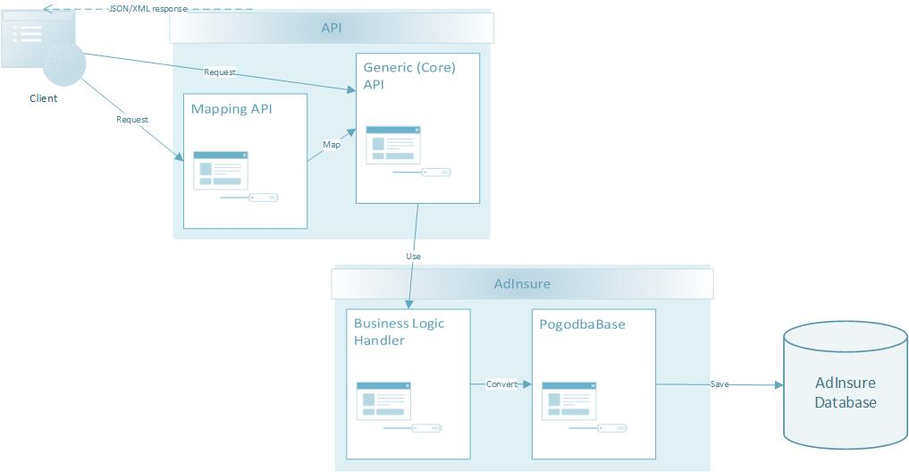

Design Specification
The following chapters contain a list and description of all WebAPI methods, business process model diagrams for the processes, and sample sequence diagrams for the two key mapped methods (Calculate and CreatePolicy).

Sample AO API Methods
All methods are mapped to A0 product NV0450001 (Triglav Osiguranje Zagreb).

get-policy (/api/public/v1/policies/NV0450001B2B/get-policy)
Returns all AO insurance policy data for requested PolicyId.

create-policy (/api/public/v1/policies/NV0450001B2B/create-policy)
Creates a new AO policy in draft status from supplied parameters. Also creates the accompanying invoice.
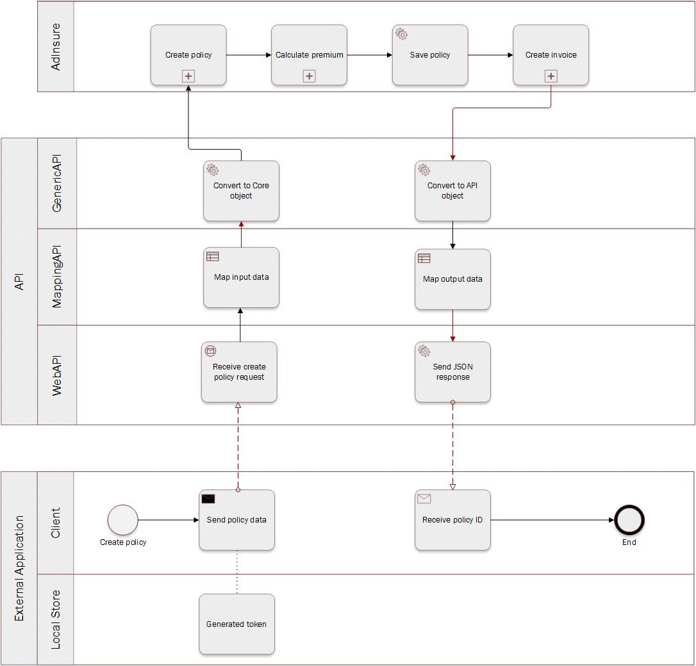
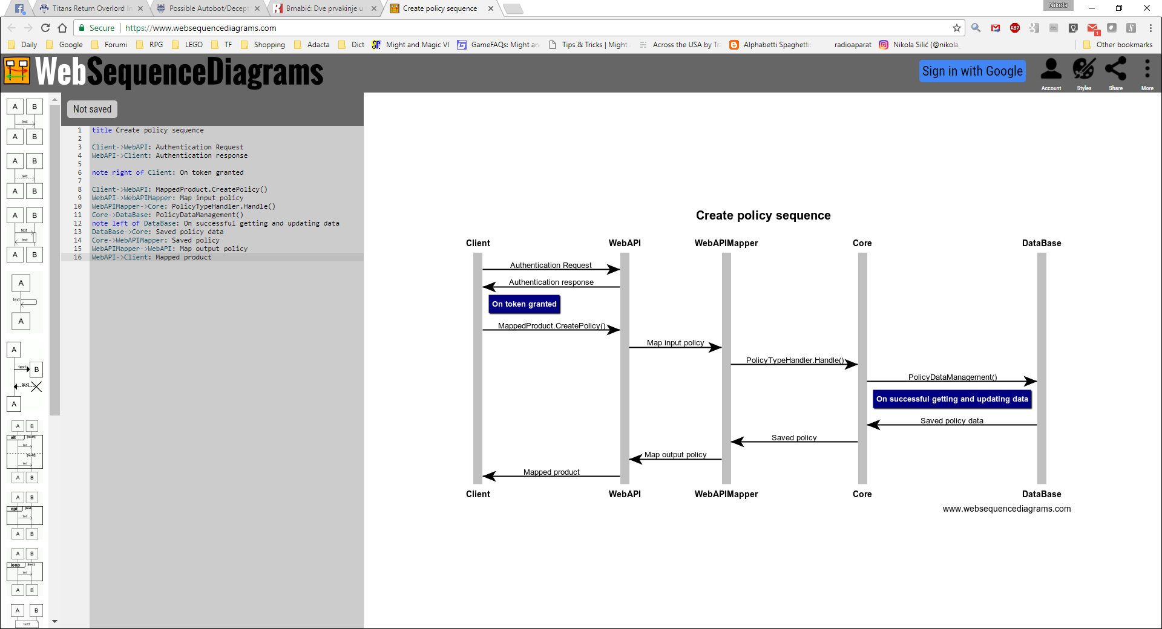

get-premium (/api/public/v1/policies/NV0450001B2B/get-premium)
Calculates and returns A0 premium from supplied parameters but does not create a policy.
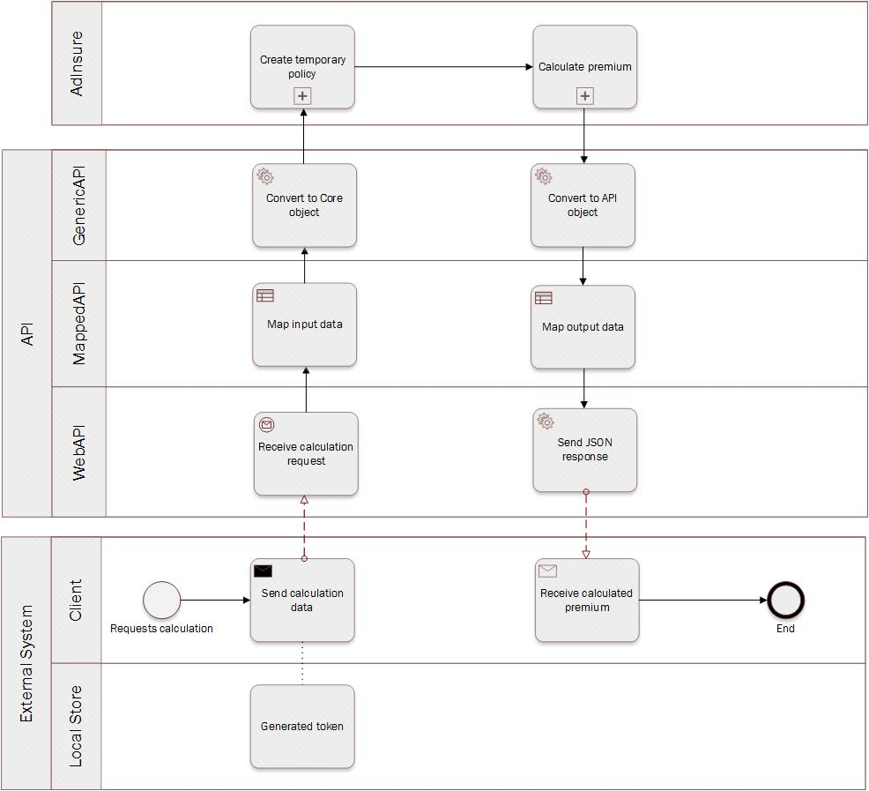
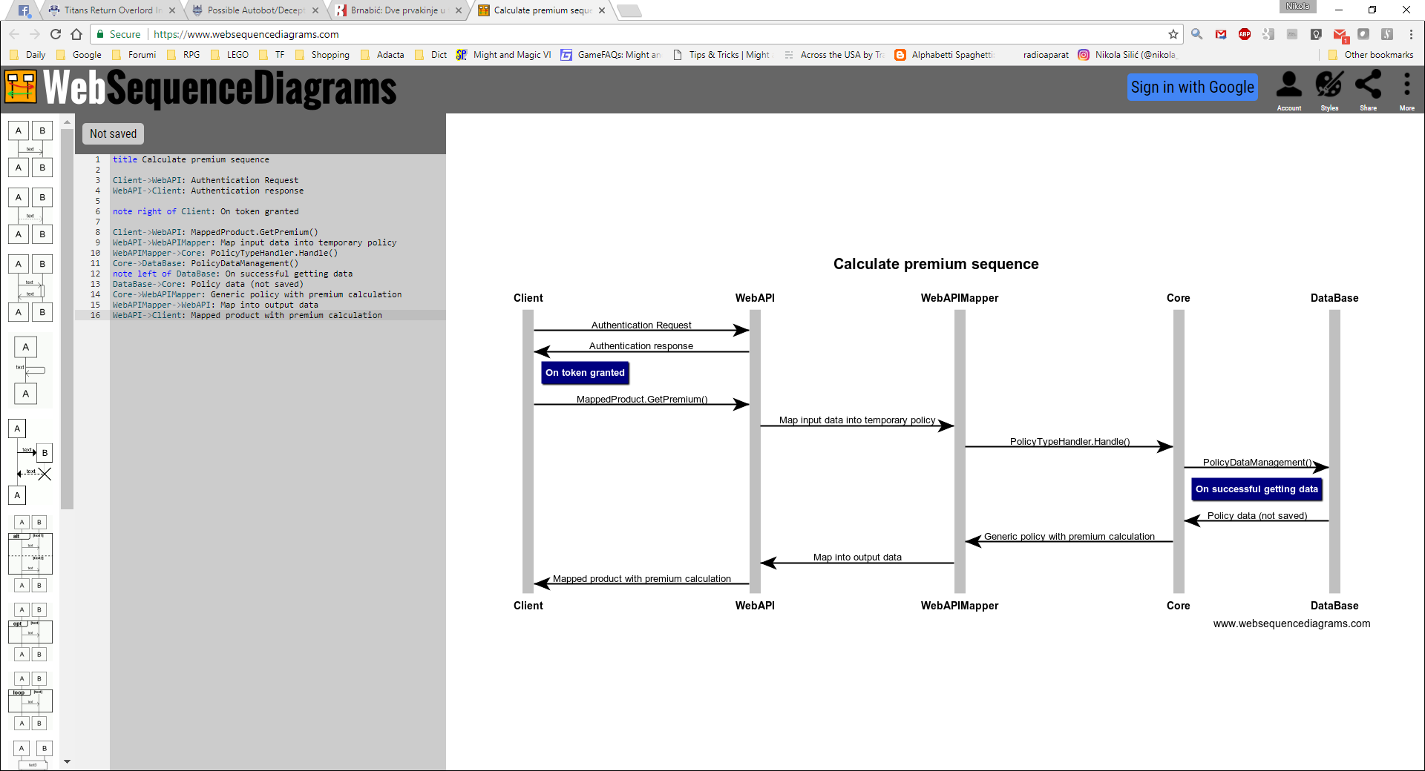

print (/api/public/v1/policies/NV0450001B2B/print)
Generates and returns A0 insurance printouts for supplied PolicyId and DocumentType. Possible document types are: “Policy” (policy) and “Invoice”.
Development note: since each product has different printouts (as defined in the product core), the print method was developed in the mappingAPI layer. It can work with any document type, but the list of specific document types should be enumerated in the mapping for each separate product.

copy-from-info-policy(/api/public/v1/policies/NV0450001B2B/copy-from-info-policy)
Creates a new policy or a policy draft by copying data from an existing policy.
The endpoint allows you to specify whether to copy invoice information, sales data, and whether the copied policy should start as a new beginning.

get-policy-document-infos(/api/public/v1/policies/NV0450001B2B/get-policy-document-infos)
Retrieves available document information for a specific policy.
The request requires the internal policy ID and a LoadType flag that controls the type/extent of document information to be returned.

get-external-documents-list(/api/public/v1/policies/NV0450001B2B/get-external-documents-list)
Retrieves a list of external documents related to the specified policy.
The request requires the product identifier and environment indicator.

search-address(/api/public/v1/policies/NV0450001B2B/search-address)
Searches for address information (settlement, postal code, etc.) that matches the given criteria.
Useful for validating or auto-completing addresses during policy creation or updates.

get-previous-policy-data(/api/public/v1/policies/NV0450001B2B/get-previous-policy-data)
Retrieves data from the previous policy version associated with the given PolicyId.
This is typically used when creating renewals, endorsements, or new versions, so that relevant policy details can be carried forward.

Software and Hardware Requirements

WebAPI Server
Requirements are identical to those of the AdInsure web server. WebAPI can be set up on the same server as the AdInsure web server; however, this represents a security challenge and may cause scalability issues.

Database Server
WebAPI uses the existing AdInsure database server.

Client Application
WebAPI can be invoked by any client capable of sending JSON or XML requests.

Configuration Management
The WebAPI service is configured via web.config configuration file.

Database Settings
<Database>
<add key="Main" value="Adacta.Utilities.Data.DbProvider=SQL;Data Source=SERVER_NAME_OR_IP;Initial Catalog=DATABASE_NAME;User ID=DBUSER;Password=DBPASSWORD"/>
</Database>

Section | Database
Key | Value | Description
Main | Adacta.Utilities.Data.DbProvider=SQL;Data Source=SERVER_NAME_OR_IP;Initial Catalog=DATABASE_NAME;User ID=DBUSER;Password=DBPASSWORD | Main database setting. Required data: server name or IP address, database name, username and password for the database user

Log Settings
<Log>
<add key="LogRoot" value=".\Logs "/>
<add key="LogLevel" value="DEBUG"/>
<add key="TimingThreshold" value="0"/>
</Log>

Section | Log
Key | Value | Description
LogRoot | Folder | root folder which will contain the log files. A separate subfolder is created each day.
LogLevel | Log detail level, e.g. DEBUG | Logging detail level.  Possible details levels are:  - CRITICAL (0)  - ERROR (1)  - WARNING (2)  - TRACE (3)  - DEBUG (4)  Only those records with a detail level equal to or lower than the setting are kept.
TimingThreshold | Time (ms) | If time-restricted logging is used, only operations that exceeded the time are logged (0 means that all operations are logged).

Data types

AO data types
Data | Type | Data Length
IsEnabled | Bool
OverheadAllowance | decimal
CoverageHeight | string
RiskFactorForOtherCountries | int
PremiumClass | String | 250
CascoCrashIntoAnimals | String | 250
CascoFiveStars | String | 250
CascoFight | String | 250
CascoGlass | string
CascoHelmetLights | string
CascoCollisionWithAnotherCar | String | 250
MotoSkiing | string
KeptAbroad | string
OneWayTrip | string
KeyLoss | string
TreatmentAfterTrafficAccident | string
ParticipationAfterTrafficAccident | string
AdditionalRantInsurance | string
KeepDistance | string
CyclistResponsibility | string
CyclistAssistance | string
BasePlus | string
PersonalVehiclePlus | string
BonusProtect | string
Fight | string
AccidentInWildlife | string
BreakingGlass | string
BreakingGlass | string
TehnicalDiscountsAndSurcharges | string

Code list
Data | 0 | 1 | 2 | 3 | 4 | 5
SumInsureGrade | 0 | 1
PersonRoles | NaturalPerson | LegalPerson
Gender | Neutral | Male | Female
AddressTypeId | Legal person additional address | Legal person headquarters | Legal person old address | Natural person old address | Natural person permanent address | Natural person current address
PolicyTypeId | Policy | Amendment | InfoPolicy | ControlPolicy | SuperPolicy | PackagePolicy

Error AO data types
Data | Type
Message | String
Code | String
Details | String
StackTrace | String
ExceptionType | String
IncidentId | String
Errors | String[]
CustomError | String

Error response
All properties are type string.

