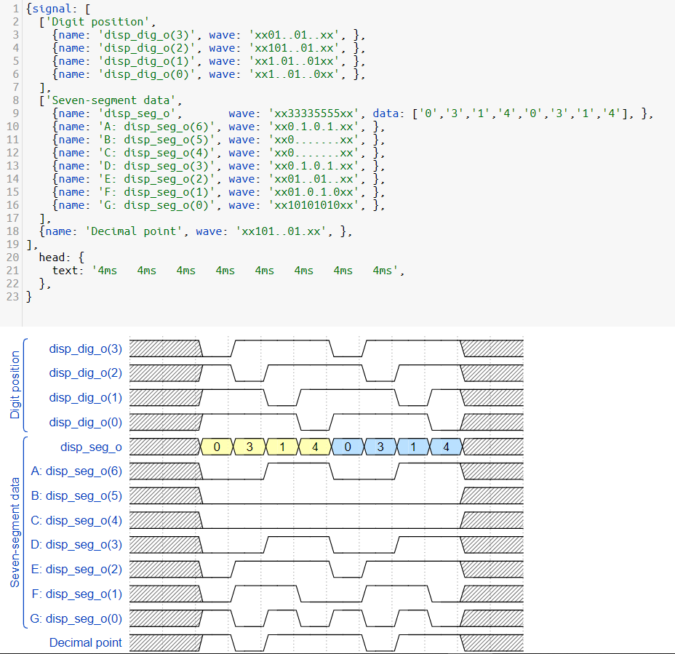

{signal: [

['Digit position',

{name: 'disp_dig_o(3)', wave: 'xx01..01..xx', },

{name: 'disp_dig_o(2)', wave: 'xx101..01.xx', },

{name: 'disp_dig_o(1)', wave: 'xx1.01..01xx', },

{name: 'disp_dig_o(0)', wave: 'xx1..01..0xx', },

],

['Seven-segment data',

{name: 'disp_seg_o', wave: 'xx33335555xx', data: ['0','3','1','4','0','3','1','4'], },

{name: 'A: disp_seg_o(6)', wave: 'xx0.1.0.1.xx', },

{name: 'B: disp_seg_o(5)', wave: 'xx0.......xx', },

{name: 'C: disp_seg_o(4)', wave: 'xx0.......xx', },

{name: 'D: disp_seg_o(3)', wave: 'xx0.1.0.1.xx', },

{name: 'E: disp_seg_o(2)', wave: 'xx01..01..xx', },

{name: 'F: disp_seg_o(1)', wave: 'xx01.0.1.0xx', },

{name: 'G: disp_seg_o(0)', wave: 'xx10101010xx', },

],

{name: 'Decimal point', wave: 'xx101..01.xx', },

],

head: {

text: '4ms 4ms 4ms 4ms 4ms 4ms 4ms 4ms',

},

}

